**Question1-Agile Manifesto**

**Main Values-**

1. Individuals and interactions over processes and tools.
2. Working software over comprehensive documentation.
3. Customer collaboration over contract negotiation
4. Responding to change over following a plan

**Principles-**

1. Satisfy the customer through early and continuous delivery of valuable software.
2. Welcome changing requirements, even late in development. Agile processes harness change for the customers competitive advantage.
3. Deliver working software frequently, from a couple of weeks to couple of months, with a preference to shorter timescale.
4. Business people and developers must work together daily throughout the project.
5. Build project around motivated individuals. Give then the environment and support they need and trust them to get the job done.
6. The most efficient and effective method of conveying information to and within a development team is face- to face conversation.
7. Working software is primary measure of progress.
8. Agile processes promote sustainable development. The sponsors, developers and users should be able to maintain a constant pace indefinitely.
9. Continuous attention to technical excellence and good design enhances agility.
10. Simplicity—the art of maximizing the amount of work not done—is essential.
11. The best architectures, requirements, and design emerge from self-organizing teams.
12. At regular intervals, the team reflects on how to become more effective, then tunes and adjusts its behaviour accordingly.

**Question 2 – User Stories- Acceptance Criteria-BV-CP – 40 Marks**

**Customer User Stories**

**US001 – Customer Registration**

**As a** customer,  
**I want** to register using my email or phone number,  
**So that** I can access the application features.

* **Acceptance Criteria**:
  + Registration must require OTP verification.
  + Users receive confirmation email/SMS.
  + Duplicate registration prevented.
* **BV:** Rs 500
* **CP:** 3

**US002 – Customer Login**

**As a** customer,  
**I want** to log in securely,  
**So that** I can access my profile and place orders.

* **Acceptance Criteria**:
  + Valid username and password.
  + Error messages for incorrect credentials.
  + Session timeout after inactivity.
* **BV:** Rs 500
* **CP:** 2

**US003 – Search Restaurants**

**As a** customer,  
**I want** to search for restaurants by cuisine/location,  
**So that** I can find food that suits my taste.

* **Acceptance Criteria**:
  + Search bar with autocomplete.
  + Filter by rating, delivery time.
  + Search results are relevant.
* **BV:** Rs 1000
* **CP:** 5

**US004 – View Restaurant Menu**

**As a** customer,  
**I want** to view the menu of a restaurant,  
**So that** I can choose food to order.

* **Acceptance Criteria**:
  + Menu displayed in categories.
  + Prices and availability shown.
  + Images for each item.
* **BV:** Rs 1000
* **CP:** 3

**US005 – Add Items to Cart**

**As a** customer,  
**I want** to add and remove items in a cart,  
**So that** I can finalize my order.

* **Acceptance Criteria**:
  + Quantity can be adjusted.
  + Total price updates dynamically.
* **BV:** Rs 500
* **CP:** 3

**US006 – Place Order**

**As a** customer,  
**I want** to place an order with a selected restaurant,  
**So that** I can receive food at my address.

* **Acceptance Criteria**:
  + Confirm address, items, and price.
  + Notification after order placement.
* **BV:** Rs 1000
* **CP:** 5

**US007 – Multiple Payment Options**

**As a** customer,  
**I want** to pay using card, wallet, UPI, or cash,  
**So that** I have flexibility in payment.

* **Acceptance Criteria**:
  + Secure gateway integration.
  + Confirm payment success/failure.
* **BV:** Rs 1000
* **CP:** 8

**US008 – Order Tracking**

**As a** customer,  
**I want** to track my order in real time,  
**So that** I know when it will arrive.

* **Acceptance Criteria**:
  + Live map tracking.
  + Status updates (Order accepted, food prepared, out for delivery, delivered).
* **BV:** Rs 1000
* **CP:** 13

**US009 – Cancel Order**

**As a** customer,  
**I want** to cancel my order within a grace period,  
**So that** I can avoid unwanted orders.

* **Acceptance Criteria**:
  + Cancellation allowed before dispatch.
  + Refund processed for prepaid orders.
* **BV:** Rs 500
* **CP:** 5

**US010 – Provide Ratings and Feedback**

**As a** customer,  
**I want** to rate and review my experience,  
**So that** I can share my opinion and improve service.

* **Acceptance Criteria**:
  + Rate restaurant and delivery separately.
  + Comments are optional.
* **BV:** Rs 500
* **CP:** 3

**🔹 Delivery Boy User Stories**

**US011 – Delivery Boy Registration**

**As a** delivery boy,  
**I want** to register and upload my documents,  
**So that** I can start receiving delivery assignments.

* **Acceptance Criteria**:
  + KYC verification process.
  + Admin approval before activation.
* **BV:** Rs 500
* **CP:** 5

**US012 – Delivery Boy Login**

**As a** delivery boy,  
**I want** to log in securely,  
**So that** I can view my deliveries.

* **Acceptance Criteria**:
  + Authentication and password reset.
  + Session expiration.
* **BV:** Rs 500
* **CP:** 2

**US013 – View Assigned Orders**

**As a** delivery boy,  
**I want** to view all my assigned orders,  
**So that** I can plan the deliveries.

* **Acceptance Criteria**:
  + Orders listed with address and status.
  + Sorting by time/distance.
* **BV:** Rs 1000
* **CP:** 3

**US014 – Accept/Reject Orders**

**As a** delivery boy,  
**I want** to accept or reject delivery requests,  
**So that** I can manage my workload.

* **Acceptance Criteria**:
  + Timer for decision window.
  + Rejected orders reassigned.
* **BV:** Rs 1000
* **CP:** 3

**US015 – Update Delivery Status**

**As a** delivery boy,  
**I want** to update pickup and delivery status,  
**So that** the system and customers stay informed.

* **Acceptance Criteria**:
  + Real-time updates.
  + Mark order as delivered.
* **BV:** Rs 1000
* **CP:** 5

**US016 – COD Payment Marking**

**As a** delivery boy,  
**I want** to mark cash received,  
**So that** the payment record stays accurate.

* **Acceptance Criteria**:
  + Confirmation prompt.
  + Cannot mark delivered unless cash marked.
* **BV:** Rs 500
* **CP:** 3

**US017 – View Ratings/Feedback**

**As a** delivery boy,  
**I want** to view my ratings,  
**So that** I can understand performance.

* **Acceptance Criteria**:
  + Ratings shown by date.
  + Read-only access.
* **BV:** Rs 100
* **CP:** 2

**US018 – Raise Delivery Issues**

**As a** delivery boy,  
**I want** to report issues (address not found, customer not available),  
**So that** admin can assist or escalate.

* **Acceptance Criteria**:
  + Select from predefined issue list.
  + Optional comments.
* **BV:** Rs 500
* **CP:** 3

**US019 – View Delivery Report**

**As a** delivery boy,  
**I want** to view delivery history and earnings,  
**So that** I can track my performance.

* **Acceptance Criteria**:
  + Monthly filter.
  + Number of orders and total revenue.
* **BV:** Rs 500
* **CP:** 5

**🔹 Restaurant User Stories**

**US020 – Restaurant Registration**

**As a** restaurant owner,  
**I want** to register and upload licenses,  
**So that** I can list my menu.

* **Acceptance Criteria**:
  + License verification.
  + Admin approval needed.
* **BV:** Rs 500
* **CP:** 5

**US021 – View Incoming Orders**

**As a** restaurant,  
**I want** to view real-time orders,  
**So that** I can prepare food on time.

* **Acceptance Criteria**:
  + Audio/visual alerts.
  + Order details with timer.
* **BV:** Rs 1000
* **CP:** 3

**US022 – Verify Delivery Boy Identity**

**As a** restaurant,  
**I want** to verify the delivery boy before handing over food,  
**So that** orders are safe.

* **Acceptance Criteria**:
  + OTP or code verification.
* **BV:** Rs 500
* **CP:** 3

**US023 – Payment Summary**

**As a** restaurant,  
**I want** to view all payment transactions,  
**So that** I can track revenue.

* **Acceptance Criteria**:
  + Daily/weekly summaries.
  + Downloadable report.
* **BV:** Rs 500
* **CP:** 3

**US024 – View Feedback & Ratings**

**As a** restaurant,  
**I want** to see customer feedback,  
**So that** I can improve service.

* **Acceptance Criteria**:
  + Filter by rating or date.
  + No reply option.
* **BV:** Rs 500
* **CP:** 3

**US025 – Raise Restaurant Issues**

**As a** restaurant,  
**I want** to report app or order issues,  
**So that** they can be resolved quickly.

* **Acceptance Criteria**:
  + Choose from issue type.
  + Track status of complaints.
* **BV:** Rs 500
* **CP:** 3

**🔹 Regional Admin User Stories**

**US026 – Regional Admin Login**

**As a** regional admin,  
**I want** to log into the system,  
**So that** I can manage my region’s operations.

* **Acceptance Criteria**:
  + Valid credentials required.
  + Error for invalid login.
* **BV:** Rs 100
* **CP:** 2

**US027 – Track Orders & Delivery Status**

**As a** regional admin,  
**I want** to track orders in real time,  
**So that** I can ensure timely deliveries.

* **Acceptance Criteria**:
  + Filter by delivery boy or area.
  + Live updates every minute.
* **BV:** Rs 1000
* **CP:** 8

**US028 – View Customer Feedback**

**As a** regional admin,  
**I want** to view feedback from customers,  
**So that** I can monitor service quality.

* **Acceptance Criteria**:
  + Filter by date or restaurant.
  + Feedback visible with ratings.
* **BV:** Rs 500
* **CP:** 3

**US029 – Manage Delivery Boys in Region**

**As a** regional admin,  
**I want** to approve, deactivate or assign delivery boys,  
**So that** operations run smoothly.

* **Acceptance Criteria**:
  + View list by area.
  + Assign orders manually if needed.
* **BV:** Rs 1000
* **CP:** 5

**US030 – Manage Restaurants in Region**

**As a** regional admin,  
**I want** to manage restaurant accounts,  
**So that** the restaurants are compliant and active.

* **Acceptance Criteria**:
  + Approve/reject restaurants.
  + Assign support contact.
* **BV:** Rs 1000
* **CP:** 5

**US031 – View Regional Revenue**

**As a** regional admin,  
**I want** to view the total earnings from my region,  
**So that** I can monitor performance.

* **Acceptance Criteria**:
  + Revenue by day/week/month.
  + Restaurant-wise breakdown.
* **BV:** Rs 500
* **CP:** 5

**US032 – Handle Refund Requests**

**As a** regional admin,  
**I want** to process refund requests,  
**So that** customers are compensated fairly.

* **Acceptance Criteria**:
  + Approve/decline refund with remarks.
  + Notification to customer and restaurant.
* **BV:** Rs 500
* **CP:** 5

**US033 – View Payments to Restaurants**

**As a** regional admin,  
**I want** to see payment records to restaurants,  
**So that** I can ensure timely payouts.

* **Acceptance Criteria**:
  + Export to Excel/PDF.
  + View pending and completed payments.
* **BV:** Rs 500
* **CP:** 4

**🔹 Admin User Stories**

**US034 – Admin Login**

**As an** admin,  
**I want** to securely log in,  
**So that** I can access all platform settings.

* **Acceptance Criteria**:
  + 2FA login.
  + IP logging.
* **BV:** Rs 100
* **CP:** 2

**US035 – Manage Regional Admins**

**As an** admin,  
**I want** to add, remove or assign regions to regional admins,  
**So that** I can manage the organizational structure.

* **Acceptance Criteria**:
  + Assign roles and permissions.
  + Show list with filters.
* **BV:** Rs 1000
* **CP:** 5

**US036 – Handle All Platform Issues**

**As an** admin,  
**I want** to manage escalated issues from users,  
**So that** I can resolve critical problems.

* **Acceptance Criteria**:
  + View by priority.
  + Assign to support agents.
* **BV:** Rs 1000
* **CP:** 5

**US037 – View Platform Feedback**

**As an** admin,  
**I want** to analyze user feedback platform-wide,  
**So that** I can identify improvement areas.

* **Acceptance Criteria**:
  + Filters by role (Customer, Restaurant, Delivery).
  + Export option.
* **BV:** Rs 500
* **CP:** 3

**US038 – Approve/Reject Accounts**

**As an** admin,  
**I want** to approve or reject accounts for restaurants, delivery boys and regional admins,  
**So that** the platform stays secure.

* **Acceptance Criteria**:
  + Status: Pending / Approved / Rejected.
  + Notification to applicant.
* **BV:** Rs 1000
* **CP:** 8

**🔹 Business Owner User Stories**

**US039 – Business Owner Login**

**As a** business owner,  
**I want** to log in securely,  
**So that** I can monitor business operations.

* **Acceptance Criteria**:
  + Secure access to reports.
  + Admin-only dashboard.
* **BV:** Rs 100
* **CP:** 2

**US040 – View Reports & Update Payments**

**As a** business owner,  
**I want** to view earnings and update payments to restaurants and delivery boys,  
**So that** I can manage cash flow efficiently.

* **Acceptance Criteria**:
  + Reports filtered by region or category.
  + Manual or scheduled payment update options.
* **BV:** Rs 1000
* **CP:** 5

**Question 3– What is epic? Write 2 epics – 5 Marks**

An Epic is a large body of work that can be broken down into smaller user stories. It represents a high-level requirement or major feature that delivers significant business value but is too big to complete in a single sprint.

**🔹 Epic 1: Customer Food Ordering Experience**

**Description:**Enable customers to search for restaurants, browse menus, place orders, make payments, and track deliveries in real-time.

**Related User Stories:**

* US001 – Customer Registration
* US002 – Customer Login
* US003 – Search Restaurants
* US004 – View Menu Items
* US005 – Add to Cart
* US006 – Place an Order
* US007 – Payment Integration
* US008 – Order Tracking
* US009 – Cancel Order
* US010 – Provide Feedback and Rating

**🔹 Epic 2: Delivery Management System**

**Description:  
Create a system that allows delivery boys to manage their tasks efficiently including viewing, accepting, delivering orders, and handling cash-on-delivery payments.**

**Related User Stories:**

* US011 – Delivery Boy Registration
* US012 – Delivery Boy Login
* US013 – View Assigned Orders
* US015 – Update Order Status
* US016 – Payment Handling (COD)
* US017 – View Feedback
* US018 – Raise Issues
* US019 – View Deliveries and Revenue
* US020 – Logout

**Question 4 –What is the difference between BV and CP – 2 Marks**

**Difference between BV (Business Value) and CP (Complexity Points) – *[2 Marks]***

| Aspect | BV (Business Value) | CP (Complexity Points) |
| --- | --- | --- |
| Meaning | Importance of the feature to the business | Effort and complexity involved in developing the feature |
| Estimated by | Stakeholders (Clients or Business Owners) | Scrum Development Team |
| Purpose | Helps prioritize features based on business impact | Helps plan sprints based on team capacity and difficulty |
| Unit | Denoted in Scrum Currency (e.g., Rs 1000, Rs 500) | Denoted in Poker Values (e.g., 1, 2, 3, 5, 8, 13, etc.) |

**Question 5 –Explain about Sprint– 5 Marks**

**Definition:**

A Sprint is a short, fixed period of time (usually 1 to 4 weeks) where the Scrum Team works to finish a set of tasks or features.

**Sprint Planning:**

* Before the Sprint starts, the team conducts Sprint Planning to decide what can be delivered and how to do it.
* This results in the Sprint Backlog – the list of tasks committed for that sprint.

**Sprint Activities:**

* Daily Scrum (Stand-Up): 15-minute daily meeting to track progress.
* Development Work: Scrum Developers work on building and completing the stories.
* Testing: QA and validation of the completed features.
* Sprint Review: End-of-sprint demo to showcase the completed work to stakeholders.
* Sprint Retrospective: In this meeting we discuss what went well, what did not go well and what we can improve in the sprint.

**Question 6 – Explain Product backlog and sprint back log– 5 Marks**

**1. Product Backlog:**

* The Product Backlog is a prioritized list of all the features, enhancements, bug fixes, and technical tasks that need to be completed to deliver a successful product.
* It is owned and maintained by the Product Owner.
* Items in the backlog are written as User Stories and are prioritized based on Business Value (BV).
* It is a living document — items can be added, refined, removed, or reprioritized anytime.

**Sprint Backlog:**

* The Sprint Backlog is a subset of the Product Backlog selected during Sprint Planning.
* It contains the User Stories the development team commits to deliver in that Sprint.
* It is managed by the Scrum Team and can include tasks, estimations (CP), and progress tracking.

**Question 7 – What is impediments log? write 2 impediments – 5 Marks**

**Definition:**

An Impediments Log is a documented list of all the obstacles, issues, or blockers that are preventing the Scrum Team from making progress in the Sprint.  
It is maintained by the Scrum Master, who is responsible for identifying and resolving these impediments quickly.

These impediments can be technical, organizational, people-related, or external factors that negatively impact the team's productivity.

**Impediments:**

* Software installation required for development software. Developers cannot proceed with development unless the software is installed. Report to IT team for resolution.
* QA environment is down due to server crash. Testers cannot validate completed user stories. Report to IT team for resolution.

**Question 8 – Explain Velocity of the Team – 1 Marks**

Velocity in Scrum is the measure of the amount of work a Scrum Team can complete during a Sprint. It is typically measured in Story Points (SP) or Complexity Points (CP) assigned to the completed User Stories.

* Formula:  
  Velocity = Total Story Points completed in a Sprint

It helps predict how much work the team can handle in future sprints.

After each sprint, the total story points of all completed user stories are summed up to determine the team's velocity.

**Question 9 – Draw Sprint Burn Charts n Product Burn Down Charts– 3 Marks**

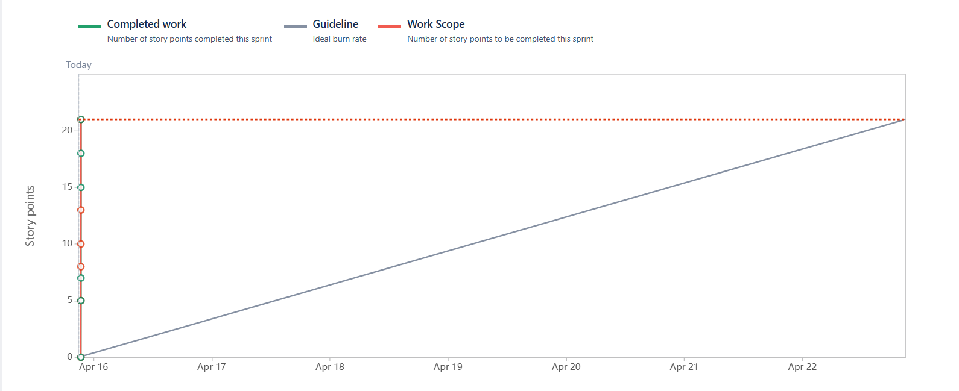

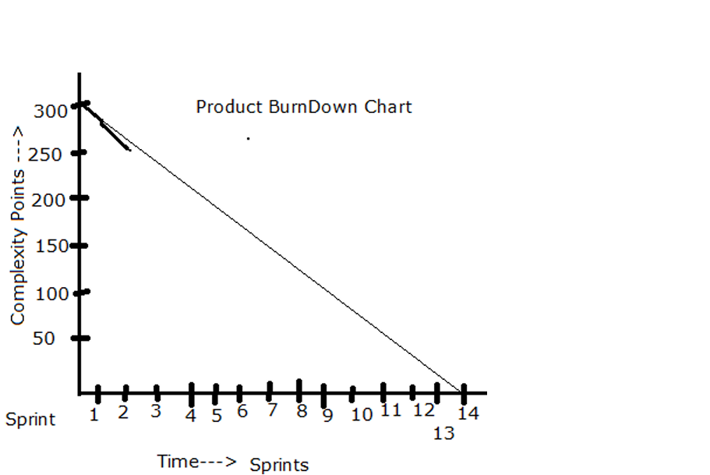

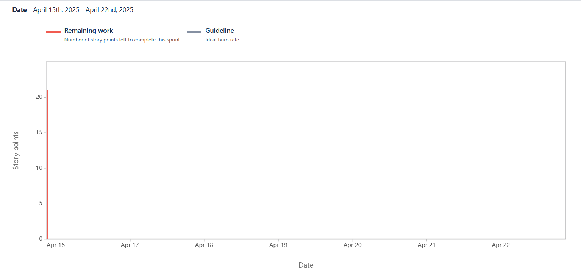

**Question 10 – Explain about Product Grooming – 2 Marks**

Product Grooming (Backlog Grooming)

Product Grooming (or Backlog Grooming) is the process of refining and prioritizing the Product Backlog to ensure that the Scrum Team works on the most valuable tasks. It is an ongoing process that helps the team stay focused on delivering business value and ensures that the backlog items are well-prepared for the upcoming sprints.

**Question 11 – Explain the roles of Scrusm Master and Product Owner – 3 Marks**

**Role of the Scrum Master:**

The Scrum Master is responsible for ensuring that the Scrum Framework is followed properly by the team and the organization. They act as a servant-leader, facilitating the Scrum process, removing impediments, and helping the team continuously improve**.**

**Key Responsibilities:**

1. Facilitates Scrum Events: Ensures that all Scrum ceremonies (Sprint Planning, Daily Standups, Sprint Review, and Sprint Retrospective) run smoothly.
2. Removes Impediments: Identifies and removes blockers that may hinder the Scrum Team’s progress.
3. Coaches the Team: Provides guidance and coaching to the Scrum Team on Scrum practices, encouraging self-organization and continuous improvement.
4. Protects the Team: Shields the team from external distractions or pressures, allowing them to focus on delivering value.
5. Ensures Scrum Adoption: Works with stakeholders and the organization to ensure that Scrum practices are understood and implemented effectively.

**2. Role of the Product Owner:**

The Product Owner is responsible for maximizing the value of the product by managing the Product Backlog and ensuring that the Scrum Team works on the highest-priority items. They serve as the voice of the customer, representing business and user needs throughout the development process.

**Key Responsibilities:**

1. Manages the Product Backlog: Defines, prioritizes, and refines the backlog items (User Stories) based on business value, customer needs, and market changes.
2. Defines Product Vision: Clearly communicates the product vision, goals, and objectives to the team, ensuring alignment.
3. Makes Prioritization Decisions: Decides the order in which features, enhancements, and bugs will be developed based on business value and stakeholder feedback.
4. Clarifies Requirements: Provides detailed requirements and answers questions from the Scrum Team about the backlog items.
5. Ensures Delivery of Value: Ensures that the team delivers the most valuable product features as quickly as possible.

**Question 12 – Explain all Meetings Conducted in Scrum Project – 8 Marks**

In Scrum, meetings (also called Scrum Events) are essential for ensuring transparency, inspection, and adaptation throughout the project. These meetings involve the Scrum Team (Scrum Master, Product Owner, and Development Team) and ensure smooth communication, progress tracking, and decision-making. There are five key Scrum meetings:

**1. Sprint Planning (Duration: 2-4 hours for a 2-week Sprint)**

**Purpose:**

The Sprint Planning meeting sets the goals and tasks for the upcoming Sprint. It helps the Scrum Team understand the work that needs to be completed.

**Participants:**

* **Product Owner**
* **Scrum Master**
* **Development Team**

**Activities:**

1. Defining Sprint Goal: The Product Owner explains the Product Backlog items to be worked on during the Sprint.
2. Selecting Backlog Items: The team collaborates to select which User Stories from the Product Backlog will be moved to the Sprint Backlog.
3. Task Breakdown: The Development Team breaks down the selected User Stories into smaller tasks (e.g., coding, testing, design).
4. Estimating Work: The team provides estimates (in Story Points or Time) for the tasks.

**Outcome:**

A Sprint Backlog is created, which contains the tasks for the Sprint along with the Sprint Goal.

**2. Daily Scrum (Stand-up) (Duration: 15 minutes)**

**Purpose:**

The Daily Scrum (or Stand-up) is a quick daily meeting where the Scrum Team discusses progress, identifies blockers, and plans for the next 24 hours.

Participants:

* Scrum Master (facilitator)
* Development Team
* Product Owner (optional)

**Activities:**

1. Each Team Member Answers Three Questions:
   * What did I do yesterday to help the team reach the Sprint goal?
   * What will I do today to help the team meet the Sprint goal?
   * Are there any impediments (blockers) preventing me from achieving my tasks?
2. **Impediments:** The Scrum Master notes any blockers or impediments and works to resolve them.

**Outcome:**

* A clear understanding of the current status.
* Immediate action to address blockers.

**3. Sprint Review (Duration: 1-2 hours for a 2-week Sprint)**

**Purpose:**

The Sprint Review is a meeting at the end of the Sprint where the Scrum Team presents the work completed and gathers feedback from stakeholders.

**Participants:**

* Product Owner
* Scrum Master
* Development Team
* Stakeholders (such as customers, managers, etc.)

**Activities:**

1. Demonstration: The Development Team demonstrates the work that was completed during the Sprint (e.g., new features, bug fixes, enhancements).
2. Feedback Collection: Stakeholders provide feedback on the work and any new requirements or changes.
3. Discuss Progress: The team discusses whether the Sprint Goal was achieved.

**Outcome:**

* Product Increment is reviewed, and Product Backlog may be adjusted based on feedback.
* The team receives insights for future improvements**.**

**4. Sprint Retrospective (Duration: 1-2 hours for a 2-week Sprint)**

**Purpose:**

The Sprint Retrospective is a meeting where the Scrum Team reflects on the past Sprint and discusses what went well, what didn’t, and how they can improve.

Participants:

* Scrum Master (facilitator)
* Product Owner
* Development Team

Activities:

1. What Went Well: The team discusses practices that were successful.
2. What Didn’t Go Well: The team reflects on issues or obstacles faced during the Sprint.
3. Improvements: The team agrees on actions to take to improve processes and performance in the next Sprint.

Outcome:

* The team creates a list of action items or improvements to apply in the next Sprint, ensuring continuous improvement.

**5. Backlog Refinement (Grooming) (Duration: Ongoing, typically 1-2 hours per week)**

**Purpose:**

Backlog Refinement (also known as Backlog Grooming) is the process of reviewing and updating the Product Backlog. It ensures that backlog items are clear, prioritized, and ready for future Sprints.

Participants:

* Product Owner
* Scrum Master
* Development Team (optional, but beneficial)

Activities:

1. Clarification of User Stories: The Product Owner clarifies any ambiguous items in the Product Backlog.
2. Prioritization: The Product Owner adjusts the priorities of backlog items based on new business needs or feedback.
3. Estimation: The team may estimate the complexity of items in the backlog.
4. Breaking Down Large Items: Large Epics are broken down into smaller User Stories.

Outcome:

A refined Product Backlog that is clear, prioritized, and well-understood by the team, enabling effective Sprint Planning.

**Question 13 – Explain Sprint Size and Scrum Size– 2 Marks**

**Sprint Size:**

Sprint Size refers to the duration and scope of work that the Scrum Team can realistically complete in a single Sprint. In Scrum, a Sprint is typically time-boxed to 1-4 weeks, with 2 weeks being the most common duration.

**Scrum Size:**

Scrum Size refers to the size of the Scrum Team and the amount of work the team can handle across all Sprints. A Scrum Team typically consists of the following roles:

* Development Team: The individuals who do the actual work (developers, testers, etc.).
* Product Owner: Responsible for maximizing the value of the product by managing the backlog.
* Scrum Master: Facilitates the Scrum process and helps remove impediments.

**Question 14 – Explain DOR and DOD – 2 Marks**

**Definition of "DOR" (Definition of Ready)**

Definition of Ready (DOR) refers to the criteria that must be met before a Product Backlog item (e.g., a User Story) can be considered ready for inclusion in a Sprint. It ensures that the team has sufficient information to begin working on a backlog item without ambiguity or confusion.

**Definition of "DOD" (Definition of Done)**

Definition of Done (DOD) refers to the criteria that must be met for a Product Backlog item (e.g., User Story) to be considered complete. It ensures the team has adhered to quality standards, delivered working software, and met the requirements outlined for the feature.

**Question 15 – Explain Prioritization Techniques and MVP – 3 Marks**

**1. Prioritization Techniques:**

Prioritization is an essential aspect of managing the Product Backlog in Scrum, helping the Product Owner decide the order in which items should be worked on based on their importance to the business, customer, and project. There are several prioritization techniques used in Scrum to determine which User Stories should be given the most attention. Below are some common prioritization techniques:

a. MoSCoW Method

This method helps in categorizing items into four categories based on urgency and importance.

* Must Have: Critical features that must be delivered for the product to function.
* Should Have: Important features but not critical for launch.
* Could Have: Nice-to-have features that can be delivered if time permits.
* Won’t Have: Features that are not required in the current release.

b. Kano Model

The Kano Model helps prioritize features based on customer satisfaction. Features are categorized as:

* Basic Needs: Expected features that customers take for granted (e.g., security, basic functionality).
* Performance Needs: Features that customers explicitly desire and which influence customer satisfaction in a linear way.
* Delighters: Features that provide unexpected pleasure and satisfaction, leading to a WOW factor.

c. Value vs. Complexity Matrix

This technique helps in categorizing features based on their business value (BV) and complexity points (CP). The features are plotted on a grid:

* High Value, Low Complexity: These features should be prioritized first as they give the most value with minimal effort.
* High Value, High Complexity: These features are important but may require more planning and effort.
* Low Value, Low Complexity: Low priority, as they provide little value.
* Low Value, High Complexity: Typically avoided unless absolutely necessary.

**Minimum Viable Product (MVP):**

* Minimum Viable Product (MVP) refers to the simplest version of a product that can be released to customers with just enough features to satisfy early adopters and gather feedback. The goal of an MVP is to maximize learning while minimizing effort and cost.

**Question 16 – Difference between Business Analyst n Product Owner – 3 Marks**

**Differences Between Business Analyst and Product Owner:**

| Aspect | Business Analyst (BA) | Product Owner (PO) |
| --- | --- | --- |
| Role Focus | Focuses on understanding and documenting business needs. | Focuses on maximizing product value and managing the product backlog. |
| Key Responsibilities | Gathers requirements, analyzes business processes, creates documentation. | Defines product vision, prioritizes backlog, and communicates with stakeholders. |
| Engagement with Stakeholders | Works closely with stakeholders to ensure requirements are understood. | Represents stakeholders in the Scrum process but is also deeply involved in product decisions. |
| Outcome Focus | Ensures that business solutions meet the organization's needs. | Ensures that the product is delivered with features that deliver business value. |
| Involvement in Development Process | May not be directly involved in development but focuses on requirements. | Works closely with the Scrum team throughout the sprint to ensure features meet business needs. |

**Question 17 – Prepare a sample Resume of 3yrs exp Product Owner – 3 Marks**

[Your Name]

Product Owner  
[Your Location]  
[Your Phone Number]

[Your Email Address]  
[LinkedIn Profile / Portfolio (if applicable)]

Professional Summary:

A results-driven Product Owner with over 3 years of experience in managing and delivering high-value products in Agile environments. Adept at collaborating with cross-functional teams, prioritizing backlogs, and ensuring products meet business goals and customer needs. Strong communication skills with a passion for delivering impactful product features and continuously improving user experience.

Core Competencies:

* Agile Methodologies (Scrum, Kanban)
* Product Backlog Management
* Stakeholder Engagement & Communication
* Prioritization Techniques (MoSCoW, Kano, WSJF)
* User Story Creation & Acceptance Criteria
* Product Roadmap Development
* Cross-Functional Team Collaboration
* Customer-Centric Approach
* Market Research & Analysis
* Release Planning & Product Strategy
* JIRA, Confluence, Trello
* Data-Driven Decision Making

Professional Experience:

Product Owner  
ABC Technologies Pvt Ltd — [Dates of Employment]  
*Location: [City, Country]*

* Managed the Product Backlog and prioritized items based on business value, customer needs, and technical feasibility.
* Collaborated with stakeholders (including business owners, developers, and designers) to define the product vision and ensure alignment with company goals.
* Wrote and refined user stories with clear acceptance criteria, ensuring that development teams had the necessary details to deliver the product effectively.
* Led sprint planning, reviews, and retrospectives to ensure smooth project execution and continuous improvement.
* Worked with the Scrum Master to remove impediments and maintain a high-velocity development process.
* Conducted user acceptance testing (UAT) to validate product features and ensure alignment with customer requirements.
* Developed and maintained product roadmaps, ensuring timely delivery of features and releases.
* Collected and analyzed customer feedback to prioritize new features and product improvements.

Achievements:

* Increased customer satisfaction by 30% within the first 6 months by prioritizing key features based on user feedback.
* Successfully led the launch of a major product release that improved user engagement by 25%.
* Reduced feature development time by 20% through better backlog management and effective sprint planning.

Junior Product Owner  
XYZ Innovations Ltd — [Dates of Employment]  
*Location: [City, Country]*

* Assisted the senior Product Owner in managing product backlogs, writing user stories, and prioritizing feature requests.
* Participated in sprint reviews and retrospectives, gathering feedback to improve the team’s performance.
* Analyzed user feedback, market trends, and competitor products to suggest potential product enhancements.
* Coordinated with cross-functional teams to ensure alignment with project timelines and goals.
* Contributed to the creation and execution of product launch strategies.

Achievements:

* Helped achieve a 90% on-time delivery rate for product releases by streamlining backlog prioritization.
* Played a key role in delivering new features that contributed to a 15% increase in product adoption.

Education:

Bachelor of Technology (B.Tech) in Computer Science Engineering  
XYZ University — [Year of Graduation]  
*Location: [City, Country]*

Certifications:

* Certified Scrum Product Owner (CSPO) — Scrum Alliance, [Year]
* Agile Certified Product Manager and Product Owner (ACPM) — [Year]
* Scrum Master Certification (CSM) — [Year] (optional)

Technical Skills:

* Project Management Tools: JIRA, Trello, Asana, Confluence
* Prototyping/Design Tools: Figma, Balsamiq
* Analytics: Google Analytics, Power BI
* Database: MySQL, MongoDB (Basic knowledge)

Projects:

Mobile App Redesign  
*Company: ABC Technologies*

* Objective: Redesigned the mobile app to improve user experience and engagement.
* Role: Led the product vision, gathered user feedback, and prioritized the product backlog.
* Outcome: Resulted in a 40% increase in app downloads and a 35% boost in daily active users.

Languages:

* English (Fluent)
* [Other Languages] (optional)

References:

Available upon request.