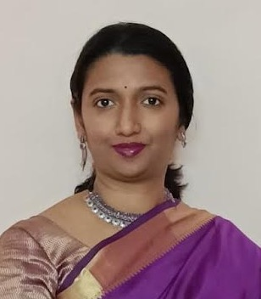  Sowmya R Shetty  Experienced and self motivated professional bringing forth valuable industry experience and a passion for Finance and Accounting with 16 years of experience.Results oriented with a proven track record of working collaboratively with Team members. Experienced in many areas of Banking ranging from Retail and Corporate Banking, Treasury, Customer Relations, Reconciliations, Administration,Payments and Settlements etc. With additional qualification of C S Executive Programme and deep understanding of Company Law, Accounting Standards. Looking for a shift in career from Retail Banking to IT. | 501 Rohini D DSK Vishwa Dhayari  Pune 411041  +91 9980366770  soumyasarolkar@gmail.com
EXPERIENCE  SBI, Pune — Deputy Manager  APRIL 2022 - PRESENT  Part of the Asset Management Team handling the task of processing and sanctioning credit proposals. Responsible for smooth functioning of the department and reducing Turnaround Time. Responsible for maintaining Asset Quality and control. Improved efficiency and numbers of the Team and TAT within 2 months of joining the new Asset Management Team.  SBI, Pune, Amravati — Assistant Manager  NOV 2017 - APRIL 2022  Was responsible for Branch Operations and was head of Credit Division in Branch. Maintained 30% + growth in Advances for 3 successive years and reduced NPA loans for 3 years in a row. Was in charge of the Audit Team in Branch and maintained AAA rating in Risk Focused Internal Audit for 2 successful years.  SBI, Bangalore, Mangalore, Pune — Assistant  MARCH 2009 - NOV 2017  Worked in Operations, Forex, Treasury, Retail Credit and Administration. Received Star of the Region Award during my tenure in Bangalore. Was part of Digital innovation of the Bank in the form of Intouch Branches in Pune. The Digital Innovation team was handpicked as it was a prestigious project for the Bank.  EDUCATION  ICSI — CS- Executive Programme  2012  Canara College, Mangalore — Bachelor of Commerce  2009  CERTIFICATIONS  JAIIB CAIIB FROM IIBF, AMFI | SKILLS  - MS Office  - Retail Banking  - Corporate Banking  - Forex  - Company Law  - Managerial  - Customer Relations  - MS Visio  - Axure  - Jira  - Balsamic  AWARDS  Star of the Region Award  Excellence in Mobile Banking  Award for MDRT in Insurance Business  LANGUAGES  English, Hindi, Kanadda, Marathi, Tulu  INTERESTS AND HOBBIES  Reading  Gardening  Hiking  Music

