Capstone Project1 – Part -2/3
Online Agriculture Products Store

Question 1 – Audits
4 Quarterly Audits are planned Q1 , Q2, Q3, Q4 for this Project What is your knowledge on how these Audits will happen for a BA ?
Answer:
Quarterly audits are formal reviews conducted every 3 months (Q1–Q4) to ensure:
- The project is progressing as planned.
- Budget and timeline are in control.
- Compliance with internal and external standards.
- Proper documentation and traceability exist.
These audits can be internal (by SOONY or APT IT management) or external (by auditors or CSR compliance teams).
Stage | Quater1 Audit Report (Requirement Gathering & Planning ) |  | Stage | Quarter 2 Audit Report (Requirement Analysis and Design )
Completed | 12 Weeks(Week1 to Week12) |  | Completed | 12 Weeks(Week13 to Week 24)
Checklist | Present the Business Requirements Document (BRD) and FRD how it was gathered.  Need to submit which elicitation techniques used and how the requirements are gathered.  Demonstrate early requirement sign-offs from business users and committee.  Ensure baseline requirements are well documented and version controlled. Email Communication - To , CC, BCC |  | Checklist | Prepare UML Diagrams and use case to represent Visually. Convert Business Requirements into Functional Documents and Share updated FRD/SRS (Functional/Software  Taking Sign off from the client regarding what functionality will be used.  Present the Requirement Traceability Matrix (RTM) linking requirements to design documents.  Utilization of tools for preparing mock-ups  Show evidence of stakeholder meetings and minutes of meetings (MoMs). Email Communication - To , CC, BCC
Stage | Quarter 3 Audit Report (Development & Testing ) |  | Stage | Quarter 4Audit Report (UAT, Go-Live Readiness & CSR Documentation)
Completed | 12Weeks(Week 25 to Week 36) |  | Completed | 12 Weeks(Week 37 to Week 48)
Checklist | Prepare JAD Session report, Developers (Juhi, Lucie, Bravo, etc.) are building as per requirements. End user Manual Preparation Document  Prepare Test Case Summary and validate that testers (Jason, Alekya) have mapped test cases to user stories/use cases.  Participate in meetings to explain requirements-related clarifications and prepare and maintaining BA and Developer MOM Email Communication - To , CC, BCC |  | Checklist | Coordinate and support UAT with stakeholders like Peter, Kevin, Ben.  Maintain a UAT defect log and capture feedback.  Submit final signed-off requirements, RTM, and UAT reports.  Help prepare CSR outcome documentation to show social impact.  Archive all BA documentation for future audits or reference.

Note – Supporting documents that’s needs to be provided to the Auditors for verifications
Documents | Purpose
BRD (Business Requirement Document) | Captures all high-level business needs
FRD/SRS | Detailed functional/system requirements
MoMs (Minutes of Meetings) | Evidence of stakeholder collaboration
RTM (Requirement Traceability Matrix) | Trace requirement to design, code, and test
UAT Plan and Reports | User testing and feedback validation

Question 2 – BA Approach Strategy
Answer:
Elicitation Techniques
Technique | Purpose
Interviews | With Mr. Henry, Peter, Kevin, Ben (Zoom or in-person) for knowing their expectations and goals
Workshops | With Stakeholders and Developer/Tester teams for gathering widder requirement reach
Questionnaires | For analysing broader farmer base requirements and experience
Observation | Understand rural user behaviour while in current process of procurement
Document Analysis | CSR goals, compliance docs, procurement methods which are been currently used along with payment channels

Stakeholder Analysis
Name | Role
Mr. Henry | Project Sponsor
Mr. Pandu | Financial Head
Mr. Dooku | Project Coordinator
Peter, Kevin, Ben | End Users (Farmers)
Mr. Karthik | Delivery Head
Mr. Vandanam | Project Manager
Juhi, Teyson, Lucie, Tucker, Bravo | Java Developers
Mike | Network Admin
John | DB Admin
Jason, Alekya | Testers

Stakeholders | Requirement Gathering | Requirement Analysis & Documnetation | Design | Development & Testing | UAT Delivery
Mr. Henry | Informed | Consulted | Informed | Informed | Informed
Mr. Pandu | Informed | Informed | Consulted | Informed | Informed
Mr. Dooku | Consulted | Consulted | Informed | Informed | Informed
Mr. Karthik | Accountable | Accountable | Consulted | Informed | Responsible
Mr. Vandanam | Accountable | Accountable | Accountable | Accountable | Accountable
Juhi, Teyson, Lucie, Tucker, Bravo | Informed | Informed | Consulted | Responsible | Consulted
Mike | Accountable | Accountable | Accountable | Accountable | Accountable
John | Consulted | Consulted | Responsible | Responsible | Accountable
Jason, Alekya | Informed | Informed | Consulted | Responsible | Responsible

Documents to be Prepared by BA
Document | Purpose
BRD (Business Requirements) | High-level business needs and and objectives for a project which is to achieved considering the expectations for all stakeholders
FRD (Functional Requirements) | Detailed system behaviour and features, Specific Functionalities and capabilities a product or system must possess. It details how the software should behave , including user interactions, data handling , and system behaviour
Use Case / User Story Docs | End-to-end flows with acceptance criteria
RTM (Traceability Matrix) | All the requirements are mapped to test case verifying that each requirement is properly tested
MoMs | Track meetings and decisions
CR Log | Track change requests in overall Product life Cycle, their status, details and impact. Log helps to manages changes effectively , ensuring they are properly evaluated, approved and implemented while minimizing disruption
UAT Plan & Sign-off Forms | Testing readiness and client approval. UAT plan outlines the scope, objectives, and strategy for user Acceptance Testing and Sign off forms document the completion and approval of the testing process

Requirement Sign off Process : It’s a formal procedure where stakeholders review, approve and officially accept documented requirements before development begins. It ensures all parties agree on the requirements, minimizing the risk of miscommunication and rework.
-Share BRD/FRD via email and project portal (e.g., Confluence or SharePoint).
-Walkthrough session with client (Stakeholders + farmers if needed).
-Collect feedback and incorporate revisions.
-Final version sent with e-signature request or formal email approval.
- Maintain a record of Sign off for future reference
- Inform all relevant parties that the requirements have been formally approved

Taking Approvals from the Client : Clearly define the deliverables, communicate proactively and provide the structured path for feedback and revision . Establish a formal meeting with the clients to keep them informed and get continuous feedback .
All deliverables (BRD, FRD, UAT) to be formally approved by:
- Mr. Dooku (Project Coordinator)
- Mr. Henry (Sponsor)
Maintain a version control system for transparency and audit readiness.
Store all signed documents on SharePoint/Confluence.

Communication Channels :
Communication Type | Tool | Frequency
Requirement Reviews | Zoom / Google Meet | As needed
Project Updates | Email, MS Teams | Weekly
Document Sharing | Share Point/Confluence | Ongoing
Status Reporting | PPT/Excel via Email | Bi-weekly
Committee Meetings | Zoom + MOM Documentation | Monthly

Handle Change request
Process:
- CR raised → Logged in Change Request Log
- BA captures impact on:
  - Requirements
  - Timeline / Budget
  - Dependencies
- PM and Developer Team analyse effort
- Approval required from:
  - Mr. Dooku (Project Coordinator)
  - Mr. Pandu (if cost involved)
- Upon approval:
  - Update BRD/FRD/RTM
  - Inform Dev/Test teams

Progress Reporting to Stakeholders
- Weekly or Monthly BA Reports to PM and Business including:
  - Completed elicitation activities
  - Pending reviews
  - Identified risks or blockers
  - Next week’s plan
- Use Dashboard or Excel Format shared via email and discussed in weekly meetings.
UAT Sign-off & Client Acceptance
UAT Process:
- Prepare UAT Plan and get it signed off by Committee.
- Coordinate test cycles with:
  - Testers (Jason, Alekya)
  - Farmers (Peter, Kevin, Ben)
- Capture defects, feedback, and fixes.
- Submit UAT Report to Committee.
UAT Sign-off:
- Final version of product shared for validation.
- Get the Client Project Acceptance Form signed by:
  - Mr. Henry
  - Mr. Dooku

Question 3 – 3-Tier Architecture
Explain and illustrate 3-tier architecture?
Answer: 3-tier architecture is a software design pattern that divides an application into 3 distinct layers
- Presentation Layer
- Business Logic Layer
- Data Layer
Presentation Layer: User Interface through which users interact with the system, example- A farmer logs into the app and browses fertilizer listings using Web browser/ mobile App.
Business Logic Layer: This layer contains the core business logic and the processing rule. It handles communication between the UI and the database. Example-the app checks product availability and validates the delivery pin code.
Data Layer: Store and manages all application data. Example- The app saves an order placed by a farmer into the orders table.


(Farmer )
Presentation Layer
(UI- Web/Mobile login front end)
-HTML, CSS, JS, UI)
↓
┌───────────────────────────────┐
│ PRESENTATION LAYER │
│ (UI – Web/Mobile Frontend) │
│ - HTML, CSS, JS, React, UI │
└───────────────────────────────┘
↓
┌───────────────────────────────┐
│ APPLICATION LAYER │
│ (Business Logic – Java, APIs) │
│ - Order Management │
│ - Product Filtering Logic │
│ - User Authentication │
└───────────────────────────────┘
↓
┌───────────────────────────────┐
│ DATA LAYER │
│ (Database – MySQL/Postgre) │
│ - User Data │
│ - Products, Orders │
└───────────────────────────────┘
Data Layer(- My SQL)
- user Data Database
- Product Details
- Order Records
Business Logic Layer(Java,API's)
- Order Management
- Product Filtering Logic
- User Authentication

Question 4 – BA Approach Strategy for Framing Questions
Business Analyst should keep What points in his/her mind before he frames a Question to ask to the Stakeholder
( 5W 1H – SMART – RACI – 3 Tier Architecture – Use Cases, Use case Specs, Activity Diagrams,Models, Page designs)
Answer: BA needs to ensure that questions are well-thought-out, aligned with business and technical goals, and elicit clear, actionable, and complete requirements from stakeholders. For this its necessary to action on the following-
5W 1H Approach
Element | Intent | Sample Questions
Who | Identify roles, actors | Who will use this feature? Who approves the purchase?
What | Understand functions/data | What should happen after the farmer places an order? What is the Purpose?
When | Capture time/sequence | When does the stock get updated? When the product will be ordered?
Where | Define locations or access points | Where should delivery be available? Where will users access the system?
Why | Uncover reasoning/motivation | Why do farmers prefer offline purchases currently? Why we are developing this application
How | Learn process or method | How does the current fertilizer procurement work? How will the overall function flows?

SMART Approach
SMART | Focus
Specific | Ask clearly about a particular need (e.g., What specific crops do you need seeds for? What kind of fertilizers and pesticides are mostly required?)
Measurable | Ask for quantifiable answers (e.g., How many units do you order monthly? )
Achievable | Keep questions grounded in what's technically possible
Relevant | Align questions with business objectives (e.g., usability for farmers)
Time-bound | Include timing or deadlines when needed considering the seasonal based nature of the crops

3 Tier Architecture: Under this concept the question needs to be framed considering the different layers of software
Example:
- How should the data be displayed to the farmers in “Application Layer”
- What should be the flow for Large or bulk orders, How the overall functional process should look like “ Business Logic Layer”
- What reports admin be able to download, Which data is required for future reference “database layer”
RACI
RACI helps to define the overall role and responsibilities within the team outlining who will be responsible, Accountable, Consulted and Informed for the each task assigned

UML/Use cases/Use case Specs, Activity Diagrams, Models, Page designs
Structure questions around user goals and flows.
- Use Cases:
What happens when a farmer places an order?
What if a product is out of stock?
- Use Case Specifications:
Are there any alternate flows if payment fails?
Should the user get an SMS and Email?
- Activity Diagrams:
Use diagram walkthroughs - Does this sequence match your real-life process?”
- Page Designs / Wireframes:
Show mockups - Is this how you’d like to see your dashboard?
Are the labels and buttons easy to understand?”

Question 5 – Elicitation Techniques
As a Business Analyst, What Elicitation Techniques you are aware of? ( BDRFOWJIPQU)
Answer: Requirement Elicitation is the process of digging out the information from the stakeholders and serves as the foundation in documenting the requirements
1) Brainstorming
2) Document Analysis
3) Reverse Engineering
4) Focus Groups
5) Observation
6) workshops
7) JAD( Joint Application Development)
8) Interviews
9) Prototyping
10) Questionnaire
11) Use case Specification

Brainstorming
Brainstorming is an elicitation technique used by Business Analysts to generate a wide range of ideas, requirements, or solutions in a short period of time. It encourages free-thinking, open communication, and creative problem-solving without immediate criticism or judgment.
Advantages- To explore multiple ideas or solutions, To identify stakeholder expectations, To uncover hidden or innovative requirements, To initiate requirement gathering when little is known
For Effective Brainstorming
-Keep sessions time-bound (30–60 mins)
-Include diverse but relevant participants
-Avoid immediate evaluation or critique
-Use a neutral facilitator (usually the BA)
-Do not limit the number of ideas
Document Analysis
Document Analysis is a structured elicitation technique where the Business Analyst reviews existing documentation (manuals, policies, contracts, reports, diagrams, etc.) to gather relevant information for the project — including business rules, processes, and legacy requirements. It can be a current system which could provide some of the inputs for the new system requirements
Advantages- Time saving process, improves accuracy and lot of useful information can easily be transferred to new system requirements.
It is one of the compulsory elicitation technique for any project and to be done:
-During the initial discovery phase
-When replacing or enhancing existing systems
-When stakeholders reference existing policies or forms
-To cross-check information obtained through interviews/workshops.

Reverse Engineering
Reverse Engineering is an elicitation technique where a Business Analyst examines an existing system, application, or process to understand how it works and derive requirements, workflows, and business rules — especially when documentation is missing or outdated. It can extract implemented requirements from the software code. Two categories for reverse engineering are –
Black Box- The system/product is studied without examining its internal structure.
White Box- The Inner workings of the system /product are studied.
Reverse Engineering is Done-
To understand legacy systems when formal documentation is unavailable
To extract functional and non-functional requirements
To prepare for system upgrades, modernization, or migration
To identify process gaps, bottlenecks, or improvement areas
Focus Groups
A Focus Group is a moderated discussion involving a selected group of stakeholders or end-users who share insights, feedback, needs, and expectations about a product, service, or system. It helps the Business Analyst gather qualitative information, validate assumptions, and uncover both functional and emotional user needs.
Focus groups should typically has 6-12 attendees (Primary users-Farmers, Business Stakeholders, SME, BA). Composition can be either heterogeneous or homogeneous.
Homogeneous- Individuals with similar characteristics. Caution- Differing prospective will not be shared
Heterogeneous- Individuals with diversified background and perspectives. Caution: Individual may be not comfortable with others background resulting in lower quality of data collected
Focus Group is used when
- You want feedback from multiple users quickly
- You're gathering initial high-level requirements
- You're validating screen designs or prototypes
- You're defining user-centric features
Observation
Observation** is an elicitation technique where the Business Analyst watches stakeholders perform their day-to-day tasks to understand actual workflows, tools, challenges, and user behaviour in a real environment.
It helps bridge the gap between what users say they do and what they actually do.
Types of Observations
Type | Description | Example
Passive Observation | Analyst silently observes without interfering | Watching a farmer place a fertilizer order at a local center
Active/Participatory Observation | Analyst interacts, asks questions during task execution | Asking the farmer questions while he’s using an existing app or ordering seeds manually

Workshop
A Workshop is a structured, interactive collaborative session where the Business Analyst brings together key stakeholders (users, SMEs, developers, testers, etc.) to discuss, analyse, and define requirements, features, and solutions in a focused, time-boxed format.
Workshops are time-efficient and ideal for resolving conflicts, validating requirements, and gathering consensus.
More Preparation Is needed
- Preparation of the requirement workshop
- Co Conduct/ run the requirement workshop
- Post requirements wrap up done by the Facilitators.
JAD (Joint Applicant Development)
JAD (Joint Application Development) is a collaborative elicitation technique where key stakeholders and the project team (including the business analyst, developers, testers, and end users) come together in a structured workshop to discuss and finalize system requirements quickly and efficiently.
Advantages | Description
Faster Decisions | Direct communication avoids delays
Iterative Feedback | Everyone can comment and refine
Clear Agreement | Less ambiguity or conflict later
Strong Collaboration | Builds trust among stakeholders

Disadvantages | Description
Scheduling | Hard to get everyone together at once
Time-Intensive | Needs planning and focus
Conflicts | Stakeholder disagreements need careful facilitation
Dominance | Risk of strong voices overpowering others

JAD Process
Define Session : Define the purpose , scope and objectives of the JAD session, selecting JAD team, invite team and obtain commitment to attend the sessions and schedule the session.
Research product: Get Familiar with the product or services, gather preliminary information, Obtaining any models
Prepare: Prepare visual aids, develop realistic agenda, prepare the meeting room
Conduct Session: Conduct session follow the agenda and ensure all participants are given equal treatment.
Draft the document: Prepare formal documents and capture the infoartion in the JAD session and is further refined through analysis efforts . Final Document is returned to the stakeholders for review and validation.
Prototyping
Prototyping is an elicitation technique where visual mockups, wireframes, or working models of the application or system are created to help stakeholders visualize the end product, validate requirements, and provide early feedback.
Instead of just talking or documenting features, the Business Analyst uses prototypes to make concepts tangible and testable.
If introduced too soon in the process the natural tendency is for the business clients to try and be a screen designers.
Screen mockups often BA will accompany written descriptions of what happens with certain buttons
Steps for Prototyping-
Gather Initial Requirements
Sketch the Flow or Screens
Create the Prototype
Review with Stakeholders
Capture Feedback
Revise and Iterate
Finalize for Sign-off

Interviews
An interview is a systematic approach to elicit information from one person or group of people in an informal or formal setting by taking to the person – the interviewee, asking relevant questions and documenting the responses.
An Interview is a one-on-one or small group elicitation technique where the Business Analyst interacts directly with stakeholders to gather detailed information about their needs, expectations, processes, pain points, and goals.
Advantages | Disadvantages
Deep, rich insights | Time-consuming
Builds rapport | May introduce bias
Uncovers unknown needs | Needs skilled interviewer
Can clarify vague responses | Limited scalability

Questionnaire
A Questionnaire is a set of structured or semi-structured questions prepared by the Business Analyst to gather specific information from stakeholders. It is usually shared via email, forms, or tools like Google Forms or Microsoft Forms.
It helps collect quantitative and qualitative data when face-to-face interaction is not feasible, especially when dealing with multiple stakeholders or users in remote locations.
Advantages | Disadvantages
Reaches many people quickly | May get limited or vague responses
Data is easy to analyze | No opportunity for follow-up questions
Stakeholders respond at their convenience | Risk of low response rate
Cost-effective & scalable | Poorly framed questions can mislead

Question 6: Which Elicitation Techniques can be used in this Project and Justify your selection of Elicitation Techniques?
Answer: According to me following techniques can be used in this project
Prototyping
Reason for Selection –
- The target users (e.g., Peter, Kevin, Ben) may not understand detailed documentation.
- Visual representations (screens, buttons, flows) will help non-technical users express what they want or correct what’s shown.
- Early feedback can be captured on usability, layout, and flows.
Benefits
-Farmers can see how they'll search for seeds or fertilizers and place an order.
-Helps build a user-friendly application by validating design choices.
-Encourages engagement and avoids misinterpretation of user needs.
We can use Balsamiq
Use case Specifications
Reason for Selection –
-Clearly outlines actor interactions (e.g., "Farmer buys a pesticide", "Manufacturer lists a product").
-Helps developers, testers, and UI designers to understand exact behaviour flow.
- Use cases are simple, structured, and easy to validate with SMEs or client committee.
Benefits
-Useful in explaining the steps involved in placing an order or updating product inventory.
-Supports functional clarity and alignment with system design.
We can use MS Word, Lucidchart, UML Tools
Document Analysis
Documents which can be analysed are Brochures, product catalogs, order forms, CSR policy, Govt policies, Internal memos etc.
Reason for Selection –
-The committee (Mr. Henry, Mr. Pandu, Mr. Dooku) or APT IT Solutions may already have internal templates, CSR policies, product catalog formats, or market research reports.
-Manufacturer companies may provide sample data of fertilizers, seeds, pesticides, etc
Benefits
-Saves time by with analysing the existing information.
-Helps understand industry standards, product attributes, pricing formats.
-Clarifies regulatory or documentation expectations (e.g., delivery timelines, return policy).
Brainstorming
Reason for Selection –
-Useful in early stages to generate ideas around: which features to include, delivery methods for rural areas, payment mechanism, mobile vs web which will be better.
- Involves technical team + client committee + stakeholders to explore creative and feasible solutions
Benefits
- Promotes team ownership and engagement.
- Drives collaborative innovation( support multilingual screens, if internet is slow)
- Encourages open dialogue and
creativity from all parties.

Question 7 – 10 Business Requirements
Answer: Below mentioned are the 10 business requirements –
BR001 – Farmers should be able to search for available products in fertilizers, seeds, pesticides
BR002 – Manufacturers should be able to upload and display their products in the application
BR003- New users (farmers or manufacturers) should be able to register using an email ID and password
BR004- The system should have a secure login functionality for both farmers and manufacturers
BR005- The application should provide a secure and easy-to-use payment gateway, including COD, Credit/Debit cards, and UPI.
BR006- Farmers should be able to browse the product catalogue without restriction.
BR007- Farmers should be able to add products to a Buy Later/Wishlist.
BR008- Once the Order is placed, the system should send an email confirmation to the farmers
BR009- Once the order is placed, we should provide the delivery tracking feature as well
BR010- System should be user friendly and mobile supportive so to be useful in remote areas.
Question 8 –Assumptions
List your assumptions
Answers: Few of the assumptions considered while working on this project
1) Internet Connectivity: It is assumed that farmers and manufacturers in remote areas have access to basic internet connectivity to use the web/mobile application.
2) Device Accessibility: It is assumed that farmers and manufacturers will have and use smartphones or desktops to access the application.
3) Valid Email ID- t is assumed that all users will have valid email addresses, which will be used for registration and communication (e.g., confirmations, password resets, login)
4) Basic Digital Literacy: It is assumed that users (farmers, manufacturer) have basic knowledge of using mobile/web apps (e.g., login, browse, add to cart, add and updated product details).
5) Logistics Partner Will Handle Deliveries: It is assumed that an external logistics partner (or an integrated system) will handle the delivery of products and provide tracking information.
6) Payment Gateway Integration: It is assumed that the project will integrate with a reliable payment gateway to support COD, UPI, and card payments from all available banks.
7) Maintain Security Standards: It is assumed that the development team will implement industry-standard authentication and data protection mechanisms.
8) Feedback from Stakeholders: It is assumed that key stakeholders (e.g., Peter, Kevin, Ben, Committee) will be available and responsive during requirement reviews, UAT, and approvals.
9) Product Catalogue Categories are Defined: It is assumed that the product categories (fertilizers, seeds, pesticides) are predefined and agreed upon by the stakeholders.
10) Manufacturers Will Maintain Product Information: It is assumed that manufacturers will upload, update and maintain their product listings.
11) Performance and Scalability: It is assumed that the system will initially support a limited number of concurrent users (e.g., 500-1000), assuming the rural adoption will grow gradually.

Question 9: Give Priority 1 to 10 numbers (1 being low priority – 10 being high priority) to these Requirements after discussions with the stakeholders
Answer:
Req ID | Req Name | Req Description | Priority
BR003 | Registration of New User | New users (farmers or manufacturers) should be able to register using an email ID and password. | 10
BR004 | Secure login Functionality | The system should have a secure login functionality for both farmers and manufacturers. | 10
BR001 | Search Functionality for available Products | Farmers should be able to search for available products in fertilizers, seeds, pesticides. | 9
BR002 | Display of available products | Manufacturers should be able to upload and display their products in the application. | 9
BR006 | Browse functionality | Farmers should be able to browse the product catalogue without restriction. | 8
BR005 | Payment Security | The application should provide a secure and easy-to-use payment gateway (COD, Card, UPI) | 8
BR010 | User friendly interface | System should be user friendly and mobile supportive to be useful in remote areas. | 7
BR009 | Delivery tracking system | Once the order is placed, a delivery tracking feature should be provided. | 6
BR008 | Email Confirmation | Once the Order is placed, the system should send an email confirmation to the farmers. | 6
BR007 | Enabling Buylater/ Wishlist functionality | Farmers should be able to add products to a Buy Later/Wishlist | 5

Question 10: Use Case Diagram

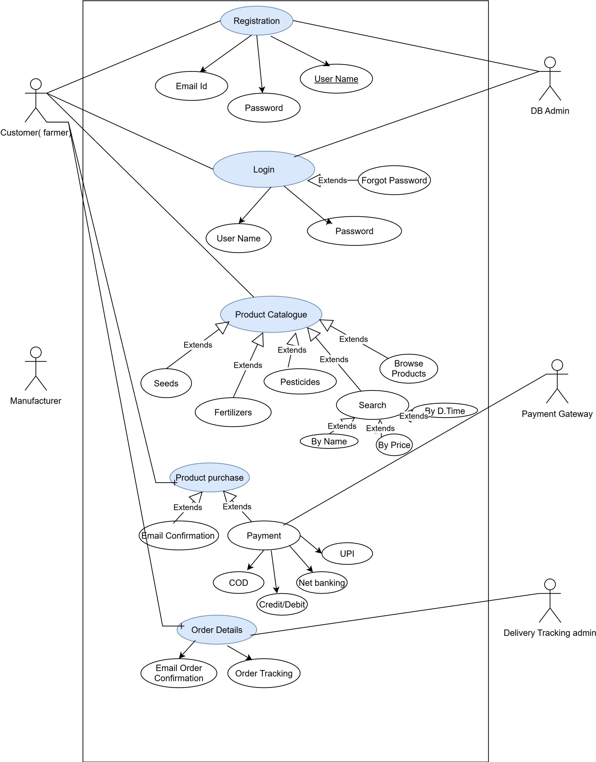

Question 11 – (minimum 5) Use Case Specs
Prepare use case specs for all use cases
Answer: Use case Specifications
Use Case ID | 1.0
Use case Name | Registration Of New User
Created by | BA | Last updated BY | BA
Date of Creation | 25-07-2025 | Last Revision date | 25-07-2025
Actor | Farmer, Manufacturer
Description | Allows users to register by creating an account with email and password
Pre- condition | User is not already registered.
Post Condition | User account is created and stored in the system.
Normal Flow of events | Step1: User select "Register" Step2: Enter Valid Email Id Step3: Select password (selecting upper case, lower case, numeric) Step 4: Select the User Type ( Farmer/ Manufacturer) Step5:System validates and stores credentials Step 6: Confirmation is sent via email.
Alternate Flow | Step1: User select "Register" Step2: Enter Valid Email Id Step3: "entered Email Id is Invalid", "Please Enter a Valid and Unique Email Id." Step 4: Page is redirected to a Registration Page
Exceptions | Lack of Proper Internet Connectivity, Error Pop up " Check your Internet Connectivity
Frequency of Use | High
Assumptions | User has a valid Email id , and mobile or laptop devise and a decent digital literacy

Use case ID | 2.0
Use case Name | Application login
Created by | BA | Last updated BY | BA
Date of Creation | 25-07-2025 | Last Revision date | 25-07-2025
Actor | Farmer, Manufacturer
Description | Allows users to securely log into the system
Pre- condition | User is registered
Post Condition | User is authenticated and redirected to dashboard
Normal Flow of events | Step1: User Click on Login Tab Step2: Enter Registered Email Id and Password. Step3: Press Enter for Login Step 4: System verifies the Credentials from the data base Step 5: System Access is Granted
Alternate Flow | Step1:User Click on Login Tab Step2: Enter Registered Email Id and Password Step3: Error," Invalid User ID " , redirect the page to login page stating, “enter valid userID or forgot user ID Tab" Step 4: Error," Invalid Password " , redirect the page to login page stating, “enter valid Password Or Forgot password" to reset Step: 5 Re- Enter User Id and Password with correct credentials , Press Enter for Login Step6: Credentials Verified Step 7: System Access is Granted
Exceptions | Lack of Proper Internet Connectivity, Error Pop up " Check your Internet Connectivity
Frequency of Use | High
Assumptions | User is registered with a valid email Id, and mobile or laptop devise and a decent digital literacy

Use Case ID | 3.0
Use case Name | Display of available products
Created by | BA | Last updated BY | BA
Date of Creation | 25-07-2025 | Last Revision date | 25-07-2025
Actor | Manufacturer
Description | Allows manufacturers to upload product information for display
Pre- condition | Manufacturer are already registered and Account is logged in
Post Condition | Products are visible to farmers.
Normal Flow of events | Step1: Login to the home page with correct credentials  Step2: Select User as “manufacturer” Step3: Page is directed to the user “Manufacturer” and click on “Product Upload” Tab .  Step 4: Input Product details like (Type, Price , Quantity, Expected Delivery Time Step5:System Stores the data and Display the product along with the details Step 6: Page is re-directed to the Input product details Tab to add more product details .
Alternate Flow | Step1: Login to the home page with correct credentials  Step2: Select User as “manufacturer” Step3: Page is directed to the user “Manufacturer” and click on “Check Inventory” or “update Inventory” Tab  Step 4: “if press check inventory tab, view the details – then press return to home page”, or “if press Update Inventory – tab open for “update in Quantity”  Step5:System Stores the data and Display the product along with the details  Step 6: Page is re-directed to the home page
Exceptions | Lack of Proper Internet Connectivity, Error Pop up " Check your Internet Connectivity
Frequency of Use | Medium
Assumptions | Manufacturer has a registered account, and mobile or laptop devise and the availability of products. manufacturers will upload, update and maintain their product listings

Use Case ID | 4.0
Use case Name | Placing Order
Created by | BA | Last updated BY | BA
Date of Creation | 25-07-2025 | Last Revision date | 25-07-2025
Actor | Farmer
Description | Facilitates placing an order for selected products
Pre- condition | Farmers has Login successfully and shortlisted the products
Post Condition | Order is created and processed
Normal Flow of events | Step1: Login to the home page with correct credentials  Step2: Select User as “Farmers” Step3: Page is directed to the user “Farmer” and click on “Product Catalogue” Tab .  Step 4: Select the Chosen Product and the no. of quantities to be ordered by pressing “Add to Cart” Step5:Once the products are selected, page is redirected to the “MyCart”  Step 6: After checking the Order- user will place order by pressing the Tab “ Confirm Order”  Step7: Choose Payment option (COD, Credit/Debit card, UPI, Net banking)  Step8 : Once Payment is done “ Order Confirmed” and email notification sent to the registered email ID
Alternate Flow | Step1: Login to the home page with correct credentials  Step2: Select User as “Farmers” Step3: Page is directed to the user “Farmer” and click on “Product Catalogue” Tab .  Step 4: Select the Chosen Product and the no. of quantities to be ordered by pressing “Add to Cart” or product is added to Wishlist to place the order Later. Step5: User Return to the Home page
Exceptions | Lack of Proper Internet Connectivity, Error Pop up " Check your Internet Connectivity. Server issue “Try login after sometime”
Frequency of Use | High
Assumptions | Farmers has a registered account , and mobile or laptop devise and the availability of products, basic digital literacy

Use Case ID | 5.0
Use case Name | Tracking Delivery Status
Created by | BA | Last updated BY | BA
Date of Creation | 25-07-2025 | Last Revision date | 25-07-2025
Actor | Farmer
Description | Enables farmers to track order status post-purchase
Pre- condition | Order is placed and Logistic partners are aligned
Post Condition | Current delivery status is shown
Normal Flow of events | Step1: Click on Order Details  Step2: Select the order to be tracked .  Step3: Click on “Track Order”  Step 4: System Retrieves the delivery status updated by the logistic partners. Step5:Display Location and estimated Delivery time.
Alternate Flow | Step1: Click on Order Details  Step2: Select the order to be tracked .  Step3: Click on “Track Order”  Step 4: System tries to Retrieve the delivery status updated by the logistic partners. Step5:No records found / Delay in delivery
Exceptions | Lack of Proper Internet Connectivity, Error Pop up " Check your Internet Connectivity. Server issue “Try login after sometime”. No updates live updates from logistic partner’s end
Frequency of Use | High
Assumptions | Logistics partners are properly aligned with the software goal. Real time tracking is updated by the logistic partners

Question 12: Activity diagrams
Answersss

Activity Diagram For user Registration & Login
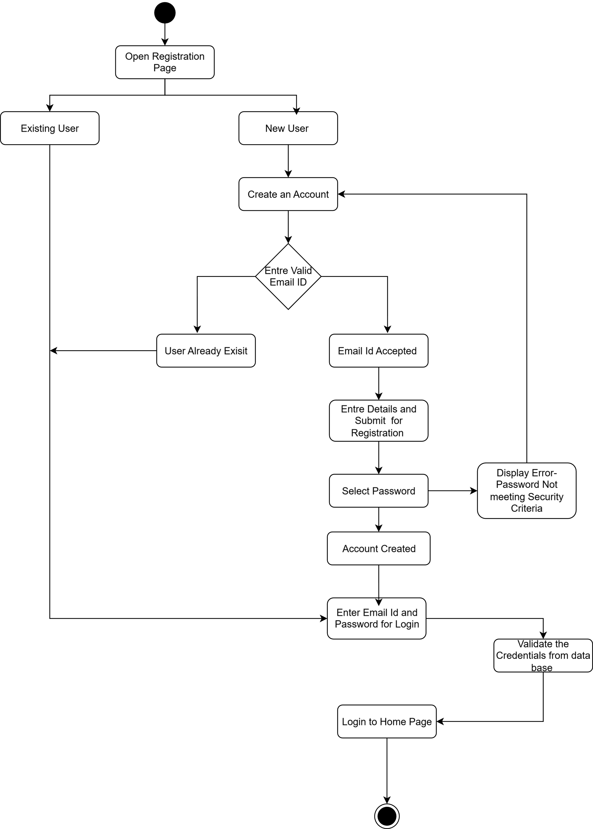

Activity Diagram for Product Search and Adding to Cart
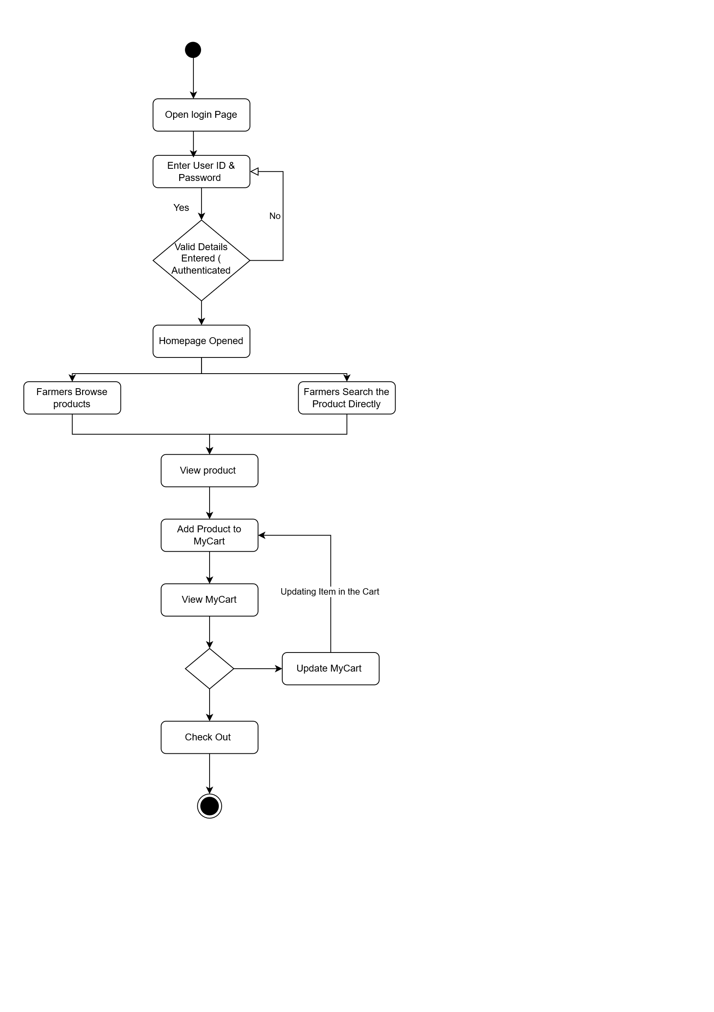

Activity Diagram For Making Payment 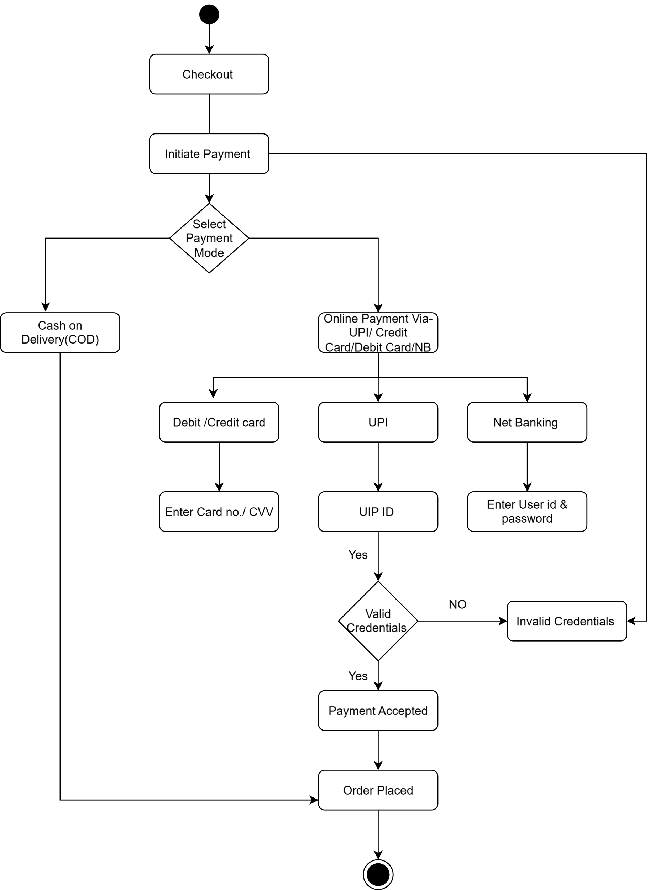

Activity Diagram For Order Processing
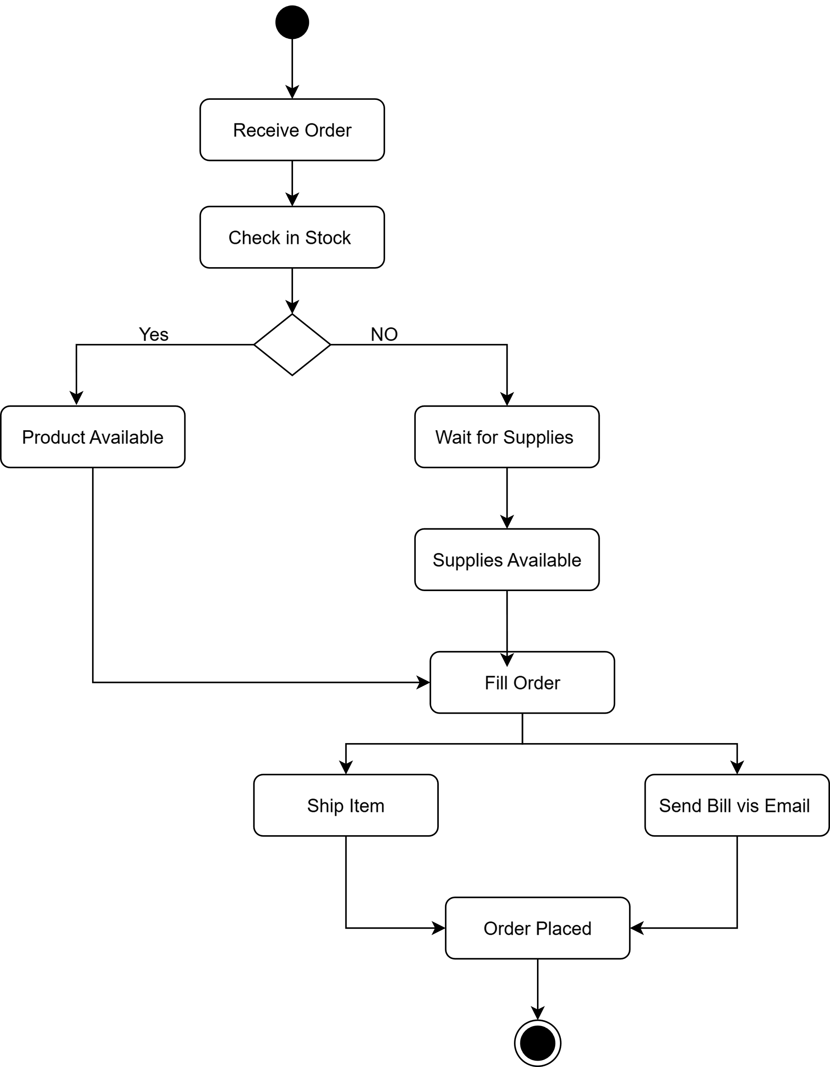

Activity Diagram For Delivery
