**Question 1 – Functional Requirements –**

**Identify minimum 20 functional requirements**

**Example:**

**Functional requirement: When an order is fulfilled, the local printer shall print a packing slip.**

**Non-Functional Requirement: Packing slips shall be printed on both sides of 4”x 6” white paper, the standard size for packing slips used by local printers.**

Answer-

|  |  |  |  |
| --- | --- | --- | --- |
| **Req ID** | **Req Name** | **Req Description** | **Priority** |
| FR0001 | Farmer Registration | Farmers should be able to register with the application | 8 |
| FR0002 | Farmer Search for Products | Farmers should be able to search for available products in fertilizers, seeds, pesticides | 8 |
| FR003 | Add to cart | Allow farmers to add product to cart. | 7 |
| FR004 | Wishlist | The system shall allow a user to add a product to their Wishlist. | 6 |
| FR005 | Order Placing | The system shall allow farmers to place an order for one or more products in the cart. | 8 |
| FR0006 | Order Management | The system shall allow farmers to view their order history. | 7 |
| FR007 | Add product | Manufacturer should be able to add product and Product details | 8 |
| FR008 | Track Delivery of Order | The system shall allow farmersto track the real-time delivery status of their placed order. | 7 |
| FR009 | Return/Exchange Product | The system shall allow farmers to request a return or exchange of a purchased product within the allowed return/exchange period. | 7 |
| FR0010 | Rating and review product | The system shall allow farmers to rate and review products they have purchased. | 7 |
| FR0011 | Payment processing | The system should enable farmers to securely pay for their orders. | 9 |
| FR0012 | Payment Options | The system shall allow farmers to select from multiple payment methods like COD/UPI etc. | 9 |
| FR0013 | Payment confirmation | Farmers should receive SMS of payment confirmation. | 6 |
| FR0014 | Search functionality | Farmers should be able to search products based on various criteria like name, brand, price using filter in search option. | 8 |
| FR0015 | Similar products | The system shall display a list of similar or related products if the particular product is out of stock. | 7 |
| FR0016 | Order cancellation | Farmers should be able to cancel their order and request for a refund. | 6 |
| FR0017 | Support for Multiple Languages | The system shall allow users to view content in their preferred language, providing a seamless localized experience. | 5 |
| FR0018 | Notify When Back in Stock | The system allow farmers to request notifications for out-of-stock products. so, they can be informed when the item becomes available again. | 4 |
| FR0019 | Apply Discount to Order or Product | The system shall allow farmers to apply discounts (automatically or manually) to the product or order level during checkout. | 2 |
| FR0020 | Checkout process | Farmers should be able to complete the checkout process by providing delivery address, payment details and confirmation of order. | 7 |
| NFR0101 | Page Loading Time | Each Page should load within 2 seconds time. | 9 |
| NFR0102 | WCAG 2.1. | The system must meet Web Content Accessibility Guidelines WCAG 2.1. | 8 |
| NFR0103 | Connectivity | System should have internet connectivity. | 10 |
| NRF0104 | Technical support system | Application can be used on any OS Android or IOS | 6 |
| NFR0105 | Authentication | Users should be required to authenticate using  username and password. | 10 |
| NFR0106 | Net banking | Bank account should be active for smooth payment process. | 8 |

**Question 2–Minimum 5 page designs –**

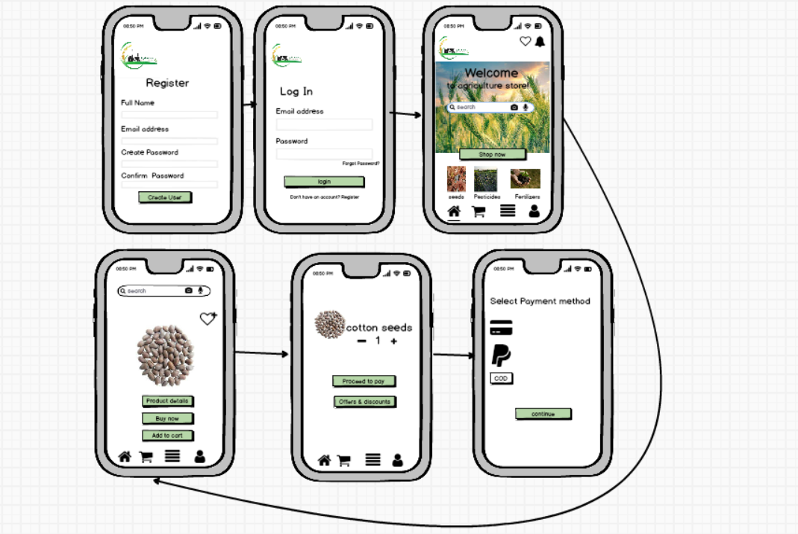**Make wireframe and prototypes**

**Question 3 – Tools (Visio, Balsamiq) - 15 Marks**

**Make a note of the Tools, which you are using for above concepts.**

Answer-

UsingBalsamiq for presenting the software requirements in the form of wireframes. This helps the software development team to visualize how the software project will look like in the very early stages of development.

**Question 4 – RTM**

**A business analyst’s key responsibilities are to keep track of the requirements and make sure that no requirement is missed.**

Mr. Henry and peter have approached you regarding the current status of the project. How will you tackle this situation?

Prepare RTM

|  |  |  |  |  |  |  |  |  |  |  |  |  |
| --- | --- | --- | --- | --- | --- | --- | --- | --- | --- | --- | --- | --- |
| Req ID | Req Name | Req Description | Design | D1 | T1 | D2 | T1 | D3 | T3 | D4 | T4 | UAT |
| FR0001 | Farmer Registration | Farmers should be able to register with the application | Y | Y | Y | Y | Y | Y | Y | Y | Y | N |
| FR0002 | Farmer Search for Products | Farmers should be able to search for available products in fertilizers, seeds, pesticides | Y | Y | Y | Y | Y | Y | Y | Y | Y | N |
| FR0003 | Add to cart | Allow farmers to add product to cart. | Y | Y | Y | Y | Y | Y | Y | N | N | N |
| FR0004 | Wishlist | The system shall allow a user to add a product to their Wishlist. | Y | Y | Y | Y | Y | Y | N | N | N | N |
| FR0005 | Order Placing | The system shall allow farmers to place an order for one or more products in the cart. | Y | Y | Y | Y | Y | N | N | N | N | N |
| FR0006 | Order Management | The system shall allow farmers to view their order history. | Y | Y | Y | N | N | N | N | N | N | N |
| FR0007 | Add product | Manufacturer should be able to add product and Product details | Y | Y | Y | N | N | N | N | N | N | N |
| FR0008 | Track Delivery of Order | The system shall allow farmersto track the real-time delivery status of their placed order. | Y | Y | Y | N | N | N | N | N | N | N |
| FR0009 | Return/Exchange Product | The system shall allow farmers to request a return or exchange of a purchased product within the allowed return/exchange period. | Y | Y | Y | N | N | N | N | N | N | N |
| FR0010 | Rating and review product | The system shall allow farmers to rate and review products they have purchased. | Y | Y | Y | N | N | N | N | N | N | N |
| FR0011 | Payment processing | The system should enable farmers to securely pay for their orders. | Y | Y | Y | N | N | N | N | N | N | N |
| FR0012 | Payment Options | The system shall allow farmers to select from multiple payment methods like COD/UPI etc. | Y | Y | Y | N | N | N | N | N | N | N |
| FR0013 | Payment confirmation | Farmers should receive SMS of payment confirmation. | Y | Y | Y | N | N | N | N | N | N | N |
| FR0014 | Search functionality | Farmers should be able to search products based on various criteria like name, brand, price using filter in search option. | Y | Y | Y | N | N | N | N | N | N | N |
| FR0015 | Similar products | The system shall display a list of similar or related products if the particular product is out of stock. | Y | Y | Y | N | N | N | N | N | N | N |
| FR0016 | Order cancellation | Farmers should be able to cancel their order and request for a refund. | Y | Y | Y | |  |  |  |  |  |  |  | | --- | --- | --- | --- | --- | --- | --- | | N | N | N | N | N | N | N | | N | N | N | N | N | N |
| FR0017 | Support for Multiple Languages | The system shall allow users to view content in their preferred language, providing a seamless localized experience. | Y | Y | Y | N | N | N | N | N | N | N |
| FR0018 | Notify When Back in Stock | The system allow farmers to request notifications for out-of-stock products. so, they can be informed when the item becomes available again. | Y | Y | Y | N | N | N | N | N | N | N |
| FR0019 | Apply Discount to Order or Product | The system shall allow farmers to apply discounts (automatically or manually) to the product or order level during checkout. | Y | Y | Y | N | N | N | N | N | N | N |
| FR0020 | Checkout process | Farmers should be able to complete the checkout process by providing delivery address, payment details and confirmation of order. | Y | Y | Y | N | N | N | N | N | N | N |
| NFR0101 | Page Loading Time | Each Page should load within 2 seconds time. | Y | Y | Y | Y | Y | Y | Y | Y | Y | N |
| NFR0102 | WCAG 2.1. | The system must meet Web Content Accessibility Guidelines WCAG 2.1. | Y | Y | Y | Y | Y | Y | Y | N | N | N |
| NFR0103 | Connectivity | System should have internet connectivity. | Y | Y | Y | N | N | N | N | N | N | N |
| NFR0104 | Technical support system | Application can be used on any OS Android or IOS | Y | Y | Y | N | N | N | N | N | N | N |
| NFR0105 | Authentication | Users should be required to authenticate using  username and password. | Y | Y | Y | Y | Y | N | N | N | N | N |
| NFR0106 | Net banking | Bank account should be active for smooth payment process. | Y | Y | Y | Y | Y | N | N | N | N | N |

**Question 5 – 10 Test Case Documents –**

**Prepare 10 Test Case Documents**

**Answer-**

Test Case 1 :

|  |  |  |  |
| --- | --- | --- | --- |
| Test Case ID | TC_001 | Test Case Name | Farmers Registration |
| Project ID | PRJ_1234 | Project name | Online agriculture product store |
| PM ID | 596 | PM Name | Mr. Vandanam |
| Test Strategy ID | T1PQ748 | Tester Id | T0101 |
| Test Plan ID | T1PQ748 | Tester Name | Ms. Alekya |
| Test Schedule ID | T1PQ748 | Date of Test |  |

|  |
| --- |
| Scenario : Online Agriculture Product store, in that we have farmers Registration in which we have 4 inputs and after that result are being shown |
| Link To that Page : |

|  |  |  |  |  |  |
| --- | --- | --- | --- | --- | --- |
| Input Data | 1.Full Name  2.Email address  3. Create Password  4.Confirm password |  |  |  |  |
| Expected Behavior | Home page/ error page |  |  |  |  |
| Actual Behavior | Same as expected |  |  |  |  |
| Comments | Test was good |  |  |  |  |
| Result Pass/Fail | Pass |  |  |  |  |

Test Case 2 :

|  |  |  |  |
| --- | --- | --- | --- |
| Test Case ID | TC_002 | Test Case Name | Farmer Search for product |
| Project ID | PRJ_1234 | Project name | Online agriculture product store |
| PM ID | 596 | PM Name | Mr Vandanam |
| Test Strategy ID | T2PQ748 | Tester Id | T0102 |
| Test Plan ID | T2PQ748 | Tester Name | Mr. Jason |
| Test Schedule ID | T2PQ748 | Date of Test |  |

|  |
| --- |
| Scenario : Verify that farmer can search for product |
| Link To that Page : |

|  |  |  |  |  |  |
| --- | --- | --- | --- | --- | --- |
| Input Data | 1.product name  2.Product brand  3.product category |  |  |  |  |
| Expected Behavior | Relevant products are shown as per the search |  |  |  |  |
| Actual Behavior | Same as expected |  |  |  |  |
| Comments | Test was good |  |  |  |  |
| Result Pass/Fail | Pass |  |  |  |  |

Test case 3 :

|  |  |  |  |
| --- | --- | --- | --- |
| Test Case ID | TC_003 | Test Case Name | Manufacturer  Adding product |
| Project ID | PRJ_1234 | Project name | Online agriculture product store |
| PM ID | 596 | PM Name | Mr Vandanam |
| Test Strategy ID | T3PQ748 | Tester Id | T0101 |
| Test Plan ID | T3PQ748 | Tester Name | Mr. Alekya |
| Test Schedule ID | T3PQ748 | Date of Test |  |

|  |
| --- |
| Scenario : Verify that farmer can add the product |
| Link To that Page : |

|  |  |  |  |  |  |
| --- | --- | --- | --- | --- | --- |
| Input Data | 1.product details  2.product description  3. price  4. product Image |  |  |  |  |
| Expected Behavior | Product added and display in product section |  |  |  |  |
| Actual Behavior | Same as expected |  |  |  |  |
| Comments | Test was good |  |  |  |  |
| Result Pass/Fail | Pass |  |  |  |  |

Test Case 4 :

|  |  |  |  |
| --- | --- | --- | --- |
| Test Case ID | TC_004 | Test Case Name | Payment Options |
| Project ID | PRJ_1234 | Project name | Online agriculture product store |
| PM ID | 596 | PM Name | Mr. Vandanam |
| Test Strategy ID | T4PQ748 | Tester Id | T0101 |
| Test Plan ID | T4PQ748 | Tester Name | Mr. Alekya |
| Test Schedule ID | T4PQ748 | Date of Test |  |

|  |
| --- |
| Scenario : Verify that farmers can select different payment options. |
| Link To that Page : |

|  |  |  |  |  |  |
| --- | --- | --- | --- | --- | --- |
| Input Data | 1.Cards  2. Net banking  3.UPI  4.COD |  |  |  |  |
| Expected Behavior | Farmer can select any one payment option and proceed for payment |  |  |  |  |
| Actual Behavior | Same as expected |  |  |  |  |
| Comments | Test was good |  |  |  |  |
| Result Pass/Fail | Pass |  |  |  |  |

Test case 5 :

|  |  |  |  |
| --- | --- | --- | --- |
| Test Case ID | TC_005 | Test Case Name | Order cancellation |
| Project ID | PRJ_1234 | Project name | Online agriculture product store |
| PM ID | 596 | PM Name | Mr Vandanam |
| Test Strategy ID | T5PQ748 | Tester Id | T0101 |
| Test Plan ID | T5PQ748 | Tester Name | Ms. Alekya |
| Test Schedule ID | T5PQ748 | Date of Test |  |

|  |
| --- |
| Scenario : Verify that farmer can cancel order |
| Link To that Page : |

|  |  |  |  |  |  |
| --- | --- | --- | --- | --- | --- |
| Input Data | 1.Order Id  2.Reason for cancellation |  |  |  |  |
| Expected Behavior | Order cancellation page |  |  |  |  |
| Actual Behavior | Same as expected |  |  |  |  |
| Comments | Test was good |  |  |  |  |
| Result Pass/Fail | Pass |  |  |  |  |

Test case 6 :

|  |  |  |  |
| --- | --- | --- | --- |
| Test Case ID | TC_006 | Test Case Name | Order Tracking |
| Project ID | PRJ_1234 | Project name | Online agriculture product store |
| PM ID | 596 | PM Name | Mr Vandanam |
| Test Strategy ID | T6Q748 | Tester Id | T0102 |
| Test Plan ID | T6PQ748 | Tester Name | Mr. jason |
| Test Schedule ID | T6PQ748 | Date of Test |  |

|  |
| --- |
| Scenario : Verify that Farmers can track their order in real-time after order placement |
| Link To that Page : |

|  |  |  |  |  |  |
| --- | --- | --- | --- | --- | --- |
| Input Data | 1.Order id  2.Product name |  |  |  |  |
| Expected Behavior | Delivery address is shown as per real-time . |  |  |  |  |
| Actual Behavior | Same as expected |  |  |  |  |
| Comments | Test was good |  |  |  |  |
| Result Pass/Fail | Pass |  |  |  |  |

Test case 7:

|  |  |  |  |
| --- | --- | --- | --- |
| Test Case ID | TC_007 | Test Case Name | Review/ Rating |
| Project ID | PRJ_1234 | Project name | Online agriculture product store |
| PM ID | 596 | PM Name | Mr Vandanam |
| Test Strategy ID | T6PQ748 | Tester Id | T0102 |
| Test Plan ID | T6PQ748 | Tester Name | Mr. jason |
| Test Schedule ID | PQ748 | Date of Test |  |

|  |
| --- |
| Scenario : Online Agriculture Product store, in that we have rating in which 4 inputs 4 compulsory and after that result are being shown |
| Link To that Page : |

|  |  |  |  |  |  |
| --- | --- | --- | --- | --- | --- |
| Input Data | 1.Experience  2. Name  3. Phone Number  4. Review |  |  |  |  |
| Expected Behavior | Review. Rating Done |  |  |  |  |
| Actual Behavior | Same as expected |  |  |  |  |
| Comments | Test was good |  |  |  |  |
| Result Pass/Fail | Pass |  |  |  |  |

Test case 8:

|  |  |  |  |
| --- | --- | --- | --- |
| Test Case ID | TC_008 | Test Case Name | Cash on Delivery |
| Project ID | PRJ_1234 | Project name | Online agriculture product store |
| PM ID | 596 | PM Name | Mr Vandanam |
| Test Strategy ID | T8PQ748 | Tester Id | T0102 |
| Test Plan ID | T8PQ748 | Tester Name | Mr. jason |
| Test Schedule ID | T8PQ748 | Date of Test |  |

|  |
| --- |
| Scenario : Online Agriculture Product store, in that COD in which 2 input 2 compulsory and click ok and after that result are being shown |
| Link To that Page : |

|  |  |  |  |  |  |
| --- | --- | --- | --- | --- | --- |
| Input Data | 1.Select COD  2. Receive payment confirmation message |  |  |  |  |
| Expected Behavior | Order confirmed |  |  |  |  |
| Actual Behavior | Same as expected |  |  |  |  |
| Comments | Test was good |  |  |  |  |
| Result Pass/Fail | Pass |  |  |  |  |

Test case 9:

|  |  |  |  |
| --- | --- | --- | --- |
| Test Case ID | TC_009 | Test Case Name | Helpline |
| Project ID | PRJ_1234 | Project name | Online agriculture product store |
| PM ID | 596 | PM Name | Mr Vandanam |
| Test Strategy ID | T9PQ748 | Tester Id | T0101 |
| Test Plan ID | T9PQ748 | Tester Name | Ms. Alekya |
| Test Schedule ID | T9PQ748 | Date of Test |  |

|  |
| --- |
| Scenario : Online Agriculture Product store, in that we have helpline in which 2 inputs 2 compulsory and after that result are being shown |
| Link To that Page : |

|  |  |  |  |  |  |
| --- | --- | --- | --- | --- | --- |
| Input Data | 1.Name  2.Number  3. Query |  |  |  |  |
| Expected Behavior | Receive calls |  |  |  |  |
| Actual Behavior | Same as expected |  |  |  |  |
| Comments | Test was good |  |  |  |  |
| Result Pass/Fail | Pass |  |  |  |  |

Test case 10:

|  |  |  |  |
| --- | --- | --- | --- |
| Test Case ID | PQ748 | Test Case Name | Download Invoice |
| Project ID | 1234 | Project name | Online agriculture product store |
| PM ID | 596 | PM Name | Mr Vandanam |
| Test Strategy ID | PQ748 | Tester Id |  |
| Test Plan ID | PQ748 | Tester Name |  |
| Test Schedule ID | PQ748 | Date of Test |  |

|  |
| --- |
| Scenario : Online Agriculture Product store, in that we have download invoice in which 3 inputs 3 compulsory and after that result are being shown |
| Link To that Page : |

|  |  |  |  |  |  |  |  |  |  |
| --- | --- | --- | --- | --- | --- | --- | --- | --- | --- |
| Input Data | 1.Order Id  2.Capcha  3.Password | |  | | |  | |  |  |
| Expected Behavior | Shows payment receipt |  |  | | | |  |  | |
| Actual Behavior | Same as expected | |  |  |  |  |
| Comments | Test was good | |  |  |  |  |
| Result Pass/Fail | Pass | |  |  |  |  |

**Question-6 – DB Design**

**After the requirements are thoroughly explained to the entire project team by business analyst, the Database architects have decided to do the database design and also to represent the in-flow and out-flow of data.**

**Draw database schema and ER diagram**

**Answer-**

**Database Schema-**

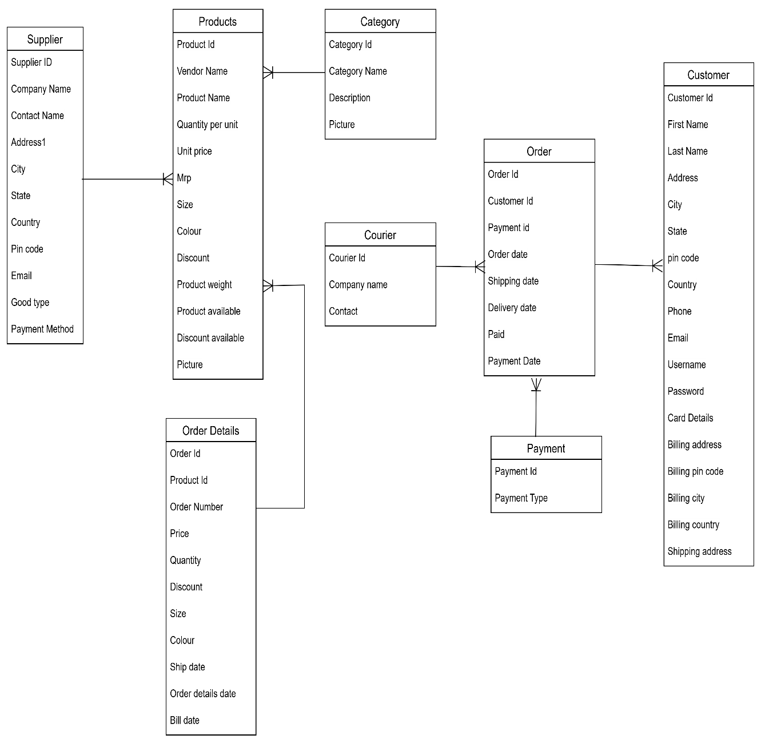

**ER diagram -**

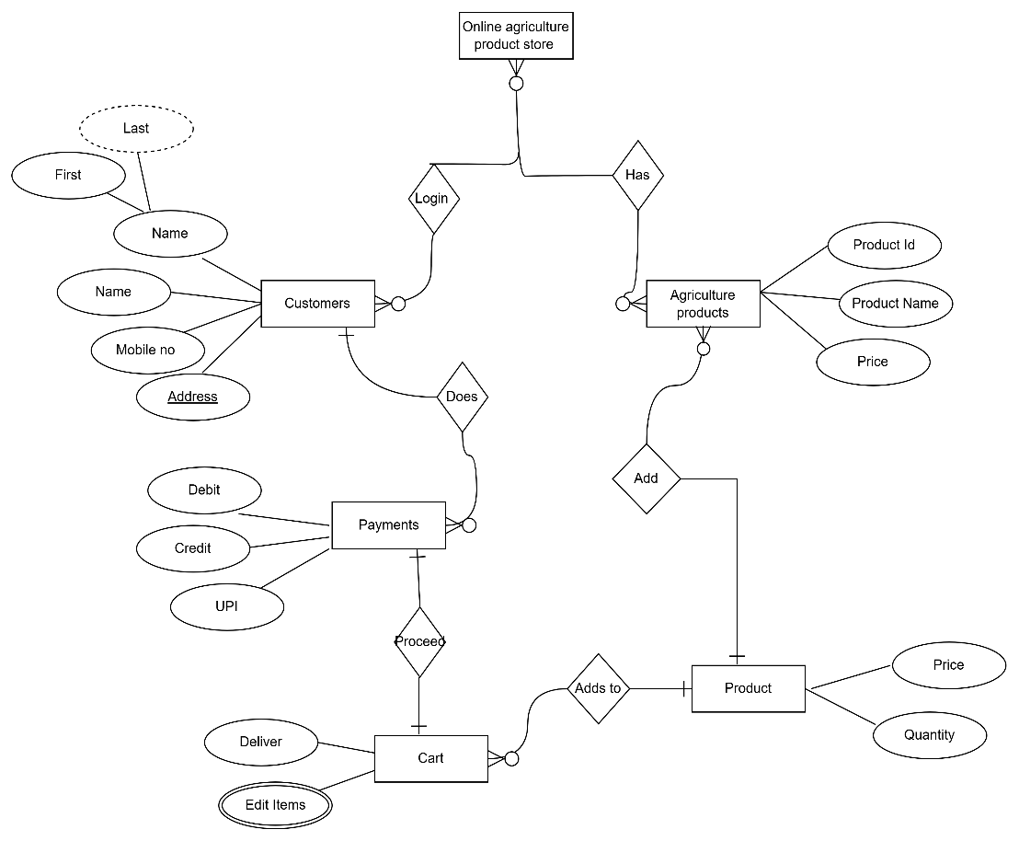

**Question 7 – Data Flow Diagram**

What is a data flow diagram? Draw a data flow diagram to represent the in-flow and out-flow of data when a Farmer is placing an order for the product

**Answer-**

**Date flow:** A Data Flow Diagram (DFD) is a graphical representation of the flow of data in a system. It illustrates how data moves between different processes, data stores, and external entities, helping to understand system operations.

Question 8 – Change Request - 10 Marks

Question 8 – Change Request - 10 Marks

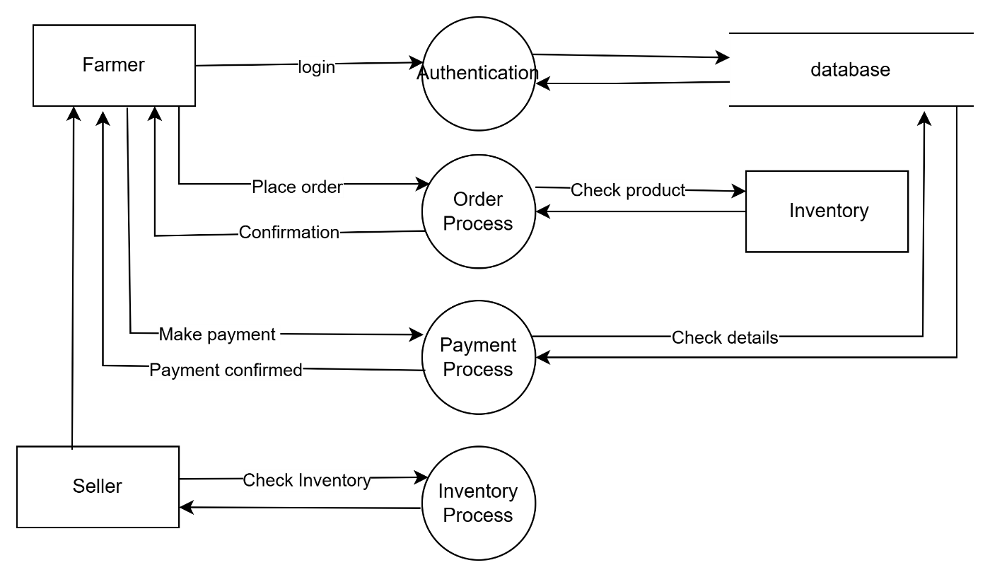

**Question 8 – Change Request –**

Due to change in the Government Taxation structure . we should change the Tax structure How do you handle change requests in a project?

**Answer :** A change request is a formal proposal for an alteration to some product or system. In project management, a change request often arises when the client wants an addition or alteration to the agreed-upon deliverables for a project. Such a change may involve an additional feature or customization or an extension of service, among other things. When there is sudden change in the tax structure by the government the entire project cost gets affected.

We will call for a meeting and discuss how we are going to tackle the system. We will discuss the areas where we can do cost-cutting, and if we are not able to do it, then we will reach out to our client and make them understand the situation and then convince them to increase the budget. There are a lot of obstacles to overcome when trying to deliver on a project. A change request will often come up throughout the course of most projects, so it is a good idea to have a plan for how to handle them ahead of time. Often, change requests are necessary and can offer many benefits. Managing this process in an effective way can allow for greater internal communication, efficiency, and alignment with overall business goals.

**Request any supporting materials**

Ask that person to put their request in writing and provide any supporting materials that might be helpful. Have that person articulate why they are requesting this change and what the anticipated benefit of their change request is. This will help the team determine whether or not the change request is worth the effort. Determine whether the change request is in inside or outside the scope

**Evaluating and Implementing a Change Request**

It is a good idea to consider what the scope of the change request is. If the team chooses to implement this change, what new requirements will this put on the project? Will have to consider all aspects of the project that will be impacted by implementing this change request. If the request is outside of the scope, a lot of problems might end up popping up – going over-budget, for example. Or having to waste too much time on a project you’d never even agreed on.

**Have the team assess the priority of the change request**

Before the team implements any changes to the project, BA should consider any possible risks. What is the expected benefit of the change being proposed? Is this change request the result of an actual need to respond to a change in the marketplace, or would it simply be nice to have?

Can consider the opinion of the person who proposed the change request, but at the same time, use common sense. The client might not know what’s in their own best interests.

Have clearly defined guidelines for evaluating the urgency, as there may be varying opinions among team members.

**Approve or reject the change request**

Now knowing the how importance (or unimportant) the change request is and understand the impact it will have on the project, the team can either approve or reject the request.

**Decide on a course of action going forward**

If the change request is approved, then the project deliverables will need to be updated. This can include plans and schedules, business process documents, and the requirements documents.

Once these updates have been made, the project manager can communicate the new course of action to everyone who will be impacted. Now you can delegate the necessary tasks to the people in charge of implementing these new changes.

**Question 9 – Change Request Vs an Enhance**

**Answer-**

As the project is in process, Ben and Kevin have contacted you. The reason is to inform you that they want the Farmers to sell their crop yields through this application i.e. Farmers should be able to add their crop yields or products and display to general public and should be able to sell them. They also want to introduce Auction system for their Crop yields. As a BA, what will be your response?

Is this a change request or an enhancement???

Answer : It is a change request because it introduces a new business process and functionality beyond the originally planned scope they said Farmers should be able to sell their crop yields through this application but it was initially not told. So, it is a change request.

|  |  |
| --- | --- |
| **Change Request (CR)** | **Change Enhancement** |
| Fix an issue or modify an existing function | Improve existing function or adding new ones |
| Change request in mostly **unplanned** | Change enhancement is mostly **planned** |
| CR can be major or minor | Generally incremental |
| Often high priority | Lower priority |
| Eg : Fix a login page | Eg : Add biometric login option |

**Question 10 – Estimations - 6 Marks**

Come up with estimations – How many Manhours required

**Answer :**

Total man hours as a whole we required is **700 man hours**

* **Project Manager** - Mr Vandanam - **100 men hours**
* **Senior Java Developer** - Ms. Juhi - **100 men hours**
* **Java Developers** - Mr Teyson, Ms Lucie, Mr Tucker, Mr Bravo - **100 men hours**
* **Network Admin** - Mr Mike - **50 men hours**
* **DB Admin** - Mr John - **50 men hours**
* **Testers** - Mr Jason and Ms Alekya - **200 men hours**
* **BA** - me - **100 men hours**

Question 11 – UAT – 6 Marks

Project has finally completed all the stages i.e., design, development, testing etc. Now, it is the role of a business analyst to contact the client for testing of the final product and have to successfully complete it. How are you going to handle this situation? And once it is done, what will be the process to close the project?

**Explain UAT Acceptance process**

**Answer :**

**1. Planning**

The Planning & Preparation phase ensures that the final product meets business requirements before going live. This phase involves defining the UAT scope, objectives, test scenarios, preparing test data, and setting up the UAT environment. Identify functionalities to be tested, focusing on business-critical workflows. Exclude technical aspects like unit testing and performance tuning. Ensure testing aligns with business needs, system integrations, and user expectations.

**2. Test Scenarios**

Once planned the UAT test, it is time to think of the different test scenarios. Here we are referring to all the situations that can arise while using the product and what needs to happen in each situation. These scenarios help with the creation of test cases. Let us assume that have asked a web development agency for an e-commerce website.

One test case would be to test the website during the sales season. As there would be many customers, testing the website’s functionality, load speed, and overall user experience is a must-have test scenario.

**3. Execution**

Once the previous steps are complete, it is time to begin the UAT testing. It is best to record and document the entire process. While the developers are not a part of the UAT team, ensure that they witness the entire UAT session. The reason for this is because the end-users might not explain the problems in a way that developers expect or need.

So, by having them witness the entire test, they will understand potential issues better. Furthermore, there may be times when end-users don’t report a problem, but developers see it themselves when watching the UAT session. So it is well worth the time of your developers to witness the UAT session.

**4. Final Decision**

The UAT test is there to analyze if the product is per the business requirements or not. If the answer comes in positive, the product is ready for launch into the market. If the answer is negative, have to go through another round of UAT testing after fixing all the bugs and glitches.

Question 12 – Project Closure Document - 6 Marks

**Explain Project closure document**

**Answer :** A Project Closure Document is a formal document that signifies the completion of a project. It outlines the final deliverables, evaluates project performance and confirms that all project objectives have been met. This document ensures a smooth transition, preventing unresolved issues and ensuring that stakeholders formally accept the project’s closure. It is the responsibility of the project manager to keep a record of all the details of every stage of the project. This assists the managers along with senior members to estimate the progress and find out the areas where more effort is needed. With the aid of this report, an organization can evaluate the ways to enhance efficiency in the future. Such reports also depict the hard work of the team and the way they accomplished their particular objectives.