**Capstone Project 1 Prep-2**

Q.1 4 Quarterly Audits are planned Q1, Q2, Q3, Q4 for this Project. What is your knowledge on how these Audits will happen for a BA?

Ans. **Audit** – Audit is a process of inspection of different books of various department by an auditor physically checking financial records, inventory and documentation records.

In Q1, Auditor will check the following details:

1. Understanding of company goals does the BA has or don’t have.

2. Understood the Current as is process.

3. BA’s understanding of Business Requirements.

4. BA conducted the Stakeholder Analysis.

5. Which Elicitation techniques has been used to gather requirements.

6. Requirement gathering and analysis was done correctly.

In Q2, Auditor will check the following details:

1. Documents have been prepared by the BA.

2. Has BA prepared all the required documents BRD and FRD to understand the requirement correctly.

3. How BA has prepared the Use case and Activity diagram.

4. Was all these documents signed and agreed by the Stakeholders, before the start of the development stage.

In Q3, Auditor will check the following details:

1. Requirements were correctly explained to the development team.

2. BA tracking the status of the project.

3. BA keeping the Stakeholders updated on the status of the project

4. BA assisting the Testing team for Testing the product.

5. BA tracking the Testing of the product.

In Q4, Auditor will check the following details:

1. BA preparing the End user manual.

2. BA preparing the client for UAT.

3. BA organizing the training sessions for the client.

4. BA helping the client to do the UAT.

5. BA taking signoff document from the client.

6. BA sending the complete timesheet to the reporting manager.

Q.2 Before the Project is going to Kick Start, The Committee asked Mr Karthik to submit BA Approach Strategy Write BA Approach strategy (As a business analyst, what are the steps that you would need to follow to complete a project – What Elicitation Techniques to apply, how to do Stakeholder Analysis RACI/ILS, What Documents to Write, What process to follow to Sign off on the Documents, How to take Approvals from the Client, What Communication Channels to establish n implement, How to Handle Change Requests, How to update the progress of the project to the Stakeholders, How to take signoff on the UAT- Client Project Acceptance Form).

Ans.

BA approach is a plan where all the business analysis activities will be executed on a project, that may include following activities:

1. Understanding business needs.

2. Stakeholder analysis.

3. Requirements Gathering Approach for the project using elicitation techniques, analysed it.

4. Create documents like BRD, FRD, SRS.

5. Requirements Review Process and Approval Cycles.

6. Explain requirements to development team.

7. Change Management approach to requirements and agreed deliverables.

8. Help to create UAT and take sign off from client.

**Elicitation Techniques** –

1.Conduct interviews with the stakeholders (Mr. Henry, Mr. Pandu, Mr. Dooku, Peter, Kevin, Ben) to gather the requirements.

2.Organize focus group sessions to understand the needs of the remote area farmers. Review existing systems and documents to gather additional information.

3.Conduct surveys and questionnaires to gather a wider perspective.

**Stakeholder Analysis** –

Conduct RACI (Responsible, Accountable, Consulted, Informed) or ILS (Involved, Lead, Support) analysis to determine the roles and responsibilities of each stakeholder. Identify the key stakeholders and prioritize their requirements. Establish effective communication channels with the stakeholders to keep them informed about the progress of the project.

**Documents** –

Write a Requirements Document (RD) to outline the functional and non-functional requirements of the project. Create a Business Requirements Document (BRD) to provide a detailed description of the project's objectives, scope, and deliverables. Create a Business Case Document for justification of undertaking project.

**Sign Off & Approval** –

Obtain sign-off from the stakeholders on the Requirements Document, Business Requirements Document and Use Case Document. Ensure that the stakeholders understand and agree with the requirements, scope, and objectives of the project.

**Communication Channel** –

Establish a regular communication schedule with the stakeholders to keep them informed about the project's progress. Create a communication plan to outline the channels and methods of communication. Schedule regular status meetings with the stakeholders to discuss the project progress and address any issues or concerns.

**Change Request** –

Handle change requests in a structured and systematic manner. Evaluate the impact of each change request on the project's scope, timeline, and budget. Calculate the risk of having change request. Obtain approval from the stakeholders before implementing the change request.

**Progress Update** –

Keep the stakeholders informed about the project progress through regular status reports and progress meetings. Highlight any risks or issues that need to be addressed. Provide regular progress updates to the stakeholders and seek their feedback.

**UAT Signoff** –

Prepare user manual and provide training sessions to client for performing UAT. Conduct User Acceptance Testing (UAT) to validate the project deliverables. Obtain sign-off from the client on the UAT form. Ensure that the project meets the client's expectations and requirements.

Q.3 3-Tier Architecture. Explain and illustrate 3-tier architecture?

Ans. In 3-tier architecture there are three layers. The presentation layer is the top most layer in this architecture and it is responsible for presenting user interference to the end user. The business logic layer is middle layer of architecture and contains business logic of system. This layer manages application logic, data validation, data processing. The Database layer is bottom layer of architecture and responsible for managing data storage and retrieval of data from database management system.

1**. Presentation layer**: It includes the Agricultural mob app screen, login page, functionality.

2**. Business logic layer**: In this case it’s a payment methods, agricultural product company details, specific rules.

3**. Database layer**: It can have company’s details, product details data, farmer’s data, payment history.

Q.4 Business Analyst should keep What points in his/her mind before he frames a Question to ask to the Stakeholder (5W 1H – SMART – RACI – 3 Tier Architecture – Use Cases, Use case Specs, Activity Diagrams, Models, Page designs)

Ans.

As a BA, the followings points should be kept in mind before framing questions to ask a Stakeholder.

**5W1H** – 1. What is the Project and what are the objectives?

2. When it should get completed?

3. Why project is initiated?

4. Who will get benefit from this project?

5. Where to get connected for requirements?

6. How much is the Budget?

**SMART** - Confirms the requirement is SMART before accepting it for development.

1)Specific – Narrowing the questions, so let every signal question only include one element you can get.

2)Measurable – The questions are better to be quantified and countable.

3)Action Oriented – Does the question influence creation of different or new feature packages.

4)Relevant – Does the question identify which features are most required from the customer.

5)Timebound – It can let you or your customer decide priority in a specific time frame.

**RACI Matrix** –

Responsible – The person who does the work to achieve the task. They have responsibility for getting the work done or decision made. The person responsible are typically working-level project team members, such as the project manager, business analyst and developers.

Accountable – The person who is responsible for the correct and through completion of the task. They are

responsible for ensuring the work is complete and suitable.

Consulted – People from whom feedback and input should be solicited. They are going to provide information for the project and with whom there can be two-way communication.

Informed – People kept informed of progress by keeping them in loop. These individuals do not have to be consulted or be a part of the decision making.

**3- Tier Architecture** –

Presentation layer - This layer display screens, pages, validation on pages, functionally.

Business logic layer - In a business logic layer all reusable components, frequently changing components, governing body rules, regulation, compliance.

Data layer - In this layer the data or information is stored. This layer performs operations like insert, update and delete to connect with the database.

**Use Case** – Develop an understanding of how the application will be used by various users.

**Use Case Specs** –

1.Who are the Primary and Secondary actors?

2.What are the Actor Goals?

3.What are the main Tasks or functions that are performed by the Actor?

4.What information does the actor desire from the system?

**Activity Diagram** – Create visual representations of how different activities and processes will flow within the application.

**Models** – Use various models to help stakeholders better understand the system, such as data models and sequence diagrams.

**Page designs** – Create mock ups and wireframes of the application's user interface to better understand user needs and preferences.

Q.5 As a Business Analyst, What Elicitation Techniques you are aware of? (BDRFOWJIPQU)

Ans.

Elicitation Technique – Elicitation Technique is the process of gathering and defining the requirements for a system.

**Brainstorming:** This technique is used to generate new ideas as much as possible in short period of time. The members included for brainstorming can be domain experts or subject matter experts. Multiple ideas and information give us a repository of knowledge and we can choose solution from different ideas.

**Document Analysis**: Document analysis is done through reading documents and understanding a product or process. It is a step by step approach to accomplish what you are supposed to do.

**Reverse Engineering**: In this Technique, any outdated documentation in an existing system, can be reversed to understand what the system does. It is an elicitation technique that can extract implemented requirements from the system. There are two types of reverse engineering techniques.

1)Whitebox Reverse Engineering: It is a type of reverse engineering where you will see more known items.

2)Blackbox Reverse Engineering: It is a type of reverse engineering where you will see more unknown items.

**Focus Groups:** By using a focus group, you can get information about a product, service from a group. The Focus group includes subject matter experts. The objective of this group is to discuss the topic and provide information.

**Observation**: Observation is an excellent elicitation technique that helps understand requirements based on observations related to process flows and work environments of stakeholders. Observation requires a business analyst to go and look at the work.

**Workshop:** Workshops have stakeholders working together to identify requirements. A requirement workshop is a structured way to capture requirements. Workshops are used to scope, identify, define and prioritize requirements for the proposed system.

**JAD:** This technique is more process-oriented and formal as compared to other techniques. These are structured meetings involving end-users, PM, SMEs, Technical team. This is used to define, clarify, and complete requirements.

**Interview:** An interview is a systematic approach to elicit information from a person or group of people. This is the most common technique used for requirement elicitation. Interview techniques should be used for building strong relationships between business analysts and stakeholders. In this technique, the interviewer directs the question to stakeholders to obtain information. One to one interview is the most commonly used technique.

**Prototype:** Prototyping is used to identify missing or unspecified requirements. In this technique, frequent demos are given to the client by creating the prototypes so that client can get an idea of how the product will look like. Prototypes can be used to create a mock-up of sites and describe the process using diagrams.

**Questionnaires / Survey:** For Survey/Questionnaire, a set of questions is given to stakeholders to quantify their thoughts. After collecting the responses from stakeholders, data is analysed to identify the area of interest of stakeholders. Questions should be based on high priority risks.

**Use case specs:** Use cases are an effective and widely used technique for eliciting software requirements. The use-case approach focuses on the goals that users have with a system, rather than emphasizing system functionality. This technique combines text and pictures to provide a better understanding of the requirements. The use cases describe the ‘what’, of a system and not ‘how’. Hence, they only give a functional view of the system. The components of the use case design include three major things Actor, Use cases, Use case diagram.

Q.6 Which Elicitation Techniques can be used in this Project and Justify your selection of Elicitation Techniques? Prototyping, Use case Specs, Document Analysis, Brainstorming.

Identify Business Requirements (which includes Stakeholder Requirements) –

BR001 – Farmers should be able to search for available products in fertilizers, seeds, pesticides

BR002 – Manufacturers should be able to upload and display their products in the application

Ans. I will prefer below elicitation techniques for this projects –

**Brainstorming:** By using this Technique, we can extract several ideas to make the Online store more useful for farmers and other users. Once we have these ideas, we can analyse and select the best ideas to implement. Brainstorming is effective with group of people to get ideas from the stakeholders.

**Prototyping:** The prototyping technique can be used to create a working model of the application's user interface, which can be used to gather feedback from stakeholders and ensure that the requirements are being met. This technique can be particularly useful for gathering requirements related to the user interface and user experience.

**Use case specs:** This technique is a combination of text and pictures which will provide me a better understanding of the requirements. These diagrams also identify the interactions between the system and its actors.

**Justification for using this elicitation technique –**

Brainstorming can be used to generate new ideas and requirements for the system. The Prototyping technique can be used in this project because it allows for quick feedback from stakeholders and can help ensure that the final product meets their needs. The Use Case Specs technique can be used to capture the functional requirements of the system, which is important for any software development project.

**Identifying Business Requirements** –

BR001 – The application should have user friendly interface.

BR002 – Application should be able to handle large number of user registration and orders.

BR003 – Application should be fast with minimal data usage.

BR004 – Farmers should be able to search for available products in fertilizers, seeds, pesticides.

BR005 – Manufacturers should be able to upload and display their products.

BR006 – All users should able to do Login details with Username and Password.

BR007 – Once the user’s login to the portal, they should also update their address details, to make sure the delivery happens to their requested address only.

BR008 – A new user should be able to create a new account by submitting their email ID and creating a secure password.

BR009 – Users should be able to browse through the Product catalogues once they visit the website.

BR010 – User should have the Buy Now option if they want to purchase the product immediately.

BR011 – Users can have a Save for Later or Wishlist option, if they want to buy any product later.

BR012 – Application should get integrated with payment gateway.

BR013 – Farmers needs to have an easy-to-use payment gateway which should include cash-on delivery (COD),Credit/Debit card and UPI options so that the user’s experience should be better.

BR014 – User should get an email confirmation regarding their order status.

BR015 – Users should be able to track their order, once placed.

BR016 – User should be able to cancel or return the product, if not happy with it.

BR017 – Users should have an option to give feedback on the Product, Delivery and Overall experience.

Q. 7 Make suitable Assumptions and identify at least 10 Business Requirements.

Ans.

|  |  |  |
| --- | --- | --- |
| **Req. ID** | **Requirement Name** | **Requirement Description** |
| BR001 | User Interface | The application should have user friendly interface. |
| BR002 | Log in | All users should able to do Login details with Username and Password. |
| BR003 | Functionality | Manufacturers should be able to upload and display their products. |
| BR004 |  | Application should be fast with minimal data usage. |
| BR005 | Purchase | User should have the Buy Now option if they want to purchase the product immediately. |
| BR006 | Functionality | Application should get integrated with payment gateway. |
| BR007 | Payment | Application should allow farmers to make payment online. |
| BR008 | Tracking | Users should be able to track their order, once order placed. |
| BR009 | Cancel and return | User should be able to cancel and return the product, if not happy with it. |
| BR010 | Feedback | Users should have an option to give feedback on the Product, Delivery and Overall experience. |

Q. 8 List your assumptions.

Ans.

1. The project should a web-based application accessible through desktop and mobile devices.

2. The product catalogue will only contains agricultural products.

3. The application will not store any financial information of the users.

4. The user should have an active registered mobile number to receive OTPs to pay for the product.

5. The delivery of the products will be outsourced to a third-party logistics company.

6. The application should have chat and call facility for inquiry or having problem regarding with product.

Q. 9 Give Priority 1 to 10 numbers (1 being low priority – 10 being high priority) to these Requirements after discussions with the stakeholders.

Ans.

|  |  |  |  |
| --- | --- | --- | --- |
| **Req. ID** | **Req. Name** | **Req. Discription** | **Priority** |
| BR001 | User Interface | The application should have user friendly interface. | 10 |
| BR002 | Functionality | Application should be able to handle large number of user registration and orders. | 7 |
| BR003 | Functionality | Application should be fast with minimal data usage. | 7 |
| BR004 | Searching available  Products | Farmers should be able to search for available products in fertilizers, seeds, pesticides. | 8 |
| BR005 | Functionality | Manufacturers should be able to upload and display their products. | 9 |
| BR006 | Login | All users should able to do Login details with Username and Password. | 8 |
| BR007 | Update information | Once the user’s login to the portal, they should also update their address details, to make sure the delivery happens to their requested address only. | 8 |
| BR008 | Create new account | A new user should be able to create a new account by submitting their email ID and creating a secure password. | 8 |
| BR009 | Product catalogue | Users should be able to browse through the Product catalogues once they visit the website. | 7 |
| BR010 | Purchase | User should have the Buy Now option if they want to purchase the product immediately. | 8 |
| BR011 | Manage product | Users can have a Save for Later or Wishlist option, if they want to buy any product later. | 6 |
| BR012 | Payment gateway | Application should get integrated with payment gateway. | 8 |
| BR013 | Options for payment | Farmers needs to have an easy-to-use payment gateway which should include cash-on delivery (COD), Credit/Debit card and UPI options so that the user’s experience should be better. | 8 |
| BR014 | Email confirmation | User should get an email confirmation regarding their order status. | 6 |
| BR015 | Tracking | Users should be able to track their order, once placed. | 7 |
| BR016 | Cancel or return | User should be able to cancel or return the product, if not happy with it. | 8 |
| BR017 | Feedback | Users should have an option to give feedback on the Product, Delivery and Overall experience. | 9 |

Q.10 Draw use case diagram.

Ans. **Use Case Diagram** – Use case diagram is a visual representation of interaction between user and system.

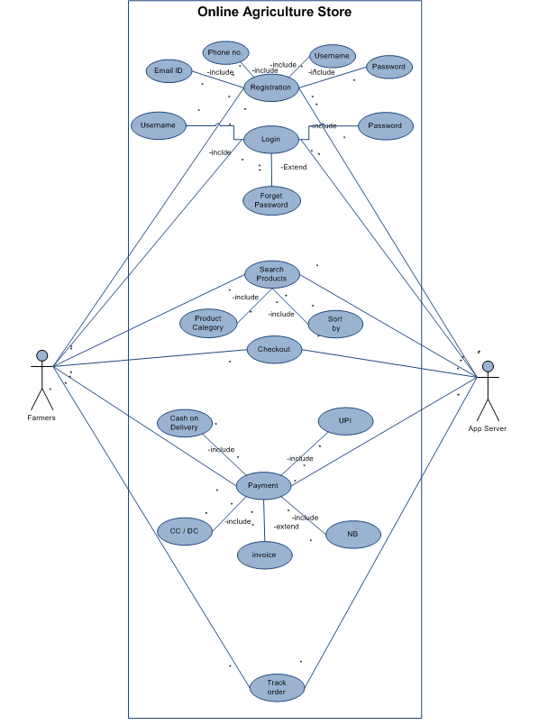

Q. 11 Prepare use case specs for all use cases (minimum 5).

Ans. **Use Case Specs** – Use Case Spec is a textual representation illustrating a sequence of events together with other related information.

1) User Login –

|  |  |
| --- | --- |
| Use Case ID | UC0001 |
| Use Case | User login |
| Created by | BA |
| Date Created | 02/01/2025 |
| Date Uploaded | 02/01/2025 |
| Actor | Farmer |
| Description | This use case describes how to login in application. |
| Pre-condition | User should has internet and valid user name or mail id and password. |
| Normal Flow | User will click on login button.  User will enter the user name or email id.  User will enter password.  User would be able to login. |
| Alternate Flow | User will click on forget password.  User will receive an OTP.  User will enter OTP.  User will enter new password and confirm new password.  User will login with username and new password. |
| Post-condition | User has login successfully. |
| Exception | If the internet connectivity is lost, the system will display ‘check your internet connectivity’. |
| Assumption | It is assumed that user has valid username and password.  It is assumed that user has login to application successfully. |

2) Searching Products –

|  |  |
| --- | --- |
| Use Case ID | UC0002 |
| Use Case | Searching of products |
| Created by | BA |
| Date Created | 03/01/2025 |
| Date Uploaded | 03/01/2025 |
| Actor | Farmer |
| Description | This use case describes how to search available products. |
| Pre-condition | User should login to application first. |
| Normal Flow | User will login in application.  User will click on search bar.  User will type product name as what they want.  User will click on search.  User would able to search available products. |
| Alternate Flow | User will login in application.  User will click on voice command.  User will speak what they want.  The system will show the list of available products. |
| Post Condition | User has searched product successfully. |
| Exception | The system might be slow due to increasing users. |
| Assumption | It is assumed that user has good knowledge of online apps or websites. |

3) Add to cart –

|  |  |
| --- | --- |
| Use Case ID | UC0003 |
| Use Case | Add to cart |
| Created by | BA |
| Date Created | 03/01/2025 |
| Date Uploaded | 03/01/2025 |
| Actor | Farmer |
| Description | This use case describes how to add a product to cart. |
| Pre-condition | The required product must available while selecting product.  User should select product with specifications. |
| Normal Flow | User will see the available products.  User will compare the products.  User will select the product.  User will click on add to cart button.  Now user would able to see required product in cart. |
| Alternate Flow | None |
| Post-condition | User has added product to cart successfully. |
| Exception | Sometimes product might be unavailable due to shortage. |
| Assumption | It is assumed that user is familiar with the system. |

4) Place Order –

|  |  |
| --- | --- |
| Use Case ID | UC0004 |
| Use Case | Place an order. |
| Created by | BA |
| Date Created | 03/01/2025 |
| Date Uploaded | 03/01/2025 |
| Actor | Farmer |
| Description | This use case describes how to place an order. |
| Pre-condition | User should have product in cart. |
| Normal Flow | User will go to cart.  User will check whether the product is having correct specification or not.  User will checkout.  User will fill name, mobile no. and address.  User will select method of payment.  User will receive an OTP.  User will type the OTP and send it.  And the order would place on desired location.  User will receive a mail of confirmation of order. |
| Alternate Flow | User will select a product.  User will get a option of buy now.  User will click on buy now button.  User will fill the required information.  User will select method of payment.  User will receive an OTP and send it.  And the order would place.  User will receive a mail of confirmation of order. |
| Post-condition | User has placed an order successfully. |
| Exception | The system might face problem with server. |
| Assumption | It is assumed that user has all the required information needed to place an order like valid account, address, Bank account, card limits, etc. |

5) Give Feedback –

|  |  |
| --- | --- |
| Use Case ID | UC0005 |
| Use Case | Feedback |
| Created by | BA |
| Date Created | 03/01/2025 |
| Date Uploaded | 03/01/2025 |
| Actor | Farmer |
| Description | This use case describes how to give feedback on product. |
| Pre-condition | User should receive a product before giving feedback option. |
| Normal Flow | User will receive a product.  User will check the product has met the required needs.  The system will update the status as delivered the product.  User will see product as delivered on his/her device.  User will get an option of give feedback on product.  Feedback form contains 1 to 10 rating for delivered product and delivery process of product. |
| Alternate Flow | None |
| Post-condition | The feedback has given successfully. |
| Exception | Sometimes the response to feedback form is slow. |
| Assumption | It is assumed that user has received product and gave feedback successfully. |

Q. 12 Activity Diagrams (minimum 5).

Ans. Activity Diagram – Activity diagram are graphical representations of workflows of stepwise activities and actions.

1) User Registration –

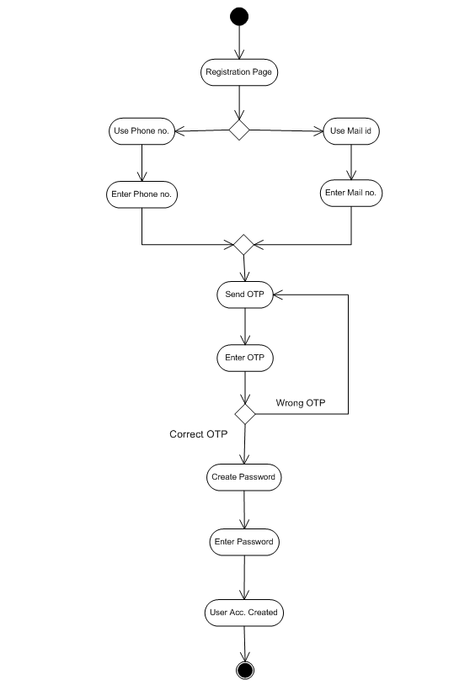

2) User Login –

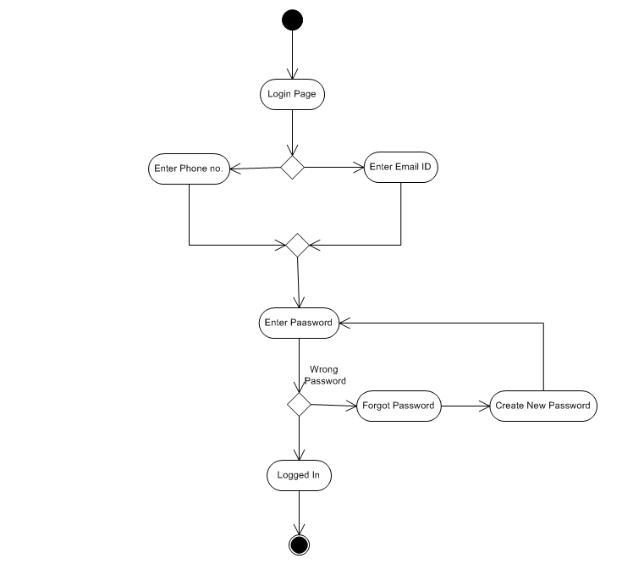

3) Placing an Order –

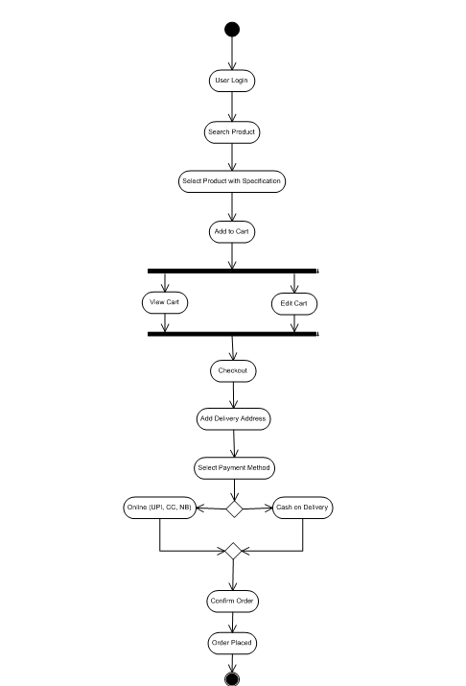

4) Cancel or Return order –

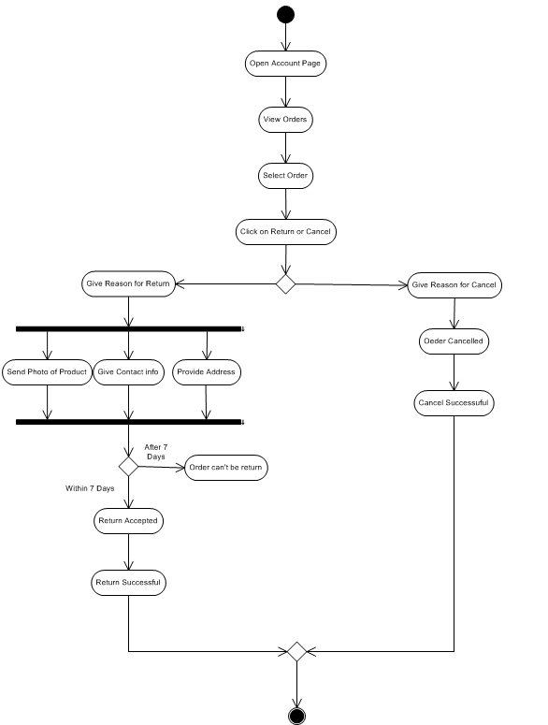

5) Seller Add and Update Products –

