Document 6- Please prepare a use case diagram, activity diagram and a use case specification document.

Answer:

Use Case Diagram:-





Activity Diagram:-

1. System Login:



2. Create Enquiry:



3. Create Quote:



4. Bid Management:



5. Sales order, procurement & payment:



6. Project Completion report:



Use Case Specifications:

|  |  |  |  |
| --- | --- | --- | --- |
| Use Case ID | UC001 | | |
| Use case name | User Login | | |
| Use Case description | Describe the process of user login in SAP ERP system. | | |
| Created by | Ms. Komal Chauhan | Last updated | NA |
| Date created | 06/03/2025 | Last revision date | NA |
| Primary Actor | Sales representative | | |
| Secondary Actor | SAP System | | |
| Basic Flow | 1. The User opens the SAP ERP login page  2. The User enters their username and password in the appropriate fields on the login screen.  3. System validate credentials.  4. If credentials are valid, user can access the system. | | |
| Alternate Flow | 1. If the User forgets their password, they can click on a "Forgot Password" link.  2. The system sends a password reset link to the User’s registered email.  3. The User resets their password and attempts to log in again. | | |
| Exceptional Flow | If the system encounters an error during the login process due to server issue, an error message is displayed to the User, and they are asked to try again later or contact support. | | |
| Pre-condition | 1. The User must have an active account registered in the system with valid credentials (username and password).  2. The User has the appropriate permissions or roles to access the system. | | |
| Post condition | User can access the system. | | |
| Assumptions | The User knows their username and password or is capable of resetting their password. | | |
| Constraints | The User is restricted to the access level specified for their role in the system. | | |
| Dependencies | Email services must be operational for password recovery functionality | | |
| Input | Username & Password | | |
| Output | User can access the system | | |
| Business Rules | Only registered users with valid credentials can access the system. | | |
| Miscellaneous Information | The User's login attempt should be logged for security and audit purposes. | | |

|  |  |  |  |
| --- | --- | --- | --- |
| Use Case ID | UC002 | | |
| Use case name | Create Enquiry | | |
| Use Case description | Customer submits enquiry to Sales representatives. Log enquiry in SAP system. | | |
| Created by | Ms. Komal Chauhan | Last updated | NA |
| Date created | 06/03/2025 | Last revision date | NA |
| Primary Actor | Customer | | |
| Secondary Actor | Sales Representative | | |
| Basic Flow | 1. Customer submit enquiry to sales representatives physically/mail/call.  2. Sales representative log enquiry in SAP System & create ENQUIRY ID.  3. Sales representative send enquiry acknowledgment with response timeline.  4. Enquiry is tracked within the SAP system, and the sales representative is notified of the next steps like prepare a quotation. | | |
| Alternate Flow | 1. If the sales representative cannot immediately acknowledge the inquiry, an automatic system-generated acknowledgment email is sent, confirming the receipt and providing a response timeline.  2. If the inquiry is incomplete, the sales representative will reach out to the customer for clarification before logging it into the system. | | |
| Exceptional Flow | If the sales representative face an issue logging the inquiry into the SAP system due to any technical failure, the inquiry details are temporarily stored manually until the issue is resolved. | | |
| Pre-condition | 1. Customer has final approval for procurement and mode to reach out Raamaya Technologies.  2. The SAP system is operational and accessible by the sales team.  3. The customer’s inquiry must include basic information like product specifications, timeline, and delivery address. | | |
| Post condition | 1. The inquiry has been logged into the SAP system and is tracked for future processing.  2. The customer is aware of the response timeline for further actions | | |
| Assumptions | 1. The SAP system is working correctly and can handle inquiry logging and tracking.  2. Sales representatives are properly trained to handle inquiries and use the SAP system for logging. | | |
| Constraints | The process assumes that the inquiry contains sufficient detail for logging. Incomplete inquiries may delay the process. | | |
| Dependencies | The entire process depends on the SAP system for logging, tracking, and managing the inquiry. | | |
| Input | 1. Enquiry submitted by customer with all the required details.  2. Sales representative send acknowledgment. | | |
| Output | 1. Logged inquiry in the SAP system with customer details and inquiry information.  2. Internal follow-up task created for the sales team to respond with a quotation or begin the bidding process. | | |
| Business Rules | 1. Enquiry logging  2. Send acknowledgement  3. Follow-up task is automatically created within the SAP system. | | |
| Miscellaneous Information | Stored enquiry details securely within the SAP system to maintain confidentiality as these are Government customers including Defence customers. | | |

|  |  |  |  |
| --- | --- | --- | --- |
| Use Case ID | UC003 | | |
| Use case name | Create Quotation | | |
| Use Case description | Finalised quotation against enquiry and send to customer over email. | | |
| Created by | Ms. Komal Chauhan | Last updated | NA |
| Date created | 06/03/2025 | Last revision date | NA |
| Primary Actor | Sales Representative | | |
| Secondary Actor | Customer, OEM | | |
| Basic Flow | 1. The sales representative reviews the details of the inquiry like product description, quantity, delivery timeline.  2. Based on enquiry details, sales representative send details to OEM for pricing & delivery timeline.  3.After receiving response from OEM, sales representative will co-ordinate with finance team for offer price to the customer.  4. After gathering all the details, sales representative generate SAP system generated quotation & send to the customer over email.  5. Sales representative take acknowledgement of receipt of quotation. | | |
| Alternate Flow | If the customer need special discounts, the sales representative works with the finance to update the quote before generating the final version. | | |
| Exceptional Flow | If the system is down, the sales representative may manually prepare the quotation document and send it to the customer, entering the data into SAP once the system is back online. | | |
| Pre-condition | 1. The sales representative has access to the SAP system and is authorized to create and send quotations.  2. The SAP system is configured with the necessary product information, pricing, and customer data. | | |
| Post condition | 1. The quotation status is updated in the SAP system to "Sent".  2. A follow-up task is created in the SAP system to track the customer's response to the quotation. | | |
| Assumptions | The customer’s inquiry contains clear product or service specifications.  1. The customer’s inquiry contains clear product specifications.  2. The SAP system is up and running during the quotation creation process.  3. The sales representative follows the defined process for pricing, discounts, and other business rules. | | |
| Constraints | 1. If the SAP system is unavailable or experiencing technical issues, the quotation may be delayed.  2. If the data in the SAP system is incorrect (e.g., outdated pricing or unavailable products), it may lead to inaccurate quotations. | | |
| Dependencies | The process is dependent on the availability and functionality of the SAP system for creating, storing, and managing quotations. | | |
| Input | Enquiry, Pricing, Product availability, Delivery & payment terms. | | |
| Output | 1. Finalised quotation sent to customer.  2. SAP system updated with the status of the quotation. | | |
| Business Rules | 1. A quotation must be created for every inquiry with sufficient detail.  2. A follow-up task should be created in the SAP system to track customer feedback on the quotation within a set period. | | |
| Miscellaneous Information | All customer data including sensitive pricing and project details must be handled in accordance with Raamaya Technologies' data security and privacy policies. | | |

|  |  |  |  |
| --- | --- | --- | --- |
| Use Case ID | UC004 | | |
| Use case name | Bid Management | | |
| Use Case description | After getting necessary government approval on quotation, customer release a bid for competitive selection process for awarding the contract. | | |
| Created by | Ms. Komal Chauhan | Last updated | NA |
| Date created | 06/03/2025 | Last revision date | NA |
| Primary Actor | Sales Representative | | |
| Secondary Actor | Customer, procurement team, finance team, legal team, OEM, vendor | | |
| Basic Flow | 1. After the quotation is sent, the government customer reviews it and may issue a formal bid.  2. Sales representative monitor GeM portal and download bid.  3. Sales representative check bid qualification, co-ordinate with OEM for pricing, document and vendor for service charge, prepare final document & submit the bid following submission of EMD fees.  4. Sales representative track the evaluation status on GeM portal.  5. After technical & financial qualification, government issue formal GeM contract on GeM portal.  6. Sales representative have to accept the order within 48 hours on GeM portal.  7. The bid management process ends once the contract is awarded or the bid is closed. | | |
| Alternate Flow | If the government customer does not issue a formal tender, the sales representative will continue to track the customer’s decision and make follow-up calls or emails to ensure the bid is still under consideration. | | |
| Exceptional Flow | If the government customer does not acknowledge the quotation within a specified period, the sales representative follows up with the customer to confirm the status of the bid. | | |
| Pre-condition | 1. The government customer has initiated the tender or bidding process.  2. Internal departments like sales, finance, procurement and legal are available and capable of reviewing the bid. | | |
| Post condition | 1. The bid is either won or lost, with all related activities tracked and updated in the SAP system.  2. The SAP system is updated with the status of the bid like awarded, rejected, and pending for evaluation. | | |
| Assumptions | 1. OEM & vendor will support for pricing and necessary documentation.  2. Internal teams like procurement, legal, finance will promptly respond to requests for adjustments or clarifications during the bid preparation.  3. The SAP system is consistently updated with the status of the bid and related milestones. | | |
| Constraints | 1. Tender submission deadlines are often strict, and there is limited time for bid preparation and submission.  2. Raamaya Technologies may face competition from other bidders, and adjustments to the bid may be required to remain competitive.  3. There may be a chance of bid scrapping.  4. There may be chances of disqualification in evaluation due to improper documentation. | | |
| Dependencies | 1. OEM &Vendor response. | | |
| Input | RFP, Bidder & OEM documents, Pricing, EMD submission. | | |
| Output | 1. A formal bid document.  2. Bid status updates in the SAP system.  3. Communication with the customer for bid evaluation status. | | |
| Business Rules | 1. The bid must be submitted by the official deadline, as specified in the RFP or tender invitation.  2. If the bid is not awarded, conduct evaluation meeting internally to assess why the bid was not successful and how to improve future submissions. | | |
| Miscellaneous Information | In cases where the customer requests adjustments, the sales team may need to revise the bid in the SAP system, ensuring that any changes are properly tracked. | | |

|  |  |  |  |
| --- | --- | --- | --- |
| Use Case ID | UC005 | | |
| Use case name | Create Sales Order | | |
| Use Case description | Create formal Sales order in SAP System. | | |
| Created by | Ms. Komal Chauhan | Last updated | NA |
| Date created | 06/03/2025 | Last revision date | NA |
| Primary Actor | Sales Representative | | |
| Secondary Actor | Customer, procurement team, finance team, OEM, vendor | | |
| Basic Flow | 1. After formal bid submitted, the government customer notifies the company of the awarded contract.  2. The sales representative accesses the SAP system and enter order details.  3. The system generates the sales order once all details have been entered and validated, creating a unique sales order number.  4. Place order to relevant distributor of respective OEMs.  5. The sales order is now ready to be processed, and the fulfilment process begins. | | |
| Alternate Flow | If the customer requires adjustments (e.g., changes in product quantity, discounts), the sales representative revises the order details in the SAP system and updates the pricing before proceeding. | | |
| Exceptional Flow | If there is an issue with the SAP system like technical error, the sales representative may manually create the sales order and input it into the system once the issue is resolved. | | |
| Pre-condition | 1. The tender has been evaluated by the customer.  2. The sales representative has access to the SAP system and the necessary permissions to create a sales order.  3. Internal approval procedures are defined. | | |
| Post condition | 1. The order status is updated to "Confirmed" or "Processing" in SAP.  2. Accept the order on GeM portal within 48 hours after contract awarded.  3. The sales team may initiate the next steps, such as fulfilling the order. | | |
| Assumptions | The internal approval processes are clearly defined, and necessary team members like finance, legal are available. | | |
| Constraints | 1. The process is dependent on the SAP system functioning properly. Any system downtime may delay the creation of the sales order.  2. If there is insufficient stock or procurement issues, the sales order cannot be processed until resolved.  3. OEM rate should be valid. | | |
| Dependencies | OEM, distributor & vendor. | | |
| Input | Accept order, Customer details, Product/service details like SKU, quantities, descriptions, Pricing and discount information, Payment terms and delivery location. | | |
| Output | 1. Sales Order Document.  2. Order status updated in the SAP system. | | |
| Business Rules | The payment terms and delivery schedule must comply with the agreed-upon terms specified in the accepted quotation or tender. | | |
| Miscellaneous Information | If products need to be ordered, the SAP system can trigger alerts to procurement to fulfill the sales order. | | |

|  |  |  |  |
| --- | --- | --- | --- |
| Use Case ID | UC006 | | |
| Use case name | Procurement Management | | |
| Use Case description | Places a procurement order with the respective distributor of the Original Equipment Manufacturer (OEM) to fulfil a government customer’s order. | | |
| Created by | Ms. Komal Chauhan | Last updated | NA |
| Date created | 06/03/2025 | Last revision date | NA |
| Primary Actor | Procurement Manager | | |
| Secondary Actor | Sales representative, OEM, distributor, finance team, logistics team. | | |
| Basic Flow | 1. A sales order is confirmed for a government customer, and the details of the products, quantities, and delivery schedule are finalized.  2. The procurement manager reviews the sales order, identifying the correct distributor, creating a purchase order.  3. Take internal approval of purchase order and place order to distributor.  4. Track shipping details & ensure timely delivery of the products to meet the government's needs.  5. The order is considered fulfilled once the products are delivered, and the SAP system is updated to reflect the completed order. | | |
| Alternate Flow | If the required products are not available from the primary distributor, the procurement team may contact secondary distributors or alternate suppliers to source the products. | | |
| Exceptional Flow | If the distributor does not confirm the order due to pricing changes, the procurement team must resolve the issue with the distributor before proceeding. | | |
| Pre-condition | 1. The procurement team has access to the SAP system and the necessary permissions to place a procurement order.  2. Raamaya Technologies should be a registered with the distributor and provides an agreed-upon catalog of products, pricing, and terms. | | |
| Post condition | 1. The SAP system is updated with the order details, including the distributor, shipping status, and delivery timeline.  3. The customer’s order status is updated to reflect the fulfillment progress. | | |
| Assumptions | The distributor has products available and can meet the order requirements within the expected timeline. | | |
| Constraints | Delays in shipping from the distributor or customs clearance may cause delays in fulfilling the customer order. LD will be applicable. | | |
| Dependencies | The process depends on the distributor’s ability to fulfill the order based on availability, pricing, and delivery schedules. | | |
| Input | Sales order, Internal approval. | | |
| Output | Purchase order document sent to the distributor. SAP system updates | | |
| Business Rules | Orders above a certain value or volume must be reviewed and approved by senior management or the finance team before placement. | | |
| Miscellaneous Information | Raamaya Technologies may have specific agreements with distributors that include volume discounts, preferred shipping terms, or guaranteed delivery times, which should be leveraged during the procurement process. | | |

|  |  |  |  |
| --- | --- | --- | --- |
| Use Case ID | UC007 | | |
| Use case name | Delivery & Installation | | |
| Use Case description | Logistic Manager coordinates the delivery and installation of products through a third-party vendor if required as per Scope Of Work mentioned in the GeM Contract. | | |
| Created by | Ms. Komal Chauhan | Last updated | NA |
| Date created | 06/03/2025 | Last revision date | NA |
| Primary Actor | Procurement team, Logistic Manager, Customer | | |
| Secondary Actor | Sales representative, Finance team. | | |
| Basic Flow | 1. Procurement Team ensures the timely delivery by tracking online status.  2. The delivery is recorded in the SAP system.  3. If installation required, the procurement manager identifies the third-party vendor responsible for installation, considering vendor capabilities, location, and past performance.  4. After installation is complete, the customer confirms successful delivery and installation. This confirmation is recorded in the SAP system.  5. The sales order is marked as complete in the SAP system. | | |
| Alternate Flow | If the customer is unavailable on the scheduled date, the logistics manager and third-party vendor will need to reschedule the installation based on the customer's availability. | | |
| Exceptional Flow | If there are issues with the shipment, such as damage or missing products, the logistics manager coordinates with the vendor to resolve the issue by sending replacement products or initiating a return process. | | |
| Pre-condition | 1. The procurement team has access to the SAP system and the necessary permissions to place a procurement order.  2. Raamaya Technologies should be a registered with the distributor and provides an agreed-upon catalog of products, pricing, and terms. | | |
| Post condition | 1. The sales order is confirmed and includes delivery and installation requirements.  2. A third-party vendor is selected, and the procurement manager has contact details and an agreement with the vendor. | | |
| Assumptions | 1. The third-party vendor has the necessary expertise and resources to deliver and install the products as specified.  2. There is a clear communication channel between Raamaya Technologies, the third-party vendor, and the government customer. | | |
| Constraints | If the products are delayed or unavailable, the delivery and installation may be postponed. | | |
| Dependencies | Delivery and installation are entirely dependent on the capabilities and availability of the distributor & third-party vendor. | | |
| Input | Sales order details, Third-party vendor availability and agreement details,  Delivery address, confirmation of delivery and installation schedule. | | |
| Output | 1. Delivery and installation status updates in the SAP system.  2. Invoice for delivery and installation services.  3. Project completion report. | | |
| Business Rules | The customer must acknowledge successful delivery and installation, sign-off on project completion report, which should be recorded in the SAP system. | | |
| Miscellaneous Information | Raamaya Technologies should have clear contractual agreements with distributor & third-party vendors, including service level agreements (SLAs), delivery timelines, installation standards, and penalties for non-compliance. | | |

|  |  |  |  |
| --- | --- | --- | --- |
| Use Case ID | UC008 | | |
| Use case name | Payment | | |
| Use Case description | Describe the process through which Raamaya Technologies receives payment from the government customer for products and services provided. | | |
| Created by | Ms. Komal Chauhan | Last updated | NA |
| Date created | 06/03/2025 | Last revision date | NA |
| Primary Actor | Finance team & customer | | |
| Secondary Actor | Sales representative | | |
| Basic Flow | 1. Once the delivery and installation (if required) are successfully completed, finance team generated an invoice on GeM portal and SAP System.  2. The customer processes the payment based on the terms outlined as per the GeM Contarct.  3. After payment is approved from authority, customer issued payment through an online mode as per account details updated on GeM portal.  4. Once the payment is made, the finance team confirms receipt of the payment and logged into SAP system.  5. After receiving the payment, the finance team sends a payment confirmation to the government customer.  6. The payment process is complete, and all related financial activities are recorded, with the order successfully closed. | | |
| Alternate Flow | If the customer encounters delays in processing the payment like internal approval delays, the finance team may follow up with the customer to remind them of the payment deadline. | | |
| Exceptional Flow | If the payment is not matching the expected amount like partial payment, the finance team will contact the customer to resolve any discrepancies. | | |
| Pre-condition | 1. The invoice has been generated by the finance team based on the sales order and delivery confirmation.  2. The customer has agreed to the payment terms and is expected to make the payment as per the invoice. | | |
| Post condition | 1. The SAP system is updated with the payment status and reflects the closure of the sales order.  2. The finance team has confirmed the receipt of payment and sent a payment confirmation to the customer. | | |
| Assumptions | The SAP system is fully integrated with the financial records, and payment status updates are automatically tracked. | | |
| Constraints | The payment terms like after 30 days or 60 days should be adhered to by the customer, with any exceptions or delays managed appropriately. | | |
| Dependencies | The system must track invoices and payments, and updates must be accurate to ensure proper financial tracking. | | |
| Input | Invoice, customer payment details and payment receipt confirmation. | | |
| Output | 1. Invoice sent to customer.  2. Payment confirmation sent to customer.  3. SAP system updated with payment status and closed sales order.  4. Final financial record and transaction history. | | |
| Business Rules | 1. If the payment is not received within the agreed terms, the finance team should follow the procedure for sending reminders and escalating the issue if necessary.  2. Invoice amount should be matched with GeM Contract amount. | | |
| Miscellaneous Information | Raamaya Technologies should clearly outline the accepted payment methods like online transfer or check in the sales order. | | |

|  |  |  |  |
| --- | --- | --- | --- |
| Use Case ID | UC010 | | |
| Use case name | Project Completion | | |
| Use Case description | It describe that the Raamaya Technologies has executed order successfully. It includes obtaining formal sign-off from the government client, and ensuring all required documentation is stored and archived in the SAP ERP system. | | |
| Created by | Ms. Komal Chauhan | Last updated | NA |
| Date created | 06/03/2025 | Last revision date | NA |
| Primary Actor | Sales Representative | | |
| Secondary Actor | Government customer | | |
| Basic Flow | 1. Sales manager ensures that all products/services have been delivered as per the agreement.  2. Sales Representative verifies that the Government Agency acknowledges the deliverables.  3. Sales manager ensures that all contract-related documentation like signed agreements, invoices, payments are filed and archived in the SAP system and marked completed.  4. Sales representative generate project completion report from SAP system and take sign of from sales manager and Government customer.  5. A post-project review is conducted to evaluate the overall success of the contract and identify any lessons learned. | | |
| Alternate Flow | If the Government customer disputes any deliverables or the final invoice, the Sales Manager and Sales Representative work together to resolve the issue. | | |
| Exceptional Flow | If there is a failure in payment, the Finance Team will engage with the Government customer to resolve payment issues, possibly involving escalation to management or legal authorities. | | |
| Pre-condition | 1. Government contract has been accepted on GeM portal.  2. All products or services outlined in the contract have been delivered successfully.  3. The SAP system is fully operational and able to track contract milestones, payments, and documentation.  4. No disputes or issues are pending in the contract’s completion. | | |
| Post condition | 1. The government contract is marked as "Completed" in the SAP ERP system.  2. All payments are processed and confirmed.  3. The contract documentation is stored for future reference.  4. The contract is closed out, and formal sign-off is received from the Government customer. | | |
| Assumptions | 1. Customer is responsive and fulfils its obligations regarding the acceptance of deliverables and payment terms.  2. The SAP system is configured to accurately track contract milestones, payments, and associated documentation. | | |
| Constraints | 1. Any delays in payment may extend the timeline for contract closure.  2. Unforeseen disputes regarding deliverables may require additional time and resources to resolve. | | |
| Dependencies | 1. Timely payment from the customer is necessary for the contract to be officially closed.  2. Integration with SAP for tracking and documentation is critical for managing contract completion and reporting. | | |
| Input | 1. Signed contract agreements and documents.  2. Product/service delivery reports.  3. Final invoices and payment details. | | |
| Output | 1. Signed Project completion report.  2. Payment receipt and confirmation.  3. Post-project review report.  4. Final report on contract performance. | | |
| Business Rules | Any changes or disputes must be resolved before marking the contract as "Completed." | | |
| Miscellaneous Information | Contract documentation must be stored and archived for future reference, especially for audit and compliance purposes. | | |

Document 7- Screens and pages:-

Answer:

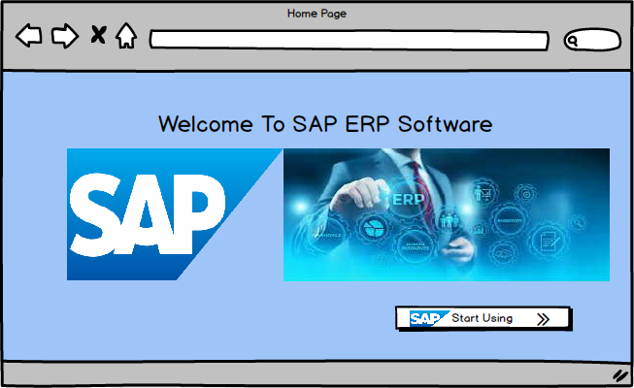

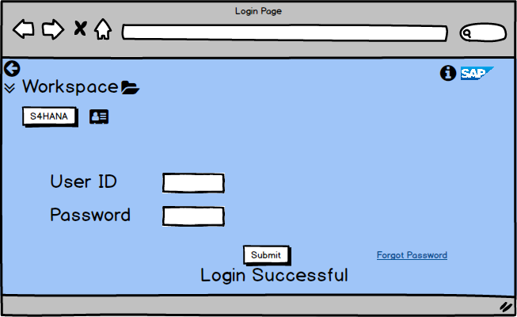

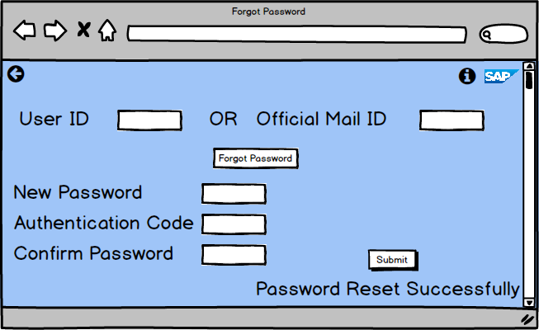

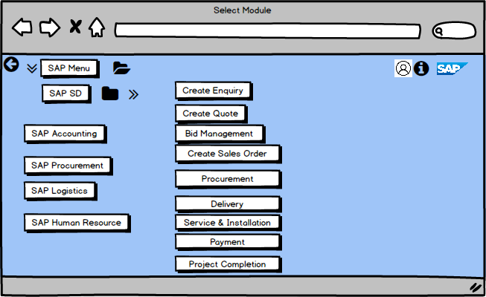

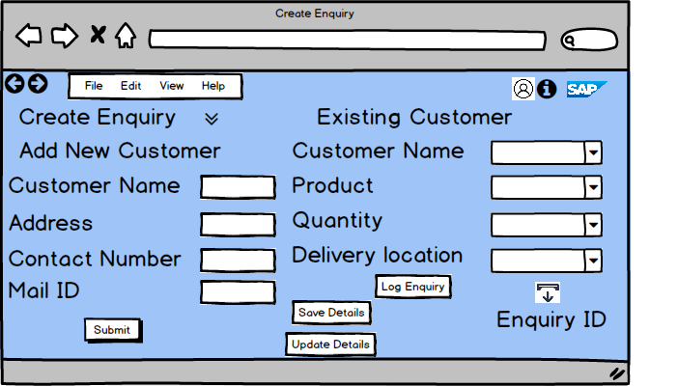

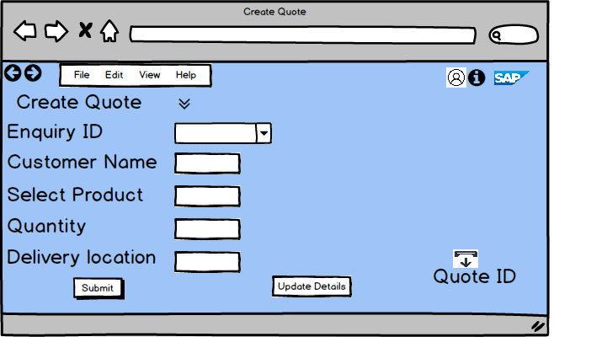

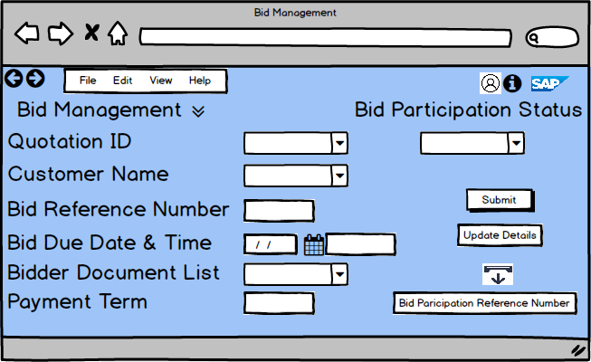

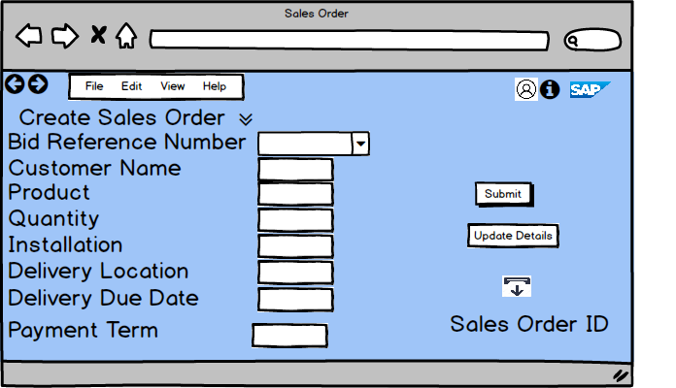

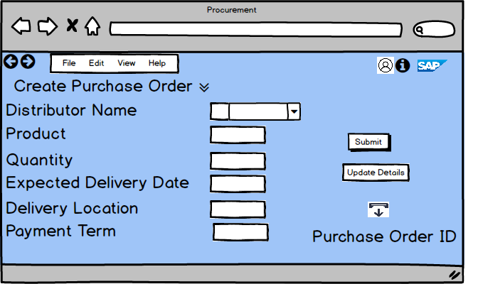

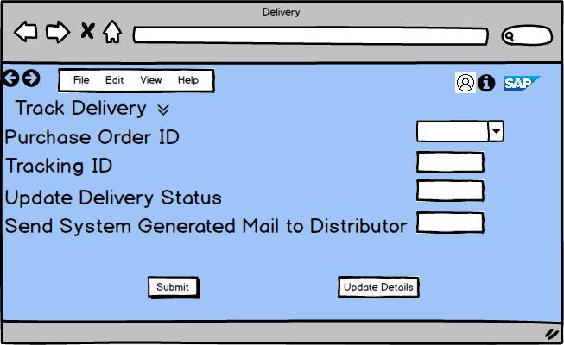

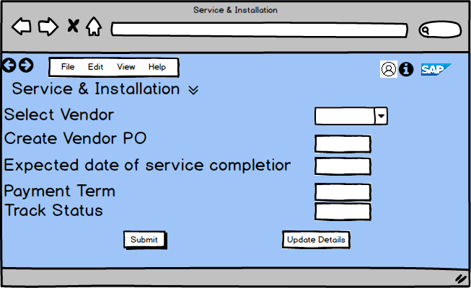

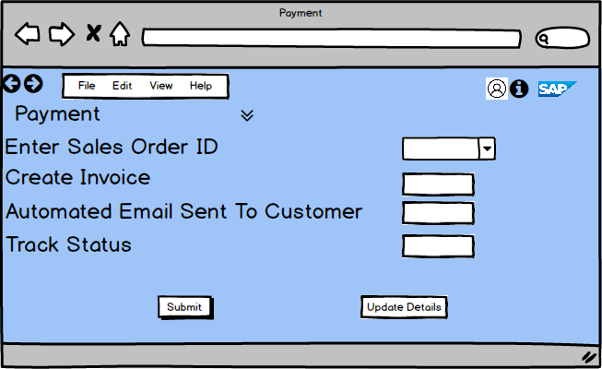

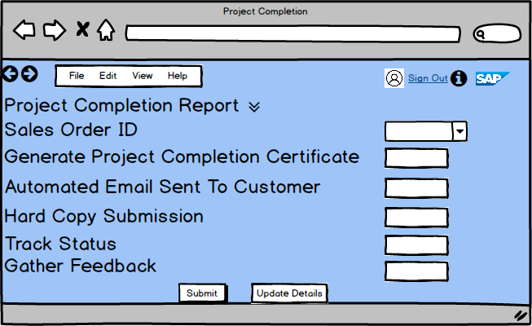

Document 8- Tools-Visio and Axure

Write a paragraph on your experience using Visio and Axure for the project.

Answer:

VISIO:

Using MS Visio for this project was a great experience as it allowed me to create clear and organized diagrams to represent complex processes. I used it to design flowcharts, use case diagrams, and activity diagrams, which helped visualize how different parts of the business workflow, like sales orders, procurement, and payments, connect and function.

Visio is user-friendly interface and its extensive library of shapes made it easy to represent various processes and relationships accurately. The ability to quickly adjust and refine the diagrams based on feedback made it a very efficient tool for communicating ideas and ensuring that all stakeholders had a clear understanding of the system’s flow. Overall, Visio was essential in mapping out the project’s processes in a way that was easy to follow and understand.

Axure:

Axure is a comprehensive design and prototyping tool used by UX/UI designers, product teams, and developers to create interactive wireframes, prototypes, and specifications for websites and applications. It is especially known for its ability to create highly functional prototypes that simulate complex interactions, workflows, and user interfaces.

Document 9- BA experience:-

Answer:

My experience as BA in following phases:

1. Requirement Gathering:

* After assigning role as a business analyst, firstly I understood the existing business process to identify pain points, inefficiencies, areas of improvement and expectation from SAP ERP.
* Identified stakeholder like management team, sales team, finance team, procurement team, finance team and scheduled meeting with each key stakeholder to understand their role and requirements.
* Conduct various elicitation techniques like brainstorming, observation, interview, document analysis, workshop, questioner to gather requirements. Documented current manual business process including enquiry, bidding, sales, delivery & payment.
* Identified reasons to slower down the business process.
* Defined business goal, objective & scope to implementing SAP ERP software such as improving accuracy, reducing manual effort, scalability in business growth.
* Captured business requirement from stakeholder.
* Prepared AS IS and TO be document.
* Identified vendor for SAP ERP Software.
* Finalised document like business case document, business process model, SWOT analysis, business requirement document.
* Stakeholder list, RACI Matrix, business requirement document.
* Taken sign off & approval from respective stakeholder.

1. Requirement Analysis:

* After gathering business requirement, requirement analysis phase started.
* There are few requirements, which are repeated, removed same requirement.
* After consulted with relevant stakeholder, prioritised requirement using MOSCOW technique.
* Validated business requirement using FURP technique.
* Cross-checked business requirement & classified into functional & non - functional requirement. Prepared requirement traceability matrix.
* Identify gaps between the current manual system and SAP ERP, assessing whether SAP can meet business requirement. Prepare GAP Analysis.
* Prepare feasibility study repot of Raamaya Technologies whether the organization have feasibility in terms of budget, hardware, software, security, SME, human resources.
* Prepared Software requirement specification.

1. Design:

* After analysing requirement, I started work for system design of SAP software. Worked with SAP consultants to design the system, including which SAP modules to implement like SAP Sales & Distribution, SAP accounting, SAP procurement.
* Created Mockups using Balsamiq tool for desired SAP ERP software.
* Scheduled JAD session for technical matter.
* Defined data flows diagram and structures to ensure smooth data transfer between different modules like tender documents, customer orders, and inventory data.
* Identify where customization is required.
* Identify security measures, to protect sensitive government data.
* Prepare use case diagram to visualise the how the actor will interact with SAP system. Define Use case specifications. Shared document with relevant stakeholder.
* Prepare activity diagram to show how the system will work and share with relevant key stakeholder.

1. Development: (Software customization)

* After completing system design, installed software & customization phase has been started.
* Customised and configure SAP modules based on business process requirement.
* Data migrated from legacy system into SAP software.
* Ensured customization & configurations done as expected as per stakeholder’s requirement.

1. Testing:

* After configuration & customization, testing phase has been started.
* Prepared test cased for each use case.
* Performed high level testing of system.
* Planned UAT and updated the system as per feedback of end user.
* Update Requirement Traceability Matrix.
* Signed off Client Project Acceptance form.
* Ensured that security measures are functioning correctly, especially for government data compliance.

1. Deployment:

* After signing on Client Project Acceptance form, created a deployment plan, deployed SAP ERP system into production environment, and ensured a smooth transition for users.
* Conducted training for end users, especially sales and operations teams, to ensure they are comfortable with the new system.
* Provided immediate support after go-live to address any issues or concerns raised by end-users.
* Project closure document.
* Monitor the system’s performance and usage, ensuring everything runs smoothly and resolving any post-deployment issues.
* Gather feedback from users to identify areas for continuous improvement in the system or its usage.