**CAPSTONE PROJECT 1- ONLINE AGRICULTURAL PRODUCTS STORE**

Mr. Henry, after being successful as a businessman and has become one of the wealthiest persons in the city. Now, Mr. Henry wants to help others to fulfil their dreams. One day, Mr. Henry went to meet his childhood friends Peter, Kevin and Ben. They live in a remote village and do farming. Mr. Henry asked his friends if they are facing any difficulties in their day-to-day work.

Peter told Mr. Henry that he is facing difficulties in procuring fertilizers which are very important for farm. Kevin said that he is also facing the same problem in-case of buying seeds for farming certain crops. Ben raised his concern on lack of pesticides which could help in greatly reducing pests in crops.

After listening to all his friends’ problems, Mr. Henry thought that this is a crucial problem faced not only by his friends but also by so many other farmers. So, Mr. Henry decided to make an online agriculture product store to facilitate remote area farmers to buy agriculture products. Through this Online Web / mobile Application, Farmers and Companies (Fertilizers, seeds and pesticides manufacturing Companies) can communicate directly with each other.

The main purpose to build this online store is to facilitate farmers to buy seeds, pesticides, and fertilizers from anywhere through internet connectivity. Since new users are involved, Application should be user friendly.

This new application should be able to accept the product (fertilizers, seeds, pesticides) details from the manufacturers and should be able to display them to the Farmers. Farmers will browse through these products and select the products what they need and request to buy them and deliver them to farmers location.

Mr. Henry has given this project through his Company SOONY. In SOONY Company, Mr Pandu is Financial Head and Mr Dooku is Project Coordinator. Mr. Henry, Mr Pandu, and Mr Dooku formed one Committee and gave this project to APT IT SOLUTIONS company for Budget 2 Crores INR and 18 months Duration under CSR initiative. Peter, Kevin and Ben are helping the Committee and can be considered as Stakeholders share requirements for the Project.

Mr Karthik is the Delivery Head in APT IT SOLUTIONS company and he reached out to Mr Henry through his connects and bagged this project. APT IT SOLUTIONS company have Talent pool available for this Project. Mr Vandanam is project Manager, Ms. Juhi is Senior Java Developer, Mr. Teyson, Ms Lucie, Mr Tucker, Mr Bravo are Java Developers. Network Admin is Mr Mike and DB Admin is John. Mr Jason and Ms Alekya are the Tester. And you joined this team as a BA.

Fertilizers, seeds, pesticides details from the manufacturers and should be able to display them to the Farmers.

To gather the business requirements from the client, you went to SOONY and met Mr. Henry. When Mr. Henry was asked about the project and what are they expecting from the project, Mr. Henry stated that he is expecting to have a login for all its users (fertilizers, seeds, pesticides manufacturers and Farmers), a product catalog of fertilizers, seeds, pesticides, a search option to search for products, payment process, and delivery tracking.

After doing the stakeholder analysis, you have found out that Peter, Kevin, Ben are the key stakeholders and you have scheduled an appointment to meet them. After meeting with them and trying to gather the stakeholder requirements, Kevin said that, a Farmer should be able to browse through the products catalog once they visit the website and need to have a search option so that they can search for any product they need. Peter said that, if a farmer wants to buy any product or add them to buy-later list, they need to login first using their email id and password. If it is a new user, then they can create a new account by submitting their email ID and creating a secure password. Ben added saying that, Farmers needs to have an easy-to-use payment gateway which should include cash-on-delivery (COD), Credit/Debit card and UPI options so that the user’s experience should be better. Kevin mentioned that, a user gets an email confirmation regarding their order status. A delivery tracker to track the whereabouts of their order.

Identify Business Requirements (which includes Stakeholder Requirements)

BR001 – Farmers should be able to search for available products in fertilizers, seeds, pesticides

BR002 – Manufacturers should be able to upload and display their products in the application

Make suitable Assumptions and identify at least 10 Business Requirements. List your assumptions Give Priority 1 to 10 numbers (1 being low priority – 10 being high priority) to these Requirements after discussions with the stakeholders

|  |  |  |  |
| --- | --- | --- | --- |
| **Req ID** | **Req Name** | **Req Description** | **Priority** |
| BR001 | Farmer Search for Products | Farmers should be able to search for available products in fertilizers, seeds, pesticides | 8 |
| BR002 | Manufacturers upload their Products | Manufacturers should be able to upload and display their products in the application | 8 |
|  |  |  |  |

Once the requirements are finalized, as a business analyst, one of the major roles is to act as a liaison between the client and the project team. To gather the requirements correctly from the client side and then to deliver those requirements to the project team in a way they understand.

To make the project team understand the requirements, you need to convert those requirements into UML diagrams and screen mock-ups. You will draw use case diagram Prepare use case specs for all use cases and you will all Activity diagrams required

**Question 1:** Functional Requirements- Identify minimum 20 functional requirements **15 marks**

**Answer: Functional requirements** **(FRs)** describe what a system, application, or process must do to fulfil its purpose. These requirements define specific behaviours, tasks, or functions the system must support to meet the needs of its users. They focus on **what the system does** and include features, workflows, or services.

|  |  |  |
| --- | --- | --- |
| Req ID | Req Name | Req Description |
| FR001 | Farmer Registration | Farmers must register by providing email IDs and creating secure passwords. |
| FR002 | |  | | --- | |  |  |  | | --- | | Farmer Login | | Farmers must log in using their email IDs and passwords. |
| FR003 | Manufacturer Registration | Manufacturers must register and log in to manage their products. |
| FR004 | Product Upload | Manufacturers can upload product details like name, description, price, and quantity. |
| FR005 | Product Catalog Browsing | Farmers can browse a categorized catalog of fertilizers, seeds, and pesticides. |
| FR006 | Product Search | Farmers can search for products using keywords. |
| FR007 | Wishlist Feature | Farmers can add products to a "buy later" list. |
| FR008 | Product Purchase | Farmers can select products and place orders. |
| FR009 | |  | | --- | |  |  |  | | --- | | Payment Gateway | | Provides payment options like COD, credit/debit cards, and UPI. |
| FR010 | Registration Email Confirmation | Farmers receive email confirmation upon successful registration. |
| FR011 | Order Email Confirmation | Farmers receive order details via email after placing an order. |
| FR012 | Delivery Tracking | Farmers can track orders with a delivery tracking feature. |
| FR013 | Product Inventory Management | Manufacturers can view and update their product inventory. |
| FR014 | Stock Availability Check | Products marked as "out of stock" are unavailable for purchase. |
| FR015 | Order History | Farmers can view their order history. |
| FR016 | Product Feedback | Farmers can provide feedback or ratings for purchased products. |
| FR017 | Manufacturer Notifications | Manufacturers get notifications for product orders. |
| FR018 | Product Filters | Farmers can filter products based on price, type, or brand. |
| FR019 | Shipping Details | Manufacturers specify shipping details and delivery timelines. |
| FR020 | Order Cancellation | Farmers can cancel orders within a defined timeframe. |

**Non-Functional Requirements (NFRs)** are the criteria that specify how a system should operate rather than what the system should do. Unlike functional requirements, which define specific behaviours or functions, NFRs focus on the quality, performance, usability, and constraints of the system. They help ensure the system is efficient, reliable, secure, and user-friendly.

|  |  |  |
| --- | --- | --- |
| Req ID | Req Name | Req Description |
| NFR001 | Responsive Design | Accessible via both desktop and mobile devices. |
| NFR002 | System Uptime | Must have an uptime of at least 99.9%. |
| NFR003 | Secure Login | Ensures secure login using SSL encryption. |
| NFR004 | Page Load Time | Page load time should not exceed 2 seconds. |
| NFR005 | Scalability | Should handle at least 10,000 simultaneous users. |
| NFR006 | Data Backup | Data must be backed up daily. |
| NFR007 | Data Privacy Compliance | Comply with regulations like GDPR or local equivalents. |
| NFR008 | Payment Security | Payment processing must be compliant and secure. |
| NFR009 | User-Friendly Interface | Intuitive navigation for both farmers and manufacturers. |
| NFR010 | Multi-Language Support | Supports multiple languages for diverse regional users. |

**Question 2:** Minimum 5 page designs - Make wireframe and prototypes **15 marks**

**Answer:**

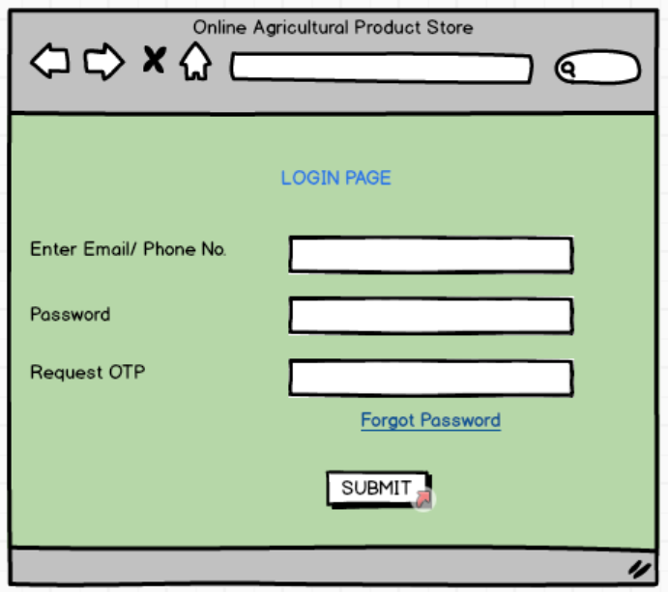

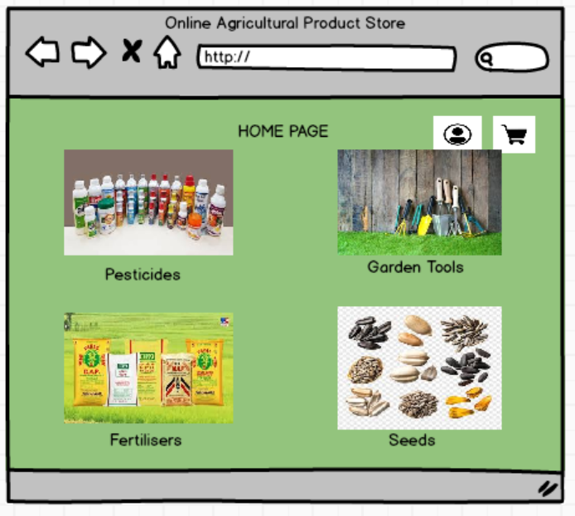

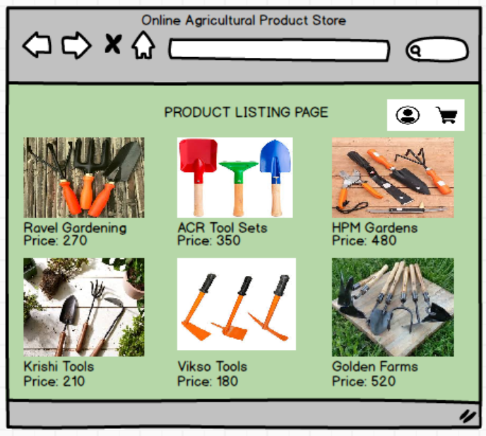

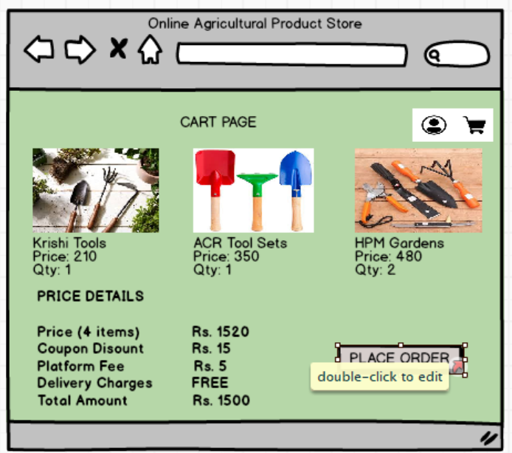

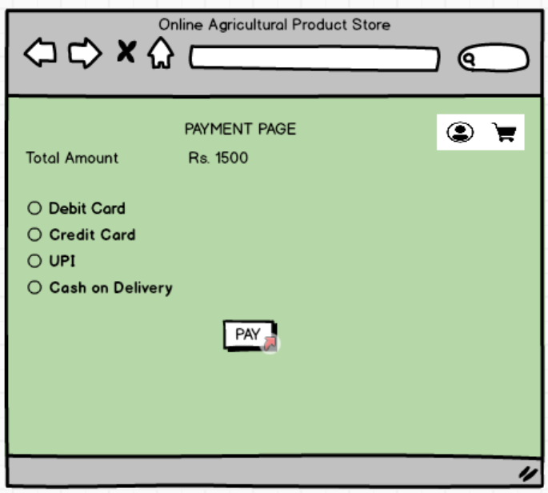

**Question 3:** Tools (Visio, Balsamiq)- Make a note of the Tools, which you are using for above concepts. **15 marks**

**Answer:** The tools mainly used to create the above concepts are MS Visio, Balsamiq and Axure RP.

* **Microsoft Visio**:
* Overview:
* **Microsoft Visio** is a powerful diagramming tool widely used to create flowcharts, organizational charts, network diagrams, and **Unified Modelling Language (UML)** diagrams.
* It offers pre-built templates and shapes for various types of diagrams, which make it versatile for different business and technical needs.
* Features:
* **UML Support**: Provides tools to create UML diagrams such as **Use Case Diagrams**, **Activity Diagrams**, **Sequence Diagrams**, and more.
* **Collaboration**: Allows multiple users to work on diagrams simultaneously if connected via cloud platforms like Microsoft 365.
* **Custom Shapes and Templates**: Includes built-in shapes, or users can customize and add new ones.
* **Integration**: Integrates seamlessly with other Microsoft tools (e.g., Word, Excel, PowerPoint).
* **Export Options**: Diagrams can be exported in formats like PDF, SVG, and PNG for easy sharing.
* Use in the Project:
* Create **Use Case Diagrams** to visually represent interactions between users (farmers, manufacturers, admin) and the system.
* Design **Activity Diagrams** to map out workflows like product search, order placement, and payment processes.
* **Balsamiq**:
* Overview:
* **Balsamiq** is a rapid wireframing tool designed to create low-fidelity mock-ups. Its sketch-like design ensures that the focus stays on functionality rather than visual design during the early stages of development.
* Features:
* **Drag-and-Drop Interface**: Offers a user-friendly interface with pre-built UI components like buttons, text fields, dropdowns, and menus.
* **Collaboration**: Mock-ups can be shared with stakeholders for feedback.
* **Low-Fidelity Style**: Keeps designs simple to encourage feedback on functionality rather than aesthetics.
* **Reusable Symbols**: Create reusable components for consistent designs.
* **Cloud and Desktop Options**: Available both as a web application and a desktop tool.
* Use in the Project:
* Design mock-ups of the **login screens**, **product catalog**, **search interface**, **cart**, **payment page**, and **delivery tracker**.
* Share these mock-ups with stakeholders (like Peter, Kevin, and Ben) for early feedback on usability and flow.
* **Axure RP**:
* Overview:
* **Axure RP** is a high-fidelity prototyping tool that allows you to create interactive prototypes for websites and mobile applications. It's more advanced compared to Balsamiq and includes interaction and dynamic features.
* Features:
* **Dynamic Content and Interactions**: Add clickable elements, animations, and dynamic panels to simulate real user interactions.
* **Mobile-Friendly Prototypes**: Create responsive prototypes for web and mobile applications.
* **Detailed Documentation**: Automatically generates functional specifications based on the prototype.
* **Team Collaboration**: Multiple users can work on a prototype, and changes are synced in real-time.
* **Integration**: Prototypes can be shared via links, and feedback can be collected directly on the design.
* Use in the Project:
* Build high-fidelity prototypes to show how the system will work from end to end, including **login, product browsing, cart management, payment, and order tracking**.
* Add **interactions**, such as clicking on a product to view details, adding to the cart, and navigating between pages.
* Generate detailed specifications that can be shared with developers.

|  |  |  |
| --- | --- | --- |
| Tool | Purpose | Example for the Project |
| MS Visio | Create UML diagrams to visualize workflows and system interactions. | Use Case Diagram for farmer-product interaction or Activity Diagram for payment. |
| Balsamiq | Design low-fidelity wireframes to gather early feedback on UI designs. | Mock-ups of login page, product catalog, and payment gateway. |
| Axure RP | Develop interactive prototypes to simulate real user interactions. | High-fidelity prototype of the order tracking and product search process. |

**Question 4:** RTM- A business analyst’s key responsibilities are to keep track of the requirements and make sure that no requirement is missed. Mr. Henry and Mr. Peter have approached you regarding the current status of the project. How will you tackle this situation? Prepare RTM. **6 marks**

**Answer:** The RTM is a table that links business requirements to their respective design, development, testing, and delivery stages. It ensures traceability from requirements to implementation and helps track project progress effectively.

**Steps to Create the RTM:**

* **Gather Requirements:** Include all business and stakeholder requirements identified during the analysis phase.
* **Assign Unique IDs:** Assign unique IDs (e.g., BR001, BR002) to each requirement for easy reference.
* **Define Requirement Priority:** Assign a priority level (1-10) to each requirement based on discussions with stakeholders.
* **Trace Development Lifecycle:** Map each requirement to design, development, and testing activities to ensure full traceability.
* **Track Status:** Include a status column to reflect the current progress of each requirement (e.g., "In Progress," "Completed," "Pending").
* **Stakeholder Responsibility:** Identify which stakeholders or team members are responsible for addressing each requirement.

|  |  |  |  |  |  |  |  |  |
| --- | --- | --- | --- | --- | --- | --- | --- | --- |
| **Req ID** | **Req Name** | **Requirement Description** | **Priority** | **Design Document** | **Development Status** | **Test Cases** | **Stakeholders** | **Status** |
| BR001 | Farmer Search for Products | Farmers should be able to search for available products in fertilizers, seeds, and pesticides. | 8 | Search_Module.docx | In Progress | TC001, TC002 | Peter, Kevin | In Progress |
| BR002 | Manufacturer Product Upload | Manufacturers should be able to upload and display their products on the platform. | 8 | Upload_Module.docx | Pending | TC003, TC004 | Manufacturers | Pending |
| BR003 | User Registration and Login | Farmers and manufacturers should be able to register/login using their email ID and secure password. | 9 | Auth_Module.docx | Completed | TC005, TC006 | Peter, Kevin, Ben | Completed |
| BR004 | Product Catalog Browsing | Farmers should be able to browse products without performing a search. | 7 | Catalog_Module.docx | In Progress | TC007 | Kevin, Ben | In Progress |
| BR005 | Secure Payment Gateway | Provide a secure payment gateway with options for COD, Credit/Debit card, and UPI. | 10 | Payment_Module.docx | Pending | TC008, TC009 | Ben, Manufacturers | Pending |
| BR006 | Order Confirmation via Email | Farmers should receive email confirmation about their order status. | 8 | Email_Module.docx | Pending | TC010 | Peter, Kevin | Pending |
| BR007 | Delivery Tracking | Farmers should be able to track their order status. | 8 | Tracking_Module.docx | Pending | TC011 | Ben, Peter | Pending |
| BR008 | User-Friendly UI/UX | The application should be simple and easy to use for farmers and manufacturers, even in remote areas. | 10 | UIUX_Document.docx | Pending | NA | All Stakeholders | Pending |
| BR009 | Multilingual Support | The application should support multiple languages to cater to farmers from different regions. | 6 | Localization.docx | Pending | TC012 | Farmers, Peter, Kevin, Ben | Pending |
| BR010 | Reporting Module for Manufacturers | Manufacturers should be able to view detailed reports about their product sales and farmer engagement. | 5 | Reporting_Module.docx | Pending | TC013 | Manufacturers | Pending |

This RTM helps to ensure no requirements are overlooked and provides a structured approach for regular status updates to stakeholders.

**Question 5:** 10 Test Case Documents- Prepare 10 Test Case Documents **10 marks**

**Answer:** Here are 10 test cases for the online agriculture product store:

|  |  |  |  |  |  |
| --- | --- | --- | --- | --- | --- |
| Test Case ID | Test Case Name | Description | Preconditions | Test Steps | Expected Result |
| TC001 | User Registration | Verify user can register successfully | User is not registered | |  | | --- | |  |  |  | | --- | | 1. Navigate to the registration page. 2. Enter email & password. 3. Click "Register". 4. Verify confirmation email. 5. Click the email link. | | User account is created and verified. |
| TC002 | User Login | Verify registered user can log in | User is registered and verified | 1. Navigate to the login page. 2. Enter valid credentials. 3. Click "Login". | User is redirected to the dashboard. |
| TC003 | Search for a Product | Verify farmers can search products | Products exist in the database | 1. Navigate to search bar. 2. Enter product name. 3. Click "Search". | Relevant products are displayed. |
| TC004 | Product Listing by Manufacturers | Verify manufacturers can upload products | Manufacturer is logged in | 1. Click "Add New Product". 2. Fill in details. 3. Upload image. 4. Click "Submit". | Product is listed on the website. |
| TC005 | Adding Product to Cart | Verify farmers can add products to cart | User is logged in, products exist | 1. Browse/search for a product. 2. Click "Add to Cart". 3. Check cart page. | Product is added to cart. |
| TC006 | Placing an Order | Verify user can place an order | User has products in cart | |  | | --- | |  |  |  | | --- | | 1. Go to cart. 2. Click "Checkout". 3. Enter details. 4. Choose payment method. 5. Click "Place Order". | | Order is successfully placed. |
| TC007 | Payment Processing | Verify successful payment processing | User has placed an order | 1. Select payment method. 2. Enter payment details. 3. Confirm payment. | Payment is processed, confirmation shown. |
| TC008 | Order Tracking | Verify farmers can track their order | Order is placed | 1. Go to "My Orders". 2. Select an order. 3. Check tracking details. | Order tracking details are visible. |
| TC009 | Email Notification for Order Status | Verify email notifications for order status | Order is placed | 1. Place an order. 2. Check email inbox. | Order confirmation email is received. |
| TC010 | Logout Functionality | Verify user can log out successfully | User is logged in | 1. Click "Logout". 2. Try accessing restricted page. | User is logged out and redirected to login. |

**Question 6:** DB Design - After the requirements are thoroughly explained to the entire project team by business analyst, the Database architects have decided to do the database design and also to represent the in-flow and out-flow of data. Draw database schema and ER diagram.  **8 marks**

**Answer:** A Database Schema defines the structure of a database, including tables, columns, data types, constraints, relationships, and indexes. It serves as a blueprint for how data is organized and stored in a database.

An Entity-Relationship (ER) Diagram visually represents the database schema, showing entities (tables), attributes (fields), and relationships among them. ER diagrams use symbols such as rectangles (entities), ovals (attributes), and diamonds (relationships) to illustrate how data is structured.

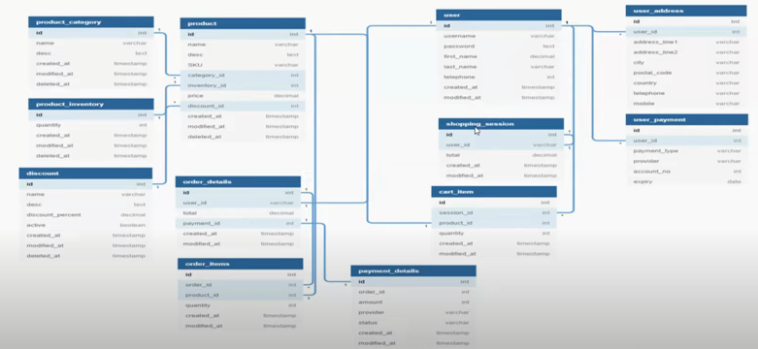

**Question 7:** Data Flow Diagram - What is a data flow diagram? Draw a data flow diagram to represent the in-flow and out-flow of data when a Farmer is placing an order for the product **3 marks**

**Answer:**

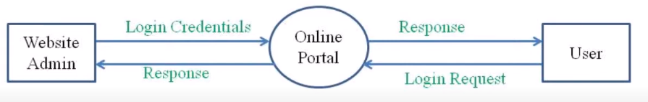

0th level DFD

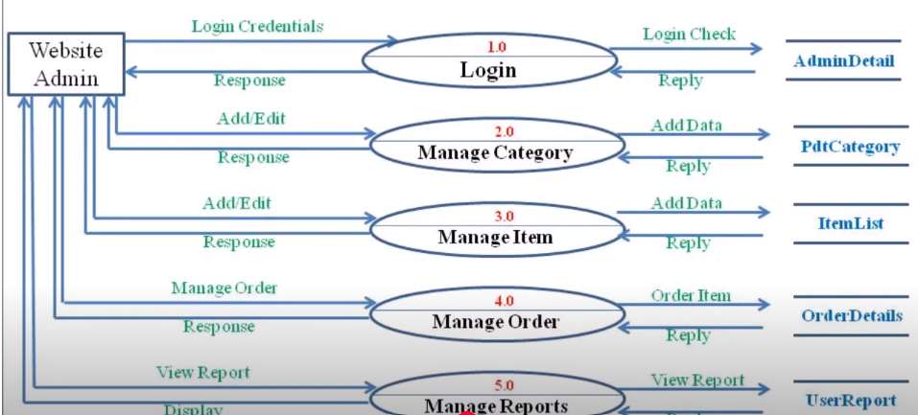

1st level DFD

**Question 8:** Change Request- Due to change in the Government Taxation structure. we should change the Tax structure How do you handle change requests in a project? **10 marks**

**Answer:** Handling change requests in a project requires a structured approach to ensure that the requested changes align with project objectives, budget, and timeline. Here’s how I would handle the change request related to the Government Taxation structure:

* **Document the Change Request (CR):**
* Identify the source of the change (Government regulations).
* Record the change request details, including why the change is needed and its impact on taxation.
* **Conduct Impact Analysis:**
* Assess how the change will impact various aspects of the project, such as:
* **Business Logic**: Changes in tax calculations for product purchases.
* **Database**: Modifications required in tax-related tables.
* **UI/UX**: Any changes required in displaying tax details to users.
* **Backend Logic**: Modifications to API services handling taxation.
* **Testing Efforts**: Regression testing to ensure no issues arise.
* **Discuss with Stakeholders:**
* Arrange a meeting with Mr. Henry, Mr. Pandu, Mr. Doku, and the APT IT Solution team.
* Explain the impact, including time, cost, and resource requirements.
* Get approval from the stakeholders on how to proceed.
* **Update Project Documentation:**
* Modify the Business Requirement Document (BRD) and Functional Requirement Document (FRD).
* Update the UML diagrams (Use Case, Activity Diagrams).
* Inform the development and testing teams about the changes.
* **Implement the Change:**
* Assign the changes to the development team (Ms. Juhi, Java developers).
* Update tax logic and integrate it into the system.
* Perform unit testing, integration testing, and regression testing.
* **User Acceptance Testing (UAT):**
* Validate the updated taxation logic with test cases.
* Share the updated version with key stakeholders for approval.
* **Deploy the Change:**
* Schedule the release with minimal disruption.
* Monitor the impact post-deployment.
* **Communicate the Change:**
* Update farmers and manufacturers regarding the new taxation policy via email/notifications.
* Provide user support in case of queries.

**Question 9:** Change Request Vs an Enhancement - As the project is in process, Ben and Kevin have contacted you. The reason is to inform you that they want the Farmers to sell their crop yields through this application i.e. Farmers should be able to add their crop yields or products and display to general public and should be able to sell them. They also want to introduce Auction system for their Crop yields. As a BA, what will be your response?

Is this a change request or an enhancement??? **5 marks**

**Answer:** A change request typically involves modifying an existing feature or functionality due to changes in business needs, legal requirements, or technical constraints. However, in this case, the request introduces **new features** (crop selling and auction system) that expand the application's scope beyond its initial purpose. This falls under **enhancement**, as it adds significant new functionality beyond the original requirements.

**BA Response & Next Steps:**

* **Requirement Analysis:**
* Schedule a meeting with stakeholders (Ben, Kevin, Peter, and Mr. Henry) to understand the detailed expectations of the **Farmer Crop Selling and Auction System** feature.
* Identify how farmers will list and manage their products, how buyers will interact, and what auction mechanisms are expected.
* Determine if any legal or regulatory considerations are involved.
* **Impact Assessment:**
* Evaluate how this enhancement affects the existing application architecture, UI/UX, database, and payment systems.
* Discuss with the Project Manager (Mr. Vandanam) and Technical Team (Developers, DB Admin, and Testers) to assess feasibility, effort estimation, and additional resource requirements.
* Check if the project timeline (18 months) and budget (₹2 Crores) need adjustments.
* Approval Process:
* Present the impact analysis to the **Committee (Mr. Henry, Mr. Pandu, Mr. Doku)** and seek their approval for this enhancement.
* If approved, update the **Business Requirement Document (BRD)** and inform **APT IT Solutions** of the additional scope.
* Prioritization & Integration:
* Work with the team to prioritize this enhancement within the existing development roadmap.
* Ensure that this new feature does not delay or negatively impact the core functionalities of the project.
* Documentation & UML Updates:
* Update **Use Case Diagrams, Activity Diagrams, and Screen Mockups** to reflect the new functionality.
* Provide updated specifications for developers and testers to ensure seamless implementation.

This approach ensures that the enhancement request is handled systematically while keeping project goals and constraints in check.

**Question 10:** Estimations- Come up with estimations – How many Manhours required **6 marks**

**Answer:** Here’s a breakdown of the estimations required for the project:

Project Estimation (Manhours Calculation):The total estimated effort required for the project is calculated based on various phases of the software development lifecycle (SDLC).

**Breakdown of Effort by Team Role**

|  |  |  |
| --- | --- | --- |
| Role | Team Members | Estimated Manhours |
| Business Analyst (BA) | Me | 600 |
| UI/UX Designer | TBD | 600 |
| Project Manager (PM) | Mr. Vandanam | 600 |
| Senior Java Developer | Ms. Juhi | 1000 |
| Java Developers | Mr. Tehsan, Ms. Lucy, Ms. Tucker, Mr. Bravo (4 devs) | 3,200 (800 each) |
| Database Administrator (DBA) | Mr. John | 900 |
| Network Administrator | Mr. Mike | 400 |
| Testers (QA Team) | Mr. Jason, Ms. Alika (2 testers) | 1,200 (600 each) |
| DevOps & Deployment | Shared among Developers & Network Admin | 400 |
| Support & Training | Shared among Project Team | 300 |

**Total Estimated Manhours: 8,700 hours**

This estimation is based on industry-standard development effort calculations for a mid-sized e-commerce platform.

**Summary**

* Development (Backend + Frontend + API) → 3,900 hours (45%)
* Testing → 1,200 hours (14%)
* Database & Network → 1,300 hours (15%)
* Requirement Gathering & UI/UX → 1,200 hours (14%)
* Deployment & Support → 700 hours (8%)
* Project Management → 600 hours (7%)

This estimation ensures that the team workload is balanced and the project is completed within the 18-month timeframe.

**Question 11:** UAT- Project has finally completed all the stages i.e., design, development, testing etc. Now, it is the role of a business analyst to contact the client for testing of the final product and have to successfully complete it. How are you going to handle this situation? And once it is done, what will be the process to close the project? Explain UAT Acceptance process. **6 marks**

**Answer: Handling the UAT Phase:** As a Business Analyst, my role in User Acceptance Testing (UAT) is to ensure that the final product meets the business requirements and expectations of the stakeholders. The following steps will be taken:

* Prepare for UAT:
* Coordinate with the client (Mr. Henry and key stakeholders like Peter, Kevin, and Ben) to define the UAT plan.
* Identify key scenarios and test cases based on business requirements.
* Ensure the test environment is ready and closely resembles the production setup.
* Provide training to stakeholders on how to test the system.
* Execute UAT:
* Invite stakeholders (farmers, manufacturers, and the SUNY team) to test the application.
* Guide them in performing different test scenarios such as product browsing, search functionality, order placement, payment processing, and delivery tracking.
* Collect feedback and document any defects or usability concerns.
* Bug Fixing & Retesting:
* Work with the development team (APT IT Solutions) to resolve any identified issues.
* Conduct a re-test with stakeholders to verify bug fixes and improvements.
* Get approval from stakeholders once all concerns are addressed.
* Obtain UAT Sign-Off:
* Once stakeholders confirm that the system meets their expectations, prepare a **UAT Sign-Off Document** for formal approval.
* Obtain the signatures of Mr. Henry, Peter, Kevin, and Ben as key stakeholders to mark successful UAT completion.

**Project Closure Process:** Once UAT is completed, the following steps will be taken to close the project:

* Deployment & Go-Live:
* Move the tested system to the production environment.
* Ensure all configurations, databases, and services are fully functional.
* Final Documentation:
* Prepare and share the final version of the Business Requirement Document (BRD), Functional Requirement Specification (FRS), and User Manuals.
* Provide training materials for farmers and manufacturers.
* Handover to the Client:
* Conduct a knowledge transfer session with the SUNY team for system maintenance.
* Provide contact details for post-go-live support.
* Post-Go-Live Support & Monitoring:
* Offer a **stabilization period** (e.g., 1-3 months) to resolve any unexpected issues.
* Monitor system performance and gather user feedback.
* Formal Project Closure & Sign-Off:
* Arrange a final meeting with Mr. Henry, Mr. Pandu, and Mr. Doku to review project deliverables.
* Obtain formal **Project Closure Sign-Off** from the SUNY team.
* Release project resources and officially close the project.

By following this structured approach, we ensure a smooth UAT process and a successful project closure.

**Question 12:** Project Closure Document - Explain Project closure document. **6 marks**

**Answer:** A **Project Closure Document** is a formal record that signifies the completion of a project. It ensures that all objectives have been met, deliverables have been handed over, and stakeholders are satisfied with the final outcome. It also serves as a reference for future projects by documenting lessons learned, project performance, and key metrics.

**Key Components of a Project Closure Document**

* Project Summary:
* Provides an overview of the project, including its objectives, scope, budget, timeline, and key stakeholders.
* Example: "The project aimed to develop an online agriculture product store for farmers and manufacturers to facilitate direct transactions."
* Project Deliverables
* Lists all the completed deliverables as per the project requirements.
* Example: "Developed a web and mobile application with product catalog, search functionality, secure login, payment processing, and delivery tracking."
* Project Performance Evaluation
* Compares actual project performance with planned metrics in terms of schedule, budget, and quality.
* Example: "The project was completed within 18 months and within the allocated budget of ₹2 crores."
* Lessons Learned
* Highlights challenges faced during the project and how they were resolved.
* Example: "User experience research should be conducted earlier to avoid last-minute design changes."
* Stakeholder Feedback
* Captures input from key stakeholders about the project’s success and areas for improvement.
* Example: "Farmers appreciated the ease of use, but some requested additional language support."
* Final Approval & Sign-Off
* Formal acceptance of the project completion by key stakeholders, including Mr. Henry and SUNY company representatives.
* Example: "Signed by Mr. Henry (Client) and Mr. Vandanam (Project Manager, APT IT Solutions)."
* Future Recommendations & Next Steps
* Suggestions for potential improvements, enhancements, or follow-up projects.
* Example: "Consider expanding the platform to include AI-based crop advisory services."

This document is critical in ensuring a smooth transition of the project into regular operations while maintaining a record of project outcomes for future reference.