**Capstone 1 Part 2**

1. **Question**- 4 Quarterly Audits are planned Q1, Q2, Q3, and Q4 for this Project what is your knowledge on how these Audits will happen for a BA?

**Answer -**

|  |  |
| --- | --- |
| Quarter 1 Audit report |  |
| Phase | Requirement Gathering/Analysis |
| Duration | Week 1 – Week 15 |
| Checklist | * BRD,SRS Documentation Preparation * Elicitation techniques for analysis * Client sign-off documentation * Email communication |

|  |  |
| --- | --- |
| Quarter 2 Audit report |  |
| Phase | System Design |
| Duration | Week 16 – Week 28 |
| Checklist | * Ensure that everything is understood by the team to make up the website/app. * System is being designed as per the client requirements. * Proper use of tools. * Email communication. |

|  |  |
| --- | --- |
| Quarter 3 Audit report |  |
| Phase | Development/Implementation/Coding |
| Duration | Week 29 – Week 55 |
| Checklist | * Handling of change requests. * Conversion of documentation into physical appearance. * Regular meeting to understand the gap. * Email communication. |

|  |  |
| --- | --- |
| Quarter 4 Audit report |  |
| Phase | Testing and Deployment |
| Duration | Week 56 – Week 78 |
| Checklist | * UAT timeline. * Proper sign-off from the client for UAT. * Testing is being done as per the planned schedules. * The Project is being delivered to the client on time. * Email communication. |

1. **Question -** Before the Project is going to Kick Start, The Committee asked Mr Karthik to submit BA Approach Strategy Write BA Approach strategy (As a business analyst, what are the steps that you would need to follow to complete a project – What Elicitation Techniques to apply, how to do Stakeholder Analysis RACI/ILS, What Documents to Write, What process to follow to Sign off on the Documents, How to take Approvals from the Client, What Communication Channels to establish n implement, How to Handle Change Requests, How to update the progress of the project to the Stakeholders, How to take signoff on the UAT- Client Project Acceptance Form )

**Answer -**

* What Elicitation Techniques to apply – Questionnaires, Interviews, Brainstorming, Documentation analysis, etc.
* How to do Stakeholder Analysis – Through RACI matrix- to understand the roles and responsibilities of all the stakeholders.
* What Documents to Write – Use case specs, FRD, BRD, etc.
* What process to follow to Sign off on the Documents- Study, analyse, and prepare the document before submitting it to the client, which can be done in person or via email.
* How to take Approvals from the Client- Keep them informed of all the updates that are happening in the project with the help of regular meetings.
* What Communication Channels to establish and implement – Meetings and email communication.
* How to Handle Change Requests – Accept through formal email only, analyse the CR, Risk analysis on CR, Document and implement it with proper measures.
* How to update the progress of the project to the Stakeholders- Through stakeholder meeting, email communication and weekly status reports.
* How to take signoff on the UAT- Client Project Acceptance Form – Prepare UAT completion report, prepare client project acceptance form, schedule UAT meeting and fix if any.

1. **Question** - Explain and illustrate 3-tier architecture?

**Answer** – 3-tier architecture consists of 3 layers, which divide the software application into 2 different parts, and each part plays an important and vital role.

1. **Application layer**— It is also known as the presentation layer. It is the outermost layer that resembles the UI of the application through which it is handled and used by the end user. E.g.—E-commerce website.

2. **Business layer**—It is the middle layer of the application, which acts as the intermediate or medium between the top layer and bottom layer. It directly supports the top and top layer. E.g., payment gateways, mail servers, etc.

3. **Data layer**—It is the bottom layer of the application, also known as the database layer, where all the data of the application is stored. It acts as the backbone of the application. E.g., Oracle, MySQL. This layer ensures that data is efficiently managed and retrieved, allowing the application to function smoothly. Additionally, it provides security measures to protect sensitive information and supports data integrity.

1. **Question -** Business Analyst should keep What points in his/her mind before he frames a Question to ask to the Stakeholder ( 5W 1H – SMART – RACI – 3 Tier Architecture – Use Cases, Use case Specs, Activity Diagrams, Models, Page designs)

**Answer –**

* **5W 1H** – It is basically considered to be a useful tool of a BA. **W**hat, **W**hen, **W**here, **W**hy, **W**ho and **H**ow. Used to extract the information from the stakeholders.
* **SMART**- It is a framework that helps in extracting and validating the requirements.

**S** - Specific - The requirements/goal should be specific and exact.

**M**- Measurable - The requirements/goal should be in a quantifiable manner.

1. Attainable – Therequirements/goal should be achievable.
2. Realistic- The requirements/goal should be appropriate/real with regards to the project.
3. Traceable/Time-bound- Setting up a deadline and timeline is almost as important. The requirements/goal should be timely and traceable, which will ensure that the project is on the right track at the right time and will also help all the persons involved in the project to stay focused.

* **RACI-** The RACI matrix represents the table in which the roles and responsibilities of all the stakeholders are being assigned.

**R** stands for Responsible

**A** stands for Accountable

**C** stands for Consulted

**I** stands for Informed

* **3 Tier Architecture-** Application layer, Business layer and Database layer

Question should be framed in such a manner that they should cover all the elements of these 3 layers.

* **Use Cases** – Use case can be considered as the action that all the system will perform, and on the basis of that, the question can be framed and asked. It basically outlines an interaction between a user (or actor) and a system to achieve the business/project goal.
* **Use case specs**- Use case specification is the detailed specified documentation of each and every use case. It carried out all the outcomes of a use case in the basic and alternative flows, which is how the system will behave with respect to each use case. Questions can be asked on the basis of all the elements of the use case specs, like precondition, post condition, basic flow, etc.
* **Activity Diagrams** – It is the visual representation of the flow of activities from the system's perspective that the system will perform to achieve the business goals. Activity diagrams emphasize activities, conditions, and events; on the basis of these elements, the question can be framed.
* **Models**- Questions can be framed with respect to the models like which model will be used in order to finished the project on time.
* **Page Design** – Page design needs to be take into consideration how each and every page should look in every interface of the application.

1. **Question**- As a Business Analyst, What Elicitation Techniques you are aware of? ( BDRFOWJIPQU)

**Answer** – Elicitation techniques are the measures that need to be taken to find out what the business actually needs. It helps in understanding the actual needs of the stakeholders and avoiding any unnecessary requirements.

* **Brainstorming**—This technique is used to be conducted in a short period of time, which generates new ideas that might help in the project to be completed in time.
* **Documentation analysis-** Review and analyse the documents that already exist in the system, which might help in developing new ideas.
* **Reverse engineering**—In this situation, if the existing information is not appropriate or outdated, then it is advisable to understand the working of the system by ourselves in order to get the idea of how this new system works and derive the requirements accordingly.
* **Focus groups**—This technique is used in groups of 5-10 members in which all will come together to share their views and suggestions.
* **Observation**—It is also known as shadowing, in which the BA observes the group of people or SME without interfering in order to understand how the old system works.
* **Workshops**—Discussion with stakeholders and project leads to understand and define the requirements. It may need to be repeated to get the exact information.
* **Joint Application Development (JAD Sessions)—**In this, the system developer and stakeholders sit together to understand the requirements and create the system design.
* **Interviews**—Users and stakeholders are being interviewed by the BA to understand the actual expectation, which will help in achieving all the business requirements at their most satisfactory level.
* **Prototyping**—In this, the early version of the app/website is being shown to the stakeholders, and users are asked to use it. It should be presented at the right time, neither too early nor too late.
* **Questionnaire**—It is a kind of survey that is taken from the users/stakeholders to obtain and understand the requirements.
* **Use case specs**—It is a document in which each and every use case is explained in brief, describing how a user will interact with the system to get the desired output.

1. **Question** - Which Elicitation Techniques can be used in this Project and Justify your selection of Elicitation Techniques?

Prototyping

Use case Specs

Document Analysis

Brainstorming

**Answer-**

* **Brainstorming—**As this would be quite new in the market, there will be lots of challenges that will come in that scenario. Brainstorming would be a better option for gathering and extracting the information. A brief session with a group of farmers can provide relevant information about the project so that it will be on the right path.   
  Like, which are the best-selling agricultural products, what is the average lifespan of an agricultural product, etc.
* **Interviews**—As Mr. Henry has come up with this idea to build this app/website. He might have a different level of expectation from this project, which might not be possible on a physical scale. Interviews would be a better option to get the proper clarity on the project so that the functioning of the app/website will be at the most satisfactory level.
* **Prototyping**—An early version of this app will clear lots of confusion and will solve problems so that they can be rectified before the completion of the project. Certain farmers also can check and test the early version of the app so they can also provide their input, which might be beneficial for the project.
* **Use case specs**—As use case specs give clarity on each and every functionality of the app, this will surely help in finding out the loopholes. With the help of basic and alternative flows, all the major gaps will get highlighted, and we will be able to resolve them on time.
* **Observation—**As of now, the farmers are buying the products from local vendors. By observing them, we can see what all they are buying the most, which mode of payment they are using, what the lifespan of the product they are buying is, how much quantity they are buying, etc. These questions will all be answered just by observing them, and then this information will be helpful in building the app.

1. **Question** - Make suitable Assumptions and identify at least 10 Business Requirements.

**Answer** –

BR001 – User should be to search and browse the products.

BR002 – User should be able to create login Id and password.

BR003 – User should be able to add items in the cart/bag.

BR004 – User should be able to make payments via different mode of payments.

BR005 – User should be able to add address for the delivery.

BR006 – User should be able to track the order.

BR007 – Users should be able to receive email confirmations.

BR008 – User (Manufacturer) should be able to accept payment via different mode of payments.

BR009 – User (Manufacturer) should be able to check and update the inventory.

BR010 – User (Manufacturer) should be able to communicate with customer via chat in case of any doubt.

1. **Question** - List your assumptions

**Answer** – Assumptions-

* Farmer will have basic idea of how to use online application/website.
* User can login though Gmail/yahoo/outlook etc.
* User might use online payment gateways due to increase in digitalisation.
* English will be conformable language for all the users.
* Sales might be less in the initial stages as the farmer might not opt for buying products online.

1. **Question** - Give Priority 1 to 10 numbers ( 1 being low priority – 10 being high priority) to these Requirements after discussions with the stakeholders.

**Answer –**

|  |  |  |  |
| --- | --- | --- | --- |
| **Req ID** | **Req Name** | **Req Description** | **Priority** |
| BR001 | User search for products | User should be to search and browse the products. | **9** |
| BR002 | User login | User should be able to create login Id and password. | **10** |
| BR003 | Add to cart | User should be able to add items in the cart/bag. | **8** |
| BR004 | Payment Gateways | User should be able to make payments via different mode of payments. | **6** |
| BR005 | Add delivery address | User should be able to add address for the delivery | **7** |
| BR006 | Order Tracking | User should be able to track the order. | **3** |
| BR007 | Email confirmation | Users should be able to receive email confirmations. | **5** |
| BR008 | Accept Payment via different modes | User (Manufacturer) should be able to accept payment via different mode of payments. | **4** |
| BR009 | Modify Inventory | User (Manufacturer) should be able to check and update the inventory. | **2** |
| BR010 | Customer Support | User (Manufacturer) should be able to communicate with customer via chat in case of any doubt. | **1** |

1. **Question** - Draw use case diagram

**Answer –**

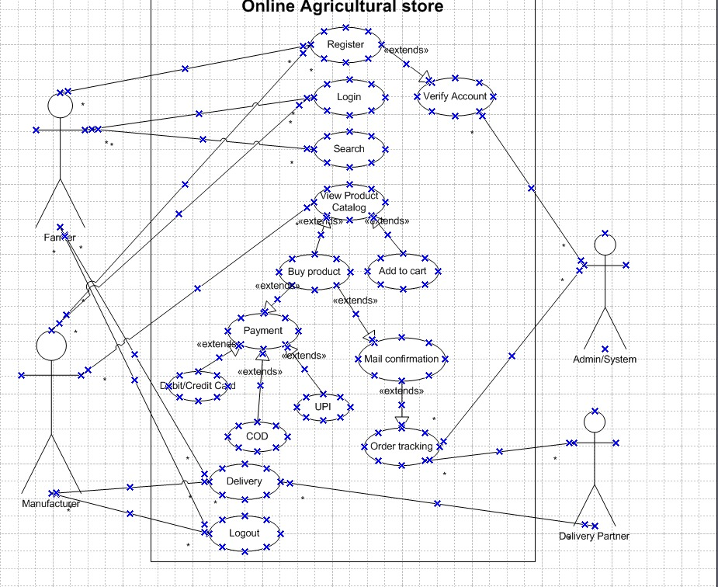

1. **Question -** Prepare use case specs for all use cases

**Answer –**

|  |  |
| --- | --- |
| **Use Case ID** | UC001 |
| **Use Case Name** | Account Registration |
| **Actors** | Farmers, Manufacturer, Admin/system |
| **Pre-Conditions** | * Good internet connection * The user is not already registered. |
| **Post-Conditions** | Account successfully registered |
| **Basic Flow** | * User open the website. * Go to sign up page. * Select user type as farmer/Manufacturer. * Enter required details – Full name, address, Phone number, email id and create password. * Submit the form. * System will analyse the details. * System will create new account into the database. * System will send new account creation email on the registered email id. * User will be redirected to login page. |
| **Alternative Flow** | * **Duplicate Email**   In step 4, when the user enters the duplicate email, then the system will show the “User Already Registered” message. Users need to sign up with the new/fresh email only.   * **Invalid Inputs**   If, in case, the user puts any information in an invalid form or misses any mandatory field, then the system will show “Invalid Input” highlighted with a red *.  Users need to put all the required information in with proper care. |
| **Assumptions** | * TheUser has a valid and accessible email ID. * User should have basic computer operating knowledge. |
| **Exceptions** | If in case internet connectivity is lost while doing registration then the system will show check you internet connectivity. |
| **Frequency of Use** | High |
| **Business Rule** | **Username –** Cannot be real name.  **Password –** Alpha numeric with one special character. |

|  |  |
| --- | --- |
| **Use Case ID** | UC002 |
| **Use Case Name** | User Login |
| **Actors** | Farmer, Manufacturer, Admin/system |
| **Pre-Conditions** | * Good internet connection. * The user should be registered on portal. |
| **Post-Conditions** | Theuser will be redirected to the respective homepage. |
| **Basic Flow** | * User open the website/App. * Go to the login page. * Enters the username, password and captcha. * Enter the OTP received on the registered phone number. * System validates the credentials and OTP. * User logged in successfully. * User’s dashboard/homepage will appear. |
| **Alternative Flow** | * **Incorrect username or password**   System will show “Invalid Username/Password”. User need to login with the correct username and password. In case user do not remember the Username/password then the user can get the link for resetting the same by clicking the Forgot “Username/Password” link.   * **Incorrect OTP or Captcha**   System will show “Invalid OTP” or “Invalid Captcha”  For OTP user need to click on resend OTP to get the fresh OTP.  For captcha user can refresh the captcha to get the fresh captcha.   * **Account Locked**   System will show “Account Locked” in case user tried to login multiple times with incorrect information.  User need to wait for 10 minutes to re-login again. |
| **Assumptions** | * Session timeout. * OTP not received due to network coverage. |
| **Exceptions** | * Browser compatibility * Internet connection |
| **Frequency of Use** | High |
| **Business Rule** | * OTP valid for 3 minutes. * 3 attempt for successful login. * Session timeout after 5 minutes. |

|  |  |
| --- | --- |
| **Use Case ID** | UC003 |
| **Use Case Name** | Add to Cart |
| **Actors** | Farmer, Admin/system |
| **Pre-Conditions** | * The user should be logged in. * The user should be in stock. |
| **Post-Conditions** | User’s cart will be update with the selected item and with specified quantity. |
| **Basic Flow** | * User search and browse the product. * User select the product and check its details. * User select the quantity and click on add to cart option to add the item to card. * If the item is already added into the cart then the quantity will get updated. * System check for any duplicacy and update the cart accordingly. * User’s cart get updated with the selected item. |
| **Alternative Flow** | * **Stock Quantity**   Item quantity will mention on the same where the item is visible. User might require more quantity as compared to the mentioned one the app.  In that use user need to wait for 4-5 days for the manufacturer to update the inventory. |
| **Assumptions** | * Items in cart remains same across all the logged in devices. * Pricing should remain same even after adding items into the cart. |
| **Exceptions** | Product might get unavailable in the mean-time while adding item into the cart. |
| **Frequency of Use** | Medium |
| **Business Rule** | User can add up to 20 items into the cart. |

|  |  |
| --- | --- |
| **Use Case ID** | UC004 |
| **Use Case Name** | Order Placement |
| **Actors** | Farmer, Manufacturer, Admin/system |
| **Pre-Conditions** | * The user should be registered on the portal. * Product should be in stock at the time of placing the order. |
| **Post-Conditions** | * Order is placed, order confirmation page with order ID will appear. * The system accepts the order and informs the manufacturer. * The system send the order placement confirmation email to the farmer. |
| **Basic Flow** | * Farmer search/browse the product. * Farmer add the product into the cart. * Review the card and proceed with putting the delivery address. * Farmer select the mode of payment (COD, UPI, and Credit/Debit Card) and then proceed accordingly. * System accept the mode of payment. * System shows order confirmation page with the order id. * System send the order confirmation email to farmer and inform the manufacturer about the order. * Manufacturer accepts the order and initiate delivery. |
| **Alternative Flow** | * **Out of stock**   The system will show “Out of Stock” in case the item is unavailable at the time of purchase. Farmers need to wait 4-5 days for the manufacturer to update the inventory.   * **Payment Failure**   The system will show “Payment Failure” if the payment fails via any digital method of payment. The system will give the user a retry option after 2-3 minutes or switch the payment mode to COD. |
| **Assumptions** | * Payment gateways are functioning properly. * Items are deliverable at the particular pin code. |
| **Exceptions** | Internet connectivity fluctuation. |
| **Frequency of Use** | Medium |
| **Business Rule** | * Farmer can retry to do to the payment online for 3 times only after that the mode of payment will automatically switch to COD. * Delivery charges depends upon the area pin code. |

|  |  |
| --- | --- |
| **Use Case ID** | UC005 |
| **Use Case Name** | Order Tracking |
| **Actors** | Farmers, Admin/system, Delivery partner |
| **Pre-Conditions** | * Order should have already been placed. * The user is logged in into the portal. * The order was confirmed by the manufacturer. |
| **Post-Conditions** | User can will view the real time status of the order. |
| **Basic Flow** | * The user logged in into the portal and click on “My Order” tab. * Select the “Order Placed” option. * System will show the real time status of the order. * User can also check the live status of the order. * System will also show option to connect with the delivery partner in the case of any issue related to order tracking. |
| **Alternative Flow** | * **Real time status is not updating**   If in case the order status is not updating then the farmer can connect with the delivery partner to get the required assistance. |
| **Assumptions** | * All the delivery partner of the sellers will provide real time tracking of the order. * User can also check the status even if the order is COD. |
| **Exceptions** | False status of the order being updated, which might result in order late delivery. |
| **Frequency of Use** | Medium |
| **Business Rule** | * Order tracking is available only after the order is shipped. * System will send notifications whenever the status gets updated. |

1. **Question -** Activity diagrams

**Answer –**

* **Registration**

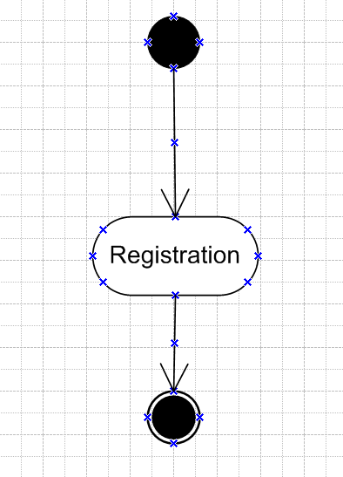

* **Search Product**

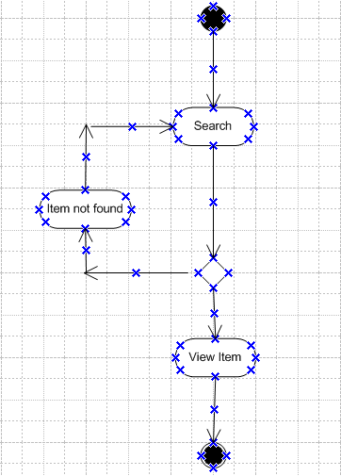

* **Login**

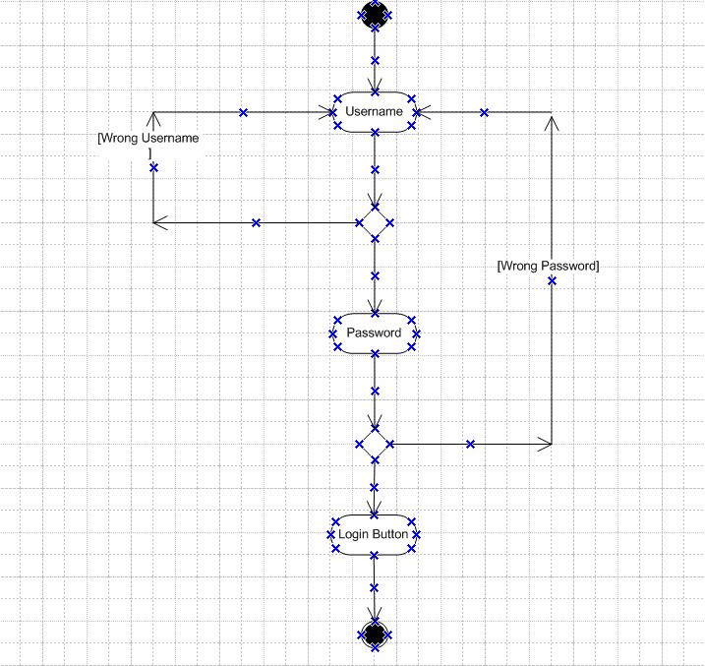

* **Add to cart**

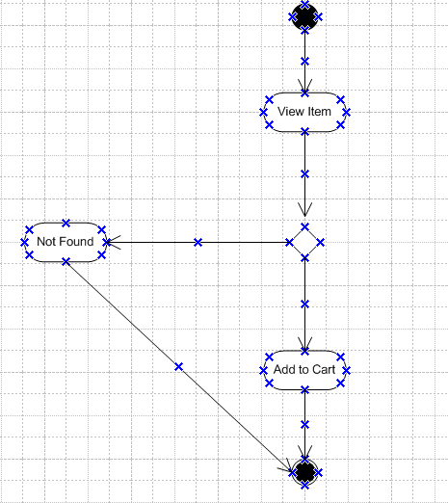

* **Delivery**

