Document 5- BRD Template

Sandeep Reddy Kata



<INVENTORY SOFTWARE>

<P_1>

<1.0.1>

<KATA SANDEEP REDDY>

Contents

1. Document Revisions……………………………………………………………………………………… 04
2. Approvals……………………………………………………………………………………………………… 04
3. RASCI Chart for This Document…………………………………………………………………….. 04

Codes Used in RASCI Chart……………………………………………………………………… 04

RASCI Chart…………………………………………………………………………………………….. 05

1. Introduction………………………………………………………………………………………………….. 05
   1. Business Goals……………………………………………………………………………………….. 05
   2. Business Objectives………………………………………………………………………………… 05
   3. Business Rules………………………………………………………………………………………… 06
   4. Background…………………………………………………………………………………………….. 06
   5. Project Objective…………………………………………………………………………………….. 07
   6. Project Scope………………………………………………………………………………………….. 07
      1. In Scope Functionality…………………………………………………………………… 07
      2. Out Scope Functionality………………………………………………………………… 08
2. Assumptions…………………………………………………………………………………………………… 08
3. Constraints…………………………………………………………………………………………………… 09
4. Risks…………………………………………………………………………………………………………..….. 09

Technological Risks…………………………………………………………………………………………. 09

Skills Risks……………………………………………………………………………………………………….. 10

Political Risks…………………………………………………………………………………………………… 10

Business Risks…………………………………………………………………………………………………. 10

Requirements Risks…………………………………………………………………………………………. 10

Other Risks………………………………………………………………………………………………………. 10

1. Business Process Overview……………………………………………………………………………… 11
   1. Legacy System (AS-IS)……………………………………………………………………………….. 12
   2. Proposed Recommendations (TO-BE)……………………………………………………….. 14
2. Business Requirements……………………………………………………………………………………. 18
3. Appendices……………………………………………………………………………………………………… 18
   1. List of Acronyms…………………………………………………………………………….. 18
   2. Glossary of Terms…………………………………………………………………………… 19
   3. Related Documents………………………………………………………………………… 20
4. Document Revisions:

|  |  |  |
| --- | --- | --- |
| Date | Version Number | Document Changes |
| 01/01/2025 | 1.0.1 | Initial Draft |
| 15/01/2025 | 1.0.2 | Second Draft |
| 30/01/2025 | 1.0.3 | Third Draft |

1. Approvals

|  |  |  |  |  |
| --- | --- | --- | --- | --- |
| Role | Name | Title | Signature | Date |
| Project Sponsor | ABC Milk Products Ltd. | Company |  | 01/01/2025 |
| Business Owner | Anoj | Co-Founder |  | 01/01/2025 |
| Project Manager | Ajith | Project Manager |  | 01/01/2025 |
| System Architect | Sobhangi | Sr. System Architect |  | 01/01/2025 |
| Development Lead | Sumisha | CTO |  | 01/01/2025 |
| User Experience Lead | Samantha | Lead User Experience |  | 01/01/2025 |
| Quality Lead | Manya | Product Head |  | 01/01/2025 |
| Content Lead | Nikhil | Content Lead |  | 01/01/2025 |

1. RACI Chart for This Document

The RACI chart identifies the persons who need to be contacted whenever changes are made to this document. RACI stands for responsible, accountable, consulted, and informed. These are the main codes that appear in a RACI chart, used here to describe the roles played by team members and stakeholders in the production of the BRD. They are adapted from charts used to assign roles and responsibilities during a project. (RACI Can be made for IT side [Project stakeholder] as mentioned above, apart from that Can also be made for Client side [Business Stakeholder]).

The following describes the full list of codes used in the table:

Codes Used in RACI Chart

* Authorize Has ultimate signing authority for any changes to the document.

R Responsible Responsible for creating this document.

A Accountable Accountable for accuracy of this document

(for example, the project manager)

S Supports Provides supporting services in the production of this document

C Consulted Provides input (such as an interviewee).

I Informed Must be informed of any changes.

RACI Chart:

|  |  |  |  |  |  |
| --- | --- | --- | --- | --- | --- |
| Name | Designation | Project Plan | BRD | Design | Test Report |
| Mr. Ajith | Project Manager | Responsible | Accountable | Informed | Informed |
| Mr. Sandeep | Business Analyst | Consulted | Responsible | Accountable | Accountable |
| Mr. Deepak | Senior Java Developer | Informed | Informed | Responsible | Informed |
| Mr. Ravi | Tester | Informed | Informed | Informed | Responsible |
| Mr. Janardhan | SPOC | Informed | Informed | Informed | Informed |
| Mr. Rahul | SPOC | Informed | Informed | Informed | Informed |
| Ms. Samantha | SPOC | Informed | Informed | Informed | Informed |
| Ms. Sobhangi | Delivery Head | Informed | Consulted | Informed | Informed |

1. Introduction

4.1 Business Goals:

The primary goal is to build a software that makes managing inventory easier and ensures customers get their ice-cream and milk products as quickly as possible. The system will keep a track of stock in real time, reduce wastage, and automate restocking so there are no shortages or excesses. It will also simplify order processing and use smart routing to deliver products faster while allowing customers to track their orders live. With data insights, the company can better predict demand and optimize supply chain operations. Most importantly, the software will help maintain high product quality and ensure compliance with food safety standards, all while making operations smoother and customer happier.

4.2 Business Objectives:

The business objectives for developing software typically align with managing inventory and delivering the goods quickly to the customers. Here are a few of the Business Objectives:

* Login
* Inventory Management
* Order fulfilment
* Logistics & Delivery
* Customer experience
* Data – Driven Decisions
* Real – Time order tracking
* Customer support & Engagement
* Supply Chain Management

4.3 Business Rules:

ABC Milk Products Ltd. and its subsidiaries are committed to protecting their customer’s personal information. This organizational policy is created to help the customers understand how their personal information will be used.

Personal information collected online

How is personal information used

How is personal information shared

How the customer information is limited to employees

Information security

Other information about ABC Milk Products Ltd. Software

* All stock movements must be recorded in real-time across manufacturing plants and warehouses.
* Automated alerts should notify when stock levels reach reorder points.
* Orders must be processed within a predefined time frame.
* System should automatically allocate orders to the nearest warehouse with available stock.
* Customers must have access to real-time order tracking and updates.
* System-generated reports should be reviewed periodically for operational improvements.
* Sales, inventory, and delivery data must be logged and sorted for trend analysis.

4.4 Background:

At first, everything was done manually, which meant deliveries often took longer than expected. Team members had to keep track of inventory by hand, and restocking was done manually whenever stock ran low, relying on manual effort.

To address these challenges and reduce the dependence on manual processes, we’re developing new software. This will automate restocking updates and track stock movements in real-time across our manufacturing plants. The system will also automatically assign orders to the nearest warehouse with available stock, ensuring quicker deliveries and smoother experience for our customers.

4.5 Project Objective:

The primary goal of this project is to develop a comprehensive software solution that enhances inventory management and ensures the fastest delivery possible for the customer. The system will enable real-time stock tracking across multiple manufacturing plants and warehouses, automate replenishment processes, and implement smart stock rotation techniques to minimize wastage. By integrating intelligent logistics solutions, such as AI-powered route optimization and GPS tracking, the software will ensure that perishable products are delivered quickly while maintaining their quality and freshness.

To streamline order fulfilment, the system will automate order processing, allocate orders based on stock availability and warehouse proximity, and provide real-time tracking for customers and internal teams. It will also include a user-friendly interface for seamless order placement, automated notifications for order status updates, and multiple payment options to enhance customer experience. The platform will enable efficient delivery scheduling, optimizing fleet management, and ensure temperature-controlled transportation for perishable products.

Furthermore, the software will leverage data analytics AI-driven demand forecasting to optimize inventory stocking, predict sales trends, and improve supply chain efficiency. It will generate insightful reports on logistics performance, order fulfilment rates, and customer preferences, enabling the company to make data-driven decisions for continuous improvement.

In addition to operational efficiency, the system will ensure strict compliance with food safety regulations by incorporating automated quality checks, real-time monitoring of storage conditions, and audit logs for traceability. By maintaining high product standards and ensuring regulatory compliance, the company can build customer trust and reduce the risk of product spoilage.

Ultimately, this project aims to create a scalable, cost-effective, and user-friendly solution that streamlines supply chain operations, reduce costs, and improves customer satisfaction. By integrating automation, AI-driven analytics, and smart logistics, the company will be able to enhance its operational efficiency, improve delivery speed, and ensure long-term business growth.

4.6 Project Scope:

The project aims to develop an intelligent software for managing inventory and optimizing delivery operations for ice-cream and milk products. The system will cover manufacturing plants, warehouses, logistics, and customer order management, ensuring efficient stock tracking, seamless order processing, and the fastest possible delivery while maintaining product quality.

4.6.1 In Scope Functionality:

* Real-time tracking of stock levels across all manufacturing plants and warehouses.
* Automated stock replenishment with notifications for low inventory levels.
* Batch tracking and expiration monitoring for perishable goods.
* Seamless order placement and processing through an integrated platform.
* Automated order allocation based on warehouse stock availability and customer location.
* Order modification and cancellation options with automated refund processing.
* GPS tracking facility for delivery vehicles for real-time monitoring.
* Delivery status notifications and estimated time of arrival updates for customers.
* Multiple payment options, including digital wallets, UPI, credit/debit cards, and cash on delivery.
* Audit logs and traceability of all stock movements and transactions.

4.6.2 Out Scope Functionality

* Procurement and maintenance of hardware such as GPS devices, temperature sensors, and warehouse automation equipment.
* Management of physical storage conditions.
* Equipment monitoring and maintenance within the manufacturing plants.
* End-to-end management of outsource logistics.
* Direct control over third-party fleet management and vehicle maintenance.
* Hiring and training of customer service representatives.
* Handling of customer disputes beyond the automated system.
* Employee attendance, payroll, and shift scheduling for warehouse and logistics staff.
* Performance tracking and appraisal management for employees.
* Development of a full-scale enterprise resource planning or customer relationship management system from scratch.
* The project should be integrated with the existing ERP/CRM solutions but will not develop a new one.

1. Assumptions

* The company has or will procure the necessary cloud infrastructure for hosting software.
* All warehouses and manufacturing plants will have internet connectivity for real-time data updates.
* GPS tracking system for delivery vehicles will be available and compatible with the software.
* The software will integrate with existing ERP, CRM, and third-party logistics platform.
* The system will support multiple payment gateways for seamless transactions.
* Employees and logistics staff will be trained to use the new system efficiently.
* The company will ensure compliance with food safety regulations, and the software will assist in tracking compliance.
* Legal and regulatory requirements for data security and privacy will be met by the software.
* Customers will have access to the internet or mobile networks to track orders.
* Seasonal demand fluctuations will be predictable and manageable through the system’s AI-driven forecasting.
* Customers will accept standard delivery times, with express options being an additional service.

1. Constraints

* The system must be cloud-based to ensure scalability and remote accessibility.
* Integration with legacy systems may be limited based on API availability compatibility.
* Real-time data updates depend on internet connectivity across all warehouses and manufacturing plants.
* GPS tracking accuracy may vary based on network availability and device compatibility.
* Delivery times are subject to external constraints such as traffic, weather conditions, and transportation regulations.
* The system must comply with local and international food safety regulations.
* The project budget must cover software development, integration, and initial training but excludes hardware procurement.
* Ongoing maintenance, updates, and support costs must be factored into operational expenses.
* The project must be completed within the defined timeline.
* User training and system onboarding must be completed before full deployment.
* Training and adoption based on the availability of internal staff for onboarding sessions.
* Support and maintenance will be provided based on predefined SLAs.

1. Risks

Technological Risks:

The software’s performance and reliability depend n various technological factors, including cloud infrastructure, system integrations, and data security. There is a risk of system downtime due to serve failures or cloud service outages, which could disrupt inventory management and order processing. Integration challenges with existing ERP, CRM, or third-party logistics platform may lead to data inconsistencies and operational inefficiencies. Additionally, cybersecurity threats, such as hacking attempts or data breaches, pose a serious risk to sensitive business and customer data, requiring robust security measures. Scalability is another concern, as inadequate system design could lead to performance bottlenecks as business operations expand.

Skills Risks:

The successful implementation and adoption of the software rely on employees and stakeholders having the necessary technical skills. Resistance to change, lack of technical expertise, and insufficient training could result in slow adoption, leading to inefficiencies in inventory and logistics management. Warehouse staff, delivery personnel, and customer service teams may struggle with transitioning from manual processes to an automated system, affecting productivity. Additionally, IT and support teams must have the expertise to handle software maintenance, troubleshooting, and future upgrades to ensure smooth operations.

Political Risks:

Government policies and regulations related to food safety, data privacy, and e-commerce can impact the software’s functionality and compliance requirements. Change in food safety standards may necessitate modifications in inventory tracking and storage conditions, leading to additional development costs. Stricter data protection laws, such as GDPR or industry-specific regulations, could impose constraints on data collection and storage, requiring enhanced security features. Trade restrictions, import/export regulations, or political instability affecting supply chains may also create unexpected challenges in inventory procurement and distribution.

Business Risks:

The software’s success depends on improving efficiency, reducing costs, and enhancing customer satisfaction. However, if the system fails to deliver expected improvements in inventory management or delivery optimization, the return on investment (ROI) may be lower than anticipated. Poor demand forecasting, stock mismanagement, or inefficiencies in order processing could lead to revenue losses. Additionally, competitive pressures from other businesses adopting similar or more advanced technologies may require frequent upgrades and feature enhancements, increasing long-term maintenance costs.

Requirements Risks:

Unclear, changing, or poorly defined project requirements pose a significant risk to successful implementation. If business stakeholders fail to define precise needs at the beginning, there could be frequent changes in scope, leading to delays and budget overruns. Inadequate communication between business teams and software developers may result in missing critical functionalities or developing features that do not align with business goals. Additionally, failure to account for future scalability and regulatory changes in the requirements phase may require costly modifications post-deployment.

Other Risks:

Several external factors may impact the project’s success, including economic downturns, inflation, and disruptions in the supply chain. Natural disasters, pandemics, or global crises affecting transportation and logistics could delay order fulfilment. Customer expectations and preferences may evolve over time, requiring continuous updates and enhancements to the system. Additionally, vendor dependency for cloud hosting, payment gateways, or third-party logistics integrations introduces risks related to pricing changes, service reliability, and contractual limitations.

1. Business Process Overview

The software will streamline the company's entire supply chain, covering inventory management, order processing, logistics, and customer fulfilment. The goal is to ensure efficient stock tracking, minimize waste, optimize delivery times, and enhance customer satisfaction. The business process can be divided into key stages.

1. **Manufacturing & Inventory Management:**

* Raw materials are procured and processed at manufacturing plants to produce ice cream and milk products.
* Finished products are transferred to warehouses and distribution centers, where they are categorized based on batch numbers, expiration dates, and storage conditions.
* The system tracks stock levels in real-time, ensuring automated replenishment and alerts for low-stock situations.
* FIFO (First In, First Out) and LIFO (Last In, First Out) inventory management techniques are used to minimize wastage.
* Quality control checks are performed to ensure compliance with food safety standards before dispatching products.

1. **Order Processing & Fulfillment:**

* Customers place orders through various sales channels, including the company’s website, mobile app, and offline retail partners.
* The system automatically assigns orders to the nearest warehouse based on stock availability and customer location.
* Order processing includes payment verification, invoicing, and packaging for shipment.
* Customers receive real-time updates on order status, including confirmation, dispatch, and estimated delivery time.

1. **Delivery Optimization:**

* The software uses AI-powered route optimization to determine the fastest and most cost-effective delivery routes.
* Delivery vehicles are tracked using GPS, ensuring real-time visibility of shipments.
* Temperature-controlled logistics are managed to maintain the freshness of ice-cream and milk products.
* The system automatically schedules and dispatches delivery fleets based on demand and traffic conditions.
* Customers receive live tracking links and delivery notifications to enhance the overall experience.

1. **Customer Experience & Feedback:**

* Customers can track orders, modify delivery preferences, and raise complaints through the online portal or mobile app.
* Automated feedback collection helps analyze customer satisfaction and improve service quality.
* AI-driven analytics generate reports on order trends, delivery efficiency, and customer behaviour for continuous improvement.

1. **Data Analytics & Reporting:**

* The system collects and analyses sales, inventory, and logistics data to forecast demand and optimize stock levels.
* Performance dashboards provide insights into key metrics such as delivery speed, order accuracy, and warehouse efficiency.
* Management can make data-driven decisions to enhance operations and reduce costs.

8.1 Legacy System (AS-IS):

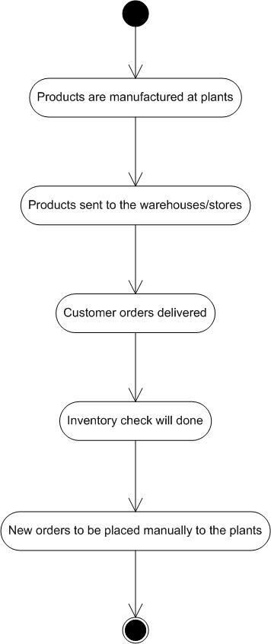

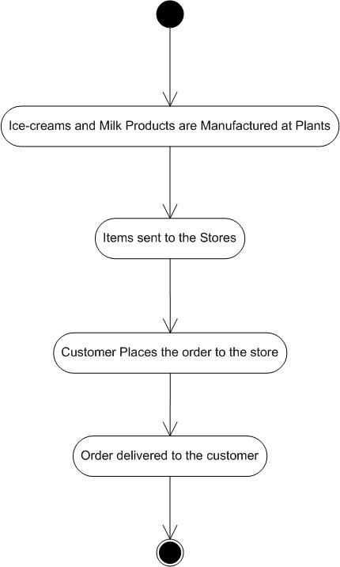

The company’s current operations rely on a mix of manual processes and legacy software systems for inventory management, order processing, and logistics. These outdated methods lead to inefficiencies, delays, and limited scalability.

* Warehouse and manufacturing plants track stock levels using spreadsheets and standalone software with no real-time integration.
* Inventory updates are done manually, leading to errors, stock discrepancies, and delays in replenishment.
* FIFO/LIFO stock management is difficult to enforce due to lack of automation, leading to product spoilage and waste.
* No automated alerts for low stock levels or expired products, resulting in stock shortages or overstocking.
* Orders received via phone, email, or physical sales representatives and manually entered the system.
* Multiple sales channels (website, app, offline retailers) operate independently, leading to inconsistencies in order data.
* Processing and verification payments are done manually, increasing order processing time.
* Limited integration between order management and inventory, causing delays in order fulfilment due to stock mismatches.
* Delivery scheduling is done manually, often leading to inefficient route planning and increased fuel costs.
* No real-time GPS tracking for delivery vehicles, making it difficult to monitor shipments and provide accurate ETAs.
* Temperature-sensitive products are transported without real-time monitoring of storage conditions.
* Delivery teams rely on paper-based logs for tracking, leading to delays in status updates and lack of visibility into last-mile logistics.
* Customers have no real-time order tracking, leading to frequent queries and complaints.
* Issues such as delayed deliveries or incorrect orders are handled manually, often causing slow response times.
* No automated feedback mechanism; customer satisfaction is gauged through sporadic surveys or complaint logs.
* Customer service relies heavily on phone support, which is time-consuming and inefficient.
* Sales, inventory, and delivery data are stored in separate systems, making consolidated report difficult.
* Managers rely on manually compiled reports, leading to delays in decision-making and inaccurate demand forecasting.
* No predictive analytics to optimize inventory, forecast sales trends, or improve delivery efficiency.
* Business performance metrics are not updated in real time, reducing agility in responding to market changes.

8.2 Proposed Recommendations (TO-BE):

* Develop a centralized cloud-based inventory management system to provide real-time stock updates across all manufacturing plants and warehouses.
* Automate stock tracking using barcode/RFID scanning to minimize human errors and stock mismatches.
* Implement AI-driven demand forecasting to optimize stock levels and reduce waste.
* Set up automated alerts for low stock, expiration dates, and replenishment triggers.
* Integrate all sales channels (website, mobile application, offline retailers) into a single order management system.
* Enable real-time inventory checks before order confirmation to avoid stock shortages.
* Automate order processing, including payment verification, invoicing, and dispatch scheduling.
* Implement AI-powered recommendation system to upsell/cross-sell products to customers.
* Introduce GPS-based delivery tracking for real-time shipment monitoring.
* Implement AI-powered route optimization to reduce delivery time and fuel costs.
* Enable automated fleet scheduling to ensure timely dispatch and order fulfilment.
* Integrate IOT-based temperature monitoring to maintain product quality during transit.
* Provide real-time order tracking and status updates via mobile app and SMS.
* Implement a chatbot-based customer support system for quick issue resolution.
* Enable a customer feedback system for continuous service improvement.
* Offer flexible delivery options such as scheduled delivery slots and express shipping.
* Develop a real-time analytics dashboard to track key performance indicators such as order accuracy, delivery speed, and stock levels.
* Implement AI-driven predictive analytics for better forecasting of demand and supply chain trends.
* Automate report generation to facilitate quick and informed decision-making

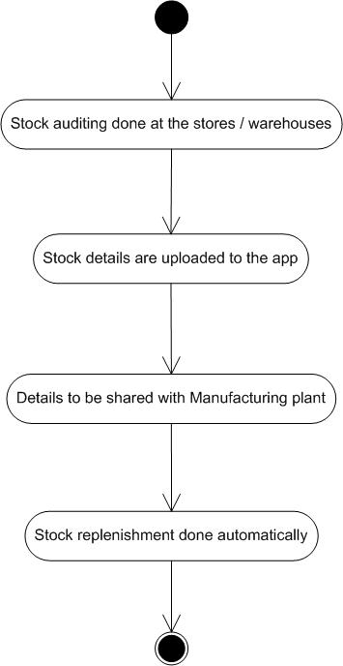

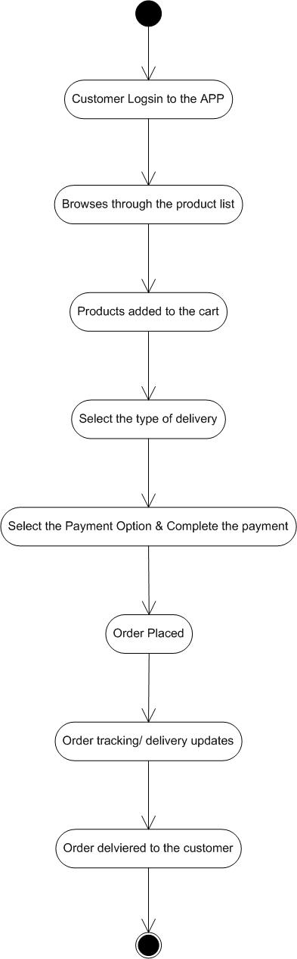

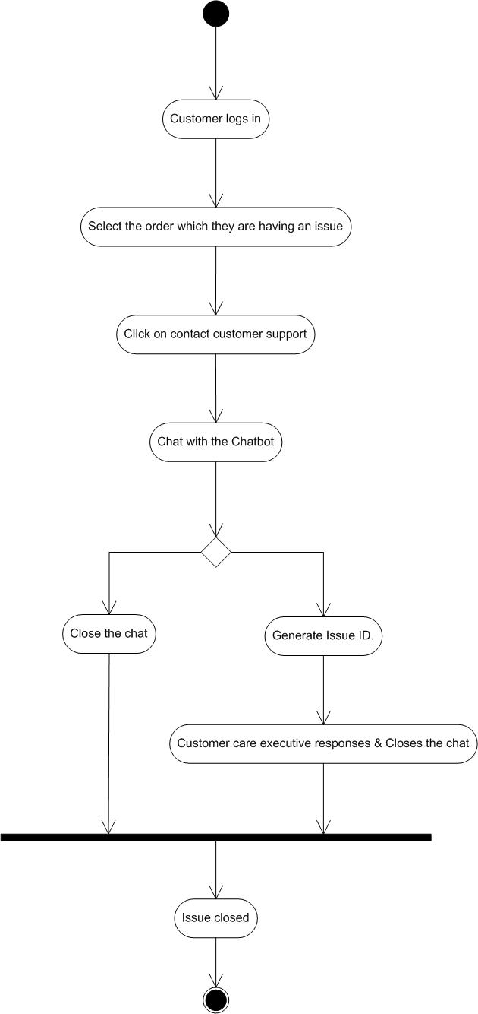

1. Business Requirements

|  |  |  |
| --- | --- | --- |
| Req ID | Requirement Description | Priority |
| BR001 | The system must provide real-time tracking of stock levels across all warehouses and manufacturing plants | 8 |
| BR002 | The system must generate automated alerts for low stock and initiate replenishment requests | 7 |
| BR003 | The system must monitor batch numbers and expiration dates to ensure compliance with food safety regulations | 7 |
| BR004 | All sales channels (website, mobile app, offline retailers) must be integrated into a single order management system | 10 |
| BR005 | Customers must receive automated notifications about order status, including processing, dispatch, and delivery updates | 9 |
| BR006 | The order management system must automatically generate invoices for completed orders | 9 |
| BR007 | Customers must be able to pay using various methods, including credit/ debit cards, UPI, net banking, and cash on delivery | 10 |
| BR008 | The system must provide real-time GPS tracking of delivery vehicles for accurate estimated arrival times | 6 |
| BR009 | Customers must be able to provide feedback and raise complaints through an integrated chatbot or support portal | 8 |
| BR010 | The system must generate real-time analytics and performance reports for inventory, sales, and logistics operations | 5 |
| BR011 | The system must send alerts for stock shortages, order delays, and delivery confirmations via SMS, email, and app notifications | 8 |
| BR012 | The inventory system must support multiple warehouses and allow seamless stock transfers between the warehouses | 5 |
| BR013 | The system must integrate with suppliers for automatic stock replenishment and order tracking | 7 |
| BR014 | The system must support different delivery modes, including express delivery, scheduled delivery, and bulk orders | 6 |
| BR015 | The logistics system must integrate with third-party delivery services for extended reach and scalability | 9 |
| BR016 | Customers must be able to request returns and refunds, with automated processing based on predefined condition | 8 |
| BR017 | The software must sync with accounting tools like quickbooks or SAP for financial tracking and taxation compliance | 5 |
| BR018 | The mobile app should support offline functionality for inventory updates in areas with low or no internet connectivity | 7 |

1. Appendices

10.1 List of Acronyms

AI – Artificial Intelligence

FIFO – First In, First Out

LIFO – Last In, Last Out

GPS – Global Positioning System

IoT – Internet of Things

SAP – Systems, Applications, and Products in Data Processing

UPI – Unified Payments Interface

ERP – Enterprise Resource Planning

SMS – Short Message Service

ETA – Estimated Time of Arrival

KPI – Key Performance Indicator

CRM – Customer Relationship Management

GDPR – General Data Protection Regulation

CCPA – California Consumer Privacy Act

ROI – Return on Investment

10.2 Glossary of Terms

FIFO – First In, First Out – An inventory method where the oldest stock is sold or used first to prevent spoilage.

LIFO – Last In, Fist Out – An inventory method where the newest stock is sold or used first, often for financial accounting

Automated Stock Replenishment – A system feature that triggers restocking based on predefined inventory thresholds.

Customer Relationship Management (CRM) – A technology system that manages a company’s interactions with current and potential customers, often integrating with lead management systems.

Automated Invoice Generation – A system that automatically creates invoices upon order confirmation.

Estimated Time of Arrival (ETA) – The predicted time when an order will be delivered to the customer.

Reporting and Analytics – Tools and processes used to analyse lead and sales data, providing insights into performance and effectiveness.

Integration – The process of connecting different software systems to allow for seamless data sharing and operational efficiency.

Automated Workflow – A series of automated actions that are triggered based on specific events or conditions within the lead management process.

Data Privacy – Legal and ethical standards governing the collection, storage, and use of personal information, important for compliance.

10.3 Related Documents

Business Requirements Document (BRD): Outlines the business needs, objectives, and requirements for the application.

Functional Requirements Specification (FRS): Details the specific functionalities that the application must include, based on the business requirements.

Project Scope Statement: Defines the boundaries of the project, including what will be included and excluded in the application development.

Stakeholder Analysis: Identifies stakeholders involved in the project, outlining their interests, influence, and impact on the application implementation.

Risk Management Plan: Documents potential risks associated with the application project, along with mitigation strategies to address those risks.

User Acceptance Testing (UAT) Plan: Outlines the criteria, process, and schedule for validating that the application meets user needs and expectations before launch.

Training Plan: Details the approach for training users on the new application, including materials, sessions, and support resources.

Data Migration Plan: Describes the strategy for transferring existing lead data from the legacy system to the new application, ensuring data integrity and continuity.

Integration Plan: Outlines how the application will connect with existing systems (like CRM and marketing tools) and the technical requirements for integration.

Change Management Plan: Details the approach for managing changes during the application implementation, including communication strategies and stakeholder involvement.

System Architecture Document: Provides a high-level view of the technical architecture of the application, including components, interactions, and data flow.

Implementation Plan: Outlines the steps, timeline, and resources required for the successful deployment of the application.

Maintenance and Support Plan: Details the procedures for ongoing maintenance, updates, and support for the application after implementation.

Quality Assurance Plan: Describes the processes for testing and ensuring the quality of the application, including functional and non-functional testing.

**Process Flow Diagram**

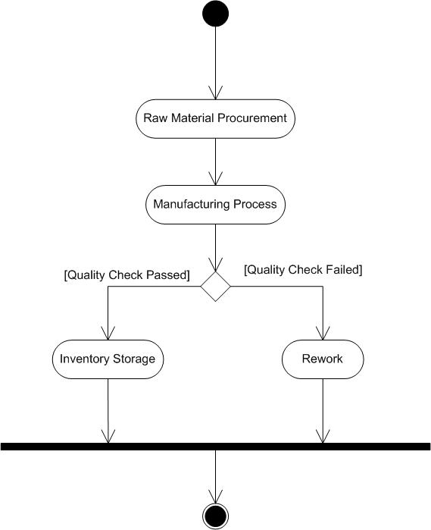

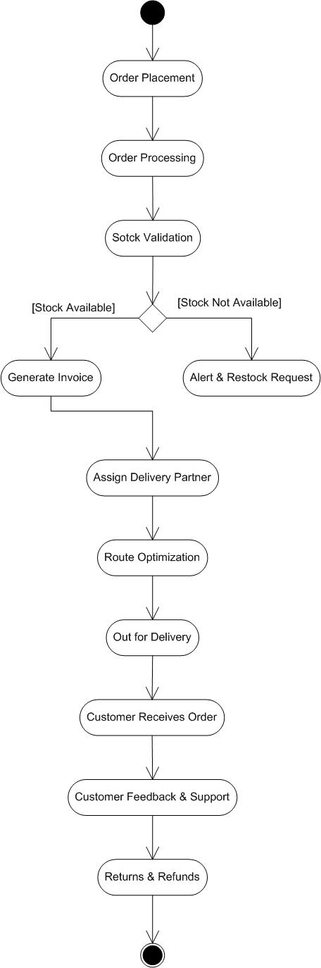

Write an introduction letter to a client introducing yourself as a business analyst in charge of working with the client and his team to start the business understanding process

Hi,

I hope you are doing well!

My name is K Sandeep Reddy, and I’m thrilled to introduce myself as the Business Analyst who will be working with your team at ABC Soft Solutions. At XYZ Soft Solutions, we’re all about creating strong partnerships, and I’m here to help you achieve your business goals.

Over the next few weeks, I’ll be getting to know and your team better, diving into your business, goals, and any challenges you might be facing. This will help us align our strategies and solutions to fit your needs perfectly. Think of this as the start of our journey together, where we’ll lay the groundwork for some amazing collaborative efforts.

I believe in open communication and truly value your input. So please, feel free to reach out with any questions or concerns. Your insights will be key in helping us come up with tailored solutions that drive success for your organization.

I’m really looking forward to working with you and am confident that together, we’ll achieve fantastic results. If you need to get in touch or want to schedule a meeting, just drop me an email at [sandeep@xyzsoftsol.com](mailto:sandeep@xyzsoftsol.com) or give me a call at +91-9030247375.

Thanks for the opportunity to work with you. I’m excited to get started and make a positive impact at ABC Soft Solutions.

Best Regards,

K Sandeep Reddy

Business Analyst

XYZ Soft Solutions

Document 5- BRD Template

Sandeep Reddy Kata



<TICKETING SYSTEM>

<P_1>

<1.0.1>

<KATA SANDEEP REDDY>

Contents

1. Document Revisions……………………………………………………………………………………… 27
2. Approvals……………………………………………………………………………………………………… 27
3. RASCI Chart for This Document……………………………………………………………………. 27

Codes Used in RASCI Chart…………………………………………………………………….… 27

RASCI Chart……………………………………………………………………………………………... 28

1. Introduction…………………………………………………………………………………………………... 28
   1. Business Goals…………………………………………………………………………..………….… 28
   2. Business Objectives……………………………………………………………………………….… 29
   3. Business Rules……………………………………………………………………………………….… 29
   4. Background………………………………………………………………………………………….….. 30
   5. Project Objective………………………………………………………………………………….….. 31
   6. Project Scope……………………………………………………………………………………….….. 31
      1. In Scope Functionality…………………………………………………………….……… 31
      2. Out Scope Functionality…………………………………………………………….…… 32
2. Assumptions…………………………………………………………………………………………….……… 32
3. Constraints……………………………………………………………………………….…….………………. 33
4. Risks…………………………………………………………………………………………………………..……. 34

Technological Risks………………………………………………………………………………………….. 34

Skills Risks………………………………………………………………………………………………….…….. 35

Political Risks……………………………………………………………………………………………………. 35

Business Risks………………………………………………………………………………………………….. 35

Requirements Risks…………………………………………………………………………………………. 35

Other Risks………………………………………………………………………………………………………. 35

1. Business Process Overview……………………………………………………………………………… 36
   1. Legacy System (AS-IS)……………………………………………………………………………….. 36
   2. Proposed Recommendations (TO-BE)……………………………………………………….. 37
2. Business Requirements……………………………………………………………………………………. 40
3. Appendices……………………………………………………………………………………………………… 40
   1. List of Acronyms…………………………………………………………………………….. 40
   2. Glossary of Terms…………………………………………………………………………… 41
   3. Related Documents………………………………………………………………………… 41
4. Document Revisions:

|  |  |  |
| --- | --- | --- |
| Date | Version Number | Document Changes |
| 01/01/2025 | 1.0.1 | Initial Draft |
| 15/01/2025 | 1.0.2 | Second Draft |
| 30/01/2025 | 1.0.3 | Third Draft |

1. Approvals

|  |  |  |  |  |
| --- | --- | --- | --- | --- |
| Role | Name | Title | Signature | Date |
| Project Sponsor | XYZ Booking | Company |  | 01/01/2025 |
| Business Owner | Anoj | Co-Founder |  | 01/01/2025 |
| Project Manager | Ajith | Project Manager |  | 01/01/2025 |
| System Architect | Sobhangi | Sr. System Architect |  | 01/01/2025 |
| Development Lead | Sumisha | CTO |  | 01/01/2025 |
| User Experience Lead | Samantha | Lead User Experience |  | 01/01/2025 |
| Quality Lead | Manya | Product Head |  | 01/01/2025 |
| Content Lead | Nikhil | Content Lead |  | 01/01/2025 |

1. RACI Chart for This Document

The RACI chart identifies the persons who need to be contacted whenever changes are made to this document. RACI stands for responsible, accountable, consulted, and informed. These are the main codes that appear in a RACI chart, used here to describe the roles played by team members and stakeholders in the production of the BRD. They are adapted from charts used to assign roles and responsibilities during a project. (RACI Can be made for IT side [Project stakeholder] as mentioned above, apart from that Can also be made for Client side [Business Stakeholder]).

The following describes the full list of codes used in the table:

Codes Used in RACI Chart

* Authorize Has ultimate signing authority for any changes to the document.

R Responsible Responsible for creating this document.

A Accountable Accountable for accuracy of this document

(for example, the project manager)

S Supports Provides supporting services in the production of this document

C Consulted Provides input (such as an interviewee).

I Informed Must be informed of any changes.

RACI Chart:

|  |  |  |  |  |  |
| --- | --- | --- | --- | --- | --- |
| Name | Designation | Project Plan | BRD | Design | Test Report |
| Mr. Ajith | Project Manager | Responsible | Accountable | Informed | Informed |
| Mr. Sandeep | Business Analyst | Consulted | Responsible | Accountable | Accountable |
| Mr. Deepak | Senior Java Developer | Informed | Informed | Responsible | Informed |
| Mr. Ravi | Tester | Informed | Informed | Informed | Responsible |
| Mr. Janardhan | SPOC | Informed | Informed | Informed | Informed |
| Mr. Rahul | SPOC | Informed | Informed | Informed | Informed |
| Ms. Samantha | SPOC | Informed | Informed | Informed | Informed |
| Ms. Sobhangi | Delivery Head | Informed | Consulted | Informed | Informed |

1. Introduction

4.1 Business Goals:

The primary goal of this online ticketing system is simple: make booking tickets as effortless as possible while ensuring a smooth and secure experience for users. We want people to find, select, and purchase tickets quickly, whether they’re booking for an event, travel, or entertainment. The platform should be intuitive, work well on all devices, and offer multiple payment options to suit everyone’s needs.

At the same time, we aim to boost sales by optimizing the booking process, offering promotions, and suggesting relevant add-ons like VIP upgrades or merchandise. Automation is key – cancellations, refunds, and seat availability should be updated in real-time, reducing manual work and improving efficiency. Security is non-negotiable, so we’ll implement strong payment protection, fraud detection, and data security measures to keep customer information safe.

Expanding our reach is another major focus. We’ll partner with event organizers, transport services, and other key players while making sure the system supports multiple languages and currencies to serve a global audience. By leveraging data and analytics, we can track customer behaviour, identify trends, and personalize recommendations using AI to enhance the suer experience.

Lastly, building a strong brand reputation is crucial. This means providing excellent customer support, ensuring system reliability with minimal downtime, and actively collecting user feedback to improve continuously. Our ultimate goal is to create a trusted, go-to platform for hassle-free ticket booking that keeps customers returning.

4.2 Business Objectives:

The business objectives for developing software typically align with providing seamless online ticket booking for customers. Here are a few of the Business Objectives:

* Login
* Ticket Booking
* Order fulfillment
* Multiple payment options
* Customer experience
* Data-Driven Decisions
* Mobile first
* Personalization
* Customer support & Engagement
* Maintaining transparency

4.3 Business Rules:

XYZ Biiking and its subsidiaries are committed to protecting their customer’s personal information. This organizational policy is created to help the customers understand how their personal information will be used.

Personal information collected online

How is personal information used

How is personal information shared

How the customer information is limited to employees

Information security

Other information about XYZ Booking Software

* Users must register with a valid email or phone number to book tickets.
* Guest checkout is allowed but requires email/phone verification for ticket delivery.
* Passwords must meet security standards.
* Tickets are allocated on a first-come, first-serve basis.
* Users can book a maximum of 6 tickets per transaction (configurable per event).
* Real-time availability must be updated after every successful transaction.
* Bookings are confirmed only after full payment is received.
* Prices are dynamically updated based on demand and availability.
* All payments must be processed through a secure and verified gateway.
* Discounts, promo codes, and loyalty rewards apply only as per system-defined conditions.
* No partial payments are allowed; full payment is required to confirm booking.
* Cancellations are subject to event-specific rules and deadlines.
* Refunds will be processed within 7 business days.
* Non-refundable tickets cannot be cancelled or modified.
* Service fees and transaction charges may be non-refundable.
* Users can modify their bookings only if the event organizer allows changes.
* Name changes or ticket transfers may require additional verification.
* User data must be encrypted and stored securely.
* The system must comply with GDPR, PCI-DSS, and other relevant data protection laws.
* Fraudulent transactions or chargebacks will result in account suspension.
* Digital or printed tickets must be scanned for entry.
* Each ticket has a unique QR code/barcode to prevent duplication.
* Lost or stolen tickets will not be reissued unless permitted by the organizer.
* 24/7 customer service must be available for urgent issues.
* Users can raise complaints or request assistance through chat, email, or phone.
* If an event is cancelled, users are entitled to a refund as per the organizer’s policy.
* If postponed, users may choose to retain or request a refund within the allowed timeframe.
* The system cannot share user data with third parties without consent.

4.4 Background:

In today’s fast-paced digital world, traditional ticket booking methods are becoming obsolete as consumers demand seamless, quick, and hassle-free experiences. Whether it’s for concerts, movies, sports events, transportation, or other entertainment services, an online ticketing system simplifies the process by enabling users to browse, select, and purchase tickets from the comfort of their homes.

The need for a robust and efficient online ticketing system has grown significantly with the increasing adoption of digital payments, mobile applications, and AI-driven personalization. Customers expect real-time availability updates, secure payment gateways, and instant confirmation, while businesses and event organizers require automation, data insights, and fraud prevention mechanisms to ensure smooth operations.

This system not only enhances convenience for users but also benefits businesses by optimizing sales, reducing manual workload, and expanding market reach. By integrating features like multiple payment options, automated cancellations and refunds, real-time seat selection, and AI-powered recommendations, an online ticketing system transforms the traditional booking experience into a modern, efficient, and customer-centric solution.

4.5 Project Objective:

The objective of this project is to develop a robust, scalable, and user-friendly online ticketing system that streamlines the entire ticketing process for users while optimizing operational efficiency for event organizers, travel services, and entertainment businesses. The platform will enable users to browse, select, and purchase tickets seamlessly, offering multiple payment options, secure transactions, and instant confirmation.

Key objectives include:

* Providing an intuitive, response interface that simplifies the booking process and ensures a hassle-free experience across devices.
* Implementing features like dynamic pricing, promotions, and upselling opportunities to maximize ticket sales and overall revenue.
* To automate ticketing, cancellations, refunds and seat availability updates to improve speed and reduce manual tasks.
* To integrate multi-language and multi-currency support, enabling global access to events and services.
* To utilize customer behaviour tracking, sales reporting, and AI-driven recommendations to enhance service offerings and business insights.
* Providing excellent customer support, maintain high system uptime, and ensure transparent pricing and refund policies.

This project aims to create a trusted, seamless, and scalable platform that meets the need of both users and businesses, positioning the system as a leading solution in the digital ticketing market.

4.6 Project Scope:

This project encompasses the development and deployment of a comprehensive online ticketing system designed to facilitate seamless ticket booking for events, travel and entertainment.

4.6.1 In Scope Functionality:

* Users can register using an email, phone number or social media accounts.
* Login authentication with password, OTP, or biometric.
* Guest checkout option with email/phone verification for ticket delivery.
* Users can search for events, movies, transport, or other ticketed services.
* Advanced filters for easy ticket discovery.
* Real-time seat selection with dynamic pricing and availability updates.
* Instant ticket generation with QR Code/ barcode.
* Multiple payment options: credit/debit cards, UPI, net banking, digital wallets.
* Booking confirmation via email and SMS with order summary.
* Order history and booking status tracking for users can be given.
* Users can request cancellations based on event-specific policies.
* Refund processing via the original payment method within a specified timeframe.
* Ticket modifications or rescheduling, if permitted by the event organizer.
* Notifications for successful cancellation, refund, or modification.
* Event organizers can create, list, and manage events with date, time, venue and pricing details.
* Real-time dashboard displaying total tickets sold, revenue and user activity.
* Access control to allow multiple admins or event managers.
* Secure payment integration with PCI-DSS compliance.
* Live customer support agents available via phone, email, and chat
* SLA to ensure timely response to support requests.
* User feedback and complaint submission portal for service improvement.

4.6.2 Out Scope Functionality

* The system will operate entirely online, meaning no physical ticket kiosks or hardware-based ticket sales will be supported.
* The platform will not integrate with on-site manual ticket counters or box office systems.
* The system will not allow users to resell or transfer purchased tickets within the platform.
* The platform will facilitate ticket sales only and will not provide venue booking services.
* No venue specific logistics like vendor management, catering, or security coordination will be included.
* The system will only support standard online payments, including credit/debit cards, UPI, net banking, and digital wallets.
* Cash-on-delivery (COD) payment options will not be available.
* The system will not include live streaming functionality for virtual events.
* There will be no built-in social networking features such as event discussion forums or community groups.
* Only verified event organizers will be allowed to list and manage events.
* The platform will offer only predefined ticket templates with fixed customization.

1. Assumptions

* Users have access to the internet and compatible device (PC, mobile, or tablet) to access the platform.
* Users can create an account or proceed with a guest checkout.
* Customers are responsible for ensuring their contact details are entered correct for ticket delivery.
* Event organizers will provide accurate event details, including date, time, location, and ticket availability.
* Users must complete the payment process before receiving a confirmed ticket.
* All payments are processed through third party payment gateways, and the platform does not store sensitive payment details.
* Ticket availability is updated in real-time based on demand and organizers inputs.
* The system will allow refunds only if the event organizer allows cancellations.
* Event managers are responsible for managing event details, including pricing, seating arrangements, and venue capacity.
* The platform assumes that events listed by organizers are legitimate and comply with legal regulations.
* Organizers must ensure they have the necessary permissions and rights to sell tickets.
* If an event is cancelled, the refund process will follow the event organizer’s policy, not the platform’s decision.
* The system assumes that event organizers will handle security and verification at the event venue.
* The ticketing system will be designed for high performance but may have occasional maintenance downtimes.
* The platform will work on all modern web browsers and mobile operating systems.
* Real-time seat selection and booking will depend on server speed and internet connectivity.
* System security and compliance will be ensured, but users must follow secure transaction practices.
* The system assumes users will read and agree to terms & conditions before booking a ticket.
* The system will comply with data protection laws (GDPR, CCPA, PCI-DSS) and ensure secure transactions.
* The platform assumes no liability for event cancellations, postponements, or organizer disputes.
* All transactions made on the platform are legally binding, and fraudulent activities will result in account suspension.

1. Constraints

* The system will be web and mobile-based only, with no offline functionality.
* Performance will depend on serve load and internet speed, high traffic may cause slowdowns.
* The platform will support only modern web browsers.
* Payment processing rely on third-party gateways, which may have their own transaction limits and downtimes.
* Data storage and backups will be handled in compliance with security standards but will be subject to storage limitations.
* Once a booking is confirmed, modifications will not be allowed unless permitted by the event organizer.
* The system will not allow multiple simultaneous bookings for the same seat or event to avoid conflicts.
* Users cannot purchase tickets beyond maximum limit set by the organizer for bulk bookings.
* User authentication will be required for account security.
* Ticket QR codes and barcodes will have anti-duplication measures, but event organizers are responsible for validating them at the venue.
* The system will not be responsible for event cancellations, delays, or venue changes organizers will handle such issues.
* No direct customer service at event venues, all support must be handled online.
* The platform will charge service fee on each transaction, which may vary based on the event type.
* Refund processing times will depend on third-party payment gateways and bank policies.
* Organizers must meet minimum sales criteria to be eligible for payment settlements.
* The system will handle high traffic loads, but peak event sales may cause temporary delays.
* The platform will have scheduled maintenance periods, during which ticket sales and booking features may be temporarily unavailable.
* Mobile app performance will depend on the user’s device specifications and operating system version.

1. Risks

Technological Risks:

The online ticketing system faces several technological risks, including server downtime during peak traffic, payment gateway failures leading to transaction errors, and cybersecurity threats like hacking and fraud. Scalability issues may arise if the system can’t handle high demand, while API failures could disrupt services like payments or notifications. Data loss or corruption may occur due to software bugs or crashes, and compatibility issues might affect performance on older devices or browsers. Additionally, latency and bugs could impact user experience, and legal risks could arise from non-compliance with regulations like GDPR or tax laws. These risks can be mitigated with scalable infrastructure, secure payments, real-time monitoring, and strong security protocols.

Skills Risks:

Skills risks refer to the potential challenges associated with the expertise required to develop, manage, and maintain the online ticketing system. One major risk is the lack of technical expertise in key areas such as cybersecurity, payment processing, and database management, which could lead to vulnerabilities in the system. Additionally, inadequate knowledge of the latest technologies and industry best practices could result in an inefficient or outdated platform. If the team lacks experience in scalability and load testing, the system might not perform well under high traffic conditions, leading to poor user experience. There’s also the risk of staff turnover, which could disrupt the project’s continuity and affect knowledge retention, especially if critical team members leave. Furthermore, insufficient training for the team on emerging technologies or specific tools might lead to implementation delays or errors. Addressing these skills risks requires ensuring that the development and support teams have the necessary expertise, continuous training, and a strong knowledge management system in place.

Political Risks:

Political risks include changes in government regulations, such as stricter data privacy laws (like GDPR or CCPA) or new taxation policies, which could require system updates and increase operational costs. Political instability in key regions could disrupt operations or payment processing, while cross-border trade restrictions might affect international ticket sales. Additionally, censorship or restrictions on online services in certain countries could prevent access to the platform. To manage these risks, staying updated on regulatory changes and having flexible compliance strategy is essential.

Business Risks:

Business risks include strong market competition from other platforms, shifting customer behaviour towards alternative booking methods, and dependence on event organizers for consistent listings. There’s also the risk of revenue fluctuations due to fewer events or price competition. Brand reputation risks can arise from poor user experiences or data breaches, potentially damaging trust. Lastly, economic downturns or crisis like pandemics can reduce event attendance and ticket sales. Managing these risks requires strong marketing, customer retention, and reliable partnerships.

Requirements Risks:

Requirement risks refer to challenges in defining and meeting the platform’s functional and non-functional requirements. These risks include changing or unclear requirements from stakeholders, which may lead to scope creep or missed features. There is also the risk of misalignment between user expectations and system capabilities, where the platform may fail to meet the needs of its users or event organizers. Additionally, incomplete or vague requirements can result in rework, delays, or a system that doesn’t fully deliver the expected value. Poorly defined performance or security requirements can lead to system failures or vulnerabilities. To manage these risks, clear communication, thorough documentation, and regular feedback from stakeholders are essential throughout the development process.

Other Risks:

The online ticketing system faces several additional risks, including operational risks like system downtime and poor customer support, which can affect user trust. Financial risks arise from unexpected costs, delayed payments, or fluctuating revenue. Legal risks include non-compliance with data privacy, taxation, or consumer protection laws, leading to penalties. User experience risks such as slow-loading pages or a complex booking process can reduce customer retention. Fraud risks like fake ticket sales or chargebacks may cause financial and reputational damage. Partnership risks stem from reliance on third-party services, which could disrupt operations if they fail. Addressing these risks requires strong security, compliance, and continuous system improvements.

1. Business Process Overview

The online ticketing system facilitates seamless event ticket booking for customers while providing event organizers with a platform to manage and sell tickets. The process begins with event organizers registering on the platform, creating event listings, and setting ticket prices, seating arrangements, and availability. Once an event is live, customers can browse events, filter based on location, category, or date, and select their preferred tickets. The system ensures a secure booking process, where users proceed checkout, make payments through integrated gateways, and receive digital tickets via email or mobile app.

For event organizers, the system offers real-time sales tracking, attendee management, and automated revenue settlements. Customers can also manage their bookings, request cancellations, or transfer tickets. Additionally, the platform includes customer support for queries, refund handling, and fraud prevention measures. The entire business process is supported by real-time notifications, analytics, and security protocols to ensure a smooth and reliable ticketing experience for both customers and organizers.

8.1 Legacy System (AS-IS):

The current ticketing system relies on traditional and fragmented methods, leading to inefficiencies in booking, payment processing, and event management. Many event organizers still use manual or semi-automated methods, sucha as phone bookings, email-based reservationas, or in-person ticket sales, which can result in errors, delays, and overselling. Some systems use standalone software that lacks integration with online payment gateways, requiring manual reconciliation of transactions, increasing administrative workload and the risk of financial discrepancies.

From a customer perspective, limited accessibility is a major issue. Many exsiting systems do not provide real-time seat availability, forcing customers to rely on physical locations or all centers for booking confirmation. Additionally, refunds and cancellations are often handled manually, leading to delays and customer dissatisfaction. The lack of robust security measures in older systems also exposes users to risks such as fraud, unathorized access, and data breaches.

Furthermore, systems struggle with scalability, meaning they cannot efficiently handle high traffic during peak event bookings, often leading to slow performance or system crashes. Without data analytics and real-time insights, event organizers face challenges in optimizing pricing, managing demand, and preventing ticket fraud. The absence of mobile-friendly and cloud-based solutions further limits user convenience and operational effciency.

Overall, the system is outdated, inefficient, and lacks the flexibility needed for modern, seamless, and secure event ticketing operations. The new online ticketing system aims to overcome those limitations by automating processes, enhancing security, integrating real-time features, and improving overall user experience.

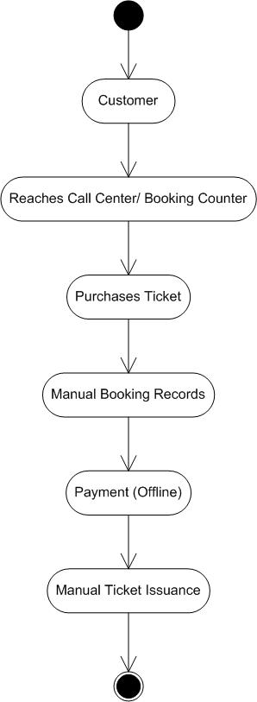

8.2 Proposed Recommendations (TO-BE):

The system represents the optimized, automated, and digital-first version of the online ticketing platform, eliminating manual processes and improving efficiency, security, and user experience.

* Customers can access the online ticketing platform via a website or mobile app.
* Customers can browse events, filter by category, location, date, and price, and view eal-time seat availability.
* The system supports personalized recommendations based on past bookings and preferences.
* This erves as the centralized hub where all ticketing operations takes place.
* Users can log in, register, and securely store their payment and booking history for a seamless experience.
* The platform integrates fraud detection mechanisms to prevent unauthorized transactions and fake ticket sales.
* Event organizers can register, create, and manage events through a dedicated dashboard.
* Event organizers can set ticket pricing, offer discounts, and track real-time sales performance.
* The system provides automated inventory management ensuring no overbooking occurs.
* When a customer selects a ticket, the system instantly checks availability and reserves it.
* Customers receive instant booking confirmation upon payment.
* If event is cancelled or rescheduled, automatic refunds or rescheduling options are processed.
* The system connects with secure and widely-used payment gateways.
* Real-time payment validation ensures seamless transactions without manual intervention.
* Once payment is successful, an e-ticket is generated instantly and delivered via email, SMS, and he mobile app.
* Customers can download or print their tickets or use a QR code for easy event entry.
* Integration with venue access control systems ensures smooth and secure check-ins.

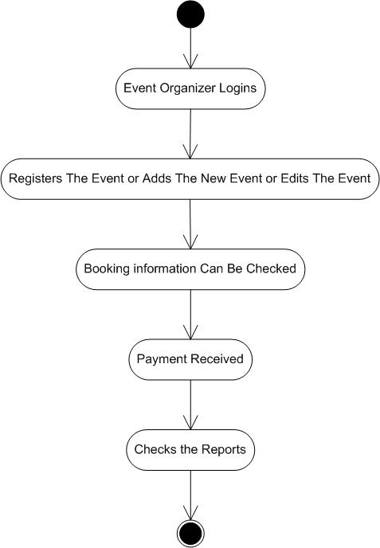

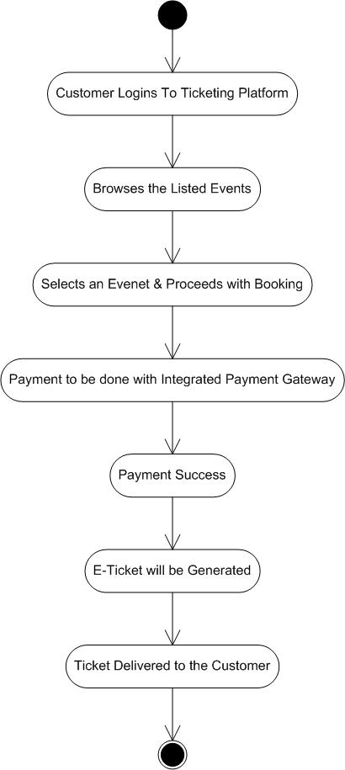

1. Business Requirements

|  |  |  |
| --- | --- | --- |
| Req ID | Requirement Description | Priority |
| BR001 | Users & Event Organizers can register the application using their E-mail or Mobile number | 10 |
| BR002 | Event managers/ Organizers should be able to create, edit, and manage event listings | 10 |
| BR003 | Customers should be able to search and select tickets | 9 |
| BR004 | Customers should be able to filter events based on location, category, price, and availability | 8 |
| BR005 | The system should provide an interactive seat map for customers to choose seats | 6 |
| BR006 | The platform must update ticket availability in real-time to prevent overbooking or double-bookings | 7 |
| BR007 | The system should support various payment methods such as UPI, Credit/ Debit Cards, and Various wallets | 9 |
| BR008 | After the successful payment, an e-ticket should be generated | 10 |
| BR009 | E-tickets should be sent via email and SMS to the customer | 9 |
| BR010 | The system should allow the customers to request refunds or cancellations based on event-specific policies | 8 |
| BR011 | Organizers should access the real-time reports and analytics via dashboards | 6 |
| BR012 | The system should provide live chat, email, and phone support for ticket-related issues | 7 |
| BR013 | Customers should receive real-time notifications for booking confirmation, event reminders, and updates | 5 |
| BR014 | Users should be able to purchase tickets without creating an account using a guest checkout feature | 8 |
| BR015 | Customers should be able to book multiple tickets at once | 7 |
| BR016 | The platform should support different ticket types with variable pricing | 8 |
| BR017 | The system should automatically calculate and process payouts to event organizers after ticket sales. | 6 |
| BR018 | Customers should be able to purchase and redeem gift cards or use in-app wallets for ticket payments | 5 |

1. Appendices

10.1 List of Acronyms

API – Application Programming Interface

OTP – One-Time Password

UI – User Interface

QR Code – Quick Response Code

GDPR – General Data Protection Regulation

CRM – Customer Relationship Management

SMS – Short Message Service

POS – Point of Sale

AI – Artificial Intelligence

UPI – Unified Payments Interface

CCPA – California Consumer Privacy Act

ROI – Return on Investment

10.2 Glossary of Terms

API – Application Programming Interface – A set of rules allowing different software applications to communicate.

Automated Booking System – A system that processes ticket reservations without manual intervention.

Booking Confirmation – A notification sent to the user after a successful ticket purchase.

Cancellation Policy – The rules and conditions under which a customer can cancel their ticket and request a refund.

CRM – Customer Relationship Management – Software used to manage customer interactions, track purchases, and offer personalized services.

Customer Support – Assistance provided to users for issues related to booking, cancellations, and event information.

Reporting and Analytics – Tools and processes used to analyse lead and sales data, providing insights into performance and effectiveness.

Integration – The process of connecting different software systems to allow for seamless data sharing and operational efficiency.

Automated Workflow – A series of automated actions that are triggered based on specific events or conditions within the lead management process.

Data Privacy – Legal and ethical standards governing the collection, storage, and use of personal information, important for compliance.

10.3 Related Documents

Business Requirements Document (BRD): Outlines the business needs, objectives, and requirements for the lead management system.

Functional Requirements Specification (FRS): Details the specific functionalities that the Online Ticketing system must include, based on the business requirements.

Project Scope Statement: Defines the boundaries of the project, including what will be included and excluded in the Online Ticketing system development.

Stakeholder Analysis: Identifies stakeholders involved in the project, outlining their interests, influence, and impact on the Online Ticketing system implementation.

Risk Management Plan: Documents potential risks associated with the Online Ticketing system project, along with mitigation strategies to address those risks.

User Acceptance Testing (UAT) Plan: Outlines the criteria, process, and schedule for validating that the Online Ticketing system meets user needs and expectations before launch.

Training Plan: Details the approach for training users on the new Online Ticketing system, including materials, sessions, and support resources.

Data Migration Plan: Describes the strategy for transferring existing lead data from the legacy system to the new Online Ticketing system, ensuring data integrity and continuity.

Integration Plan: Outlines how the Online Ticketing system will connect with existing systems (like CRM and marketing tools) and the technical requirements for integration.

Change Management Plan: Details the approach for managing changes during the Online Ticketing system implementation, including communication strategies and stakeholder involvement.

System Architecture Document: Provides a high-level view of the technical architecture of the lead management system, including components, interactions, and data flow.

Implementation Plan: Outlines the steps, timeline, and resources required for the successful deployment of the Online Ticketing system.

Maintenance and Support Plan: Details the procedures for ongoing maintenance, updates, and support for the lead management system after implementation.

Quality Assurance Plan: Describes the processes for testing and ensuring the quality of the Online Ticketing system, including functional and non-functional testing.

**Process Flow Diagram**





**SRS Document**

**Introduction:**

1. **Purpose:**

The purpose of this document is to define the requirements of an Online Ticketing System that allows users to browse, book, and manage tickets for events. It’ll support event organizers in managing ticket sales, pricing, and attendance effectively.

1. **Scope:**

The system will provide web and mobile friendly platform for users to book tickets, choose seats, and make secure payments. Event organizers can create and manage events, monitor sales, and track attendance. The system will integrate payment gateways, offer digital tickets with QR codes, and send notifications.

1. **Overview:**

This document covers functional and non-functional requirements, system architecture, constraints, and assumptions for the Online Ticketing System.

**System Overview:**

The online ticketing system is a web and mobile-based platform designed to simplify ticket booking for events such as concerts, movies, sports matches, and conferences. The system provides a seamless experience for users to search for events, select seats, make secure payments, and receive digital tickets. Event organizers can manage event listings, set ticket prices, and track sales analytics.

The platform integrates with multiple payment gateways, ensuring secure transactions. Users receive QR-coded digital tickets, which can be scanned at event entrances for validation. The system also supports real-time notifications, refunds, and promotional discounts. Designed for scalability, the system can handle high traffic loads and offers multi-language support for the users.

**Overall Description:**

1. **Product Perspective:**

The Online Ticketing System will function as a standalone web and mobile application, integrating third-party payment gateways and analytics tools. The system will act as an intermediary between event organizers and customers, facilitating ticket sales, event promotions, and customer engagement. It will provide a user-friendly interface and advanced search and filtering capabilities ensuring ease of access for users of all technical backgrounds.

The system will integrate external payment gateways to handle transactions securely. It will also interface with existing CRM tools to track customer behaviour and provide insights for event organizers.

The online ticketing system is designed to be scalable, supporting multiple event categories such as concerts, sports, theatre, and conferences. It will include features such as loyalty programs, promotional codes, and user reviews to enhance engagement. The platform will be cloud-hosted, ensuring high availability and performance under heavy user traffic.

1. **User Classes and Characteristics:**

* **Customers –** Book tickets, manage bookings, receive event updates.
* **Event Organizers –** Create/manage events, track ticket sales, configure pricing
* **Administration –** Monitor platform activity, manage disputes, handle security.

1. **Operating Environment:**

The online ticketing system will operate in a diverse environment, supporting multiple platforms and technologies to ensure seamless accessibility and performance.

* **Web Application:** The system will be accessible via modern web browsers. It will be built using React.js for a responsive and dynamic user interface.
* **Mobile Application:** Native mobile applications will be available for Android and iOS platforms, developed using Flutter to ensure a consistent use experience across devices.
* **Cloud Hosting:** The system will be hosted on AWS, Azure, or Google Cloud, providing scalability, high availability, and security. Load balancing and auto-scaling mechanisms will be used to handle high traffic.
* **Database Management:** A cloud-based relational database such as PostgreSQL or MangoDB will be used for data storage, ensuring high-speed access to data integrity.
* **Payment Gateway Integration:** Secure transaction processing will be enabled using third-party payment gateways like Stripe, PayPal, and Razorpay.
* **Security and Compliance:** The system will implement SSL/TLS encryption, GDPR Compliance, and multi-factor authentication (MFA) to ensure data protection and regulatory adherence.
* **Performance and Caching:** The system will use CDN services to optimize page loading times and caching mechanisms like Redis to improve performance.
* **Backup and Disaster Recovery:** Automated daily backups will be performed to prevent data loss, with disaster recovery strategies in place to ensure minimal downtime.
* **Notifications and Alerts:** Real-time push notifications and email alerts will be supported via Firebase, Twilio, or SendGrid for user communication.
* **Third-Party Integrations:** The platform will support integrations with CRM tools, analytics services, and event promotion platforms to enhance functionality.

1. **Design and Implementation Constraints:**

* The system must comply with GDPR, PCI-DSS, and local data protection laws to ensure user data security and payment safety.
* The platform must ensure real-time updates for ticket availability to prevent overselling and discrepancies.
* Transactions rely on third-party payment gateways like Stripe, PayPal, and Razorpay, making uptime and performance dependent on their services.
* The system must be highly scalable, capable of handling large traffic loads during peak ticket sales without performance degradation.
* The application must work seamlessly across web and mobile platforms, ensuring a responsive UI and consistent user experience.
* The system must support multiple currencies and languages to cater to global audiences.
* The database must be highly available, with regular automated backups and disaster recovery strategies in place.
* Implementation of SSL/TLS encryption, multi-factor authentication (MFA), and role-based access control to prevent unauthorized access.
* Event organizers will have predefined templates for event pages, limiting dep UI customization to maintain consistency.
* The system will be cloud-hosted, with dependencies on third-party CDN services for performance optimization.
* The system relies on third-party APIs for payment processing, notifications, analytics, and customer support which may introduce external dependencies and potential downtimes.
* The system is primarily designed for online usage, with limited offline capabilities for ticket validation using pre-downloaded QR codes.
* The platform must be compatible with the latest versions of major browsers and mobile operating systems while supporting backward compatibility for a reasonable period.
* Customer support will operate within defined hours, and response times will vary based on ticket priority.
* Limited integration with external event promotion platforms, CRM, and marketing automation tools, depending on API compatibility.
* Refund policies will be managed by event organizers, and the system will not handle direct refunds but facilitate the process through payment gateways.
* Performance testing will be limited to simulated peak loads and may not fully reflect real-world event surges.

1. **Assumptions & Dependencies:**

* The system assumes that users have stable internet connectivity to browse, book tickets, and complete transactions.
* The system relies on services like stripe, paypal, and raorpay, which may have their own processing times and downtimes.
* Each event will have a unique ID to prevent duplicate listings and conflicts in ticket bookings.
* The system assumes that event organizers provide correct event details, pricing, and scheduling.
* Any updates or new features must go through Google Play Store and Apple App Store review processes, which may cause delays.
* Dependencies on external APIs for payments, notifications, and analytics mean any service disruption can affect the system’s functionality.
* Compliance with data protection laws may require periodic updates to the platform.

**Functional Requirements:**

|  |  |  |  |
| --- | --- | --- | --- |
| **Req Id** | **Req Name** | **Req Description** | **Priority** |
| FR001 | Login | Users can login via email, mobile OTP, or social media | 10 |
| FR002 | Profile Update | Users can update profile details and save payment preferences | 7 |
| FR003 | Event Search | Users can browse events by category, location, date, and price | 9 |
| FR004 | Event Listing | Event Organizers can list their events | 10 |
| FR005 | Seat Booking | Customers can select seats using an interactive seat map | 8 |
| FR006 | Ticket Management | Users can view, download, and print purchased ticket | 6 |
| FR007 | Payment Processing | The system should support multiple payment options with secure transactions | 9 |
| FR008 | Refund & Cancellation | Users can cancel tickets based on the event’s refund policy; system automatically processes refunds based on the payment method used | 8 |
| FR009 | Event Pricing | Event organizers can set pricing tiers for different ticket categories | 7 |
| FR010 | Notifications | Users receive email and SMS confirmation after booking | 9 |
| FR011 | Social Media Integration | Users can share events on social media platforms | 6 |
| FR012 | Customer Support | Users can raise support tickets for issues related to bookings | 7 |
| FR013 | Chat Support | System supports live chat support for instant assistance | 8 |
| FR014 | Review & Ratings | Users can leave review and rate events after attending | 7 |
| FR015 | Analytics & Reports | Organizers can export sales reports in Excel/PDF formats | 8 |
| FR016 | Guest Checkout | Users can purchase tickets without registration, using a guest checkout feature | 9 |
| FR017 | Event Rescheduling | Event organizers should be able to reschedule or postpone the events, system should automatically send notifications to users | 7 |
| FR018 | Digital Wallets | Users can add funds to digital-wallet for faster ticket purchases | 6 |
| FR019 | Ticket Sharing | Users can share tickets with friends and family via email or app | 7 |
| FR020 | Multiple Organizer Accounts | Companies can create team accounts where multiple employees can manage a single event | 8 |

**Non-Functional Requirements:**

|  |  |  |  |
| --- | --- | --- | --- |
| **Req ID** | **Req Name** | **Req Description** | **Priority** |
| NFR001 | Scalability | The system should support thousands of concurrent users | 9 |
| NFR002 | Security | The system must comply with industry standards such as SSL/TLS encryption, GDPR, and PCI-DSS | 10 |
| NFR003 | Performance | Page load times should not exceed 3 seconds under normal conditions | 9 |
| NFR004 | Availability | System uptime should be at least 99% | 8 |
| NFR005 | Maintainability | The system should allow easy updates and bug fixes | 8 |
| NFR006 | Usability | The interface should be intuitive and user-friendly | 10 |
| NFR007 | Backup & Recovery | Automated daily backups with a disaster recovery plan should be there | 9 |
| NFR008 | Responsiveness | The UI must be optimized for desktop and mobile devices | 10 |
| NFR009 | Data Integrity | All transactions must be logged and auditable | 8 |
| NFR010 | Fault Tolerance | The system should handle unexpected failures and continue functioning using redundant servers and failover mechanisms | 7 |
| NFR011 | Data Retention | User data should be retained for a specified period and managed according to legal and regulatory requirements | 9 |
| NFR012 | Logging & Monitoring | System logs must be maintained for error tracking, performance monitoring, and security analysis | 8 |
| NFR013 | Session Management | User sessions should expire after a configurable period of inactivity to enhance security | 7 |
| NFR014 | Usability Testing | The system should undergo regular usability testing to ensure an optimal user experience | 9 |
| NFR015 | Browser Compatibility | The web application should work seamlessly across major browsers | 10 |
| NFR016 | Mobile Responsiveness | The platform must be mobile-friendly and optimized for different screen sizes | 10 |
| NFR017 | Payment Processing Speed | Transactions should be processed within 5 seconds to enhance user experience | 9 |
| NFR018 | Notification Delivery | System notifications, including emails and SMS alerts, should be delivered within 10 seconds of a triggering event | 8 |

**System Architecture:**

The Online Ticketing System follows a three-tier architecture, ensuring scalability, security, and efficiency. The system consists of:

* **Presentation Layer (Frontend):** User interfaces for web and mobile applications.
* **Application Layer (Backend):** Business logic and APIs for processing user requests.
* **Data Layer (Database & Storage):** Securely stores event details, user data, and transaction records.

**Presentation Layer (Frontend):**

* Web Application – Built with React.js for an interactive and responsive user experience.
* Mobile Application – Developed using Flutter for cross-platform support on iOS & Android.
* Features – It consists of User Registration & Login, Event Search & Filtering, Seat Selection & Booking, Payment Processing, Ticket Generation, and Notification & Alerts.

**Application Layer (Backend & APIs):**

* Technology Stack – Node.js / Django / Spring Boot.
* Key Functionalities: It consists of the following key functionalities
  + Authentication & Authorization: Secure login, multi-factor authentication (MFA), and user role management.
  + Event Management: CRUD operations for event organizers to create, update, and delete events.
  + Ticket Booking & Payments: API integrations with Stripe, PayPal, and Razorpay.
  + Notifications: Real-time updates using WebSockets, Firebase, or Twilio SMS/Email.
  + Ticket Validation: QR code generation & scanning for event entry validation.
  + User Profile Management: Booking history, preferences, and loyalty rewards.
  + Analytics & Reporting: Event performance insights, sales reports, and user engagement tracking.

**Data Layer (Database & Storage):**

* Primary Database: PostgreSQL / MangoDB (for structured & unstructured data storage).
* Caching Mechanism: Redits for fast retrieval of frequently accessed data.
* File Storage: AWS S3 / Google Cloud Storage for storing digital tickets, event images, and documents.
* Backup & Recovery: Automated daily backups with disaster recovery strategies in place.

**MAKE AN ERD OF CREATING A SUPPORT TICKET**

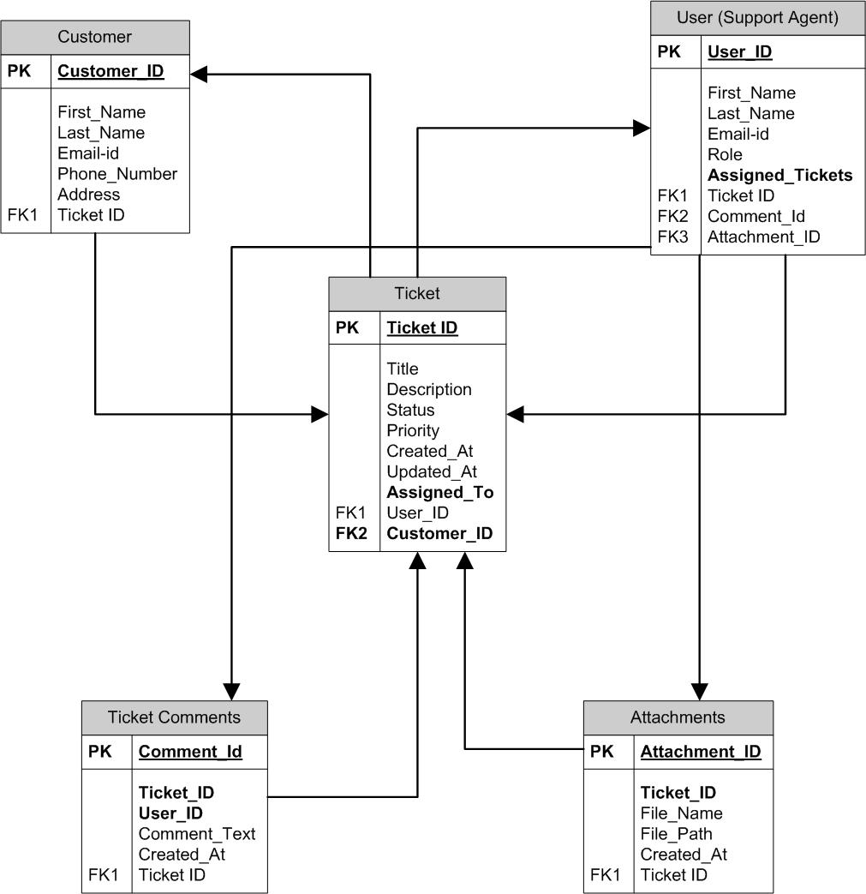

**USER STORY OF SHOPPING FROM E-COMMERCE**

|  |  |  |  |
| --- | --- | --- | --- |
| **User Story No:** 1 | **Tasks:** 2 | | **Priority:** Highest |
| **Value statement:**  As a User,  I want to create an account,  So that I can make purchases | | | |
| **BV: 5**00 | | **CP:** 2 | |
| **Acceptance criteria:**   * User can sign up with an email or mobile number and password. * User receives a confirmation mail. * User cannot register with an existing email or mobile number. | | | |
| **User Story No:** 2 | **Tasks:** 2 | | **Priority:** Highest |
| **Value statement:**  As a User,  I want to log-in securely  So that I can access my account | | | |
| **BV:** 200 | | **CP:** 2 | |
| **Acceptance criteria:**   * User can with valid credentials. * Incorrect credentials show an error message. * Password reset option should be made available. | | | |

|  |  |  |  |
| --- | --- | --- | --- |
| **User Story No:** 3 | **Tasks:** 3 | | **Priority:** Medium |
| **Value statement:**  As a User,  I want to reset my password  If I forget it. | | | |
| **BV:** 100 | | **CP:** 2 | |
| **Acceptance criteria:**   * User can request a password reset. * User receives a resent link via email or otp via mobile number. * User can set up a new password and log in. | | | |

|  |  |  |  |
| --- | --- | --- | --- |
| **User Story No:** 4 | **Tasks:** 1 | | **Priority:** Highest |
| **Value statement:**  As a User,  I want to browse products  So that I can find what I need | | | |
| **BV:** 500 | | **CP:** 2 | |
| **Acceptance criteria:**   * Products are listed. * Products are categorized. * Clicking on a category shows relevant products. | | | |

|  |  |  |  |
| --- | --- | --- | --- |
| **User Story No:** 5 | **Tasks:** 1 | | **Priority:** Medium |
| **Value statement:**  As a User,  I want to search for products  So that I can quickly find specific items | | | |
| **BV:** 200 | | **CP:** 2 | |
| **Acceptance criteria:**   * A search bar is made available. * User searches the items that they need. * Results display matching products with images and prices. | | | |

|  |  |  |  |
| --- | --- | --- | --- |
| **User Story No:** 6 | **Tasks:** 4 | | **Priority:** Medium |
| **Value statement:**  As a User,  I want to filter products  So that I can refine my choices | | | |
| **BV:** 100 | | **CP:** 3 | |
| **Acceptance criteria:**   * Products can be browsed on the site. * Filters are made available for the products. * Applying filters updates product listings. | | | |

|  |  |  |  |
| --- | --- | --- | --- |
| **User Story No:** 7 | **Tasks:** 2 | | **Priority:** Low |
| **Value statement:**  As a User,  I want to view product details  So that I can make informed decisions | | | |
| **BV:** 50 | | **CP:** 1 | |
| **Acceptance criteria:**   * User clicks on the product. * User selects the product details. * Product page includes images, price, description, and reviews. | | | |

|  |  |  |  |
| --- | --- | --- | --- |
| **User Story No:** 8 | **Tasks:** 2 | | **Priority:** Medium |
| **Value statement:**  As a User,  I want to see the product availability status  So that I can purchase the product | | | |
| **BV:** 100 | | **CP:** 1 | |
| **Acceptance criteria:**   * User selects the product. * “In stock” or “Out of stock” is displayed on the product page. | | | |

|  |  |  |  |
| --- | --- | --- | --- |
| **User Story No:** 9 | **Tasks:** 2 | | **Priority:** Low |
| **Value statement:**  As a User,  I want to add a product to my Wishlist  So that I can view for later reference | | | |
| **BV:** 50 | | **CP:** 2 | |
| **Acceptance criteria:**   * User selects the item/ product. * User clicks on “Add to Wishlist” saves the product to Wishlist. | | | |

|  |  |  |  |
| --- | --- | --- | --- |
| **User Story No:** 10 | **Tasks:** 3 | | **Priority:** Medium |
| **Value statement:**  As a User,  I want to add products to my cart  So that I can place order | | | |
| **BV:** 100 | | **CP:** 2 | |
| **Acceptance criteria:**   * User selects the product. * User clicks on “Add to Cart” adds the item to the cart. * Cart displays added items. | | | |

|  |  |  |  |
| --- | --- | --- | --- |
| **User Story No:** 11 | **Tasks:** 2 | | **Priority:** Low |
| **Value statement:**  As a User,  I want to view my cart with product details and total price  So that I can purchase the products | | | |
| **BV:** 100 | | **CP:** 2 | |
| **Acceptance criteria:**   * User clicks on the cart. * Cart shows product name, image, quantity, price, and total. | | | |

|  |  |  |  |
| --- | --- | --- | --- |
| **User Story No:** 12 | **Tasks:** 2 | | **Priority:** Medium |
| **Value statement:**  As a User,  I want to edit my cart  So that I can add or remove items | | | |
| **BV:** 100 | | **CP:** 2 | |
| **Acceptance criteria:**   * User clicks on cart. * Selects the product that user wants to add or remove. * Cart updates automatically. | | | |

|  |  |  |  |
| --- | --- | --- | --- |
| **User Story No:** 13 | **Tasks:** 2 | | **Priority:** Low |
| **Value statement:**  As a User,  I want to proceed to checkout from cart  So that I can by items in the cart | | | |
| **BV:** 200 | | **CP:** 2 | |
| **Acceptance criteria:**   * User clicks on Cart. * User clicks on “Checkout” redirects to the checkout page. | | | |

|  |  |  |  |
| --- | --- | --- | --- |
| **User Story No:** 14 | **Tasks:** 2 | | **Priority:** Highest |
| **Value statement:**  As a User,  I want to add my shipping address  So that I can order items to my address | | | |
| **BV:** 200 | | **CP:** 2 | |
| **Acceptance criteria:**   * User clicks on add new address. * User adds the address or selects the saved one. | | | |

|  |  |  |  |
| --- | --- | --- | --- |
| **User Story No:** 15 | **Tasks:** 3 | | **Priority:** Highest |
| **Value statement:**  As a User,  I want to choose a payment method  So that I can pay for the items. | | | |
| **BV:** 500 | | **CP:** 4 | |
| **Acceptance criteria:**   * User selects the items and clicks on checkout. * In the checkout page user selects the address. * User clicks on payment. * User selects the payment mode from the available (UPI/ Debit Card/ Credit Card/ COD). | | | |

|  |  |  |  |
| --- | --- | --- | --- |
| **User Story No:** 16 | **Tasks:** 2 | | **Priority:** Medium |
| **Value statement:**  As a User,  I want to apply a discount coupon  So that I can get a discount on the item that I’m purchasing | | | |
| **BV:** 100 | | **CP:** 2 | |
| **Acceptance criteria:**   * User clicks on the discount code section. * User enters the discount coupon details. * Valid coupons apply a discount. * Invalid coupons show an error message. | | | |

|  |  |  |  |
| --- | --- | --- | --- |
| **User Story No:** 17 | **Tasks:** 2 | | **Priority:** Lowest |
| **Value statement:**  As a User,  I want to receive an order confirmation after payment  So that I can check my order details | | | |
| **BV:** 50 | | **CP:** 2 | |
| **Acceptance criteria:**   * User confirms and pays for the order. * Post the payment user receives an confirmation over mail | | | |
| **User Story No:** 18 | **Tasks:** 2 | | **Priority:** Highest |
| **Value statement:**  As a User  I want to track my order  So that I can know the status of my order | | | |
| **BV:** 200 | | **CP:** 3 | |
| **Acceptance criteria:**   * User clicks on the orders. * User selects the order to know the status of it. * Clicks on the track order. | | | |

|  |  |  |  |
| --- | --- | --- | --- |
| **User Story No:** 19 | **Tasks:** 2 | | **Priority:** Medium |
| **Value statement:**  As a User,  I want to have an option to cancel the order  So that I can cancel the order | | | |
| **BV:** 50 | | **CP:** 4 | |
| **Acceptance criteria:**   * User selects the order to cancel. * User clicks on the cancel order button. | | | |

|  |  |  |  |
| --- | --- | --- | --- |
| **User Story No:** 20 | **Tasks:** 3 | | **Priority:** Medium |
| **Value statement:**  As a User,  I want to have a request refund option  So that I can request for a refund | | | |
| **BV:** 100 | | **CP:** 3 | |
| **Acceptance criteria:**   * User selects the order. * User click on request for refund. * Selects the reason for requesting a refund & uploads the required details for getting the refund. | | | |

|  |  |  |  |
| --- | --- | --- | --- |
| **User Story No:** 21 | **Tasks:** 2 | | **Priority:** Highest |
| **Value statement:**  As a User  I want to have return option  So that I can return the product within the return period | | | |
| **BV:** 500 | | **CP:** 3 | |
| **Acceptance criteria:**   * User selects the order. * User clicks on return product option. * User selects the valid reason for returning the order. * Return will be accepted if the product is within the return period. | | | |
| **User Story No:** 22 | **Tasks:** 2 | | **Priority:** Medium |
| **Value statement:**  As a User,  I want to edit my profile  So that I can update my information | | | |
| **BV:** 200 | | **CP:** 2 | |
| **Acceptance criteria:**   * User logs in to their account. * User clicks on my account. * Clicks on profile update button and updates the relevant information. * Clicks on save information. | | | |

|  |  |  |  |
| --- | --- | --- | --- |
| **User Story No:** 23 | **Tasks:** 3 | | **Priority:** Lowest |
| **Value statement:**  As a User  I want to save my payment details  So that I can use the details for future purchases. | | | |
| **BV:** 50 | | **CP:** 3 | |
| **Acceptance criteria:**   * User clicks on payment options. * Saved cards details are available at checkout. | | | |

|  |  |  |  |
| --- | --- | --- | --- |
| **User Story No:** 24 | **Tasks:** 4 | | **Priority:** Highest |
| **Value statement:**  As a User  I want to contact customer support  So that I can resolve my issues/concerns | | | |
| **BV:** 500 | | **CP:** 4 | |
| **Acceptance criteria:**   * User logs in to their account. * User selects help/contact support section and chat with them. * User can select a product that they need help and can chat with the customer support. | | | |

|  |  |  |  |
| --- | --- | --- | --- |
| **User Story No:** 25 | **Tasks:** 2 | | **Priority:** Lowest |
| **Value statement:**  As a User,  I want to view recommended products  So that I can view and purchase | | | |
| **BV:** 100 | | **CP:** 3 | |
| **Acceptance criteria:**   * App takes the browsing history of the user. * Suggested products appear based on the browsing history. | | | |

|  |  |  |  |
| --- | --- | --- | --- |
| **User Story No:** 26 | **Tasks:** 2 | | **Priority:** Lowest |
| **Value statement:**  As a User,  I want to view invoices of my orders  So that I can download the invoices when needed | | | |
| **BV:** 100 | | **CP:** 1 | |
| **Acceptance criteria:**   * User selects the product for which they need invoice. * User clicks on invoice and download the invoice when needed. | | | |

|  |  |  |  |
| --- | --- | --- | --- |
| **User Story No:** 27 | **Tasks:** 2 | | **Priority:** Medium |
| **Value statement:**  As a User,  I want to set price alerts for specific products  So that I can purchase products when the price triggers | | | |
| **BV:** 100 | | **CP:** 2 | |
| **Acceptance criteria:**   * User can enable alerts for price drops. * User receives an email or notification when the price changes. | | | |

|  |  |  |  |
| --- | --- | --- | --- |
| **User Story No:** 28 | **Tasks:** 2 | | **Priority:** Lowest |
| **Value statement:**  As a User  I want to select gift wrap options at checkout  So that I can order gift wrapping for the product | | | |
| **BV:** 50 | | **CP:** 1 | |
| **Acceptance criteria:**   * User selects the product. * User selects the “Gift Wrap” option and orders the product. | | | |

|  |  |  |  |
| --- | --- | --- | --- |
| **User Story No:** 29 | **Tasks:** 2 | | **Priority:** Medium |
| **Value statement:**  As a User,  I want to track my shipment in real-time  So that I can view the order status | | | |
| **BV:** 100 | | **CP:** 2 | |
| **Acceptance criteria:**   * User clicks on the order page. * Order tracking page shows the current shipment status. | | | |

|  |  |  |  |
| --- | --- | --- | --- |
| **User Story No:** 30 | **Tasks:** 2 | | **Priority:** Medium |
| **Value statement:**  As a User,  I want to select preferred slot for delivery  So that I can select my preferred delivery time and date. | | | |
| **BV:** 100 | | **CP:** 2 | |
| **Acceptance criteria:**   * Delivery slot options appear at checkout if available. * User can select the preferred date and time for delivery. | | | |

|  |  |  |  |
| --- | --- | --- | --- |
| **User Story No:** 31 | **Tasks:** 2 | | **Priority:** Medium |
| **Value statement:**  As a User,  I want to write review to the product  So that I can leave a review and upload images for a product | | | |
| **BV:** 200 | | **CP:** 3 | |
| **Acceptance criteria:**   * User can select the product from order page. * Users can submit review with text and images. | | | |

|  |  |  |  |
| --- | --- | --- | --- |
| **User Story No:** 32 | **Tasks:** 1 | | **Priority:** Lowest |
| **Value statement:**  As a User,  I want to browse in guest mode  So that I can browse products without creating an account | | | |
| **BV:** 100 | | **CP:** 2 | |
| **Acceptance criteria:**   * Users can open the app. * Users can add products to the cart and checkout as guests. | | | |

|  |  |  |  |
| --- | --- | --- | --- |
| **User Story No:** 33 | **Tasks:** 2 | | **Priority:** Lowest |
| **Value statement:**  As a User,  I want to subscribe for a premium membership  So that I can have exclusive access to products and faster shipping | | | |
| **BV:** 200 | | **CP:** 2 | |
| **Acceptance criteria:**   * Users can purchase a premium membership which is available. * Users will have early access to new products. * Discounts and benefits apply automatically at checkout. | | | |

|  |  |  |  |
| --- | --- | --- | --- |
| **User Story No:** 34 | **Tasks:** 2 | | **Priority:** Medium |
| **Value statement:**  As a User,  I want to subscribe to a product  So that I can have product for automatic reordering at regular intervals | | | |
| **BV:** 100 | | **CP:** 2 | |
| **Acceptance criteria:**   * Users can set up automatic orders. * Payment is processed automatically based on subscription settings. * Subscription can be paused and resumed depending on the requirements. | | | |

|  |  |  |  |
| --- | --- | --- | --- |
| **User Story No:** 34 | **Tasks:** 2 | | **Priority:** Lowest |
| **Value statement:**  As a User,  I want to create a wishlist  So that I can add products | | | |
| **BV:** 50 | | **CP:** 1 | |
| **Acceptance criteria:**   * User can select the product. * User can click on add to wishlist. | | | |

|  |  |  |  |
| --- | --- | --- | --- |
| **User Story No:** 35 | **Tasks:** 2 | | **Priority:** Medium |
| **Value statement:**  As a User,  I want to receive alerts when a sold-item is back in stock  So that I can purchase the product. | | | |
| **BV:** 100 | | **CP:** 2 | |
| **Acceptance criteria:**   * User can select the product. * User can subscribe for back-in-stock notifications. * Email or push notification is sent when stock is available. | | | |

|  |  |  |  |
| --- | --- | --- | --- |
| **User Story No:** 36 | **Tasks:** 2 | | **Priority:** Lowest |
| **Value statement:**  As a User,  I want to see virtual try-on feature  So that I can see how the product looks in real | | | |
| **BV:** 100 | | **CP:** 3 | |
| **Acceptance criteria:**   * User can select the product. * User can select the photo or use a live camera for try-on. | | | |

|  |  |  |  |
| --- | --- | --- | --- |
| **User Story No:** 37 | **Tasks:** 2 | | **Priority:** Lowest |
| **Value statement:**  As a User,  I want to report  So that I can report a fraudulent seller or listing | | | |
| **BV:** 50 | | **CP:** 2 | |
| **Acceptance criteria:**   * Users can flag suspicious products or sellers. * Reports are viewed by the admin team. | | | |

|  |  |  |  |
| --- | --- | --- | --- |
| **User Story No:** 38 | **Tasks:** 3 | | **Priority:** Medium |
| **Value statement:**  As a User,  I want to see 360-degree view of product before buying  So that I can view how the product looks | | | |
| **BV:** 200 | | **CP:** 3 | |
| **Acceptance criteria:**   * Users can select the product. * Product page includes interactive 360-degree images. | | | |

|  |  |  |  |
| --- | --- | --- | --- |
| **User Story No:** 39 | **Tasks:** 2 | | **Priority:** Highest |
| **Value statement:**  As a Seller,  I want to track my sales  So that I can view my earnings through the dashboard | | | |
| **BV:** 200 | | **CP:** 2 | |
| **Acceptance criteria:**   * Seller logs into the dashboard. * Seller dashboard displays total sales, revenue, and pending orders. | | | |

|  |  |  |  |
| --- | --- | --- | --- |
| **User Story No:** 40 | **Tasks:** 2 | | **Priority:** Highest |
| **Value statement:**  As a Seller,  I want to manage product inventory  So that I can receive low-stock alerts. | | | |
| **BV:** 500 | | **CP:** 3 | |
| **Acceptance criteria:**   * Inventory management system alerts sellers when stock is low. * Sellers can track products through inventory management system. | | | |