**Document 6- Please prepare a use case diagram, activity diagram and a use case specification document.**

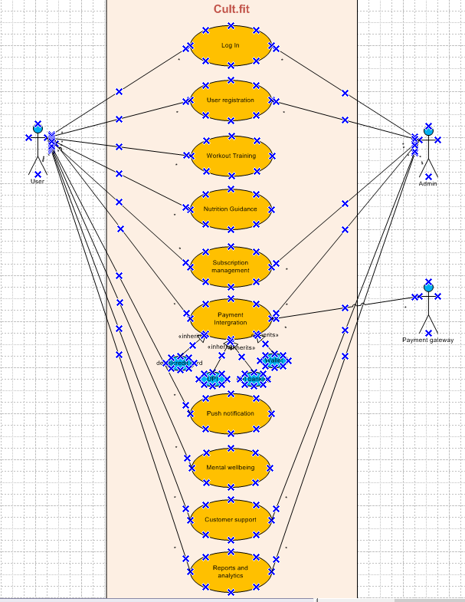



Use case specification document and activity diagram.

Use case specification: UC001- Log In

|  |  |
| --- | --- |
| Use case ID: | UC-001 |
| Use case name: | Log In |
| Description: | Allows registered users to log into the application using valid credentials. |
| Actors: | Registered user |
| Preconditions: | User must be registered and have valid login credentials. |
| Post conditions: | User is authenticated and redirected to the dashboard. |
| Normal flow: | 1. User enters login credentials 2. Clicks on login button 3. System verifies credentials 4. User is logged in |
| Alternative flow: | Invalid credentials: Show error message and retry option |
| Exceptions: | Servers/database errors |

Use case specification: UC002- User Registration

|  |  |
| --- | --- |
| Use case ID: | UC-002 |
| Use case name: | User registration |
| Description: | Allows a new user to register using email or phone. |
| Actors: | New User |
| Preconditions: | User not registered |
| Post conditions: | User is added to the system can log in. |
| Normal flow: | 1. User selects "Register"  2. System prompts for required details  3. User submits form  4. System validates and saves the data  5. Confirmation is shown |
| Alternative flow: | Duplicate email/phone number: show error. |
| Exceptions: | Network/server error |

Use case specification: UC003- Workout Training

|  |  |
| --- | --- |
| Use case ID: | UC-003 |
| Use case name: | Workout Training |
| Description: | Allows user to log workouts, track calories burned and view history. |
| Actors: | Registered user |
| Preconditions: | User must be logged in. |
| Post conditions: | Workout data is stored and analytics updated. |
| Normal flow: | 1. User navigates to Workout section 2. User logs workout data 3. System calculates calories burned 4. User views history |
| Alternative flow: | None |
| Exceptions: | Data entry error |

Use case specification: UC004- Nutrition Guidance

|  |  |
| --- | --- |
| Use case ID: | UC-004 |
| Use case name: | Nutrition Guidance |
| Description: | Provides personalized meal plans and tracks calorie intake. |
| Actors: | Registered user |
| Preconditions: | User must be logged in |
| Post conditions: | Meal plan is generated and calorie intake is recorded. |
| Normal flow: | 1. User opens Nutrition section 2. System recommends meals 3. User logs meal intake 4. Calories are tracked |
| Alternative flow: | No data for recommendation: prompt user to input preferences |
| Exceptions: | API/engine failure for recommendations |

Use case specification: UC005- Subscription Management

|  |  |
| --- | --- |
| Use case ID: | UC-005 |
| Use case name: | Subscription management |
| Description: | Allows user to purchase, renew or cancel subscriptions. |
| Actors: | Registered user |
| Preconditions: | User is logged in. |
| Post conditions: | Subscription status is updated. |
| Normal flow: | 1. User accesses Subscription section 2. Chooses an action (purchase/renew/cancel) 3. System processes request 4. Confirmation is displayed |
| Alternative flow: | Payment failure: Show error |
| Exceptions: | Server/payment system error |

Use case specification: UC006- Payment Integration

|  |  |
| --- | --- |
| Use case ID: | UC-006 |
| Use case name: | Payment integration |
| Description: | Handles secure payments via cards, UPI and wallets. |
| Actors: | Registered user |
| Preconditions: | User initiates a transaction. |
| Post conditions: | Payment is processed and acknowledged. |
| Normal flow: | 1. User selects payment method 2. Enters payment info 3. System validates and completes transaction 4. Receipt/confirmation shown |
| Alternative flow: | Invalid payment details: show error |
| Exceptions: | Payment gateway failure. |

Use case specification: UC007- Push Notification

|  |  |
| --- | --- |
| Use case ID: | UC-007 |
| Use case name: | Push notification |
| Description: | Sends alerts for classes, reminders and offers. |
| Actors: | System background and user |
| Preconditions: | User must be registered for notifications. |
| Post conditions: | Notifications are received by the user. |
| Normal flow: | 1. System checks for new events 2. Sends push notifications 3. User receives alerts |
| Alternative flow: | None |
| Exceptions: | Notification service failure. |

Use case specification: UC008 – Mental Wellbeing Section

|  |  |
| --- | --- |
| Use case ID: | UC008 |
| Use case name: | Mental wellbeing section |
| Description: | Provides guided meditation, stress relief sessions and expert content. |
| Actors: | Registered user |
| Preconditions: | User must be logged in. |
| Post conditions: | User views/accesses wellbeing resources. |
| Normal flow: | 1. User opens Mental Wellbeing section 2. Selects content (meditation/session/article) 3. System delivers selected content |
| Alternative flow: | None |
| Exceptions: | Content loading error |

Use case specification: UC009 – Customer Support

|  |  |
| --- | --- |
| Use case ID: | UC009 |
| Use case name: | Customer support |
| Description: | Users can contact support via chat, email |
| Actors: | Users and customer support agent |
| Preconditions: | User must be logged in and support team is active. |
| Post conditions: | User receives help or issue resolution. |
| Normal flow: | 1. User opens support section 2. Selects contact method 3. System connects to support 4. Support interaction occurs |
| Alternative flow: | No support available: suggest call back/email option. |
| Exceptions: | Chat/email service outage. |

Use case specification: UC010 – Reports and analytics

|  |  |
| --- | --- |
| Use case ID: | UC010 |
| Use case name: | Reports and analytics |
| Description: | Displays user progress reports and nutrition tracking data. |
| Actors: | Registered user |
| Preconditions: | User must have workout/nutrition data logged. |
| Post conditions: | Reports are shown to the user. |
| Normal flow: | 1. User opens Reports section 2. System retrieves data 3. Analytics are generated and displayed |
| Alternative flow: | No data available show message |
| Exceptions: | Data retrieval issues. |

Activity diagram

Log in page



Workout tracking page



Nutrition guidance page



Subscription management page





Customer support page



Repots and analytics page



**Document 7- Screens and pages**

Login page

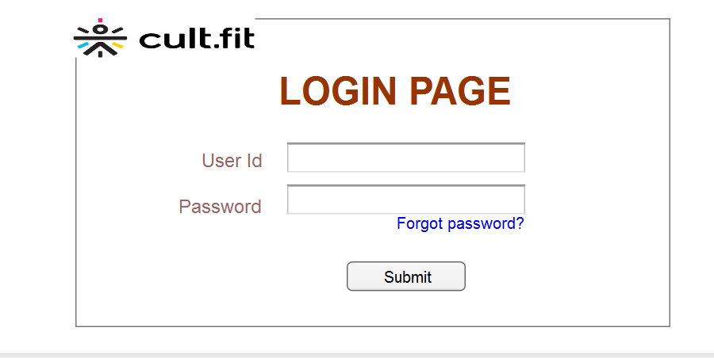



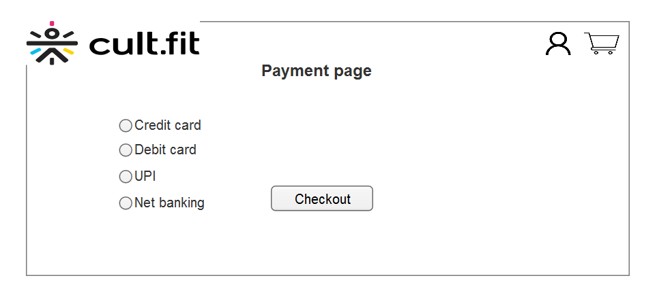

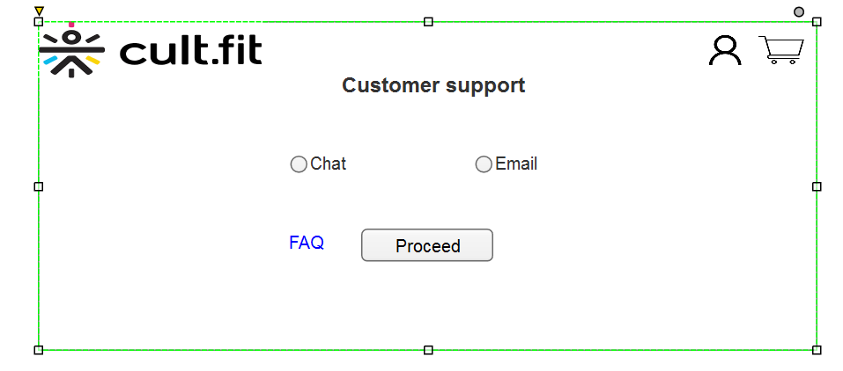

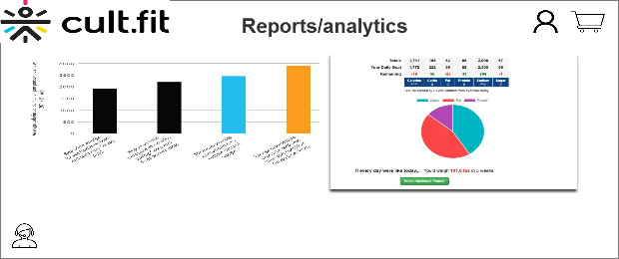

**Document 8- Tools-Visio and Axure**

Microsoft Visio

This tool is used to create UML diagrams, flowcharts and process visualizations that support requirement analysis and system design phases.

Application in the project:

* Use case diagrams- To depict user interactions with the system.
* Activity diagram- For representing the flow of control or data.
* Sequence and class diagrams- Used during discussions with developers and testers to explain object interaction and system structure.
* Shared with stakeholders for visual clarity during requirement walkthroughs and design reviews.

Key features

* Drag and drop functionality for diagramming
* Industry standard for BA documentation
* Great for quick edits and collaboration.

Axure RP

This tool is used for designing interactive wireframes and clickable prototypes, primarily during the design and client validation stages.

Application in the project:

* Created low-fidelity and high fidelity mock-ups of critical pages (e.g. payment page, customer support interface).
* Used dynamic panels and interactions to simulate real time user behaviour.
* Enabled client demonstrations to validate UX decisions and gather feedback before development.
* Integrated notes for documentation directly within the prototype.

Key features

* Powerful for building complex UI behaviour without code
* Supports conditional logic, forms and dynamic content
* Reduces ambiguity by letting stakeholders interact with a real feeling model

In my project, I extensively used **Microsoft Visio** and **Axure RP** to design and visualize system functionalities and user interactions. Visio was instrumental in creating detailed **use case diagrams, activity diagrams**, and **process flows,** which helped in clearly communicating the system’s behaviour and structure to both stakeholders and the development team.

On the other hand, Axure was my go-to tool for building **interactive wireframes and prototypes.** It allowed me to simulate user journeys, test functionality early, and gather feedback efficiently, ensuring that the final design aligned well with user expectations. Together, these tools significantly enhanced the clarity and effectiveness of our requirements documentation and UI/UX validation process.

**Document 9- BA Experience**

As a business analyst on the Cultfit app enhancement project, I played a pivotal role throughout the software development lifecycle, ensuring that business needs were accurately captured, communicated and delivered.

1 Requirement gathering

At the outset, we adopted the MoSCoW technique to prioritize and classify requirements effectively. A unique challenge during this phase was the limited availability of the client, which required me to proactively identify the alternate points of contact from the client’s end and extract critical information on time.

To ensure clarity and feasibility, I validated requirements using FURPS model (functionality, usability, reliability and supportability). During this process I identified and eliminated multiple duplicate and redundant requirements, streamlining scope early on.

We used prototyping techniques to help stakeholders visualize the solution, which also encouraged them to provide more specific and actionable feedback.

2 Requirement analysis

I translated business requirements into UML diagrams and activity diagrams to provide the team with a clear visual understanding of the functional and process flows. Sharing these diagrams prompted valuable team discussion, where I considered and incorporated feedback to ensure alignment across stakeholders.

Simultaneously, I worked on preparing both the business requirement specifications and the software requirement specification (SRS) documents to solidify our project documentation.

3 Design

From the finalized use case diagrams, I delivered detailed test cases, including both positive and negative scenarios, emphasizing the importance of through test coverage to mitigate potential risks in later development stages.

I maintained constant communication with the client to align on design documents and solution approaches, while also updating the requirements traceability matrix to ensure every requirement was being addressed.

4. Development

I facilitated JAD (Joint Application Development) sessions with the technical team to align development with business goals. At times, I encountered resistance and lack of cooperation from certain team members, in these situation I approached them individually to clarify the concerns, reinforce project goals and promote a collaborative atmosphere.

My role also involved clarifying ongoing technical queries, referring back to requirement diagrams and conducting regular meetings with tech team and client. For members unable to attend I recorded sessions and scheduled 1 on 1 catch-ups to ensure no information gaps.

5 Testing

During the testing phase, I prepared test case from use cases and performed high level testing to validate core functionality. I coordinated with the client to obtain test data and updated RTM accordingly.

I facilitated client sign-off on completed features and ensures the client was prepared for User Acceptance Testing (UAT) by providing guidance and walkthroughs.

6 Deployment

As we approached project closure, I forwarded the finalized RTM along with the project closure document to the client. I also coordinated the creation and distribution of end-user manuals and took charge of organizing and delivering training sessions for end users.

I ensured full attendance during these training sessions and worked to make the transition to the enhanced Cultfit app smooth for all stakeholders.

This project gave me comprehensive exposure to the waterfall model, refined my skills in stakeholder management, requirement validation and cross functional communication and solidifies my approach as a proactive and adaptable Business analyst.