Assignment 1:
Business Requirements Document (BRD)
- Document Revisions
Version | Date | Author | Description of Changes
1 | 20/02/25 | P Singa Ram | Initial Draft

- Approvals
Role | Name | Title | Signature | Date
Project Sponsor
Business Owner
Project Manager
System Architect
Development Lead
User Experience Lead
Quality Lead
Content Lead

- RASCI Chart for This Document:
3.1 Codes Used in RASCI Chart:
- R: Responsible (Does the work)
- A: Accountable (Owns the work)
- C: Consulted (Provides input)
- I: Informed (Kept up-to-date)
3.2 RASCI Chart:
Task | Project Manager | Business Analyst | Developers | QA Engineers | DevOps | Stakeholders
Requirement Gathering | A | R | C | I | I | C
System Design | A | R | C | I | I | C
Development | I | C | R | I | C | I
Testing | I | C | C | R | I | I
Deployment | I | C | I | I | R | I
User Training | A | R | I | I | I | C
- Introduction
[Company Name] specializes in manufacturing and distributing ice-cream and milk products. To enhance operational efficiency and customer satisfaction, the company seeks to develop a software solution to manage inventory across manufacturing plants and warehouses while ensuring the quickest delivery to customers.

4.1 Business Goals:
- Increase operational efficiency
- Improve customer satisfaction
- Reduce costs associated with waste and inefficient delivery
- Gain real-time visibility into inventory and delivery processes
4.2 Business Objectives:
- Implement a centralized inventory management system.
- Optimize delivery routes and schedules.
- Provide real-time tracking of orders and deliveries.
- Automate stock replenishment and demand forecasting.
4.3 Business Rules:
- Inventory must be tracked at each stage of the supply chain (manufacturing plant, warehouse, delivery).
- Delivery routes must adhere to traffic regulations and delivery time windows.
- Stock replenishment must be triggered when inventory levels fall below a predefined threshold.
4.4 Background:
Currently, [Company Name] manages inventory and deliveries using manual processes, leading to inefficiencies, inaccuracies, and delays. A software solution is needed to automate these processes and provide real-time visibility into operations.
4.5 Project Objective:
To develop and implement a Manufacturing & Delivery Management System that streamlines inventory management and optimizes delivery operations, resulting in increased efficiency, reduced costs, and improved customer satisfaction.
4.6 Project Scope:
4.6.1 In Scope Functionality:
- Inventory Management: Real-time stock tracking, automated alerts, batch tracking, integration with manufacturing units.
- Delivery Management: Order processing, route optimization, real-time vehicle tracking, customer notifications.
- Reporting and Analytics: Dashboards and reports on inventory levels, delivery performance, and other key metrics.
4.6.2 Out Scope Functionality:
- Integration with payment gateways.
- Management of employee payroll.
- Development of a mobile app for customers to place orders. (Considered for future phases)
- Assumptions:
- Real-time inventory updates are possible from manufacturing units.
- Delivery tracking infrastructure is available.
- Integration with existing ERP systems is feasible.
- Constraints:
- Budget limitations.
- Availability of resources.
- Integration with existing legacy systems.
- Dependency on third-party logistics APIs for delivery tracking.

- Risks:
- Technological Risks: Compatibility with legacy systems.
- Skills Risks: Availability of skilled developers for Java, Golang, and cloud services.
- Political Risks: Data privacy regulations.
- Business Risks: Potential delays in deployment affecting revenue.
- Requirements Risks: Changes in business requirements during development.
- Other Risks: Integration risks with third-party logistics.
- Business Process Overview
- 8.1 Legacy System (AS-IS) Currently, inventory and delivery management are managed manually, leading to delays and inefficiencies.
- 8.2 Proposed Recommendations (TO-BE) The proposed system will automate inventory tracking and delivery management, providing real-time updates and optimized delivery routes.
- Business Requirements
9.1 Functional Requirements
- Inventory Management:
  - Centralized dashboard for inventory monitoring.
  - Automated alerts for low stock and expiry dates.
  - Batch tracking and quality control checks.
  - Integration with manufacturing units for real-time stock updates.
- Delivery Management:
  - Order processing and fulfillment.
  - Route optimization using AI algorithms.
  - Real-time vehicle tracking and dispatch management.
  - Customer notifications (SMS/Email) for order status updates.
9.2 Non-Functional Requirements
  - High availability and scalability.
  - Secure access control and user authentication.
  - Mobile-friendly interfaces for drivers and warehouse managers.
  - Integration with third-party ERP and logistics systems.
- Appendices
10.1 List of Acronyms
- ERP: Enterprise Resource Planning
- AI: Artificial Intelligence
- SMS: Short Message Service
10.2 Glossary of Terms
- Inventory Management: Process of tracking and managing stock levels.
- Route Optimization: Finding the most efficient delivery routes.
10.3 Related Documents
- System Architecture Document
- User Training Manuals

2. Prepare process flow diagram using your imagination.
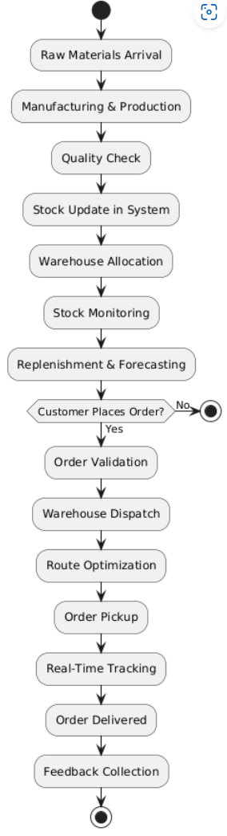
Assignment 2:
1. Write an introduction letter to a client introducing yourself as a business analyst in charge of working with the client and his team to start the business understanding process.

P Singa Ram
Business Analyst
psingaramdrl@gmail.com | 9439438835
20.02.2025

Mr Nagarjuna S
Project Manager
Pure Milk & Ice Creams Pvt Ltd
nagarjunas@puremilnicecream.in
- Subject: Introduction as Your Business Analyst & Next Steps
Dear Nagarjuna S,
I hope this email finds you well. My name is P Singa Ram, and I am the Business Analyst assigned to work with you and your team on the [Project Name]. I am excited to collaborate and assist in understanding your business needs, defining project requirements, and ensuring we build a solution that aligns with your goals.
Our first step will be to conduct a business understanding process, where I will work closely with you to gather insights about your operations, challenges, and expectations for the project. This will help us establish a clear roadmap and ensure the final solution meets your specific needs.
I would love to schedule a kickoff meeting at your convenience to discuss the project scope, key objectives, and next steps. Please let me know a suitable time for you and your team.
Looking forward to working with you and making this project a success. Please feel free to reach out if you have any questions.

Best regards,
P Singa Ram
Business Analyst

Prepare a brief BRD and SRS for a project- Horoscope or Ticketing system or online store.

Business Requirements Document (BRD)
Project Name: Ticketing System
Client: [Client Name]
Date: [Date]
Prepared By: P Singa Ram

1. Introduction
The Ticketing System is designed to manage and track customer or internal support requests efficiently. It enables users to create, assign, and resolve tickets while ensuring proper communication between stakeholders. The system aims to improve response times, enhance issue resolution, and provide insights into operational performance.

2. Goal
The goal of this project is to develop a centralized ticketing system that allows users to report issues, monitor their progress, and ensure timely resolution by support teams.

3. Objectives
- Streamline Ticket Creation & Management: Provide a structured workflow for users to submit, update, and track tickets.
- Enhance Communication: Enable notifications and collaboration between users and support agents.
- Automate Ticket Assignment: Assign tickets based on predefined rules and agent availability.
- Improve Resolution Times: Reduce delays through prioritization and escalation mechanisms.
- Provide Analytics & Reporting: Generate reports on ticket trends, resolution times, and performance metrics.

4. Use Case Diagram
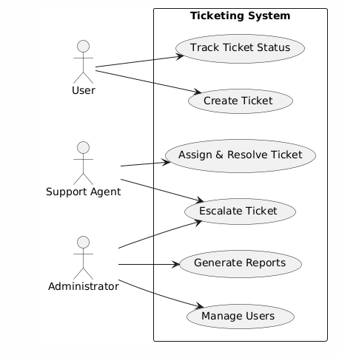

5. Use Case Specification
5.1 Use Case: Create Ticket
Use Case ID | UC-01
Name | Create Ticket
Actor | User
Description | User submits a new ticket describing an issue.
Precondition | User must be logged into the system.
Steps | Ticket is created, assigned, and logged in the system.
1. User navigates to the "Create Ticket" page.
2. User fills in required details (issue description, priority, category).
3. User submits the ticket.
4. System assigns the ticket to an available support agent.
5. Confirmation is displayed, and a notification is sent.
Postcondition
5.2 Use Case: Assign & Resolve Ticket
Use Case ID | UC-02
Name | Assign & Resolve Ticket
Actor | Support Agent
Description | A support agent views, assigns, and resolves a ticket.
Precondition | A ticket must be created and pending resolution.
Steps | The ticket is resolved and marked as closed.
1. Support agent logs into the system.
2. Agent views the list of open tickets.
3. Agent assigns the ticket to themselves or another agent.
4. Agent works on resolving the issue and updates the ticket status.
5. Once resolved, the agent closes the ticket.
6. System notifies the user about resolution.
Postcondition
5.3 Use Case: Escalate Ticket
Use Case ID | UC-03
Name | Escalate Ticket
Actor | Support Agent, Administrator
Description | A ticket is escalated to a higher level of support.
Precondition | A ticket must be unresolved or require higher-level intervention.
Steps | The ticket is resolved at an appropriate support level.
1. Support agent identifies the need for escalation.
2. Agent updates the ticket with escalation details.
3. System notifies the administrator or senior support staff.
4. The escalated ticket is reassigned to a higher-tier support agent.
5. Higher-tier agent resolves and closes the ticket.
Postcondition
5.4 Use Case: Generate Reports
Use Case ID | UC-04
Name | Generate Reports
Actor | Administrator
Description | The administrator generates reports on ticket trends and performance metrics.
Precondition | The system must contain historical ticket data.
Steps | The report is generated successfully and available for analysis.
1. Administrator logs into the system.
2. Admin navigates to the reporting section.
3. Admin selects the desired report type and time frame.
4. System fetches and generates the report.
5. Admin views, downloads, or shares the report.
Postcondition

6. Business Requirements
6.1 Functional Requirements
Ticket Creation & Management
- Users can create new tickets with details such as issue type, priority, and description.
- Support agents can update ticket statuses (e.g., Open, In Progress, Resolved, Closed).
- Tickets can be assigned to specific agents or teams based on predefined rules.
- Users can view and track the status and history of their submitted tickets.
- Support agents can add internal notes, resolutions, and attachments to tickets.
Notification & Communication
- Automated email/SMS notifications for ticket creation, status updates, and resolution.
- In-app notifications for real-time updates on ticket progress.
- Collaboration tools for communication between users and support agents within the ticket.
Ticket Assignment & Routing
- Automated ticket assignment based on agent availability, skills, and workload.
- Escalation mechanisms for high-priority or overdue tickets.
- Manual reassignment of tickets by supervisors or managers.
Reporting & Analytics
- Dashboard displaying key metrics such as ticket volume, resolution time, and agent performance.
- Customizable reports on ticket trends, user satisfaction, and operational efficiency.
- Export reports in various formats (e.g., Excel, PDF).
User Roles & Access Control
- Role-based access control for users, support agents, supervisors, and administrators.
- Permissions to view, edit, or delete tickets based on roles.
- Secure login with multi-factor authentication.
6.2 Non-Functional Requirements
Performance & Scalability
- The system should support concurrent access by at least 1000 users without performance degradation.
- Scalability to handle increased ticket volume during peak periods.
Security
- Secure data storage and transmission with encryption (e.g., SSL/TLS).
- Compliance with data privacy regulations (e.g., GDPR).
- Regular security audits and vulnerability assessments.
Usability & Accessibility
- User-friendly interface with intuitive navigation.
- Accessible to users with disabilities, compliant with WCAG 2.1 standards.
- Responsive design for compatibility with desktop, tablet, and mobile devices.
Reliability & Availability
- System availability of 99.9% to ensure continuous access.
- Automatic failover and disaster recovery mechanisms.
- Regular data backups to prevent data loss.
Integration & Compatibility
- Integration with third-party systems (e.g., CRM, email, SMS gateways).
- Compatibility with major browsers (e.g., Chrome, Firefox, Safari, Edge).
- API support for custom integrations and data synchronization.
Maintainability & Support
- Modular architecture for easy maintenance and updates.
- Comprehensive documentation for developers and end-users.
- Dedicated support team for issue resolution and enhancements.

Make an ERD of creating a support ticket.

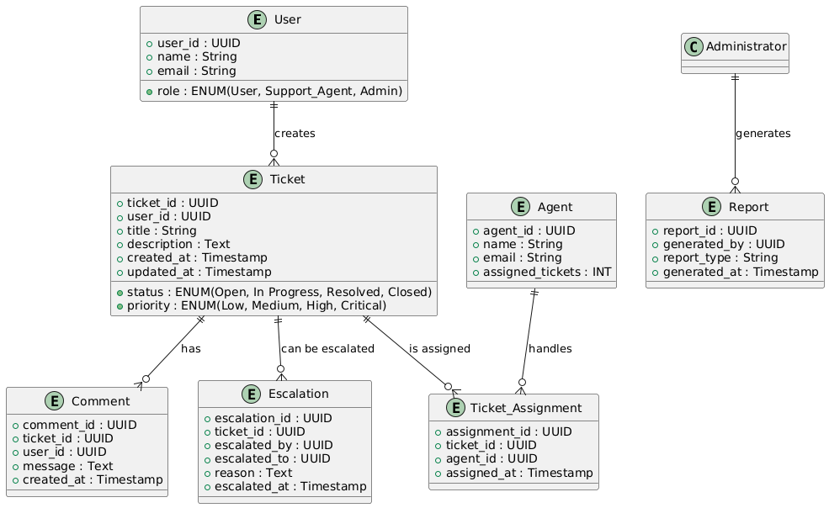

User story of shopping from ecommerce.
User Story No: 1 | Tasks: 03 | Priority: High
I WANT TO CREATE AN ACCOUNT
SO THAT I CAN SAVE MY PERSONAL DETAILS AND TRACK ORDERS
BV: 200 | CP: 03
Acceptance Criteria:
✅ Users should be able to register with an email and password.
✅ Users should receive a confirmation email upon successful registration.
✅ Users should be able to log in using their credentials.
✅ Users should be able to reset their password if forgotten.
User Story No: 2 | | Tasks: 03 | Priority: High
Acceptance Criteria:
As a user, I want to log in securely using my email and password so that I can access my account.
BV: 500 | CP: 03
Acceptance Criteria:
Secure password authentication.
✔ "Remember Me" functionality.
✔ Error handling for invalid credentials.
User Story No: 3 | Tasks: 04 | Priority: High
As a user, I want to reset my password if I forget it so that I can regain access to my account.
BV: 200 | CP: 03
Acceptance Criteria:
✔ Password reset via email.
✔ Password reset link expiration.
✔ Secure password reset process.
User Story No: 4 | Tasks: 04 | Priority: High
As a user, I want to update my profile details so that my information is up to date.
BV: 200 | CP: 03
✔Acceptance Criteria:
Profile update form.
Validation for profile fields.
Confirmation message on update.
User Story No: 5 | Tasks: 04 | Priority: High
As a user, I want to view my order history so that I can track my past purchases.
BV: 100 | CP: 03
Acceptance Criteria:
✔ Order history page.
✔ Display of order details (date, items, amount).
✔ Option to reorder.
User Story No: 6 | Tasks: 04 | Priority: High
As a user, I want to browse products by category so that I can easily find what I need.
BV: 100 | CP: 03
Acceptance Criteria:
✔ Product categories displayed.
✔ Category pages with product listings.
✔ Clear navigation between categories.
User Story No: 7 | Tasks: 04 | Priority: High
As a user, I want to search for products using keywords so that I can quickly find items.
BV: 200 | CP: 03
Acceptance Criteria:
✔ Search bar functionality.
✔ Relevant search results.
✔ Handling of no results.
User Story No: 8 | Tasks: 04 | Priority: High
As a user, I want to filter products by price, brand, and rating so that I can narrow my search results.
BV: 200 | CP: 03
Acceptance Criteria:
✔ Filter options for price, brand, and rating.
✔ Dynamic update of results on filter selection.
✔ Clear display of applied filters.
User Story No: 9 | Tasks: 04 | Priority: High
As a user, I want to sort products by price, popularity, and ratings so that I can find the best deals.
BV: 200 | CP: 03
Acceptance Criteria:
✔ Sort options for price, popularity, and ratings.
✔ Accurate sorting of results.
✔ Visual indication of current sorting order.
User Story No: 10 | Tasks: 04 | Priority: High
As a user, I want to view product details so that I can learn more about a product before purchasing.
BV: 200 | CP: 03
Acceptance Criteria:
✔ Detailed product page.
✔ Product images, description, specifications.
✔ Customer reviews and ratings.
User Story No: 11 | Tasks: 04 | Priority: High
As a user, I want to add products to my shopping cart so that I can purchase them later.
BV: 500 | CP: 03
Acceptance Criteria:
✔ "Add to Cart" button on product page.
✔ Confirmation message on adding to cart.
✔ Cart icon showing number of items.
User Story No: 12 | Tasks: 04 | Priority: High
As a user, I want to remove products from my cart if I change my mind.
BV: 200 | CP: 03
Acceptance Criteria:
✔ "Remove" option for cart items.
✔ Update of cart total on removal.
✔ Confirmation message on removal.
User Story No: 13 | Tasks: 04 | Priority: High
As a user, I want to update the quantity of items in my cart so that I can adjust my order.
BV: 200 | CP: 03
Acceptance Criteria:
✔ Quantity input field for cart items.
✔ Update of cart total on quantity change.
✔ Validation for quantity input.
User Story No: 14 | Tasks: 04 | Priority: High
As a user, I want to save products to my wishlist so that I can buy them later.
BV: 200 | CP: 03
Acceptance Criteria:
✔ "Add to Wishlist" button on product page.
✔ Confirmation message on adding to wishlist.
✔ Wishlist page with saved items.
User Story No: 15 | Tasks: 04 | Priority: High
As a user, I want to move items from my wishlist to my cart so that I can easily purchase them.
BV: 200 | CP: 03
Acceptance Criteria:
✔ "Move to Cart" option on wishlist items.
✔ Update of cart and wishlist on moving items.
User Story No: 16 | Tasks: 04 | Priority: High
As a user, I want to enter my shipping details so that my order is delivered to the correct address.
BV: 500 | CP: 03
Acceptance Criteria:
✔ Shipping address form.
✔ Validation for address fields.
✔ Option to save multiple addresses.
User Story No: 17 | Tasks: 04 | Priority: High
As a user, I want to select a payment method (credit card, PayPal, etc.) so that I can complete my purchase.
BV: 500 | CP: 03
Acceptance Criteria:
✔ Integration with payment gateways (Stripe, PayPal, etc.).
✔ Secure handling of payment information.
✔ Support for multiple payment methods.
User Story No: 18 | Tasks: 04 | Priority: High
As a user, I want to apply discount codes at checkout so that I can save money.
BV: 200 | CP: 03
Acceptance Criteria:
✔ Discount code input field.
✔ Validation for discount codes.
✔ Update of order total on applying discount.
User Story No: 19 | Tasks: 04 | Priority: High
As a user, I want to review my order summary before payment so that I can ensure everything is correct.
BV: 200 | CP: 03
Acceptance Criteria:
✔ Order summary page with all details.
✔ Clear display of items, shipping address, payment method, and total.
✔ Option to edit order before proceeding.
User Story No: 20 | Tasks: 04 | Priority: High
As a user, I want to receive an order confirmation email so that I have proof of my purchase.
BV: 100 | CP: 03
Acceptance Criteria:
✔ Automated order confirmation email.
✔ Email includes order details and tracking information.
User Story No: 21 | Tasks: 04 | Priority: High
As a user, I want to track my order status so that I know when it will be delivered.
BV: 200 | CP: 03
Acceptance Criteria:
✔ Order tracking page.
✔ Real-time updates on order status.
✔ Estimated delivery date and time.
User Story No: 22 | Tasks: 04 | Priority: High
As a user, I want to get notifications for order dispatch and delivery so that I stay informed.
BV: 200 | CP: 03
Acceptance Criteria:
✔ Email or SMS notifications for dispatch and delivery.
✔ Customizable notification preferences.
User Story No: 23 | Tasks: 04 | Priority: High
As a user, I want to change my shipping address before dispatch so that my order reaches the correct location.
BV: 200 | CP: 03
Acceptance Criteria:
✔ Option to edit shipping address on order tracking page.
✔ Validation for new address.
✔ Confirmation message on address update.
User Story No: 24 | Tasks: 04 | Priority: High
As a user, I want to view the estimated delivery time so that I can plan accordingly.
BV: 200 | CP: 03
Acceptance Criteria:
✔ Estimated delivery time displayed on order tracking page.
✔ Updates to delivery time if delays occur.
User Story No: 25 | Tasks: 04 | Priority: High
As a user, I want to contact customer support regarding my order if I have any issues.
BV: 200 | CP: 03
Acceptance Criteria:
✔ "Contact Support" link on order tracking page.
✔ Integration with customer support system.
User Story No: 26 | Tasks: 04 | Priority: High
As a user, I want to request a return if I receive a defective or incorrect product.
BV: 200 | CP: 03
Acceptance Criteria:
✔ "Request Return" option on order details page.
✔ Reason for return selection (e.g., defective, wrong item, size issue).
✔ Option to upload supporting images/videos.
✔ Confirmation message on return request.
✔ Return request status tracking.
As a user, I want to schedule a pickup for returned items so that I don’t have to visit a store.
BV: 200 | CP: 03
Acceptance Criteria:
✔ Option to schedule pickup date and time.
✔ Address selection for pickup (same as delivery or new address).
✔ Confirmation of pickup schedule (date, time, address).
✔ Integration with logistics provider for pickup scheduling.
✔ Option to reschedule or cancel pickup.
User Story No: 28 | Tasks: 04 | Priority: High
As a user, I want to get a refund after my return is approved so that I can receive my money back.
BV: 200 | CP: 03
Acceptance Criteria:
✔ Refund initiated automatically after return approval.
✔ Refund amount calculation (including any applicable deductions).
✔ Notification to user about refund initiation.
✔ Refund status tracking (e.g., pending, processed, completed).
✔ Support for multiple refund methods (original payment method, store credit, etc.).
User Story No: 29 | Tasks: 04 | Priority: High
As a user, I want to exchange a product instead of returning it so that I get the correct item.
BV: 200 | CP: 03
Acceptance Criteria:
✔ "Request Exchange" option on order details page.
✔ Option to select the replacement item (same product in different size/color, or different product).
✔ Exchange request approval process.
✔ Shipping of replacement item after receiving returned item.
✔ Tracking of exchange order.
User Story No: 30 | Tasks: 04 | Priority: High
As a user, I want to receive an email notification about my refund status so that I stay updated.
BV: 200 | CP: 03
Acceptance Criteria:
✔ Automated email notifications about refund status changes (e.g., initiated, processed, completed).
✔ Clear information about refund amount and method in the email.
User Story No: 31 | Tasks: 04 | Priority: High
As a user, I want to leave a review for a product so that I can share my experience.
BV: 200 | CP: 03
Acceptance Criteria:
✔ Text review input field.
✔ Option to add images/videos to the review.
✔ Review submission process.
✔ Display of user's review on the product page.
User Story No: 32 | Tasks: 04 | Priority: High
As a user, I want to rate a product with stars so that I can provide feedback.
BV: 500 | CP: 03
Acceptance Criteria:
✔ Star rating system (e.g., 1 to 5 stars).
✔ Clear visual representation of the rating.
✔ Aggregation of ratings to display average rating.
User Story No: 33 | Tasks: 04 | Priority: High
As a user, I want to view other users’ reviews before purchasing so that I can make an informed decision.
BV: 200 | CP: 03
Acceptance Criteria:
✔ Display of reviews on product page.
✔ Sorting and filtering options for reviews (e.g., by rating, date).
✔ Clear indication of reviewer information (e.g., username, date).
User Story No: 34 | Tasks: 04 | Priority: High
As a user, I want to report fake or inappropriate reviews so that the platform maintains quality.
BV: 200 | CP: 03
Acceptance Criteria:
✔ "Report" button or link on reviews.
✔ Reporting process with reason selection.
✔ Moderation system for handling reported reviews.
User Story No: 35 | Tasks: 04 | Priority: High
As a user, I want to ask questions about a product so that I can get more details before buying.
BV: 200 | CP: 03
Acceptance Criteria:
✔ "Ask a Question" section on product page.
✔ Question input field.
✔ Display of questions and answers.
✔ Notification to sellers about new questions.
User Story No: 36 | Tasks: 04 | Priority: High
As an admin, I want to add new products to the catalog so that customers can purchase them.
BV: 200 | CP: 03
Acceptance Criteria:
✔ Product creation form with required fields (name, description, price, images, etc.).
✔ Product categories and tags management.
✔ Product visibility and status control (e.g., active, inactive).
✔ Confirmation message on successful product creation.
User Story No: 37 | Tasks: 04 | Priority: High
As an admin, I want to manage product inventory so that out-of-stock products are updated.
BV: 200 | CP: 03
Acceptance Criteria:
✔ Real-time inventory tracking.
✔ Low stock alerts and notifications.
✔ Option to update inventory levels manually or via bulk upload.
✔ Automatic update of product status to "out of stock" when quantity reaches zero.
User Story No: 38 | Tasks: 04 | Priority: High
As an admin, I want to process orders and manage deliveries so that customers receive their items on time.
BV: 200 | CP: 03
Acceptance Criteria:
✔ Order management dashboard with order details and status.
✔ Option to assign orders to delivery personnel.
✔ Integration with delivery tracking system.
✔ Delivery status updates and notifications.
User Story No: 39 | Tasks: 04 | Priority: High
As a seller, I want to view sales analytics and reports so that I can track my business performance.
BV: 200 | CP: 03
Acceptance Criteria:
✔ Sales dashboard with key metrics (revenue, orders, units sold, etc.).
✔ Customizable reports with filters and date range selection.
✔ Data visualization tools (charts, graphs) to display sales trends.
User Story No: 40 | Tasks: 04 | Priority: High
As a seller, I want to respond to customer queries about my products so that I can provide better service.
BV: 200 | CP: 03
Acceptance Criteria:
✔ Customer query management system.
✔ Notification of new customer queries.
✔ Option to respond to queries and track their status.
✔ Integration with customer support system.

