**Online Agriculture Products Store Part :2  
1. Prepare 4 quarterly Audits for BA:**

|  |  |
| --- | --- |
| **Stage** | **Q1 Audit Report (Requirement gathering phase)** |
| **Completed** | 9-10 weeks |
| **Check list** | BRD Template |
|  | Elicitation results report |
|  | Duplicate requirement report |
|  | Grouping of functionalities-feature client sign off |
|  | Email communication |
| **Stage** | **Q2 Audit Report (Requirement Analysis phase)** |
| **Completed** | 8-9weeks (9th to 20th week) |
| **Check list** | UML Diagrams |
|  | Business to functional req. mapping |
|  | Client sign off document |
|  | RTM document version control |
|  | Email communication |
| **Stage** | **Q3 Audit Report (Design)** |
| **Completed** | 8-9 weeks (21st to 29th week) |
| **Check list** | Tool utilization |
|  | Documented proofs on client communication |
|  | Stakeholder MOM |
|  | Email communication |
| **Stage** | **Q4 Audit Report (Development)** |
| **Completed** | 35 weeks (30st to 64th week) |
| **Check list** | JAD session report |
|  | End user manual preparation |
|  | BA and Developer MOM |
|  | Email communication |

**2. Ba approach strategy:**1. What Elicitation techniques to apply:  
 We have many elicitation techniques to apply used to gather requirements.  
 Brainstorming, Document analysis, Reverse engineering, focus groups & observation.  
2. How to do Stakeholder analysis RACI:  
 Stakeholder can be divided using RACI (Responsible, Accountable, Consulted and informed). This way we can perform stakeholder analysis.  
3. Documents to be prepared:  
 BRD, FRD Use case documentation, test case documents etc.  
4.What process to follow to sign off on Documents:   
 Sign off to be taken on SRS this is a primary & important document.Sign off can be taken by using E-mail confirmation from Client.  
5.How to take approvals from the Client:  
 Establish a formal meeting with the clients to keep them informed and get continuous feedback6.What Communication channels to establish n implement:  
 Regular meetings-weekly, status meetings, bi-weekly sprint reviews, and monthly stakeholders updates.  
7.How to handle change request:  
 Change request form, Do impact analysis, approval process, documentation.8.How to update the progress of the project to the stakeholders:  
 Weekly status reports, monthly review meetings.  
9.How to take sign off on the UAT-Client project acceptance form:  
 UAT preparation, conduct UAT, fix issues, acceptance form, final review, obtain sign-off  
  
**3. 3-Tier approach:**   
3-Tier Architecture is a software design pattern that separates an application into three layers: Presentation, Business Logic, and Data. This improves scalability, maintainability, and security.

**1. Presentation Layer (Client Tier)**

Role: User interface that interacts with end users.  
Technologies: HTML, CSS, JavaScript, React, Angular, Vue.js.  
Examples: Web browsers, mobile apps, desktop applications.

**2. Business Logic Layer (Application Tier)**Role: Processes business rules, logic, and workflows.Technologies: Java, Python, .NET, Node.js, Spring Boot, Express.js.Examples: API servers, middleware, authentication services.

**3. Data Layer (Database Tier)**Role: Stores and manages application data.Technologies: MySQL, PostgreSQL, MongoDB, Oracle DB.Examples: User accounts, transaction history, product inventory.

User Interaction (Presentation Layer) – The user submits a request via a web app or mobile app.Processing (Business Logic Layer) – The application processes the request, applies business logic, and interacts with the database.Data Retrieval (Data Layer) – The database fetches the required data and sends it back through the business layer to the user interface.  
  
**4. BA approach strategy or framing questions:**  
The 5W1H framework is useful tool for gathering information and understanding a situation by answering questions abput who, what, when, where, why and how.  
  
The SMART technique can help in creating questions: Specific, measurable, attainable, relevant & time bound.  
  
The RACI charts help define and clarify roles and responsibilities within the team by outlining who is responsible, accountable, consulted and informed for each task.  
  
UML is standardized way of diagramming and modeling software systems to aid in design, development and communication between team members.

An activity diagram, a type of Unified Modeling Language (UML) diagram, visually represents the flow of activities within a system or process, similar to a flowchart, but with more specific symbols and notations  
  
**5.Elicitation Techniques:**

**1. Interviews**One-on-one or group discussions with stakeholders to gather information.  
Understanding business needs, clarifying requirements.  
Time-consuming, dependent on stakeholder availability.

**2. Surveys & Questionnaires**A set of structured questions sent to multiple stakeholders.  
Collecting quantitative data and feedback from a large audience.  
Low response rates, unclear responses.

**3. Workshops**Interactive sessions involving multiple stakeholders.  
Brainstorming, collaborative requirement gathering, aligning stakeholders.  
Requires skilled facilitation and stakeholder availability.

**4. Focus Groups**A selected group of stakeholders discussing their needs and expectations.  
Gathering diverse perspectives on a product or service.  
Group dynamics can sometimes lead to biased feedback.

**5. Observation (Job Shadowing)**Watching users perform their tasks in real-time.  
Understanding real workflows and identifying pain points.  
Users may alter behavior when observed (Hawthorne effect).

**6. Document Analysis**Reviewing existing documents, reports, policies, or system artifacts.  
Understanding current processes, legal constraints, and historical data.  
Documents may be outdated or incomplete.

**7. Prototyping**Creating visual models or wireframes of a system before development.  
Validating user requirements and refining UI/UX.  
Requires time and design expertise.

**8. Brainstorming**Generating multiple ideas in a group setting without judgment.  
Exploring new solutions and innovative ideas.  
Can be unstructured if not facilitated well.

**9. Mind Mapping**Visually organizing ideas and relationships. Structuring complex ideas and identifying dependencies. Requires visualization tools or skilled facilitators.

**10. Interface Analysis:** Evaluating how different systems interact with each other. Understanding data flow between applications. Requires technical knowledge of integrations.  
  
**6.Justify the project elicitation techniques:  
1. Surveys & Questionnaires**A set of structured questions sent to multiple stakeholders.  
Collecting quantitative data and feedback from a large audience.  
Low response rates, unclear responses.  
  
**2. Brainstorming**Generating multiple ideas in a group setting without judgment.  
Exploring new solutions and innovative ideas.  
Can be unstructured if not facilitated well.  
  
**3.JAD sessions**  
It’s a structured workshop-based method that brings together stakeholders, users, BAs, developers, and other key participants in a focused, facilitated session to identify and agree on software requirements.

**7. 10 Business requirements:** BR001: Farmer should be able to search for available products in fertilizers, seeds, pesticides.  
BR002: Manufacturers should be able to upload and display their products in the application**.**BR003: farmer should be able to check the variety of products for same category.  
BR004: Farmer should be able to filter the products on the basis of price, weight, brands.  
BR005: Farmer should be able to give feedback to the manufacturer and rate the product.  
BR006: farmer should be able to get invoice on mail and the tracking status on sms.  
BR007: Manufacture should be able to add new product to category.  
BR008: Logistic and delivery agents should be able to update the tracking status to order.  
BR009: Farmer should be able to return the product if it is no matching the expectations.  
BR010: Manufacturer should be able to update regarding availability of product. **8. Assumptions:**1. A user can login using facebook or google account.  
2. A user has a minimum farming knowledge.  
3. Online shopping trend is increasing, the farmers prefer online shopping.  
4. The manufacturer has the products to add into the category in the application, the need is to reach at right person.  
5. The logistic and delivery system has found the rout to reach such remote locations. **9.The project requirements Priority:**

|  |  |  |  |
| --- | --- | --- | --- |
| Req. ID | Name | Description | Priority |
| BR001 | Farmer search  for product | Farmer should be able to search for available products in  fertilizers, seeds, pesticides. | 10 |
| BR002 | Manufacturer upload  products | Manufacturers should be able to upload and display  their products in the application. | 3 |
| BR003 | Farmer browse  diff product | farmer should be able to check the variety of products  for same category. | 5 |
| BR004 | Farmer filter  out products | Farmer should be able to filter the products on the basis of  price, weight, brands. | 4 |
| BR005 | Feedback to vendors | Farmer should be able to give feedback to the manufacturer and  rate the product. | 6 |
| BR006 | Order documents | farmer should be able to get invoice on mail and the tracking status on sms. | 8 |
| BR007 | Manufacturer add  product category | Manufacture should be able to add new product to category. | 1 |
| BR008 | Logitics update  the status | Logistic and delivery agents should be able to update the tracking  status to order. | 9 |
| BR009 | Return policy  for farmer | Farmer should be able to return the product if it is no matching the expectations. | 7 |
| BR010 | Availibility update  of product | Manufacturer should be able to update regarding availability of product. | 2 |

**10. Use case Diagram:**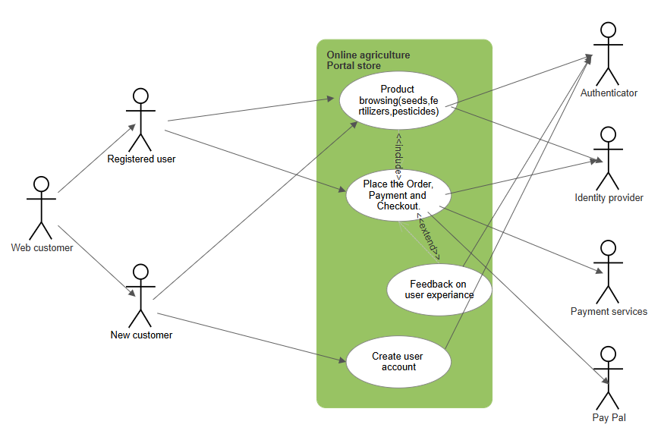

Online Agriculture product store

**11. Use case specification:**

|  |  |
| --- | --- |
| Use case ID | APUC001 |
| Use case name | Farmer login into the application |
| Actor | Farmer |
| Description | Farmer wants to buy some seeds, he will login into the online platform |
| Pre condition | The internet connectivity should be there. The mobile app or desktop brower should be avilable Valid credential |
| Post condition | User should be successfully logged in. |
| Basic flow | User search the portal website Enter the user name & password Click on submit |
| Alternate flow | If the user is not logged in, prompt to register or proceed as guest. |
| Exception flow | Login failed-Display error page |
| Includes | NA |
| Extends | Forget password |
| Business rule | without valid credential cannot login to portal |
| Priority | High |
| Frequency of use | Very often |
| Assumptions | Valid credentials |
| Notes or issue | Write forget password use case separate |

|  |  |
| --- | --- |
| Use case ID | APUC002 |
| Use case name | Farmer checkout with expected product application |
| Actor | Farmer |
| Description | Farmer wants to buy some seeds, he found the expected one and place order |
| Pre condition | The internet connectivity should be there. The mobile app or desktop brower should be avilable Valid credential |
| Post condition | User should be able to place order for expected product successfully. |
| Basic flow | User search the portal website Browse the expected product Select one and checkout |
| Alternate flow | If the user is not logged in, prompt to register or proceed as guest. |
| Exception flow | Payment failure — display error and allow retry. |
| Includes | Checkout |
| Extends | User exp feedback |
| Business rule | Payment should be done. All mandatory fields should be filled. |
| Priority | High |
| Frequency of use | Very often |
| Assumptions | Paymentgateway is available |
| Notes or issue | Write Refund/return use cases separately. |

|  |  |
| --- | --- |
| Use case ID | APUC003 |
| Use case name | Farmer write down the review for received product |
| Actor | Farmer |
| Description | Farmer wants togive the review of the ordered product. |
| Pre condition | The internet connectivity should be there. The mobile app or desktop brower should be avilable Valid credential |
| Post condition | User should be able towrite the review for received product |
| Basic flow | User search the portal website Browse the expected product Select received one and write down the review. |
| Alternate flow | If the review window is not available throw error |
| Exception flow | Failed to upload review — display error and allow retry. |
| Includes | Log out |
| Extends | NA |
| Business rule | Product should be order. Star rating and photo is mandate |
| Priority | low |
| Frequency of use | Rarely |
| Assumptions | Feedback window is available |
| Notes or issue | Write Refund/return use cases separately. |

|  |  |
| --- | --- |
| Use case IDD20D18C3:D19C3:D19C3:D18 | APUC004 |
| Use case name | Manufacturer add the new product |
| Actor | Manufacturer |
| Description | Manufacturer wants add new product to category. |
| Pre condition | The internet connectivity should be there. The mobile app or desktop brower should be avilable Valid credential |
| Post condition | User should be able to add the new product to respective category. |
| Basic flow | User search the portal website Login into manufacturer account enter the new product details, pictures and value. And post it |
| Alternate flow | If the posting is not accessible, throw error |
| Exception flow | Failed to upload post — display error and allow retry. |
| Includes | Retry |
| Extends | NA |
| Business rule | Fill all the manadate fields Update the stock details |
| Priority | High |
| Frequency of use | Very often |
| Assumptions | Add new window is available |
| Notes or issue | Write remove product use cases separately. |

|  |  |
| --- | --- |
| Use case IDD20D18C3:D19C3:D19C3:D18 | APUC005 |
| Use case name | Delivery agents update the tracking status |
| Actor | Delivery agents |
| Description | Delivery agent wants update the tracking status |
| Pre condition | The internet connectivity should be there. The mobile app or desktop brower should be avilable Valid credential |
| Post condition | User should be able to update the tracking status ordered product . |
| Basic flow | User search the portal website Login into logistic account account Update the tracking status of the product |
| Alternate flow | the status is not updating, throw error |
| Exception flow | Failed to update the status — display error and allow retry. |
| Includes | Retry |
| Extends | NA |
| Business rule | Fill all the manadate fields Update the tracking status |
| Priority | High |
| Frequency of use | Very often |
| Assumptions | Add product tracking status window is available |
| Notes or issue | Write stock status of product use cases separately. |

**12.Activity diagrams:**

