# **SunKey**

# Document 1: Definition of Done

**Introduction**

In the development of the lease management platform for Sun Communities, the Definition of Done (DoD) ensures that each feature such as lease creation, payment integration, ledger visibility, and billing is fully completed, validated, and meets business expectations. It aligns the Agile team on what “done” truly means, maintaining consistent quality and readiness for production deployment.

**Purpose and Scope**

The DoD outlines the completion criteria for user stories and product increments delivered within each sprint. Its purpose is to guarantee that all functionalities such as MH/RV lease processing, payment workflows, and property bill visibility are not only developed and tested but also accepted by stakeholders and ready for customer use. This standard applies to every deliverable in the system and ensures the platform remains reliable, scalable, and user-friendly.

**DoD Checklist**

* **User Story Acceptance Criteria Met:** All functional requirements like lease submission, payment, and ledger view are met and validated by the Product Owner.
* **Code Developed & Peer Reviewed:** Lease management and payment processing code is written, peer-reviewed, and approved as per project standards.
* **Unit Testing Completed**: Backend services for lease processing, payment gateway integration, and ledger updates are covered by unit tests.
* **Code Merged into Main Branch**: Clean, functioning code is merged without conflicts or critical bugs impacting other modules.
* **Feature Passed QA Testing:** Features such as lease creation, bill generation, and payment flows pass regression and functional testing.
* **UI/UX Verified**: The application interface (MH/RV screens, ledger view, etc.) matches approved wireframes and is user-friendly across devices.
* **Documentation Updated**: User help guides (e.g., how to lease a property or check bills) and technical system flow diagrams are updated.
* **Demo Completed with Stakeholders**: New features are demoed with internal teams (e.g., operations, compliance) and feedback is addressed.
* **Ready for Production Deployment**: Features are stable, tested across environments, and ready for rollout in production without further rework.
* **Retrospective Feedback Addressed**: Lessons from sprint retrospectives (e.g., issues in payment handling or validations) are documented and resolved.

## Document 2- Product Vision

|  |  |
| --- | --- |
| **Scrum Project** | |
| **Name:** | **SunKey Project** |
| **Venue:** | Unykloud Office / Virtual Meeting (Zoom or Teams) |
| **Date:** | 04th April 2025 |
| **Start time:** | 04th April 2025 |
| **End time:** | 01st April 2027 |
| **Duration:** | 2 Years |
| **Client:** | Sun Communities |
| **Stakeholder list:** | Business Analyst: Srikar |
| Product Owner: Chaitanya |
| Developers: Jay Krishna |
| Testers: Nageshwar rao |
| Designers: Vasantha Lakshmi |
| Marketing Team: Neha, Subi |
| Sun Users: Srivatsav, Raghuveer |

|  |  |
| --- | --- |
| **Scrum Team** | |
| **Scrum Master:** | James Beyonc |
| **Product owner:** | Khaleed Ahmend |
| **Scrum Developer 1:** | Daniel Clings |
| **Scrum Developer 2:** | Brandy Nelson |
| **Scrum Developer 3:** | Paramesh |
| **Scrum Developer 4:** | Ankit Singh |
| **Scrum Developer 5:** | Prabhu |

|  |  |
| --- | --- |
| **Vision**: To create a seamless, user-friendly digital platform that simplifies MH/RV lease management, enhances customer experience, and ensures transparency in property billing and payments. | |
| **Target Group** | **Market Segment:** Residential real estate leasing, specifically focusing on manufactured homes (MH) and recreational vehicle (RV) communities.  **Target Users:** Potential and existing Sun Communities residents looking to lease MH/RV properties, manage payments, and view property-related information online.  **Target Customers:**   * **Primary:** End-users (residents/tenants) interacting with the platform for lease and billing. * **Secondary:** Sun Communities' internal teams (e.g., leasing agents, support staff, compliance teams) who manage property operations and customer interactions. |
| **Needs** | **Problem Solved:** The traditional lease process was manual, time-consuming, and lacked transparency in billing, ledger updates, and payment tracking for MH/RV customers.  **Benefits Provided:**   * Offers a **centralized digital platform** for residents to lease properties, view ledgers, and make payments easily. * Improves **transparency and accuracy** in billing and property-related transactions. * Reduces **manual intervention** for Sun Communities staff, streamlining operations and improving customer satisfaction. |
| **Product** | **What product is it?:** It is a digital lease management platform designed for Sun Communities that enables customers to lease MH/RV properties, view their ledgers, pay bills, and manage property-related transactions seamlessly.  **What makes it desirable and special?**   * Provides a self-service experience with real-time access to lease and payment information. * Combines ease of use with complete transparency, reducing dependency on manual support. * Tailored specifically for MH/RV property leasing, addressing a niche but essential market segment.   **Is it feasible to develop the product? :** Yes, the product is technically and operationally feasible. It has already been developed and enhanced through Agile iterations, with active user feedback and stakeholder involvement guiding continuous improvement. |
| **Value** | **How is the product going to benefit the company?**   * Enhances operational efficiency by automating lease and payment processes. * Improves customer satisfaction and retention through a smooth digital experience. * Reduces manual workload for staff, saving time and reducing errors. * Enables data-driven decisions through real-time access to customer and financial data.   **What are the business goals?**   * Streamline lease management and billing for MH/RV properties. * Digitize customer interactions to minimize physical paperwork and delays. * Scale the leasing process efficiently as customer demand grows. * Increase transparency and trust in billing and financial processes.   **What is the business model?**   * The platform operates as an internal service platform for Sun Communities, supporting its leasing operations. * Revenue is generated indirectly by improving customer onboardingspeed, reducing service costs, and enabling faster lease closures. * Supports long-term value through customer retention and improved operational scalability. |

# Document 3: User stories

|  |  |  |
| --- | --- | --- |
| **User story No:** 001 | **Tasks:** Develop an online lease application form for tenants. | **Priority:** High |
| **Value statement:** As a user (tenant), I want to submit a lease application online, so that I can easily apply for an MH/RV lease without visiting an office. | | |
| **BV:** Reduces manual paperwork and processing time.   Improves customer convenience and application tracking. | | **CP:** Eliminates delays in lease processing caused by manual paperwork.  Provides real-time confirmation of lease application submission. |
| **Acceptance criteria:**   * The user should be able to fill out and submit the lease application online. * The system should validate required fields and eligibility criteria. * A confirmation email should be sent upon successful submission. | | |

|  |  |  |
| --- | --- | --- |
| **User story No:** 002 | **Tasks:** Implement a payment module for tenants to pay their lease bills online. | **Priority:** High |
| **Value statement:** As a user (tenant), I want to view and pay my lease bills online, so that I can manage my payments efficiently and avoid late fees. | | |
| **BV:** Reduces missed payments and late fees.  Improves cash flow for Sun Communities by ensuring timely payments. | | **CP:** Eliminates the need for in-person payments.  Provides transparency in billing and payment history. |
| **Acceptance criteria:**   * The user should be able to view outstanding bills in the app. * Payment processing should be secure and support multiple payment methods. * A receipt should be generated and emailed after a successful transaction. | | |

## Document 4: Agile PO Experience

**Key Responsibilities & Contributions:**

* Defined the product vision and roadmap, ensuring alignment with Sun Communities' strategic goals.
* Managed and prioritized the product backlog, focusing on high-impact features like lease applications, ledger tracking, and online payments.
* Created user stories with clear acceptance criteria, ensuring seamless collaboration between business and development teams.
* Worked closely with UI/UX designers to deliver an intuitive user experience for tenants and leasing administrators.
* Led Sprint Reviews and Demos, collecting stakeholder feedback to refine and enhance features iteratively.
* Ensured timely and high-quality feature delivery while adapting to evolving business needs.

**Sprint Meetings I’ve Managed:**

* **Sprint Planning:** Defined sprint objectives, prioritized backlog items, and estimated effort with the team.
* **Daily Stand-ups:** Tracked progress, addressed blockers, and ensured continuous development flow.
* **Sprint Review:** Showcased completed features to stakeholders and gathered feedback for future iterations.
* **Sprint Retrospective:** Analyzed sprint performance, identifying improvements for better team efficiency.

**User Stories Creation:**

* Developed clear, actionable user stories using the INVEST principle (Independent, Negotiable, Valuable, Estimable, Small, Testable).
* Example: As a tenant, I want to submit a lease application online, so that I can secure an MH/RV lease without visiting an office.
* Ensured each user story had well-defined acceptance criteria, facilitating smooth development and validation.

**Scrum Role and Responsibilities:**

* Acted as the Product Owner, ensuring Agile best practices were followed for iterative and value-driven development.
* Collaborated with the Scrum Master to remove roadblocks and keep the development team aligned with sprint goals.
* Maintained continuous communication with stakeholders, ensuring business requirements were accurately translated into product features.
* Ensured incremental product releases, allowing for early user feedback and continuous product refinement.

**Vision of the Product’s Function and Operation:** The **MH/RV Lease Management Platform** is designed to streamline lease applications, payments, and tenant ledger management for Sun Communities. It provides an intuitive digital experience where tenants can easily apply for a lease, view billing details, and make secure payments, reducing manual paperwork and improving operational efficiency. The system ensures seamless lease processing, real-time financial tracking, and compliance with leasing regulations, ultimately enhancing customer satisfaction and business performance.

## Document 5: Product and sprint backlog and product and sprint burndown charts

**A.**

**Product Backlog**

|  |  |  |  |  |  |  |
| --- | --- | --- | --- | --- | --- | --- |
| User Story ID | User Story | Tasks | Priority | BV | CP | Sprint |
| US001 | As a tenant, I want to submit a lease application online, so I can lease a home without visiting the office. | Design lease application form UI and  Integrate form with backend API | High | 8 | 5 | 1 |
|  |  |  |  |  |  |
| US002 | As a tenant, I want to view my payment ledger, so I can track my rent dues and history. | |  | | --- | | Create ledger view UI and |  |  | | --- | |  |  |  | | --- | | Fetch and display ledger data |  |  | | --- | |  | | High | 7 | 4 | 2 |
|  |  |  |  |  |  |

**Sprint Backlog**

|  |  |  |  |  |  |  |  |  |  |  |  |
| --- | --- | --- | --- | --- | --- | --- | --- | --- | --- | --- | --- |
| |  | | --- | | **User Story ID** |  |  | | --- | |  | | |  | | --- | | **User Story** |  |  | | --- | |  | | Tasks | Owner | Status | | **Estimated Effort (hrs)** | | --- |  |  | | --- | |  | |
| US001 | |  | | --- | | As a tenant, I want to submit a lease application online, so I can lease a home without visiting the office. |  |  | | --- | |  | | |  | | --- | | Design lease application form UI |  |  | | --- | |  | | |  | | --- | | UI Developer |  |  | | --- | |  | | |  | | --- | | In Progress |  |  | | --- | |  | | |  | | --- | | 8 hrs |  |  | | --- | |  | |
| Integrate form with backend API | |  | | --- | | Backend Dev |  |  | | --- | |  | | |  | | --- | | To Do |  |  | | --- | |  | | 10hrs |

**Sprint Burndown:**

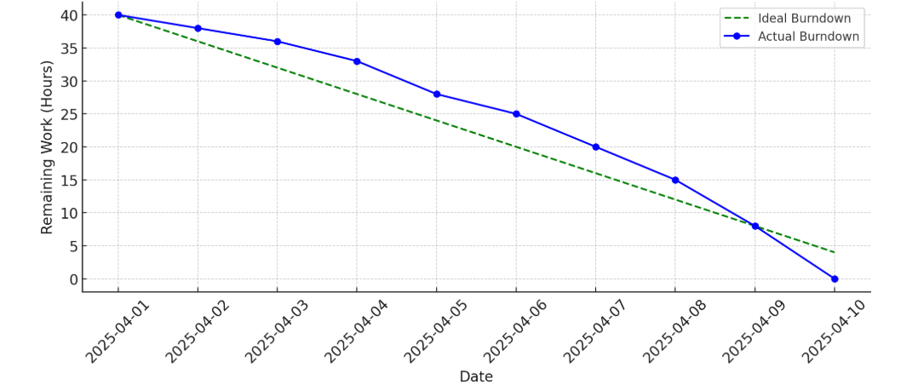

**Product burndown:**

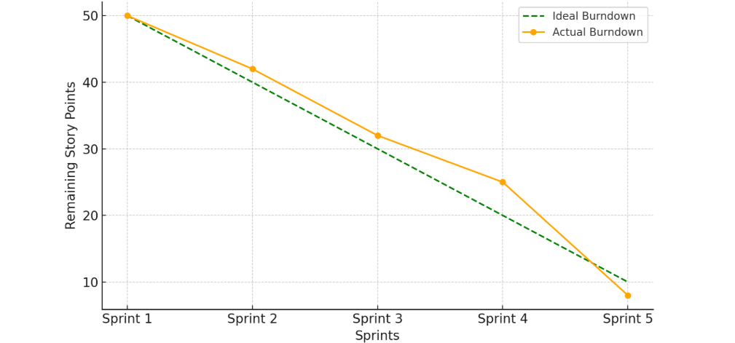

## Document 6: Sprint meetings

**Meeting Type 1: Sprint Planning meeting**

|  |  |
| --- | --- |
| **Date** | 1st April 2025 |
| **Time** | 11:00 AM |
| **Location** | Zoom |
| **Prepared By** | Srikar |
| **Attendees** | Kamalesh, Nagar, Avesh |

**Agenda Topics**

|  |  |
| --- | --- |
| **Topic** | How many sprints can be planned to completed this project and total efforts required. |
| **Presenter** | Srikar |
| **Time Allotted** | 60 min |

**Other Information**

|  |  |
| --- | --- |
| **Observers** | Stakeholders, Sun IT lead |
| **Resources** | Project backlog, Sprint backlog, JIRA board |
| **Special Notes** | Focus on UI enhancements |

**Meeting Type 2: Sprint review meeting**

|  |  |
| --- | --- |
| **Date** | 01st Aug 2025 |
| **Time** | 11:00 Am |
| **Location** | Teams |
| **Prepared by** | Srikar |
| **Attendees** | Tilak, Digvesh, Rishab, Jamie. |

**Agenda Topic**

|  |  |
| --- | --- |
| **Topic** | Demo |
| **Presenter** | Sai |
| **Time Allotted** | 15 mins |

|  |  |
| --- | --- |
| **Sprint status** | Completed UI design fixes, Backend API optimization and Dark mode feature |
| **Things to demo** | Improved website loading speed, Dark mode |
| **Quick updates** | Bug fixes, Minor UI enhancements |
| **What’s next** | Add real time data sync |

**Meeting Type 3: Sprint retrospective meeting**

|  |  |
| --- | --- |
| **Date** | 1st Nov 2025 |
| **Time** | 11:00 Am |
| **Location** | Teams |
| **Prepared by** | Vaishnavi |
| **Attendees** | Santner, Morgon |

|  |  |
| --- | --- |
| **Agenda** | To discuss and review the team performance. |
| **What went well** | Successfully delivered 1 milestone |
| **What didn’t go well** | It will be more efficient if we have all the required accesses before the development phase. |
| **Questions** | N/A |
| **Reference** | N/A |

**Meeting Type 4: Daily Stand-up meeting**

|  |  |  |  |  |  |  |  |  |
| --- | --- | --- | --- | --- | --- | --- | --- | --- |
| **Question** | **Name/Role** | **Week “1” (from 01-04-2025 to 07-04-2025)** | | | | | | |
|  |  | **Monday** | **Tuesday** | **Wednesday** | **Thursday** | **Friday** | **Saturday** | **Sunday** |
| **What did you do yesterday?** | **Developer 1:** Jaykrishna | Worked on login module | Fixed API bugs | Performed code review | Refractured codebase | Implemented New Feature | WO | WO |
| **Developer 2:** Nagnath | Resolved UI issues | Worked on performance fixes | Updated database schema | Created unit tests | Added error handling | WO | WO |
| **Developer 3:**  Santosh | Worked on frontend design | Integrated third party API’s | Conducted testing | Fixed UI responsiveness | Provided demo to client | WO | WO |
| **What will you do today?** | **Developer 1:** Jaykrishna | Develop search functionality | Create API endpoints | Write unit tests | Work on UI refinements | Perform regression testing | WO | WO |
| **Developer 2:** Nagnath | Work on security patch | Create CD pipeline | Fix reported bugs | Review Code | Test stage environment | WO | WO |
| **Developer 3:**  Santosh | Develop user profile module | Enhance UX design | Review backend logic | Add error logging | Update documentation | WO | WO |
| **What (If any) is blocking your progress?** | **Developer 1:** Jaykrishna | Lack of test data | Waiting for API response | Dependency on DevOps team | Unstable staging environment | Pending code review | WO | WO |
| **Developer 2:** Nagnath | Database downtime | Environment Issues | Delayed code review | Unclear requirements | Lack of test coverage | WO | WO |
| **Developer 3:**  Santosh | Access issue to server | Waiting for credentials | Broken build pipeline | Slow network connection | Lack of testing resources | WO | WO |