A company is having manufacturing plants and warehouses in various parts of the country. They manufacture ice-cream and milk products. They want to build software to achieve two goals.
- Manage the inventory
- Quickest delivery to the customers

Case Study: Mother Dairy – Smart Inventory & Delivery Management
Mother Dairy, a leading manufacturer of ice-cream and milk products, operates multiple manufacturing plants and warehouses across the country. With rising demand, the company faced challenges in inventory control and fast delivery. Issues such as overstocking in some warehouses, shortages in others, manual record-keeping, and inefficient delivery routes were affecting customer satisfaction and increasing operational costs.
To resolve these challenges, Mother Dairy initiated the development of a centralized software system named DairyComp. This platform will provide real-time inventory monitoring, AI-powered demand forecasting, and smart route optimization to ensure the quickest deliveries. It will integrate warehouse management, order processing, and GPS tracking for end-to-end visibility from production to doorstep delivery.
The solution is expected to deliver up to 30% faster deliveries, minimize wastage of perishable goods, ensure better stock availability, and reduce logistics costs. Through a structured implementation plan—covering requirement gathering, design, development, testing, and deployment— DairyComp will transform Mother Dairy’s supply chain into an efficient, reliable, and customer-focused operation.

Assignment 1
1. Please make a BRD which can be presented to the client along with complete development and resource plan .
Business Requirements Document (BRD)
Project Name: DairyComp – Smart Inventory & Delivery Management System
Client: Mother Dairy Pvt. Ltd.
Version: 1.0
Date: 11 August 2025
Prepared by: [Your Name] – Business Analyst
1. Document Revisions
Date | Version No. | Document Changes
05/02/2025 | 0.1 | Initial Draft
10/02/2025 | 0.2 | Added Functional Requirements section
15/02/2025 | 0.3 | Added Requirement Traceability Matrix
20/02/2025 | 0.4 | Added feedback from stakeholders
25/02/2025 | 1.0 | Final version approved by Project Sponsor

2. Approvals
Role | Name | Title | Signature | Date
Project Sponsor | Mr. Rajesh Kumar | Director – Operations
Business Owner | Ms. Anjali Mehta | Head – Supply Chain
Project Manager | Mr. Vivek Sharma | IT Project Manager
System Architect | Mr. Sandeep Verma | Lead System Architect
Development Lead | Ms. Ritu Malhotra | Senior Software Development Lead
User Experience Lead | Mr. Karan Desai | UX/UI Design Lead
Quality Lead | Ms. Priya Nair | QA & Testing Lead
Content Lead | Mr. Arvind Gupta | Technical Documentation Lead

3. RASCI Chart for This Document
Codes Used in RASCI Chart
- * Authorize – Has ultimate signing authority for any changes to the document.
- R Responsible – Responsible for creating this document.
- A Accountable – Accountable for accuracy of this document.
- S Supports – Provides supporting services in the production of this document.
- C Consulted – Provides input (such as an interviewee).
- I Informed – Must be informed of any changes.
Name | Position | * | R | A | S | C | I
Mr. Rajesh Kumar | Project Sponsor | * |  |  |  | C | I
Ms. Anjali Mehta | Business Owner |  |  | A |  | C | I
Mr. Vivek Sharma | Project Manager |  | R | A | S | C | I
Mr. Sandeep Verma | System Architect |  |  |  | R | C | I
Ms. Ritu Malhotra | Development Lead |  |  |  | R | C | I
Mr. Karan Desai | User Experience Lead |  |  |  | S | C | I
Ms. Priya Nair | Quality Lead |  |  |  | S | C | I
Mr. Arvind Gupta | Content Lead |  |  |  | R | C | I

4. Introduction
4.1. Business Goals
Mother Dairy aims to transform its supply chain operations through a centralized, technology-driven solution—DairyComp—to address critical challenges in inventory management, demand forecasting, and delivery optimization.
The organization’s primary goals are:
- Ensure real-time inventory visibility across all manufacturing plants and warehouses to prevent overstocking and stockouts.
- Improve delivery speed by up to 30% through AI-powered route optimization.
- Minimize wastage of perishable goods by implementing predictive analytics for demand forecasting.
- Integrate operational processes from production to doorstep delivery for seamless coordination.
- Enhance customer satisfaction through improved product availability and on-time delivery.

Organization Need:
Due to the rapid increase in product demand, manual record-keeping and fragmented systems have led to inefficiencies, high logistics costs, and inconsistent customer experiences. An integrated IT solution is essential to streamline operations, optimize resources, and maintain competitiveness in the FMCG market.

4.2. Business Objectives
To provide an IT solution for:
- Mobile Application for Android and iOS platforms
- E-Learning Management System (LMS) for employee training and operational efficiency:
- Human Resource Management System (HRMS) for managing workforce operations:
4.4. Background
Mother Dairy, a leading producer of ice-cream and milk products, operates multiple manufacturing plants and warehouses across the country. Over time, the company has experienced significant challenges in managing its supply chain effectively due to:
- Overstocking in certain warehouses leading to wastage of perishable goods.
- Stock shortages in other locations causing delays and customer dissatisfaction.
- Manual inventory tracking, resulting in errors and inefficiencies.
- Inefficient delivery route planning, increasing transportation costs and delaying deliveries.
To address these issues, the company proposed the DairyComp project—an integrated IT platform that will unify inventory control, demand forecasting, order management, and delivery optimization. By implementing DairyComp, Mother Dairy expects:
- 30% faster deliveries through AI-powered route planning.
- Reduced wastage by aligning production and distribution with demand forecasts.
- Improved customer satisfaction through timely deliveries and better product availability.
- Lower operational costs by streamlining processes and reducing manual work.

4.5. Project Objective
The main objective of the DairyComp project is to design, develop, and implement a centralized

- smart inventory and delivery management solution:
- Alignment with Business Objectives:
- Requirements for Interaction with Other Systems:
4.6. Project Scope
The DairyComp project will focus on delivering a Smart Inventory & Delivery Management System for Mother Dairy using the Waterfall methodology.
In this phase, our focus is on providing essential features like:
- Mobile applications for Android and iOS.
- AI-powered inventory forecasting.
- Route optimization for deliveries.
- HRMS for staff management.
- E-Learning platform for employee training.

4.6.1. In-Scope Functionality
The following functionalities will be developed and delivered in the current project:
- Centralized Inventory Management with real-time stock updates across all plants and warehouses.
- AI-driven Demand Forecasting to predict stock requirements and avoid overstock/shortages.
- Order Management System for processing, tracking, and managing customer orders.
- Delivery Route Optimization using GPS integration for shortest and fastest delivery paths.
- Mobile Applications (Android & iOS) for customers, delivery personnel, and warehouse staff.
- E-Learning Management System (LMS) for employee training and operational guidelines.
- Human Resource Management System (HRMS) for staff records, payroll, and attendance.
- Integration with ERP for procurement, finance, and supplier management.
- Automated Notifications & Alerts for stock replenishment, order status, and delivery updates.
- Analytics & Reporting Dashboard for business insights and performance tracking.

4.6.2. Out-of-Scope Functionality
The following functionalities are not included in the current project:
- Integration with international warehouse systems outside the country.
- Multi-language support (initial release will be in English only).
- Drone-based delivery system for product distribution.
- Automated production line control within manufacturing plants.
- Customer loyalty program integration (planned for future phase).
- Augmented Reality (AR) features in the mobile app for product visualization.
- In-built payment gateway (will use third-party integration only).

5. Assumptions
The following assumptions have been made while defining the requirements for the DairyComp project:
- All manufacturing plants and warehouses have stable internet connectivity to enable real-time data synchronization.
- Required hardware (servers, handheld devices, GPS trackers) will be procured and installed before system deployment.
- Stakeholders will be available for timely feedback during requirement gathering and testing phases.
- Mobile application will be compatible with the latest two versions of Android and iOS.
- Integration with existing ERP or accounting systems will be supported via APIs.
- Data security and compliance requirements will be provided by the client at the start of the design phase.
6. Constraints
The following constraints will apply to the DairyComp project:
- The project must be completed within the approved budget and timeline (6 months).
- Development will follow the Waterfall methodology, with no overlapping phases.
- All functionalities must comply with FSSAI and relevant government regulations for food storage and delivery.
- Mobile app size should not exceed 100 MB for both Android and iOS versions.
- System must support a maximum of 10,000 concurrent users without performance degradation.
- The application must be hosted on the client’s preferred cloud provider (AWS).
- Only English will be supported in the initial release; regional languages will be out of scope for Phase 1.

7. Risk Analysis
7.1. Technological Risks
- Integration challenges between mobile apps, AI forecasting, and legacy ERP systems could cause delays. Mitigation: Conduct early API integration tests and prepare fallback APIs.
- AI forecasting model may underperform if there is insufficient historical data. Mitigation: Collect enough data before training and allow post-launch tuning.
- Dependency on GPS accuracy for route optimization may lead to incorrect delivery paths. Mitigation: Use multiple GPS providers and provide manual route entry options.

7.2. Skills Risks
- Lack of experienced AI/ML developers may impact the forecasting module. Mitigation: Hire consultants or upskill current staff.
- Shortage of developers skilled in both Android and iOS development could delay mobile app delivery. Mitigation: Use a cross-platform framework like Flutter or React Native.

7.3. Political Risks
- Changes in local or state government policies could affect dairy product distribution. Mitigation: Maintain compliance with regulations and monitor policy updates.
- Interstate transport restrictions could delay deliveries. Mitigation: Maintain buffer inventory in regional warehouses.

7.4. Business Risks
- If the project is canceled, inefficiencies in inventory and delivery will persist, leading to revenue loss. Mitigation: Regularly review project progress to ensure business alignment.
- Competitors may release similar systems earlier, reducing competitive advantage. Mitigation: Fast-track critical features and use phased releases.

7.5. Requirements Risks
- Incomplete requirement gathering due to limited stakeholder availability may lead to missed features. Mitigation: Conduct multiple requirement workshops and get documented sign-offs.
- Misinterpretation of user needs for route optimization may lead to dissatisfaction. Mitigation: Create prototypes and collect feedback before development.

7.6. Other Risks
- Natural disasters (floods, heavy rains) could disrupt dairy delivery. Mitigation: Keep contingency routes and extra stock.
- Vendor delays in supplying IT infrastructure could postpone project milestones. Mitigation: Have secondary vendor agreements in place.

8. Business Process Overview
The DairyComp project will follow the Waterfall methodology, with each phase completed before moving to the next. The overall process flow is:
- Requirement Gathering – Collect detailed requirements from Mother Dairy stakeholders, covering inventory, delivery, HRMS, and e-learning needs.
- System Design – Create system architecture, database design, and user interface mock-ups for mobile and web applications.
- Development – Build core modules including inventory management, delivery route optimization, HRMS, and training platform.
- Testing – Perform unit, integration, system, and user acceptance testing to ensure functionality, performance, and security.
- Deployment – Implement the system in Mother Dairy’s environment, launch mobile apps, and migrate essential data.
- Maintenance & Support – Provide ongoing updates, bug fixes, and performance enhancements post-launch.

8.1. Legacy System (AS-IS)
Currently, Mother Dairy manages inventory and deliveries through manual record-keeping and isolated software tools, leading to:
- Lack of real-time stock visibility.
- Delays in delivery route planning.
- No predictive analytics for demand forecasting.
- High manual intervention for order tracking and updates.
8.2. Proposed Recommendations (TO-BE)
The proposed Smart Inventory & Delivery Management System will:
- Automate inventory tracking with real-time updates.
- Use AI-powered forecasting to predict demand and manage stock levels.
- Optimize delivery routes through GPS-enabled route planning.
- Integrate HRMS for staff management and payroll.
- Include an e-learning platform for continuous employee training.
- Provide mobile apps (Android & iOS) for easy order tracking and management.
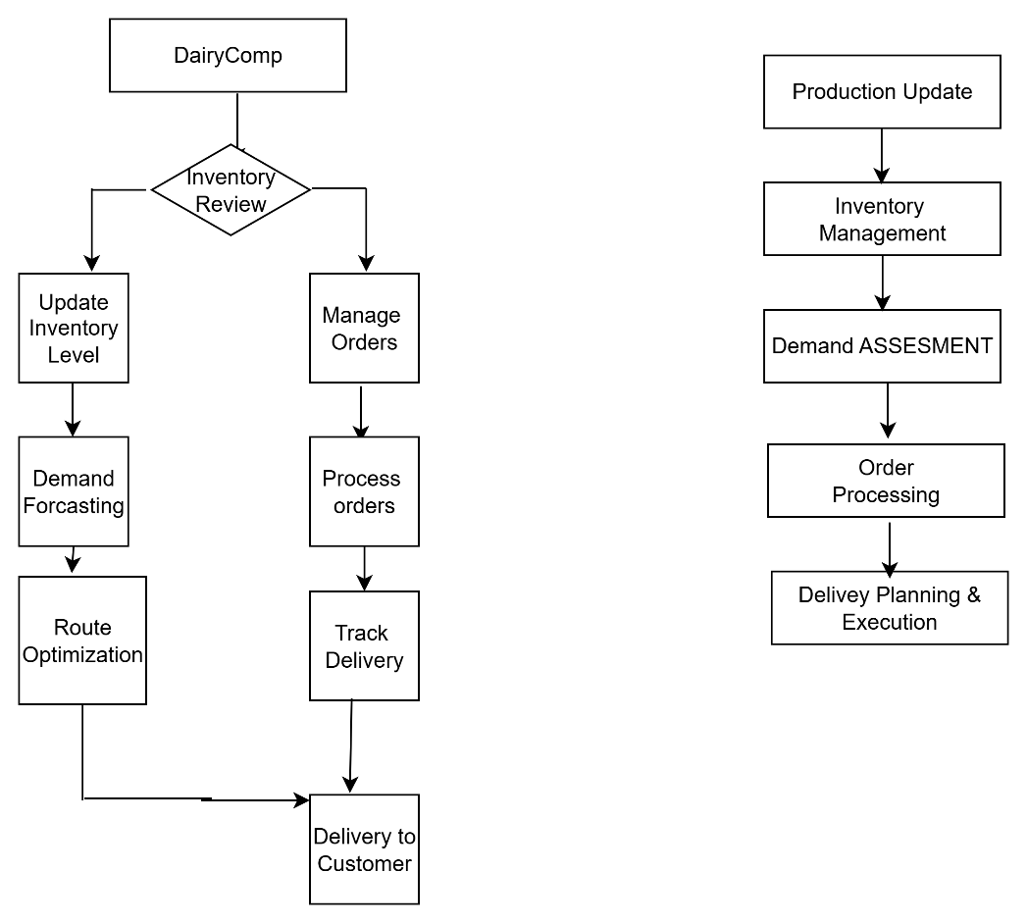
As- Is
To-BE

9.Business Requirement
Req. ID | Business Requirement | Priority
BR-01 | Real-time inventory tracking across all warehouses | High
BR--02 | Automated low-stock alerts and reorder triggers | High
BR-03 | Batch and expiry date tracking for perishable items | Medium
BR-04 | Stock adjustment audit trail for accountability | Medium
BR--05 | GPS-enabled route optimization for fastest delivery | High
BR--06 | Real-time delivery status updates for customers | High
BR—07 | Vehicle load planning and scheduling | Medium
BR-08 | Mobile and web-based order placement | High
BR-09 | Integration with payment gateways (UPI, cards, net banking) | High
BR-10 | Order modification and cancellation | Medium
BR-11 | AI demand prediction based on seasonal trends | High
BR-12 | AI-based suggestions for optimal stock levels | Medium
BR-13 | Employee attendance and payroll management | High
BR-14 | Performance tracking and reporting | Medium
BR-15 | Online training modules for staff | High
BR-16 | Progress tracking and quiz-based evaluation | Medium

Functional Requirement
No. | Requirement Type | Requirement | Description
FR1 | Functional | Real-time Inventory Tracking | System should allow warehouse managers to view live stock levels across all locations.
FR2 | Functional | AI-powered Demand Forecasting | Predict future demand using historical sales and seasonal patterns.
FR3 | Functional | Smart Route Optimization | Generate fastest and most cost-effective delivery routes using GPS data.
FR4 | Functional | Order Management | Create, track, and update orders from placement to delivery.
FR5 | Functional | Warehouse Transfer Management | Initiate and track stock transfers between warehouses to balance inventory.
FR6 | Functional | Alerts & Notifications | Send automatic alerts for low stock, delayed deliveries, or overstock situations.
FR7 | Functional | GPS Vehicle Tracking | Monitor delivery vehicles in real-time for location and estimated delivery time.
FR8 | Functional | Role-based Access Control | Different user permissions for Admin, Warehouse Manager, Driver, and Customer Support.
FR9 | Functional | Delivery Confirmation | Capture electronic proof of delivery (POD) including digital signature or photo.
FR10 | Functional | Integration with ERP | Connect DairyComp with existing ERP for accounting and invoicing.

Non functional Requirement
No. | Requirement Type | Requirement | Description
NFR1 | Non-Functional | Performance | System should process and update inventory data within 2 seconds.
NFR2 | Non-Functional | Scalability | Should support addition of new warehouses, delivery hubs, and users without downtime.
NFR3 | Non-Functional | Security | Use encryption (AES-256) for data at rest and TLS 1.3 for data in transit.
NFR4 | Non-Functional | Reliability | Maintain 99.9% uptime for the system.
NFR5 | Non-Functional | Usability | Interface should be intuitive and accessible for non-technical warehouse staff.
NFR6 | Non-Functional | Compliance | Must comply with FSSAI and data protection regulations (e.g., GDPR if applicable).
NFR7 | Non-Functional | Availability | System should be available 24/7 for operations across different regions.
NFR8 | Non-Functional | Maintainability | Code should be modular and documented for easy updates.
NFR9 | Non-Functional | Response Time | Delivery route recalculation should be completed within 5 seconds after a change in conditions.
NFR10 | Non-Functional | Backup & Recovery | Automatic daily backups and disaster recovery plan with <4 hours RTO (Recovery Time Objective).

10. Appendices
10.1. List of Acronyms
Acronym | Full Form
AI | Artificial Intelligence
API | Application Programming Interface
BRD | Business Requirements Document
ERP | Enterprise Resource Planning
GPS | Global Positioning System
HRMS | Human Resource Management System
IoT | Internet of Things
KPI | Key Performance Indicator
SKU | Stock Keeping Unit
UAT | User Acceptance Testing
UI | User Interface
UX | User Experience

10.2. Glossary of Terms
Term | Definition
Inventory Management | Process of monitoring, controlling, and maintaining stock levels to ensure product availability.
Route Optimization | The process of determining the most efficient delivery paths using GPS and AI algorithms.
Demand Forecasting | Predicting future product demand based on historical sales data, seasonality, and trends.
Perishable Goods | Products like milk and ice cream with a limited shelf life that require special storage and handling.
Reorder Level | Pre-defined stock quantity at which an automated alert triggers for replenishment.
Order Management System (OMS) | A digital system that manages the order lifecycle from placement to delivery.
Batch Tracking | Recording product batches for traceability in case of recalls or quality checks.
Delivery Tracking | Real-time monitoring of delivery vehicles and shipments.

10.3. Related Documents
- Business Case Document – Justifies the project’s purpose, expected benefits, and ROI.
- Use Case Specifications – Detailed functional flows for each system feature.
- Functional Requirements Specification (FRS) – Defines system behaviors and capabilities.
- Non-Functional Requirements Specification (NFRS) – Defines performance, scalability, and security needs.
- System Architecture Document – Describes the technical architecture, components, and integrations.
- Test Plan & Test Cases – Outlines UAT and QA testing approach, scenarios, and acceptance criteria.
- Deployment Plan – Defines rollout strategy and post-go-live support.

10.2 Glossary of Terms
Term | Definition
Inventory Management | Process of monitoring stock levels, movements, and availability in warehouses and plants.
Demand Forecasting | Using historical data and AI models to predict future demand for products.
Route Optimization | Process of finding the fastest and most cost-effective delivery paths.
Order Management | End-to-end handling of customer orders from placement to delivery.
Batch Tracking | Tracking products by production batch to manage expiry and quality control.
Role-Based Access Control (RBAC) | Security approach where system access is determined by the user’s role.
Scalability | Ability of the system to handle increased workload without performance issues.
Data Retention | Policy that defines how long data is stored before being archived or deleted.

10.3 Related Documents
Document Name | Description | Version/Date
Mother Dairy Strategic IT Plan (2025–2028) | High-level IT transformation roadmap for Mother Dairy. | v1.0 – Jan 2025
Supply Chain Audit Report (2024) | Assessment of existing supply chain processes and performance. | v2.0 – Oct 2024
GPS Vendor Integration Manual | API documentation for GPS tracking system integration. | v3.1 – Mar 2025
Warehouse Process SOP | Standard operating procedures for warehouse operations. | v1.5 – Jun 2024
IT Security & Compliance Guidelines | Security and compliance policies applicable to DairyComp. | v2.2 – Feb 2025

Resource Plan and Development Plan for the Mother Dairy – DairyComp case study
Resource Plan
Role | Responsibility | Quantity | Duration
Project Manager | Oversee project execution, manage timelines, budget, and communication with stakeholders | 1 | Full project duration (12 months)
Business Analyst | Requirement gathering, documentation, liaison between business & technical teams | 1 | Months 1–3, ongoing support
Solution Architect | Design overall system architecture, select technology stack | 1 | Months 2–3
UI/UX Designer | Design intuitive and user-friendly interfaces for web & mobile | 1 | Months 2–4
Backend Developers | Develop core application logic, database integration, APIs | 3 | Months 3–9
Frontend Developers | Implement user interface for web and mobile platforms | 2 | Months 3–9
AI/ML Specialist | Develop and integrate AI-powered demand forecasting models | 1 | Months 4–8
GIS/GPS Integration Engineer | Implement smart route optimization and GPS tracking | 1 | Months 5–8
QA/Test Engineers | Conduct functional, integration, performance, and UAT testing | 2 | Months 7–10
Database Administrator (DBA) | Design, optimize, and maintain the database | 1 | Months 3–12
DevOps Engineer | Manage deployments, CI/CD pipelines, cloud infrastructure | 1 | Months 4–12
Training Specialist | Conduct training for warehouse & logistics teams | 1 | Months 10–12
Support Staff | Provide post-deployment support | 2 | Months 12+ (Go-live & stabilization)

Development Plan:

Phase | Activities | Duration | Deliverables
1. Requirement Gathering & Analysis | - Stakeholder interviews- Current process study (As-Is)- Define scope & objectives- Finalize functional & NFRs | Month 1–2 | BRD, SRS
2. System Design | - Architecture design- UI/UX wireframes- Database schema- API specifications | Month 2–3 | System Architecture Document, Wireframes
3. Development | Backend: Core logic, AI model integration, GPS modules Frontend: Web & mobile UI -Integration: APIs, payment, warehouse systems | Month 3–8 | Working application modules
4. Testing | - Unit testing- Integration testing- Performance testing- UAT with key warehouse & delivery staff | Month 7–10 | Test Reports, UAT Sign-off
5. Deployment & Training | - Deploy to production- Train staff across warehouses & logistics hubs | Month 10–12 | Production environment, Training manuals
6. Go-Live & Support | - Monitor system performance- Provide stabilization support | Month 12+ | Go-live report, Support logs

2.Draw the Process flow diagram using your imagination

Assignment 2:
1. Write an introduction letter to a client introducing yourself as a business analyst in charge of working with the client and his team to start the business understanding process

APT IT Solutions Pvt. Ltd.
Plot No. 45, Tech Park Road,
Pune – 411057, Maharashtra, India
✉ rashmi.a@aptitsolutions.com | ☎ +91-90000-00000
Date: 11 August 2025
To
Mr. Rajesh Sinha
Managing Director
Dairy Fresh Foods Ltd.
Mumbai, Maharashtra, India

Subject: Introduction as Your Business Analyst for the Dairy Supply Chain Management Project

Dear Mr. Sharma,

I hope this message finds you well.
I am Rashmi Asole, and I have been assigned as the Business Analyst from APT IT Solutions Pvt. Ltd. to work with you and your team on the Dairy Supply Chain Management System project. My primary responsibility is to ensure that your business needs are accurately understood, documented, and transformed into effective, practical technical solutions.
During this engagement, I will:
- Collaborate closely with your stakeholders to understand existing processes, goals, and challenges.
- Conduct requirement-gathering sessions, interviews, and process analysis workshops.
- Document business and functional requirements with clarity for the development team.
- Act as the communication bridge between your team and our technical experts.
Our initial focus will be on the Business Understanding Phase, where we will map out your current supply chain processes and identify opportunities for improving inventory control and delivery timelines. This foundation will guide our design and implementation phases effectively.
I look forward to building a productive and collaborative partnership with you and your team at Dairy Fresh Foods Ltd. Please feel free to reach out to me directly if you have any questions before our project kickoff meeting.

Thank you, and I am excited to start this journey together.

Best regards,
Rashmi Asole
Business Analyst
APT IT Solutions Pvt. Ltd.

2. Prepare a brief BRD and SRS for a project- Horoscope or Ticketing system or online store.
Ticketing System
BookMyTicket is an online platform designed to simplify ticket booking across multiple transportation modes, including buses, trains, metro trains, flights, rental cars, cabs, and bikes. The system enables passengers to search travel options by origin, destination, date, and transport type, check real-time availability, and make secure online payments from any device.
Currently, passengers use separate portals or offline counters for different travel modes, leading to fragmented booking experiences, delays, and lack of real-time updates. BookMyTicket aims to provide a centralized system where users can view schedules, compare prices, select seats or vehicles, and confirm bookings instantly.
The platform delivers digital tickets via email or mobile wallet, supports multiple payment gateways, offers loyalty rewards, and sends automated journey reminders. Transport operators and rental service providers will have access to a centralized dashboard for schedule management, vehicle inventory, pricing, and promotional campaigns.
Initially launching in metro cities for bus, train, metro, and cab bookings, the service will gradually expand to include flights and rentals in smaller towns, ensuring maximum convenience and accessibility for all travelers.

Version | Date | Author | Changes Made
1.0 | 13-Aug-25 | Rashmi Asole | Initial Draft of BRD
Business Requirement Document
1. Document Revisions

2. Approvals
Role | Name / Designation | Signature | Date
Project Sponsor | Mr. Henry – Sponsor, SOONY Company |  | 13-Aug-2025
Business Owner | Dominique – Head of Recruitment, HR Dept |  | 13-Aug-2025
Project Manager | Mr. Vandanam – Project Manager, APT IT Solutions |  | 13-Aug-2025
System Architect | Mr. Karthik – Delivery Head, APT IT Solutions |  | 13-Aug-2025
Development Lead | Ms. Juhi – Senior Java Developer |  | 13-Aug-2025
User Experience Lead | Ms. Alekya – UI/UX Specialist |  | 13-Aug-2025
Quality Lead | Mr. Jason – QA Lead |  | 13-Aug-2025
Content Lead | Sarah – Director of HR |  | 13-Aug-2025

3. RASCI Chart for This Document
Codes Used in RASCI Chart
- R – Responsible
- A – Accountable
- S – Supportive
- C – Consulted
- I – Informed

Activity | BA | Sponsor | Delivery Head | Dev Team | Transport Partners
Requirement Gathering | R | C | S | I | C
BRD Approval | A | A | C | I | I
System Design Input | C | I | R | S | C
UAT Planning | R | C | S | S | C

4. Introduction
4.1 Business Goals
- Provide a unified ticket booking platform for multiple transportation modes.
- Offer real-time availability, pricing, and secure payment options.
- Enhance user convenience and reduce fragmented travel booking processes.
4.2 Business Objectives
- Centralize booking for buses, trains, metro, cabs, rental cars, bikes, and flights.
- Enable transport operators to manage schedules, pricing, and promotions through a single dashboard.
- Improve customer satisfaction and retention via loyalty rewards and reminders.
4.3 Business Rules
- Users must be registered to book tickets.
- Cancellations and refunds follow operator-specific policies.
- Payments must be processed through approved gateways.
4.4 Background
Currently, travelers rely on multiple booking portals or offline counters for each mode of transportation. This results in delays, inconsistent pricing, and a lack of real-time updates.
4.5 Project Objective
Develop a web and mobile-based platform to integrate ticket booking across various transport services.
4.6 Project Scope
4.6.1 In Scope Functionality
- Multi-transport mode search & booking.
- Real-time schedule & seat availability.
- Multiple payment gateway integration.
- E-ticket generation via email/mobile wallet.
4.6.2 Out Scope Functionality
- Offline ticket booking counters.
- Manual ticket printing services.
- Non-transport-related bookings (e.g., hotels, events).

5. Assumptions
- All transport operators will share real-time API access for schedules and availability.
- Users will have internet-enabled devices for bookings.

6. Constraints
- Limited launch scope to metro cities in phase 1.
- Dependent on third-party transport APIs.

7. Risks
- Technological Risks
- Skills Risks
- Political Risks
- Business Risks
- Requirements Risks
- Other Risks

8. Business Process Overview
The project will follow the Waterfall Model, ensuring each phase is completed before moving to the next. This approach allows structured documentation and clear handoffs between teams.
Overall Flow:
- Requirement Gathering & Analysis – Collect detailed functional and non-functional requirements from stakeholders such as transportation companies, cab services, metro authorities, and rental operators.
- System Design – Prepare high-level and detailed design documents, database schema, UI/UX wireframes, and ERDs.
- Development – Code the modules for user registration, ticket booking, payment gateway, and ticket generation.
- Testing – Conduct unit testing, integration testing, system testing, and UAT to ensure all functionalities work as expected.
- Deployment – Deploy the system to production servers with necessary configuration and security measures.
- Maintenance – Monitor the live system, fix bugs, and implement updates as required.
8.1 Legacy System (AS-IS)
Separate portals or counters for each transport mode, causing delays and inconsistent updates.
8.2 Proposed Recommendations (TO-BE)
Single platform integrating all transport services with unified booking, payment, and ticket delivery.

Process Flow

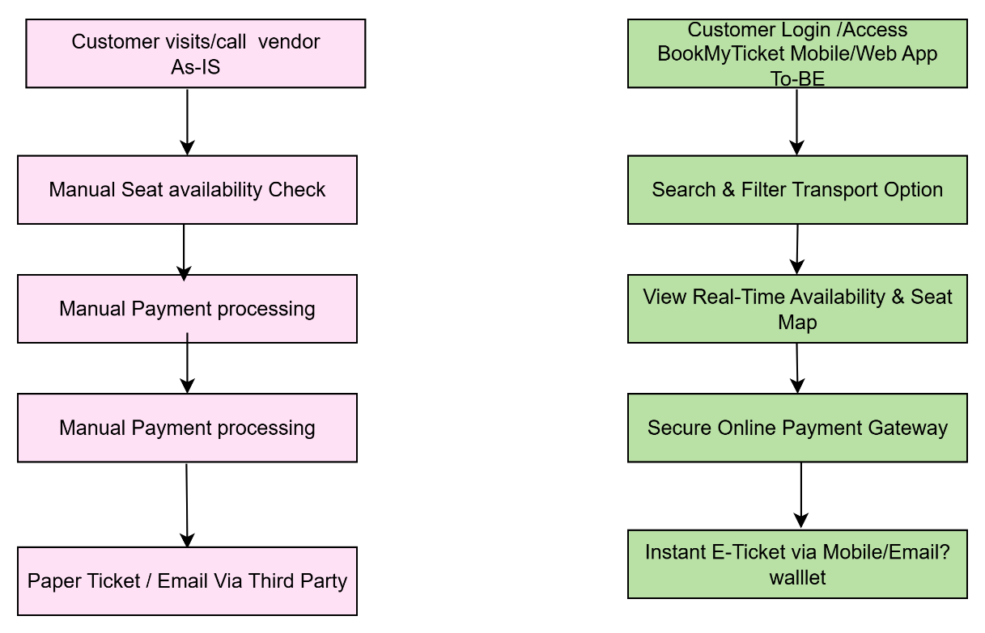

8. Business Process Overview
8.1. Legacy System (AS-IS)
Limited availability and transparency in pricing.
- No centralized platform for comparing options across transportation modes.
- Manual booking confirmations leading to delays.
- Lack of integrated payment gateways.

8.2. Proposed Recommendations (TO-BE)
Offer a unified search and comparison feature for multiple transport modes.
- Show real-time availability and dynamic pricing.
- Provide secure integrated payment gateways supporting multiple methods.
- Generate instant e-tickets stored in user profiles or mobile wallets.
- Allow users to track bookings and cancellations in real time.

9. Business Requirement
ID | Req Name | Req Description | Priority
BR001 | User Registration & Login | Users should be able to register and log in securely using email, mobile number, or other credentials. | 8
BR002 | Search Transportation Options | Users should be able to search transportation modes (Bus, Train, Metro, Rental Car, Rental Bike) by source, destination, and journey date. | 8
BR003 | Real-Time Availability | System should display real-time seat or vehicle availability for the selected transportation mode. | 8
BR004 | Seat Selection | Users should be able to select available seats before booking (if applicable). | 7
BR005 | Fare Calculation | System should calculate total fare based on mode, distance, seat type, and other parameters. | 8
BR006 | Payment Gateway Integration | The system should integrate with secure payment gateways to process transactions. | 8
BR007 | E-Ticket Generation & Delivery | The system should generate an e-ticket and deliver it via email, SMS, or WhatsApp after payment. | 8
BR008 | Ticket Cancellation & Refund | Users should be able to cancel tickets within allowed limits and get refunds accordingly. | 8
BR009 | Booking History | Users should be able to view their past and upcoming trip bookings. | 7
BR010 | Admin Schedule Management | Admins should be able to manage transportation schedules, fares, and availability. | 8
BR011 | Notifications & Reminders | The system should send notifications for upcoming trips, cancellations, or schedule changes. | 7
BR012 | Data Security & Encryption | Sensitive user and payment data should be encrypted to ensure security. | 8
BR013 | Mobile Responsiveness | The application should be mobile-friendly and responsive across devices. | 7
BR014 | Transaction Logging | All booking and payment transactions should be logged for audit purposes. | 7

Functional Requirements
No. | Functional Requirement | Description
FR1 | User Registration & Login | Allow passengers to create accounts, log in securely, and manage their profiles.
FR2 | Search Travel Options | Search trips by origin, destination, travel date, and transportation type.
FR3 | View Real-Time Availability | Display live seat/vehicle availability for buses, trains, metro, and cabs.
FR4 | Schedule & Price Comparison | Enable users to compare schedules and fares for selected routes.
FR5 | Seat & Vehicle Selection | Allow users to choose preferred seats or specific vehicles.
FR6 | Secure Online Payment | Support multiple payment gateways (credit/debit cards, UPI, wallets).
FR7 | Digital Ticket Generation | Generate e-tickets and send via email/SMS/mobile wallet.
FR8 | Journey Reminders & Notifications | Send automated reminders and alerts about trip status.
FR9 | Loyalty Program | Offer reward points for completed bookings.
FR10 | Operator Dashboard | Provide transport operators with tools to manage schedules, pricing, and promotions.
FR11 | Booking Management | Allow users to view, modify, or cancel bookings.
FR12 | Multi-Mode Integration | Integrate bus, train, metro, cab (and later flight/rental) services into one system.

Non-Functional Requirements
No. | Non-Functional Requirement | Description
NFR1 | Performance | System should display search results within 3 seconds for 90% of queries.
NFR2 | Availability | 99.9% uptime to ensure uninterrupted booking services.
NFR3 | Scalability | Support increased traffic during peak seasons and festivals without performance issues.
NFR4 | Security | Encrypt payment transactions (PCI-DSS compliant) and user data (AES-256).
NFR5 | Usability | Mobile-first responsive design for easy access on smartphones, tablets, and desktops.
NFR6 | Interoperability | Support integration with multiple transport APIs and payment gateways.
NFR7 | Maintainability | Codebase should allow for easy updates and new feature integration.
NFR8 | Reliability | Ensure booking confirmation accuracy and prevent double bookings.
NFR9 | Localization | Support multiple languages and currencies.
NFR10 | Regulatory Compliance | Adhere to local transport and data protection regulations.

10. Appendices
10.1 List of Acronyms
Acronym | Full Form
API | Application Programming Interface
BRD | Business Requirements Document
DBMS | Database Management System
ERD | Entity Relationship Diagram
GPS | Global Positioning System
OTP | One-Time Password
UI | User Interface
UX | User Experience
UAT | User Acceptance Testing
SDLC | Software Development Life Cycle

10.2 Glossary of Terms
Acronym | Full Form
API | Application Programming Interface
BRD | Business Requirements Document
DBMS | Database Management System
ERD | Entity Relationship Diagram
GPS | Global Positioning System
OTP | One-Time Password
UI | User Interface
UX | User Experience
UAT | User Acceptance Testing
SDLC | Software Development Life Cycle

10.3 Related Documents
Document Name | Description
System Requirements Specification (SRS) | Detailed technical requirements for the system.
Feasibility Study Report | Analysis of technical, operational, and financial feasibility.
Project Plan | Schedule, milestones, and resource allocation for the project.
Test Plan Document | Detailed approach, scope, and test cases for system testing.
UI/UX Design Document | Wireframes, mockups, and style guidelines for the user interface.
Deployment Plan | Strategy and steps for moving the system from development to production.

3.Make an ERD of creating a support ticket/Ticketing life cycle.

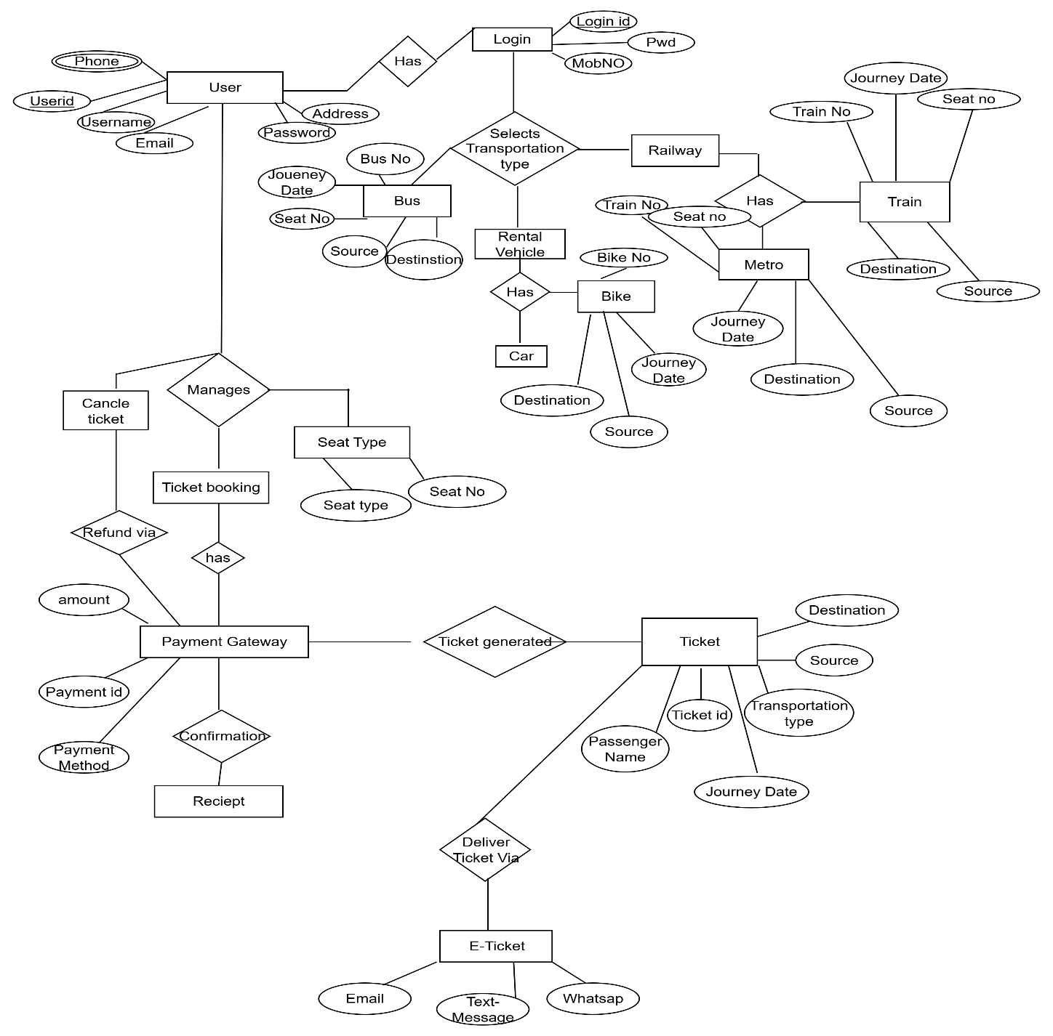

SRS for a project - Ticketing system
1.0 Introduction
1.1 Overview
BookMyTicket is an online unified ticket booking platform designed to streamline travel reservations across multiple transportation modes, including buses, trains, metro trains, flights, rental cars, cabs, and bikes.
The system enables passengers to:
- Search travel options by origin, destination, travel date, and transport type.
- View real-time availability and pricing.
- Select preferred seats or vehicles.
- Make secure online payments from any device.
- Receive digital tickets instantly via email or mobile wallet.
Problem Statement:
Currently, passengers must use separate portals or offline counters for different travel modes, leading to delays and discomfort booking experience.
Proposed Solution:
BookMyTicket will provide a centralized booking system offering Scheduling, multipayment gateway operator dashboard , Loyalty rewards and discount.

1.2 Acronyms and Definitions
Term | Description
BMT | BookMyTicket – the centralized travel booking platform
OTP | One-Time Password used for authentication during login or payments
API | Application Programming Interface – enables integration with transport operators
PG | Payment Gateway – facilitates secure online transactions
UI | User Interface – the visual layout through which users interact with the system
UAT | User Acceptance Testing – process of verifying if the system meets user needs
NFC | Near Field Communication – for contactless ticket scanning
ETA | Estimated Time of Arrival – travel time prediction feature
QR Code | Machine-readable code for digital ticket validation
LMS | Loyalty Management System – handles reward points for repeat customers

1.3 Operational Requirement
1.3.1 Software Requirements
Category | Requirement
Operating System (Server) | Linux (Ubuntu 22.04 LTS) or Windows Server 2019
Operating System (Client) | Windows 10/11, macOS 12+, Android 10+, iOS 14+
Web Server | Apache 2.4 / Nginx 1.22
Database | MySQL 8.0 or PostgreSQL 14
Programming Languages | Java 17 / Node.js 18 for backend; HTML5, CSS3, JavaScript (React/Angular) for frontend
Frameworks | Spring Boot (Java) or Express.js (Node.js)
APIs | RESTful APIs for transport operator integrations
Payment Integration | Razorpay, PayU, Stripe, or PayPal SDK
Browser Support | Google Chrome (latest), Mozilla Firefox (latest), Safari (latest), Microsoft Edge (latest)
Mobile App Framework | Flutter or React Native for cross-platform development
Security Protocols | SSL/TLS encryption, OAuth 2.0, JWT authentication
Other Tools | Google Maps API for route and ETA calculations, QR Code generation libraries

1.3.2 Hardware Requirements
IT -Side
Component | Specification
Production Server | Quad-Core Processor (Intel Xeon / AMD EPYC), 32 GB RAM, 1 TB SSD, 1 Gbps Network
Testing/Staging Server | Dual-Core Processor, 16 GB RAM, 512 GB SSD
Network | 100 Mbps dedicated connection
Backup System | AWS S3 / Google Cloud daily backups
Peripheral Devices | QR scanners, NFC devices at stations

Client Side-
Component | Minimum Specification | Recommended Specification
Desktop/Laptop | Dual-Core CPU, 4 GB RAM, 500 MB disk | Quad-Core CPU, 8 GB RAM
Mobile Device | Quad-Core CPU, 3 GB RAM, 200 MB storage | Octa-Core CPU, 6 GB RAM
Internet | 10 Mbps broadband | 25 Mbps broadband

1.4 References
- Project Proposal – BookMyTicket Integrated Online Travel Booking System, Version 1.0, dated 12-3-2025
- User Requirements Document (URD) – Compiled from stakeholder interviews, focus group sessions, and online survey feedback.
- IEEE Std 830-1998 – IEEE Recommended Practice for Software Requirements Specifications.
- UI/UX Design Guidelines – W3C Accessibility Standards (WCAG 2.1), Web Content Accessibility Guidelines.
- Payment Gateway Integration Manuals – Razorpay API Documentation, PayPal REST API Guide.
- Government Transport Data Feeds – National Train Enquiry System (NTES) API documentation, State Transport Corporation APIs.

1.5 Design and Implementation Constraints
- Technology Stack Constraints
  - Programming Language: Must be developed using Java (Spring Boot) for backend and ReactJS for frontend to ensure scalability and modularity.
  - Database: MySQL for relational data and Redis for caching real-time availability.
  - Mobile App: Android app using Kotlin; iOS app using Swift.
  - Payment Integration: Must use PCI-DSS-compliant gateways like Razorpay and PayPal.
- Development Standards
  - Follow IEEE SRS 830 documentation standards.
  - Code must comply with OWASP security guidelines to protect sensitive user data.
  - Follow Agile Scrum methodology for iterative development and stakeholder feedback.
  - UI must meet WCAG 2.1 accessibility standards.
- Hardware Limitations
  - Client devices may include low-end smartphones; the application must load within 3 seconds on 3G networks.
  - Backend servers should support a minimum of 10,000 concurrent users without performance degradation.
- Integration Constraints
  - Must integrate with government transport APIs (e.g., NTES for trains) and third-party rental platforms via REST APIs.
  - All external APIs must support JSON or XML as data interchange formats.
- Regulatory and Legal Constraints
  - Must comply with GDPR and Indian IT Act 2000 for user data privacy.
  - Must follow taxation rules for each state/country for booking transactions.

1.6 Assumed Factors That Could Affect the Requirements
1. External Components and Integrations
- The system assumes that third-party APIs, libraries of the software components will be available, stable, and compatible.
- Integration with external modules depends on timely delivery and compliance with agreed specifications.
2. Development Environment
- The development assumes access to required hardware, software tools, IDEs, and platforms as planned. Any changes in software versions, OS platforms, or tools may necessitate additional development or testing effort.
3. Operating Environment
- The system assumes specific operating conditions such as network bandwidth, server capacity, and client hardware capabilities. Changes in expected load or operating environment may require modification of system design or performance tuning.
4. Stakeholder Availability
- Timely input and feedback from key stakeholders are assumed for requirement validation, reviews, and testing, Delays in stakeholder responses can affect requirement finalization.
5. Regulatory and Compliance Factors
- It is assumed that applicable legal, security, and compliance regulations will not change during development. Any changes in laws or standards may require updates to system requirements or design.
6. Project Dependencies
- Dependencies on other ongoing projects (e.g., data source systems, third-party services) are assumed to be met as scheduled.
7. Resource Availability
- The availability of skilled personnel, both internal and external, is assumed throughout the project lifecycle. Any resource constraints may affect the project timeline or quality of deliverables.

2.0 System Overview
BookMyTicket is an online platform designed to simplify provides digital ticket booking across multiple transportation modes, including buses, trains, metro trains, flights, rental cars, cabs, and bikes. The system enables passengers to search travel options by origin, destination, date, and transport type, check real-time availability, and make secure online payments from any device.

2.1 Current System
Currently, passengers use separate portals or offline counters for different travel modes, which leads to:
- Fragmented booking experiences requiring multiple logins or visits.
- Delays in booking confirmations due to offline or semi-automated processes.
- Lack of real-time updates on availability, seat allocation, and pricing.
- Manual ticket handling and limited digital payment options.

2.2 Proposed System
The proposed BookMyTicket system provides a centralized and integrated platform for booking all types of transport tickets. Key aspects include:
- Unified Booking Experience.
- Real-Time Availability.
- Secure Payments.
- Digital Tickets.
- Journey Management.
- Operator Dashboard.
- Scalable Rollout.

2.2 Benefits of the Proposed System
The BookMyTicket system offers the following benefits to both passengers and transport operators:
For Passengers / Users
- Centralized Booking
- Time-Saving
- Real-Time Availability
- Easy Price Comparison
- Secure Online Payments
- Digital Tickets
- Journey Reminders
- Loyalty Rewards
- User-Friendly Interface
- For Transport Operators / Service Providers
- Centralized Dashboard
- Inventory Management
- Promotional Campaigns
- Reporting & Analytics
- Operational Efficiency
- Scalable Platform
- Organizational / Business Benefits
- Customer Satisfaction.
- Revenue Growth.
- Reduced Operational Costs
- Data-Driven Decisions
- Competitive Advantage

3.1 Project Contents
The UI of the system is designed to cover all modules and functionalities, including both passenger- and operator-facing components.
The project UI consists of the following components:
A. Login Component
- Functionality: Allows both passengers and operators to securely access the system.
- Components Include:
  - Username input
  - Password Input:
  - Forgot Password:
  - Login Button:
  - Sign-Up Option (for passengers)
- A. Passenger Module
  - Functionality: Enables users to search for travel options, book tickets, make payments, and manage their profiles.
  - Components Include:
    - Home/Search Page:
    - Results/Availability Page:
    - Booking Page:
    - Confirmation Page:
    - User Profile:.
    - Notifications & Reminders.
- B. Operator / Service Provider Module
  - Functionality: Allows transport operators and rental service providers to manage schedules, inventory, pricing, and promotional campaigns.
  - Components Include:
    - Dashboard:
    - Schedule Management:
    - Inventory Management:
    - Pricing & Promotions:
    - Reports & Analytics:
- C. Common Components
  - Navigation Menu:
  - Search & Filter Options:
  - Responsive Design:
  - Error Handling & Validation

D. Common Components
- Navigation Menu:
- Search & Filter Options:
- Responsive Design:
- Error Handling & Validation.

4.1 Acceptance
The client will review and formally accept the BookMyTicket application upon delivery of the following:
- Prototypes:
  - Interactive or static prototypes of the application screens demonstrating functionality and user flow.
  - Feedback on prototypes must be incorporated before final development.

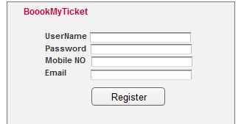

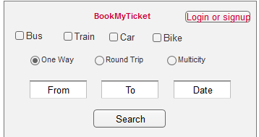

Application:
- Fully functional application meeting all agreed-upon requirements.
- Includes both passenger and operator modules with all features implemented.
1. Fully Functional Application –
A fully functional application is a software system that is completely developed, integrated, and tested, ready to be used by end-users. It should:
- Meet all the requirements defined in the SRS (functional and non-functional).
- Have all modules working correctly without critical bugs.
- Be deployable and usable on the intended platform (web, mobile, or both).
- Include user interfaces, business logic, database, and integration with external systems (e.g., payment gateways).
In simple terms: it’s the “real working software”, not just a prototype or a partially done system.

2. What It Includes in a Real Project (BookMyTicket Example)
A. Passenger Module
- Login/Sign-Up for passengers.
- Search & Filter for travel options (bus, train, metro, flight, cab, rental).
- View Results with schedules, prices, and seat availability.
- Booking Functionality with seat/vehicle selection.
- Payment Gateway Integration for online payments.
- Digital Ticket Generation (PDF/email/mobile wallet).
- Booking History and Profile Management.
- Notifications & Reminders for upcoming trips.
B. Operator / Service Provider Module
- Operator Login for transport providers.
- Dashboard showing bookings, revenue, and schedules.
- Schedule Management: add, edit, cancel schedules.
- Inventory Management: track buses, trains, cabs, or rental vehicles.
- Pricing & Promotions: set fares, discounts, loyalty points.
- Reports & Analytics: generate revenue, booking, and usage reports.
C. Common / System-Wide Features
- Login & Role-Based Access Control (passenger vs operator).
- Error Handling & Validation (e.g., invalid inputs, failed payment).
- Responsive Design (works on mobile, tablet, and desktop).
- Integration with External Services (payment gateways, email/SMS notifications).
- Security Measures (data encryption, secure authentication).

Installation Guide for BookMyTicket
1. System Requirements
Hardware Requirements:
- Processor: 2.0 GHz or higher
- RAM: Minimum 4 GB (8 GB recommended)
- Hard Disk: 50 GB free space
- Network: Internet connectivity
Software Requirements:
- Operating System: Windows 10 or above / Linux / macOS
- Web Server: Apache Tomcat 9.x or equivalent
- Database: MySQL 8.x or PostgreSQL
- Java Runtime Environment (JRE) 11 or higher
- Web Browser: Latest versions of Chrome, Firefox, Edge

2. Installation Steps
Step 1: Database Setup
- Install MySQL/PostgreSQL.
- Create a database named BookMyTicketDB.
- Import the provided SQL schema (BookMyTicketDB.sql) using command line or GUI tools like phpMyAdmin.
Step 2: Server Setup
- Install Apache Tomcat (or compatible server).
- Copy the BookMyTicket.war file to the webapps directory of Tomcat.
- Start the Tomcat server.
- Verify deployment by accessing http://localhost:8080/BookMyTicket.
Step 3: Configuration
- Update database credentials in the configuration file config.properties.
- Ensure email/SMS gateway credentials are configured for notifications.
Step 4: User Access
- Open a web browser and navigate to http://<server-ip>:8080/BookMyTicket.
- Login using default credentials (provided separately by the admin).
- Change default passwords after the first login.

3. Troubleshooting
- Cannot connect to database: Check username, password, and database server status.
- Server not starting: Verify correct Tomcat version and port availability.
- Pages not loading properly: Clear browser cache or check firewall settings.

User Manual for BookMyTicket
1. Login
- Open the application URL in a web browser.
- Enter your registered Email/Username and Password.
- Click Login.
- For new users, click Sign Up to create an account.

2. Passenger Module
Search & Booking:
- Enter Origin, Destination, Travel Date, and Transport Type.
- Click Search.
- Browse available options and fares.
- Select the preferred schedule and seats/vehicle.
- Enter passenger details and click Proceed to Payment.
- Make payment via preferred payment gateway.
- Download or receive digital ticket via email/mobile wallet.
Profile & History:
- Access My Profile to view personal details.
- View Booking History to check previous bookings and ticket status.
- Redeem loyalty rewards if applicable.

3. Operator / Service Provider Module
Dashboard:
- Login using operator credentials.
- Access the dashboard to view bookings, revenue, and schedules.
Schedule & Inventory Management:
- Add, edit, or cancel transport schedules.
- Update seat/vehicle availability.
- Set pricing and promotional campaigns.
Reports:
- Generate daily, weekly, or monthly booking and revenue reports.
- Export reports in PDF or Excel formats for record-keeping.

4. Notifications
- Passengers receive automated reminders for upcoming journeys via email or SMS.
- Operators receive notifications about bookings and cancellations in real time.

5. Logging Out
- Click Logout on the top-right corner to end the session securely.

4. User story of shopping from ecommerce
case Study: Development of Cross-Platform E-commerce Application
Objective:
The primary goal of this project is to provide our customers with a seamless, fast, and enjoyable shopping experience that increases customer satisfaction, retention, and overall sales.
Business Overview:
Our company operates in the retail sector, offering a wide range of products including electronics, fashion, groceries, and home essentials. We currently manage sales through a basic website that has limited functionality and lacks modern e-commerce features. There is no dedicated mobile application, which is resulting in a significant loss of potential customers who prefer shopping through mobile devices.
Current Challenges:
- Website interface is outdated and not mobile-friendly.
- Customers face difficulty in browsing multiple categories and checking out in a single transaction.
- No real-time inventory updates, leading to issues with product availability.
- Limited payment options and occasional transaction failures.
- Absence of a customer loyalty or reward system.
- Lack of personalized recommendations to enhance the shopping experience.
- No integrated refund and return management system.
Proposed Solution:
We require the design and development of a cross-platform e-commerce application (web, Android, and iOS) with the following core features:
- User Authentication: Secure registration/login with options for social media and email.
- Product Browsing & Search: Advanced search, filters, and category browsing.
- Real-time Inventory Management: Automatic stock updates and display of availability.
- Unified Shopping Cart: Ability to add products from multiple categories and checkout in a single transaction.
- Payment Gateway Integration: Multiple secure payment options including cards, UPI, wallets, and cash on delivery.
- Order Tracking: Live status updates and notifications for order progress.
- Loyalty Program: Points and rewards for repeat customers.
- Personalized Recommendations: AI-driven suggestions based on user behaviour.
- Returns & Refunds Management: Easy return requests and automated refund process.

4. User story of shopping from ecommerce.

User Story 1: Customer Registration
User Story No:1 | Tasks: 3  1Design and create the Registration UI with fields for Name, Email, Mobile No, Password, and Address.  2. Implement backend logic for user registration  3. Display success notification and send confirmation email/SMS |  | Priority: Highest
AS A CUSTOMER, I WANT TO REGISTER USING MY EMAIL,AND MOB NO SO THAT I CAN CREATE AN ACCOUNT.
BV : 500 |  | CP: 2
Acceptance Criteria-
- Registration form contains fields for Name, Email, Mobile No, Password, and Address.
- “”Register” button submits the form.
- Password must be minimum 8 characters with at least one number and one special character.
- On successful registration, a confirmation message is shown and an email/SMS is sent.

User Story 2: Social Media Registration
User Story No: | Tasks: 2  1Integrate Google & Facebook login APIs for quick registration.  2Store user profile information received from the API in the database. |  | Priority: High
AS A CUSTOMER, I WANT TO REGISTER USING MY GOOGLE OR FACEBOOK ACCOUNT, SO THAT I CAN QUICKLY CREATE AN ACCOUNT WITHOUT MANUAL ENTRY.
BV : 500 |  | CP: 3
Acceptance Criteria-
- Social login buttons (Google, Facebook) are available on registration screen.
- On clicking, the system fetches name, email, and profile picture.
- If account exists, system logs in; if not, system creates a new account.

User Story 3: Email Verification
User Story No:3 | Tasks: 2  - Generate verification email with secure token.  - Implement email verification logic to activate account. |  | Priority: High
AS A CUSTOMER, I WANT TO VERIFY MY EMAIL ADDRESS AFTER REGISTRATION, SO THAT MY ACCOUNT IS SECURE AND TRUSTWORTHY.
BV : 500 |  | CP: 2
Acceptance Criteria-
- Email verification link is sent after registration.
- Clicking the link activates the account and redirects to login page.
- Expired or invalid token shows an error message.

User Story 4: Mobile Number Verification (OTP)
User Story No:4 | Tasks: 3  - integrate OTP sending service (SMS gateway).  - Create OTP verification UI and backend.  - Auto-verify OTP if correct, reject if expired or wrong. |  | Priority: High
AS A CUSTOMER, I WANT TO VERIFY MY MOBILE NUMBER THROUGH OTP, SO THAT I CAN ENSURE ACCOUNT SECURITY AND ENABLE ORDER UPDATES.
BV : 400 |  | CP: 3
Acceptance Criteria-
- OTP is sent immediately after mobile number entry.
- OTP is valid for 5 minutes.
- If OTP is correct, user can proceed, else show error

User Story 5: Profile Setup after Registration
User Story No:5 | Tasks: 2  - Create a profile setup wizard for adding optional details (Profile Photo, Alternate Address, Preferences).  - Save details in user profile table |  | Priority: Medium
AS A CUSTOMER, I WANT TO COMPLETE MY PROFILE AFTER REGISTRATION, SO THAT I CAN PERSONALIZE MY SHOPPING EXPERIENCE.
BV : 100 |  | CP: 2
Acceptance Criteria-
- Optional profile completion screen appears after registration.
- User can upload profile photo and add preferences.
- Changes are saved and visible in “My Account” section.

User Story 6: Customer Login
User Story No:6 | Tasks: 3  - Create login UI with Email/Mobile and Password fields.  - Implement backend authentication with password encryption.  - Show login success/failure messages. |  | Priority: Highest
AS A CUSTOMER, I WANT TO LOGIN TO MY ACCOUNT, SO THAT I CAN ACCESS MY PROFILE AND SHOP.
BV : 500 |  | CP: 2
Acceptance Criteria-
- Login accepts email or mobile number with password.
- Successful login redirects to home page.
- Incorrect credentials display an error message.

User Story 7: Social Media Login
User Story No:7 | Tasks: 2  - Integrate Google/Facebook login APIs for existing accounts.  - Link social media ID to registered email. |  | Priority: High
AS A CUSTOMER, I WANT TO LOGIN USING MY GOOGLE OR FACEBOOK ACCOUNT, SO THAT I CAN AVOID REMEMBERING PASSWORDS.
BV : 400 |  | CP: 3
Acceptance Criteria-
- Social login buttons available on login screen.
- If linked account exists, login is successful.
- • If not, user is prompted to register.

User Story 8: Remember Me Option
User Story No:8 | Tasks: 1  implement “Remember Me” with secure token-based login. |  | Priority: Medium
AS A CUSTOMER, I WANT THE SYSTEM TO REMEMBER MY LOGIN, SO THAT I DON’T HAVE TO ENTER CREDENTIALS EVERY TIME.
BV : 100 |  | CP: 1
Acceptance Criteria-
- Checkbox for “Remember Me” available.
- User remains logged in until manually logged out or token expires.

User Story 9: Two-Factor Authentication (2FA)
User Story No:9 | Tasks: 3  - Add 2FA setting in account preferences.  - Send OTP on every login attempt.  - Validate OTP before granting access. |  | Priority: High
AS A CUSTOMER, I WANT TO ENABLE TWO-FACTOR AUTHENTICATION, SO THAT MY ACCOUNT IS MORE SECURE.
BV : 500 |  | CP: 3
Acceptance Criteria-
- 2FA sends OTP to registered mobile/email.
- OTP must be entered after password.
- Incorrect OTP denies access.

User Story 10: Forgot Password (Email Link)
User Story No:10 | Tasks: 2  - Generate password reset link and send to email.  - Create UI for entering new password. |  | Priority: High
AS A CUSTOMER, I WANT TO RESET MY PASSWORD VIA EMAIL, SO THAT I CAN REGAIN ACCESS IF I FORGET IT.
BV : 400 |  | CP: 2
Acceptance Criteria-
- Password reset email sent on request.
- Link is valid for a limited time (e.g., 30 minutes).
- New password must meet security requirements.

User Story 11: Forgot Password (OTP on Mobile)
User Story No:4 | Tasks:  - Send OTP for password reset to mobile.  - Allow setting a new password after OTP verification. |  | Priority: High
AS A CUSTOMER, I WANT TO RESET MY PASSWORD USING MOBILE OTP, SO THAT I CAN RECOVER MY ACCOUNT QUICKLY.
BV : 500 |  | CP: 2
Acceptance Criteria-
- OTP sent to registered mobile number.
- OTP valid for 5 minutes.
- User can set a new password after OTP verification.

User Story 12: Change Password from Account
User Story No:12 | Tasks: 2  - Create UI for current and new password input.  - Implement backend validation and update logic. |  | Priority: Medium
AS A CUSTOMER, I WANT TO CHANGE MY PASSWORD FROM MY ACCOUNT SETTINGS, SO THAT I CAN UPDATE IT REGULARLY.
BV : 100 |  | CP: 1
Acceptance Criteria-
- Requires entering current password before new one.
- New password must meet security rules.
- Success confirmation shown.

User Story 13: Password Strength
User Story No:13 | Tasks: 1  Implement live password strength indicator in UI. |  | Priority: Low
AS A CUSTOMER, I WANT TO SEE PASSWORD STRENGTH WHILE CREATING OR CHANGING PASSWORD, SO THAT I CAN CHOOSE A SECURE ONE
BV : 10 |  | CP: 1
Acceptance Criteria-
- Strength levels shown (Weak, Medium, Strong).
- Updates in real-time as user types.

User Story 14: Account Lock after Failed Attempts
User Story No:14 | Tasks: 2  - Track consecutive failed login attempts.  - Lock account for specific duration after max attempts. |  | Priority: Medium
AS A CUSTOMER, I WANT MY ACCOUNT TO BE LOCKED AFTER TOO MANY FAILED LOGIN ATTEMPTS, SO THAT UNAUTHORIZED ACCESS IS PREVENTED.
BV : 400 |  | CP: 2
Acceptance Criteria-
- After 5 failed attempts, account is locked for 15 minutes.
- Email/SMS sent notifying the user about the lock.

User Story 15: Logout
User Story No:15 | Tasks: 1  Implement logout function that clears session/token. |  | Priority: Highest
AS A CUSTOMER, I WANT TO LOG OUT OF MY ACCOUNT, SO THAT NO ONE ELSE CAN ACCESS IT FROM MY DEVICE
BV : 500 |  | CP: 2
Acceptance Criteria-
- Logout button available in menu.
- Clicking it ends the session and redirects to login screen.

User Story 16: Browse Products by Category
User Story No:16 | Tasks: 3  - Create category listing UI.  - Implement backend API to fetch products by category.  - Display products with images, names, and prices. |  | Priority: Highest
AS A CUSTOMER, I WANT TO BROWSE ALL PRODUCTS BY CATEGORY, SO THAT I CAN EASILY FIND ITEMS I’M INTERESTED IN.
BV : 500 |  | CP: 3
Acceptance Criteria-
- Categories are displayed on the home screen or menu.
• Selecting a category shows only products from that category.
• Products are shown with images, names, and prices.

User Story 17: Search Products by Name
User Story No:17 | Tasks: 3  - Add search bar to the product listing page.  - Implement backend search API with keyword matching.  - Display filtered results instantly. |  | Priority: Highest
AS A CUSTOMER, I WANT TO SEARCH PRODUCTS BY NAME, SO THAT I CAN QUICKLY LOCATE SPECIFIC ITEMS
BV : 500 |  | CP: 3
Acceptance Criteria-
- Search bar is visible and functional on product listing pages.
- Search results update based on the entered keyword.
- Search supports partial matches and case insensitivity.

User Story 18: Apply Price Filters
User Story No:18 | Tasks: 3  - Create price range slider UI.  - Implement backend filtering logic based on min/max price.  - Show results only within the selected range. |  | Priority: Highest
AS A CUSTOMER, I WANT TO FILTER PRODUCTS BY PRICE RANGE, SO THAT I CAN SHOP WITHIN MY BUDGET
BV : 500 |  | CP: 3
Acceptance Criteria-
- Price filter slider is functional.
• Products outside the range are hidden.
• Filter can be reset to default.

User Story 19: Apply Brand Filters
User Story No:19 | Tasks: 3  - Create brand filter checklist UI.  - Implement backend filtering by selected brand(s).  - Display updated results dynamically. |  | Priority: High
AS A CUSTOMER, I WANT TO FILTER PRODUCTS BY BRAND, SO THAT I CAN VIEW ITEMS FROM MY PREFERRED MANUFACTURERS
BV : 400 |  | CP: 3
Acceptance Criteria-
Brand filter is shown in the sidebar or filter menu.
• Selecting one or more brands updates results.
• Multiple brand selection is supported.

User Story 20: Sort Products by Price
User Story No:20 | Tasks: 3  - Create sort dropdown UI.  - Implement sorting logic for ascending/descending prices.  - Update displayed products accordingly. |  | Priority: High
AS A CUSTOMER, I WANT TO SORT PRODUCTS BY PRICE, SO THAT I CAN SEE THE CHEAPEST OR MOST EXPENSIVE ITEMS FIRST
BV : 500 |  | CP: 2
Acceptance Criteria-
- Sort options include “Low to High” and “High to Low”.
• Selected sort order applies immediately.
• Sorting works with applied filters.

User Story 21: Sort Products by Popularity
User Story No:21 | Tasks: 3  - Add “Popularity” option in sort dropdown.  - Implement logic to rank products based on orders or ratings.  - Display sorted results. |  | Priority: Medium
AS A CUSTOMER, I WANT TO SORT PRODUCTS BY POPULARITY, SO THAT I CAN SEE THE MOST TRENDING ITEMS FIRS
BV : 100 |  | CP: 1
Acceptance Criteria-
Popularity ranking is based on sales or rating data.
• Sorting applies instantly.
• Works alongside other filters.

User Story 22: Product Quick View
User Story No:22 | Tasks: 3  - Add “Quick View” button on product thumbnails.  - Display popup with essential details (image, price, description).  - Add “Add to Cart” option in popup. |  | Priority: Medium
AS A CUSTOMER, I WANT TO QUICKLY VIEW PRODUCT DETAILS, SO THAT I CAN DECIDE WITHOUT NAVIGATING AWAY FROM THE LISTING
BV : 100 |  | CP: 3
Acceptance Criteria-
- Quick view shows key product info.
• Popup can be closed without leaving the page.
• “Add to Cart” from popup works.

User Story 23: View Product Details Page
User Story No:23 | Tasks:  - Create detailed product page UI.  - Fetch and display product info, images, reviews.  - Add related products section. |  | Priority: Highest
AS A CUSTOMER, I WANT TO VIEW DETAILED PRODUCT INFORMATION, SO THAT I CAN MAKE AN INFORMED PURCHASE DECISION
BV : 500 |  | CP: 4
Acceptance Criteria-
Product details page shows title, price, description, images, stock status, reviews.
• Page loads quickly with all details.
• Related products are suggested.

User Story 24: View Product Ratings and Reviews
User Story No:24 | Tasks:  - Display average rating on product listing and detail page.  - Show customer reviews with username and date.  - Implement pagination or “Load More” for reviews. |  | Priority: High
AS A CUSTOMER, I WANT TO READ PRODUCT RATINGS AND REVIEWS, SO THAT I CAN TRUST THE QUALITY BEFORE BUYING
BV : 500 |  | CP: 3
Acceptance Criteria-
Ratings displayed as stars (1–5).
• Reviews sorted by date or helpfulness.
• Works on web and mobile.

User Story 25: Add Product to Wishlist
User Story No:25 | Tasks: 3  - Add “Add to Wishlist” button.  - Implement backend logic to store wishlist items.  - Show wishlist in user profile. |  | Priority: High
AS A CUSTOMER, I WANT TO ADD PRODUCTS TO MY WISHLIST, SO THAT I CAN SAVE THEM FOR FUTURE PURCHASE
BV : 500 |  | CP: 3
Acceptance Criteria-
- Wishlist button available on listing and detail pages.
• Items saved persist in user account.
• Wishlist is accessible from profile.

User Story 26: Add Product to Cart
User Story No:26 | Tasks: 3  - Implement "Add to Cart" button on product detail page.  - Update cart icon with item count dynamically.  - Store cart data in session/local storage and sync with backend. |  | Priority: Highest
AS A CUSTOMER, I WANT TO ADD PRODUCTS TO MY CART, SO THAT I CAN PURCHASE THEM LATER
BV : 1000 |  | CP: 3
Acceptance Criteria-
- Add to Cart" button visible on each product detail page.
- Cart icon shows updated item count after adding a product.
- Product remains in the cart until user removes it or completes checkout.

User Story 27: View Cart
User Story No:27 | Tasks: 2  - Display cart page listing all added products, quantities, and prices.  - Provide "Remove" and "Update Quantity" options |  | Priority: Highest
AS A CUSTOMER, I WANT TO VIEW MY CART, SO THAT I CAN REVIEW MY SELECTED ITEMS BEFORE PURCHASE
BV : 1000 |  | CP: 2
Acceptance Criteria-
- Cart displays all added items with correct price and quantity.
- User can update quantity or remove items.

User Story 28: Apply Coupon Code
User Story No: | Tasks: 3  - Implement coupon code input and validation logic.  - Apply discount and update total amount dynamically. |  | Priority: High
AS A CUSTOMER, I WANT TO APPLY A COUPON CODE, SO THAT I CAN GET DISCOUNTS ON MY PURCHASE
BV : 500 |  | CP: 3
Acceptance Criteria-
- Coupon code field is available on cart/checkout page.
- Valid coupons apply discounts correctly; invalid codes show error.

User Story 29: Proceed to Checkout
User Story No:29 | Tasks: 3  - Create checkout form for address, shipping method, and payment selection.  - Pre-fill saved address details for logged-in users.  - Validate and submit checkout data to backend. |  | Priority: Highest
AS A CUSTOMER, I WANT TO PROCEED TO CHECKOUT, SO THAT I CAN PROVIDE MY SHIPPING AND PAYMENT DETAILS
BV : 1000 |  | CP: 3
Acceptance Criteria-
- Checkout form collects address, shipping, and payment info.
- Only logged-in users can proceed.

User Story 30: Select Payment Method
User Story No: | Tasks: 3  - Display available payment methods (Credit/Debit Card, UPI, Wallet, COD).  - Integrate selection into checkout process. |  | Priority: Highest
AS A CUSTOMER, I WANT TO SELECT A PAYMENT METHOD, SO THAT I CAN PAY IN MY PREFERRED WAY
BV : 1000 |  | CP: 2
Acceptance Criteria-
- User can select from multiple payment options.
- Selected method is saved and processed in payment gateway.

User Story 31: Make Online Payment
User Story No: | Tasks: 3  - Integrate payment gateway API (e.g., Razorpay/Stripe).  - Handle payment success and failure callbacks.  - Update order status accordingly. |  | Priority: Highest
AS A CUSTOMER, I WANT TO MAKE ONLINE PAYMENTS SECURELY, SO THAT MY TRANSACTION IS SAFE AND VERIFIED
BV : 1000 |  | CP: 4
Acceptance Criteria-
- Payment is processed via secure gateway.
- Success leads to order confirmation page; failure prompts retry.

User Story 32: Cash on Delivery Option
User Story No:32 | Tasks: 1  Provide COD option and mark payment status as "Pending". |  | Priority: High
AS A CUSTOMER, I WANT TO OPT FOR CASH ON DELIVERY, SO THAT I CAN PAY AFTER RECEIVING MY ORDER
BV : 500 |  | CP: 1
Acceptance Criteria-
- COD option is available where applicable.
- Order is placed without immediate payment.

User Story 33: View Order Confirmation
User Story No: | Tasks: 3  - Show confirmation page with order ID, summary, and estimated delivery.  - Send confirmation email/SMS to customer. |  | Priority: Highest
AS A CUSTOMER, I WANT TO RECEIVE ORDER CONFIRMATION, SO THAT I KNOW MY ORDER IS PLACED SUCCESSFULLY
BV : 1000 |  | CP: 3
Acceptance Criteria-
- Confirmation page is shown immediately after order placement.
- Notification is sent to registered email/phone

User Story 34: Track Order Status
User Story No:34 | Tasks: 2  - Display current order status (Processing, Shipped, Out for Delivery, Delivered).  - Provide tracking link for shipment |  | Priority: High
AS A CUSTOMER, I WANT TO TRACK MY ORDER STATUS, SO THAT I KNOW WHEN TO EXPECT MY DELIVERY
BV : 500 |  | CP: 2
Acceptance Criteria-
- Order status updates in real time.
- • Tracking link redirects to courier tracking page.

User Story 35: Cancel Order
User Story No:35 | Tasks: 2  - Implement order cancellation option for eligible orders.  - Update inventory and payment refund status. |  | Priority: High
AS A CUSTOMER, I WANT TO CANCEL MY ORDER, SO THAT I CAN AVOID RECEIVING ITEMS I NO LONGER NEED
BV : 500 |  | CP: 3
Acceptance Criteria-
- Cancel option is available before dispatch.
- Refund process is triggered for prepaid orders.

User Story 36: Vendor Login
User Story No:36 | Tasks: 2  - Create vendor login page with email/password authentication.  - Connect to vendor management backend. |  | Priority: Highest
AS A VENDOR, I WANT TO LOG IN TO MY ACCOUNT, SO THAT I CAN MANAGE MY PRODUCTS AND ORDERS
BV : 1000 |  | CP: 2
Acceptance Criteria-
- Vendor credentials verified against database.
- Access restricted to vendor-specific dashboard.

User Story 37: Vendor Product Management
User Story No:37 | Tasks: 3  - Allow vendors to add, edit, and delete product listings.  - Upload product images and details.  - Sync updates with customer storefront. |  | Priority: Highest
AS A VENDOR, I WANT TO MANAGE MY PRODUCTS, SO THAT I CAN KEEP MY STORE UPDATED
BV : 1000 |  | CP: 3
Acceptance Criteria-
- Vendors can create and modify product entries.
- Changes reflect instantly on storefront.

User Story 38: Vendor Order Management
User Story No:38 | Tasks: 2  - Display list of customer orders for vendor’s products.  - Allow status updates (Processing, Shipped, Delivered). |  | Priority: High
AS A VENDOR, I WANT TO MANAGE ORDERS, SO THAT I CAN FULFILL CUSTOMER PURCHASES PROMPTLY
BV : 500 |  | CP: 2
Acceptance Criteria-
- Orders displayed with customer details.
- Vendor can update order status.

User Story 39: Admin Dashboard
User Story No:37 | Tasks: 3  - Provide admin view for managing vendors, products, and customers.  - Display sales reports and analytics.  - Enable admin actions like ban/unban users. |  | Priority: Highest
AS AN ADMIN, I WANT TO MANAGE THE ENTIRE PLATFORM, SO THAT I CAN ENSURE SMOOTH OPERATIONS
BV : 1000 |  | CP: 3
Acceptance Criteria-
- Admin can manage all entities in the system.
- Dashboard shows real-time data.

User Story 40: Customer Support
User Story No:37 | Tasks: 3  - Integrate live chat widget into website/app.  - Route queries to support team.  - Save chat history for reference. |  | Priority: High
AS A CUSTOMER, I WANT TO CHAT WITH CUSTOMER SUPPORT, SO THAT I CAN RESOLVE ISSUES QUICKLY
BV : 500 |  | CP: 3
Acceptance Criteria-
- Chat option visible on help/contact page.
- Messages delivered instantly to support team.

