**Capstone Project -1 Part- 2**

1. 4 Quarterly Audits are planned Q1 , Q2, Q3, Q4 for this Project. What is your knowledge on how these Audits will happen for a BA?

* The audits are done as a part of quality assurance procedure and can have both the internal and the external audits that belong to any standard that the IT company follow. The four quarterly audits which are planned for this project are:

|  |  |
| --- | --- |
|  | Quarterly Audits Q1 |
| Stage | Requirement gathering and design alignment |
| Completed | 10 weeks (week 1 to week 10) |
| Checklist | * Validate the requirement of the stakeholders * Functional requirement document is clear * Gap analysis * Use cases and the user stories are agreed by the stakeholders * Communication |

|  |  |
| --- | --- |
|  | Quarterly Audits Q2 |
| Stage | Design review and requirement traceability |
| Completed | 14 weeks (week 14 to week 28) |
| Checklist | * Design document are aligned with the business requirement * User interface reflects the need of the farmer * Validate the test cases * Confirm both functional and nonfunctional requirement * Communication |

|  |  |
| --- | --- |
|  | Quarterly Audits Q3 |
| Stage | Development and design requirement |
| Completed | 14weeks (week 36 to week 50) |
| Checklist | * Conduct reviews to ensure the feature matches the requirement * Work with the test team to ensure that the test cases matches the business requirement * Any change in the requirement * Ensure UAT is clear * Check for the issue in the development phase |

|  |  |
| --- | --- |
|  | Quarterly Audits Q4  20weeks (week 52 to week 72) |
| Stage | Final evaluation and project completion |
| Completed | 10 weeks (week 1 to week 10) |
| Checklist | * All features are completed and functioning according to the requirement * Review the feedback from the user and verify that any issue or gap have addressed * Confirm that the documents is aligned with the final product and is easy for farmer to use * Ensure that post-launch support and maintenance plans are in place. |

1. Before the Project is going to Kick Start, The Committee asked Mr Karthik to submit BA Approach Strategy Write BA Approach strategy (As a business analyst, what are the steps that you would need to follow to complete a project – What Elicitation Techniques to apply, how to do Stakeholder Analysis RACI/ILS, What Documents to Write, What process to follow to Sign off on the Documents, How to take Approvals from the Client, What Communication Channels to establish n implement, How to Handle Change Requests, How to update the progress of the project to the Stakeholders, How to take signoff on the UAT- Client Project Acceptance Form ) Your Team Project Manager - Mr Vandanam Senior Java Developer - Ms. Juhi Java Developers - Mr Teyson, Ms Lucie, Mr Tucker, Mr Bravo Network Admin - Mr Mike DB Admin - Mr John. Technical Team have assembled to discuss on the Project approach and have finalised to follow 3-tier architecture for this project.

* BA Approach Strategy: The Business Analysis Approach is the plan that the senior or lead business analyst on a project would create describing the way that all the Business Analysis activities will be executed

This could include:

* Business Analysis resources and their Roles & Responsibilities
* Requirements Gathering Approach for the project (techniques to be used, high level planning)
* Stakeholder Engagement
* Requirements Review Process and Approval Cycles
* Change Management approach to requirements and agreed deliverables.
* Other elements such as team structure, assumptions and constraints could also be included.

As a Business Analyst, following are the steps which needs to be followed to complete a Project.

Elicitation Techniques to apply: There are several Elicitation techniques to be used to elicit the requirement, however for this project, we are going to use the below Elicitation techniques.

* Interviews: Conduct structured interviews with stakeholders such as Mr. Henry, the Committee, and farmers (Peter, Kevin, Ben) to understand their expectations.
* Workshops: Organize requirement workshops with the technical team and stakeholders to clarify and prioritize features.
* Surveys & Questionnaires: Distribute forms to farmers and agricultural companies to collect additional data on their needs.
* Observation: Study the existing process of purchasing agricultural products in remote areas to identify gaps.
* Document Analysis: Review relevant industry regulations and existing marketplace models to align the solution with best practices.

RACI matrix

|  |  |  |  |  |
| --- | --- | --- | --- | --- |
| Task | Responsible | Accountable | Consulted | Informed |
| Requirement Gathering | BA | PM | Farmers, Manufacturers | Committee, Dev Team |
| UI/UX Design | Dev Team | Senior Dev | Farmers | Committee, BA |
| Development | Dev Team | Senior Dev | BA, PM | Committee |
| Testing | Testers | PM | Dev Team | Committee, BA |
| UAT & Sign-off | Client | BA, PM | Testers | Committee |
| Deployment | Network Admin, DB Admin | PM | BA, Dev Team | Committee, Client |

Documents to Write

* Project vision Document
* Business Analysis Plan
* Stakeholder Analysis Document (RACI)
* Business Requirements Document.
* Functional requirement specification (FRS)/ Functional Specification Document (FSD)
* System requirement specification (SRS)/ System Requirement Document (SRD)

Sign-off Process for Documents

* Draft the document and share it with relevant stakeholders for review.
* Conduct a review meeting to gather feedback.
* Update the document based on feedback and redistribute for final approval.
* Obtain formal sign-off from the client and relevant stakeholders.

Client Approvals & Communication Channels

To ensure streamlined communication and approvals:

* Communication Tools: Utilize Emails, Slack, and Microsoft Teams for daily updates and discussions.
* Weekly Meetings: Conduct stakeholder meetings to present progress.
* Approval Process: Use a formal email/document trail for approvals with acknowledgment from the client.
* Escalation Matrix: Establish a process for resolving conflicts and addressing high-priority issues.

Handling Change Requests (CRs)

* Document the requested change and analyze the impact.
* Review feasibility with the technical team.
* Update requirements and obtain approval from stakeholders.
* Implement changes in subsequent development cycles.

Project Progress Updates

* Weekly Reports: Sent to the Committee and key stakeholders.
* Sprint Reviews: Conducted at the end of each development cycle.
* Dashboard Tracking: Maintain a real-time progress tracker using tools like Jira or Trello.
* UAT & Client Project Acceptance
* UAT Execution: Provide test cases and scenarios to the client for validation.
* Issue Tracking: Log defects and ensure resolutions before final deployment.
* Final Sign-off: Obtain approval through the Client Project Acceptance Form.
* Go-Live: Deploy the application post-approval and ensure smooth handover

1. Explain and illustrate 3-tier architecture?

* A 3-Tier Architecture is a software design pattern that separates an application into three logical layers:
* Application Layer
* Business Logic Layer
* Data Layer

Diagram to depict the 3-tier architecture

Screens, Pages, Validation on pages

-------------------------Application Layer -------------------------------

Frequently changing component, government rules and regulation etc

------------------------Business Logic Layer-----------------------------

Database component connecting to database

-----------------------------Data Layer------------------------------------

Application layer:

This is the front end of the application, user interact with this layer through a mobile browser or through a web server and responsible for taking user input example Farmers and manufacturers use a web or mobile app to browse products, place orders, and manage their accounts.

Business Application Layer:

This layer process user request and applies business rule. It acts as a bridge between the front-end team and the database, handling transactions, security and application logic example when a farmer places an order for seeds, this layer verifies the availability, calculates cost and process the order request

Data layer:

This layer is responsible for storing and managing data in a structure format. It handles products, orders, user details and transaction record example the database stores details about different fertilizers along with order placed by farmer

1. Business Analyst should keep What points in his/her mind before he frames a Question to ask to the Stakeholder ( 5W 1H – SMART – RACI – 3 Tier Architecture – Use Cases, Use case Specs, Activity Diagrams, Models, Page designs)

* As a business analyst we need to structure question carefully before engaging with the stakeholder, so there is some approach

5W 1H means (who, what, when, where, why, how )

* Who are the stakeholders?
* What are the main features which is required?
* When should the project be delivered?
* Where will this platform be hosted?
* Why is this application important for farmers?
* How will the transaction, logistics and user support will be managed?
* SMART goals (specific, measurable, achievable, relevant and time bond)
* Specific: Define the clear requirement like what product should be listed? What payment method should be integrated?
* Measurable: what success metrics will define the platform effectiveness
* Achievable: can farmer in remote area will able to access this platform with their current internet infrastructure
* Relevant: Does the platform solve the current problem
* Time bound: Ensure project milestone align with the 18 months deadline
* Raci matrix: For clarity in roles and responsibility
* Responsible, accountable, consulted and informed
* 3Tier Architecture consideration
* Application Layer:

How will the application be designed for farmers with the digital literacy?

What language option should be included?

* Business layer:

How will product listings, payment, and orders be managed?

What role will manufacturers play in updating their inventory?

* Data Layer:

How will the product data, order history, and user data be stored securely?

What backup and disaster recovery measures will be in place?

* Use cases and use case specification:
* Use case:

Farmer registers, browses products, place an order, makes a payment and track delivery Manufacturer uploads products, manage stocks, process order and update prices

Admin verifies the transaction, mange disputes, and ensures smooth platform functioning

* Use cases specs:

What are the pre conditions for example user registration?

What happen in normal and exception scenarios?

* Activity Diagram, models and page design
* Activity Diagram: show the flow of user interaction from login to order placement
* Models: define data flow, API interaction and entity relationship
* Pade design: what should be the structure of key page (home page, product listing, cart, checkout)

1. As a Business Analyst, What Elicitation Techniques you are aware of? (BDRFOWJIPQU)

* As a Business Analyst (BA), elicitation is a crucial part of gathering and understanding requirements from stakeholders. There are several elicitation techniques that can be used, and based on the acronym BDRFOWJIPQU
* B - Brainstorming

Used to generate ideas, solutions, or requirements in a collaborative session with stakeholders.

* D - Document Analysis

Reviewing existing documentation, reports, and artifacts to gather relevant information.

* R - Research

Conducting market research, competitive analysis, and studying industry trends to gather insights.

* F - Focus Groups

Engaging a group of stakeholders (e.g., farmers, manufacturers) to discuss their needs and concerns.

* I - Observation

Watching end users (farmers, suppliers) in their real environment to understand pain points.

* W - Workshops

Facilitating structured discussions with multiple stakeholders to define requirements collaboratively.

* J - Job Shadowing

Following users (farmers, logistics personnel) as they perform their daily tasks to identify inefficiencies.

* I - Interviews

Conducting one-on-one or group interviews with stakeholders to gather in-depth information.

* P - Prototyping

Creating mockups or wireframes to visualize requirements and get early feedback.

* Q - Questionnaires/Surveys

Distributing structured questionnaires to a large group to gather diverse input.

* U - User Stories / Use Cases
* Writing user-centric scenarios to capture functional and non-functional requirements.

1. Which Elicitation Techniques can be used in this Project and Justify your selection of Elicitation Techniques?

* As a Business Analyst (BA) for this project, you need to gather and document requirements effectively. The following elicitation techniques will be useful:

Prototyping, Use case Specs, Document Analysis, Brainstorming

Prototyping is essential as the application must be user-friendly, especially for farmers who may not be familiar with digital platforms. Creating wireframes, mockups, or interactive UI prototypes will help stakeholders visualize the system and provide feedback before development begins.

Use Case Specifications will be beneficial as the system involves different users, including farmers, manufacturers, and administrators. Use cases will define how these actors interact with the system, ensuring clarity for developers and testers regarding functionalities such as browsing products, placing orders, and communication between stakeholders.

Document Analysis is crucial to review existing regulations, business rules, and agricultural standards that may impact the platform. Analyzing previous project reports and financial guidelines will also help define clear requirements related to pricing, delivery, and vendor transactions

Brainstorming sessions will facilitate discussions among the project team, committee members, and farmers, generating innovative ideas for features, payment options, and usability improvements. This collaborative approach will help identify potential challenges and solutions while also addressing non-functional requirements like scalability and security.

1. Make suitable Assumptions and identify at least 10 Business Requirements.

* A business requirement is a high-level need or objective that a business must fulfil to achieve its goals below are some if the business requirement

BR001: login with the help of user id and password for all its user

BR002: Manufacturers should be able to upload and display their products in the application

BR003: Farmers should be able to search for available products in fertilizers, seeds, pesticides

BR004: The app should have a search option so that they can search for the product they required BR005: The payment process should be simple and should have different option to make payment like cash on delivery, credit/debit card etc

BR006: user get an email confirmation regarding their order confirmation and order status

BR007: app should have a order tracking system to allow framer to track their order status and delivery progress

BR008: Farmers should be able to browse through the product catalog without logging in but must log in to purchase or save items for later.

BR009: The platform should allow manufacturers to manage their inventory, update product details, and set pricing.

BR010: The application should have a customer support/helpdesk feature for farmers and manufacturers to raise queries or issues.

1. List your assumptions

* Below is the list of assumption which we make in this project
* Assumption1: A user can login using Facebook or google account
* Assumption2: The search functionality will allow filtering based on category, price, brand, and location.
* Assumption3: Farmers will have access to smartphones/computers and internet connectivity in remote areas.
* Assumption4: A review and rating system will help farmers choose quality products.
* Assumtion5: The platform will be available as both a web and mobile application.
* Assumption6: Farmers are comfortable with online transactions or will adapt to them over time.

1. Give Priority 1 to 10 numbers (1 being low priority – 10 being high priority) to these Requirements after discussions with the stakeholders

|  |  |  |  |
| --- | --- | --- | --- |
| Req ID | Req Name | Req Description | Priority |
|  |  |  |  |
| BR001 | Login details | login with the help of user id and password for all its user | 10 |
| BR002 | Manufacture uploads their product | Manufacturers should be able to upload and display their products in the application | 9 |
| BR003 | Farmer search for products | Farmers should be able to search for available products in fertilizers, seeds, pesticides | 10 |
| BR004 | Search option | The app should have a search option so that they can search for the product they required | 4 |
| BR005 | Payment option | The payment process should be simple and should have different option to make payment like cash on delivery, credit/debit card etc | 5 |
| BR006 | Order conformation and status | user get an email confirmation regarding their order confirmation and order status | 3 |
| BR007 | Order tracking live update about delivery | App should have an order tracking system to allow framer to track their order status and delivery progress | 8 |
| BR008 | Browse product without logging | Farmers should be able to browse through the product catalog without logging in but must log in to purchase or save items for later. | 4 |
| BR009 | Manufacturer inventory update | The platform should allow manufacturers to manage their inventory, update product details, and set pricing. | 8 |
| BR010 | Customer support | The application should have a customer support/helpdesk feature for farmers and manufacturers to raise queries or issues. | 7 |

1. Draw use case diagram

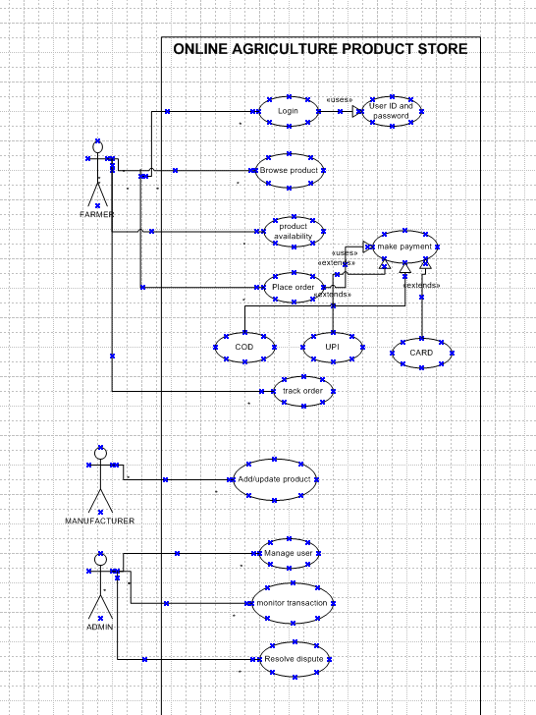

1. Prepare use case specs for all use cases

|  |
| --- |
| Use Case: Register User (Farmer/Manufacturer) |
| Primary Actor: Farmer / Manufacturer |
| Goal: Allow users (Farmers and Manufacturers) to register on the platform. |
| Preconditions: The user has access to the internet and the registration page. |
| Main Success Scenario:   1. User accesses the registration page. 2. User selects whether they are a Farmer or Manufacturer. 3. User enters required details (Name, Email, Phone Number, Address). 4. User submits the registration form. 5. System validates the data and creates the account. 6. A confirmation message or email is sent to the user. |
| Postconditions: User account is created and stored in the system. |
| Exceptions:   * If the user enters invalid details, they are prompted to correct them. * If the email/phone number is already in use, the system alerts the user. |

|  |
| --- |
| Use Case: Login User |
| Primary Actor: Farmer / Manufacturer |
| Goal: Allow users to log in to the system using their credentials. |
| Preconditions: The user must have already registered. |
| Main Success Scenario:   1. User accesses the login page. 2. User enters their credentials (email/phone number and password). 3. System validates the credentials. 4. Upon successful validation, the user is logged in and directed to the dashboard. |
| Postconditions: User is logged in and can now access their dashboard and features. |
| Exceptions: If the credentials are incorrect, the user is prompted to try again. |

|  |
| --- |
| Use Case: View Product Listings (Seeds, Fertilizers, Pesticides) |
| Primary Actor: Farmer |
| Goal: Allow farmers to browse through product listings. |
| Preconditions: The user is logged in. |
| Main Success Scenario:   1. User navigates to the product listing page. 2. System displays a list of available products categorized by type (seeds, fertilizers, pesticides). 3. User filters products based on categories, price, or other specifications. 4. User can click on a product to view more details (description, price, available stock). |
| Postconditions: User can see a detailed view of any product listed. |
| Exceptions: If no products are available, the system will show a message indicating so. |

|  |
| --- |
| Use Case: Request Product Purchase |
| Primary Actor: Farmer |
| Goal: Allow farmers to request products they want to purchase. |
| Preconditions: The user has browsed the product listings. |
| Main Success Scenario:   1. User selects a product from the list. 2. User chooses the quantity and adds the product to the cart. 3. User reviews their cart and proceeds to checkout. 4. User enters delivery details (address, contact number). 5. User submits the order request. 6. The system sends a confirmation of the order to the farmer. |
| Postconditions: The order request is sent to the manufacturer for processing. |
| Exceptions:   * If the product is out of stock, the system notifies the user. * If there is an issue with delivery details, the system prompts for correction. |

|  |
| --- |
| Use Case: Product Details Submission (Manufacturer) |
| Primary Actor: Manufacturer |
| Goal: Allow manufacturers to submit new products (seeds, fertilizers, pesticides) to the platform. |
| Preconditions: The manufacturer is logged in. |
| Main Success Scenario:   1. Manufacturer accesses the product submission page. 2. Manufacturer fills in the product details (name, category, description, price, available stock). 3. Manufacturer submits the product details. 4. The system stores the product information and displays a confirmation message. |
| Postconditions: The product is added to the platform and available for farmers to browse. |
| Exceptions:   * If any required information is missing, the system prompts for the missing fields. * If a duplicate product is detected, the system alerts the manufacturer. |

|  |
| --- |
| Use Case: Manage Product Inventory (Manufacturer) |
| Primary Actor: Manufacturer |
| Goal: Allow manufacturers to manage product inventory (update stock or details). |
| Preconditions: The manufacturer is logged in. |
| Main Success Scenario:   1. Manufacturer accesses the product management page. 2. Manufacturer selects a product from the inventory. 3. Manufacturer updates the stock quantity or product details (price, description). 4. The system updates the product information and confirms the update. |
| Postconditions: The product inventory is updated on the platform. |
| Exceptions:   * If the manufacturer tries to update with invalid data, the system prompts for correction. * If there is a stock mismatch, the system alerts the manufacturer. |

1. Activity diagrams

* Adding or updating product Order Cancellation

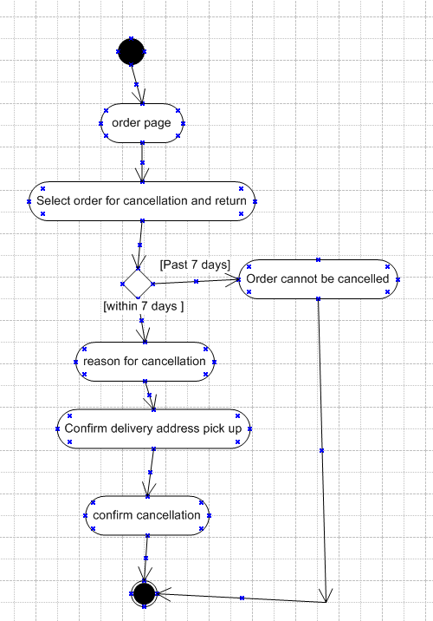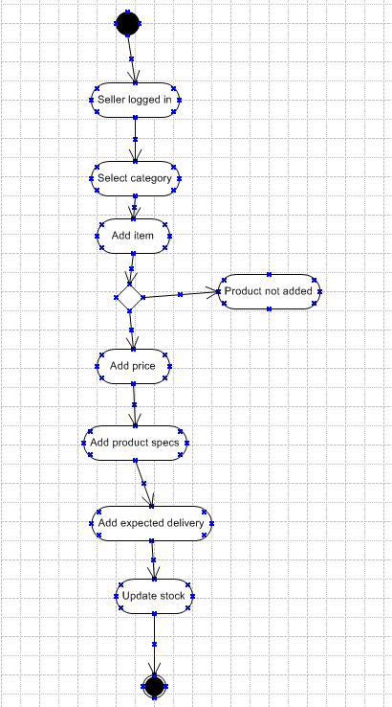

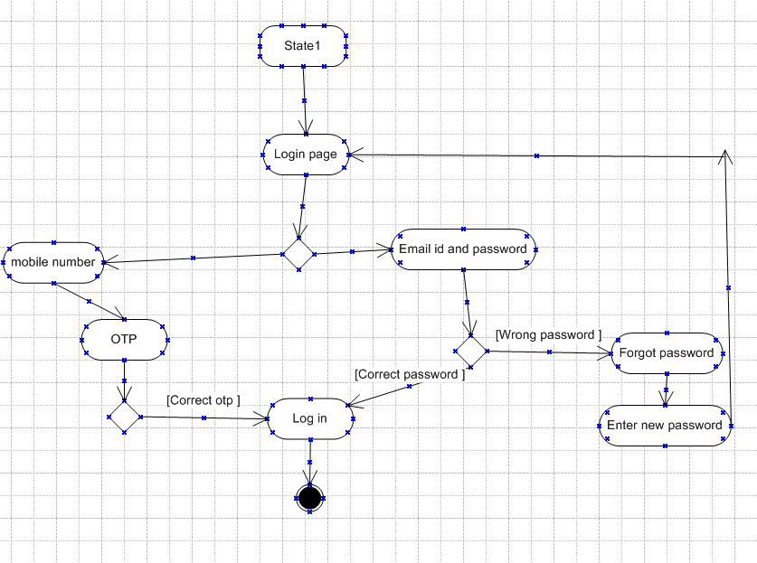User Login Buying Fertilizers

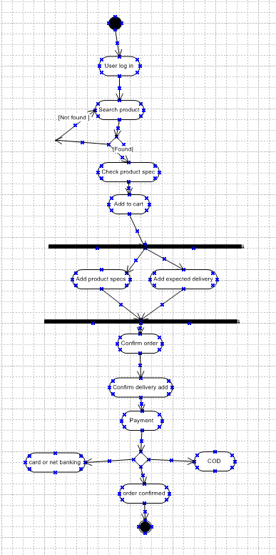

Buying fertilizers