Document 6
USE Case Diagrams
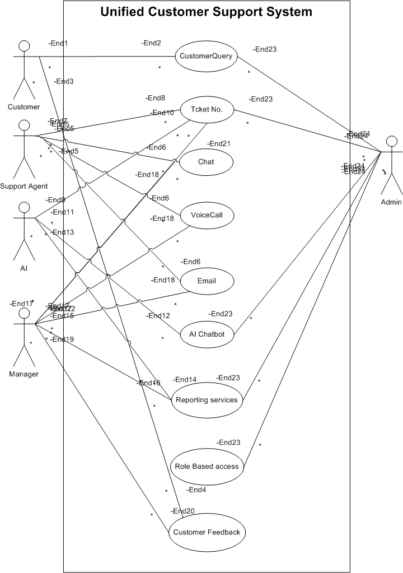
Activity Diagrams
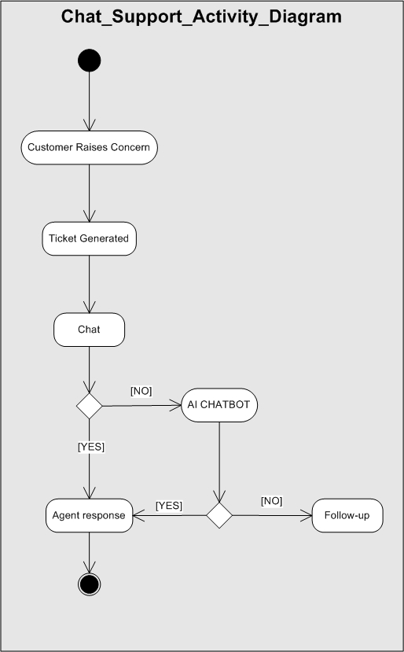 | 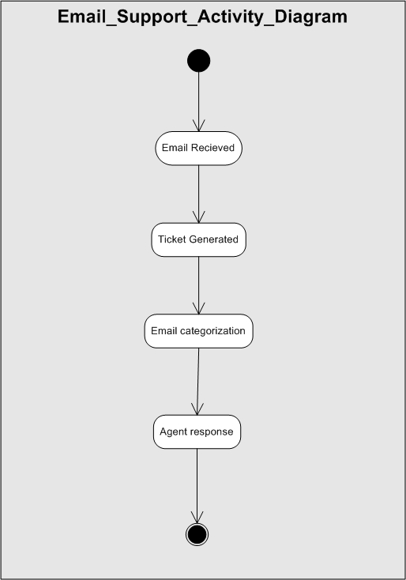
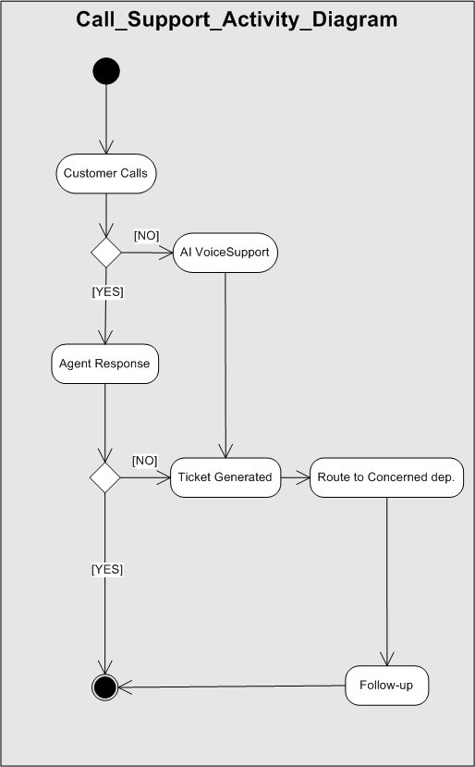 | 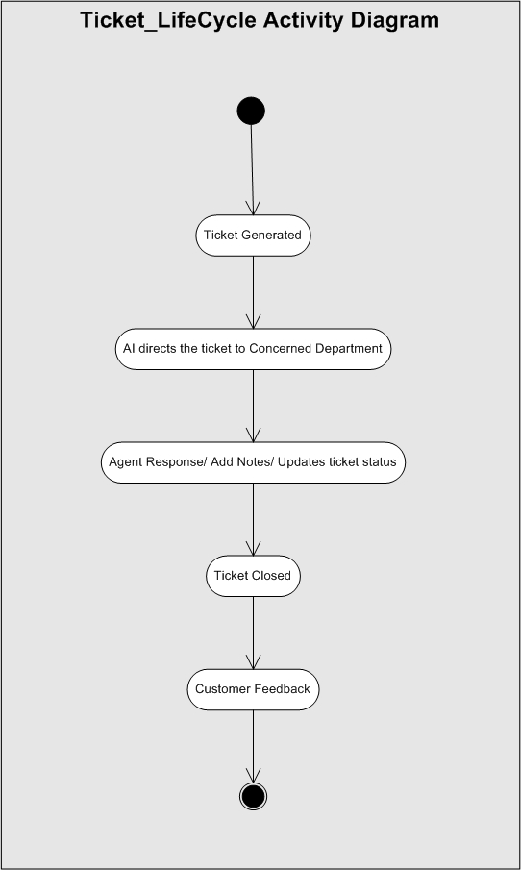
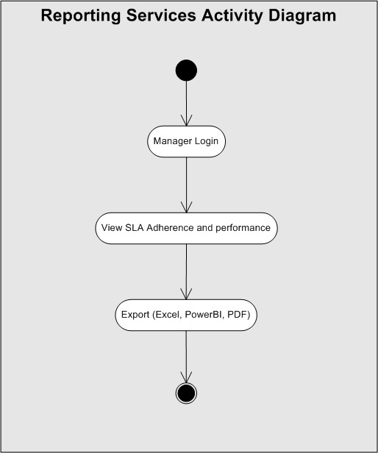

Use case specification document.
USE CASE ID: CHAT-001 | USE CASE Name: Customer Chat Support
Created By: Jay Kishan Sahu | Date Created: 25/02/2025
- Use Case Description | Enables customers to communicate with agents in real time through chat.
- Actors | Primary Actor: Customer  Secondary Actor: Support Agent
- Pre-Conditions | Customer initiates chat; internet connection available.
- Basic Flow | - Customer initiates a chat session via web interface.  - AI bot greets the user and collects basic info.  - A ticket is created and routed to an agent.  - Agent responds in real time.  - Chat ends and transcript is saved to ticket
- Alternate Flow | If no agent is available, bot provides fallback response and promises follow-up.
- Exceptional Flow | If chat system fails, prompt the customer to send an email and log an incident.
- Post-Conditions | Transcript stored; ticket updated.
- Frequency of Use | High
- Special Requirements | Low-latency chat infrastructure.

USE CASE ID: Email-001 | USE CASE Name: Email Ticket Creation
Created By: Jay Kishan Sahu | Date Created: 25/02/2025
- Use Case Description | Automatically creates support tickets from customer emails.
- Actors | Primary Actor: Customer  Secondary Actor: System
- Pre-Conditions | Email received at support address.
- Basic Flow | - Customer sends an email to support address.  - System reads and parses email.  - Ticket is created and categorized using AI.  - Customer gets an acknowledgment email.
- Alternate Flow | If AI fails to categorize, default to 'General Inquiry'.
- Exceptional Flow | If mailbox access fails, log error and alert admin.
- Post-Conditions | Ticket created and acknowledged.
- Frequency of Use | High
- Special Requirements | IMAP or SMTP email integration

USE CASE ID: Call-001 | USE CASE Name: VoIP-Based Call Support
Created By: Jay Kishan Sahu | Date Created: 25/02/2025
- Use Case Description | Facilitates support calls using VoIP with call logging and recording.
- Actors | Primary Actor: Customer  Secondary Actor: Support Agent
- Pre-Conditions | Customer calls support line.
- Basic Flow | - Customer calls support number.  - IVR directs call to appropriate agent.  - Agent handles issue and logs call.  - Call is recorded and associated with a ticket.
- Alternate Flow | If all agents are busy, place the call-in queue or offer callback option.
- Exceptional Flow | If VoIP system fails, display offline notice and redirect to chat/email.
- Post-Conditions | Call log and recording saved, ticket updated.
- Frequency of Use | High
- Special Requirements | Integration with VoIP provider.

USE CASE ID: Ticket-001 | USE CASE Name: Ticket Lifecycle Management.
Created By: Jay Kishan Sahu | Date Created: 25/02/2025
- Use Case Description | Manages the entire lifecycle of a support ticket.
- Actors | Primary Actor: Support Agent  Secondary Actor: Admin
- Pre-Conditions | Ticket exists in the system.
- Basic Flow | - Ticket is created from chat/email/call.  - Agent updates status and adds notes.  - Resolution is provided.  - Ticket is closed after customer confirmation.
- Alternate Flow | If ticket needs escalation, it is reassigned with higher priority.
- Exceptional Flow | If agent forgets to update status, system sends reminder.
- Post-Conditions | Ticket closed with resolution details.
- Frequency of Use | High
- Special Requirements | Status change logs, timestamps

USE CASE ID: AI-001 | USE CASE Name: Ticket Routing
Created By: Jay Kishan Sahu | Date Created: 25/02/2025
- Use Case Description | AI assigns tickets to the best-suited agent/team.
- Actors | Primary Actor: System  Secondary Actor: Support Agent
- Pre-Conditions | Ticket is generated.
- Basic Flow | - Ticket is analyzed by AI engine.  - Relevant category, sentiment, and tags are extracted.  - Best-suited agent is assigned automatically.
- Alternate Flow | If no agent is available, assign to fallback team.
- Exceptional Flow | If routing engine fails, assign to manual review queue.
- Post-Conditions | Ticket routed and assigned.
- Frequency of Use | High
- Special Requirements | AI model training and agent skill mapping.

USE CASE ID: BOT-001 | USE CASE Name: AI Chatbot Resolution
Created By: Jay Kishan Sahu | Date Created: 25/02/2025
- Use Case Description | Bot handles common queries and creates tickets for unresolved issues.
- Actors | Primary Actor: Customer  Secondary Actor: AI Bot
- Pre-Conditions | Chatbot is configured and trained.
- Basic Flow | - Bot greets and queries customer intent.  - Bot suggests solutions or articles.  - If unresolved, ticket is escalated to agent.
- Alternate Flow | Bot follows up with links or prompts for more info.
- Exceptional Flow | Bot crashes or loops—redirect to agent.
- Post-Conditions | Query resolved or ticket created.
- Frequency of Use | High
- Special Requirements | NLP integration, FAQ knowledge base.

USE CASE ID: Integrate-001 | USE CASE Name: Jira Integration
Created By: Jay Kishan Sahu | Date Created: 25/02/2025
- Use Case Description | Allows support tickets to be linked and tracked with Jira issues.
- Actors | Primary Actor: Support Agent  Secondary Actor: System
- Pre-Conditions | Integration configured.
- Basic Flow | - Agent flags ticket for dev team.  - Jira issue is created and linked.  - Updates are synced in both systems.
- Alternate Flow | Allow manual entry of Jira issue ID.
- Exceptional Flow | If API fails, alert user to retry later.
- Post-Conditions | Ticket and issue linked.
- Frequency of Use | Low
- Special Requirements | Jira API access and credentials.

USE CASE ID: Report-001 | USE CASE Name: SLA Dashboard Reporting
Created By: Jay Kishan Sahu | Date Created: 25/02/2025
- Use Case Description | Displays SLA metrics and performance for management.
- Actors | Primary Actor: Manager  Secondary Actor: Admin
- Pre-Conditions | Ticket data exists.
- Basic Flow | - Manager logs in to dashboard.  - Applies filters for team, period, ticket type.  - Views SLA adherence and escalation rates.
- Alternate Flow | Export report to CSV or PDF.
- Exceptional Flow | If no data available, show default 'No Results'.
- Post-Conditions | Report viewed or downloaded.
- Frequency of Use | Medium
- Special Requirements | Realtime analytics engine.

Document 7
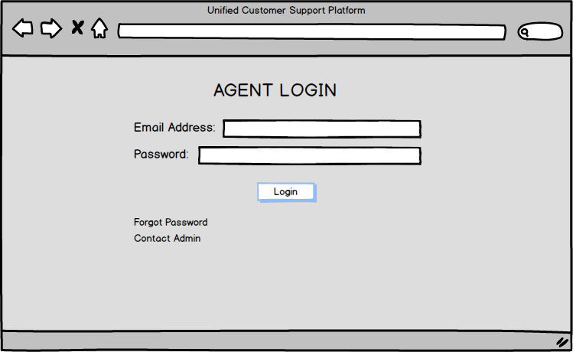
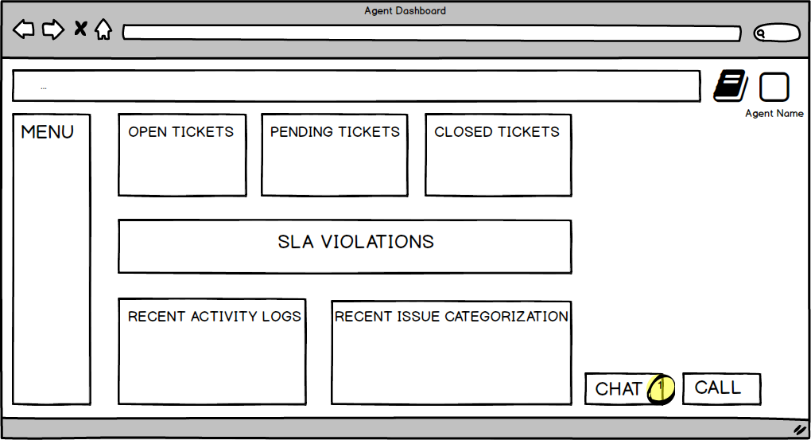
Screens and Pages.
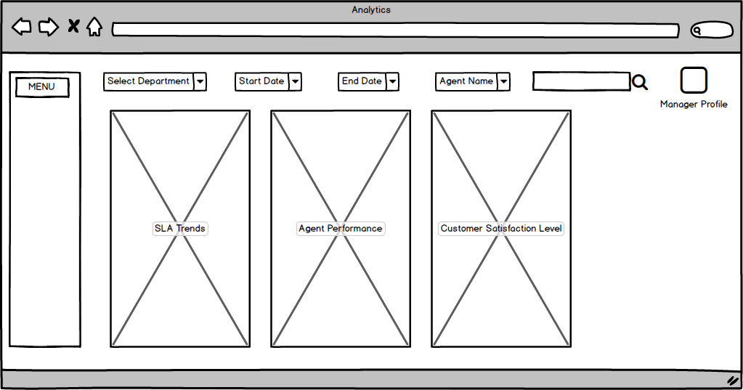
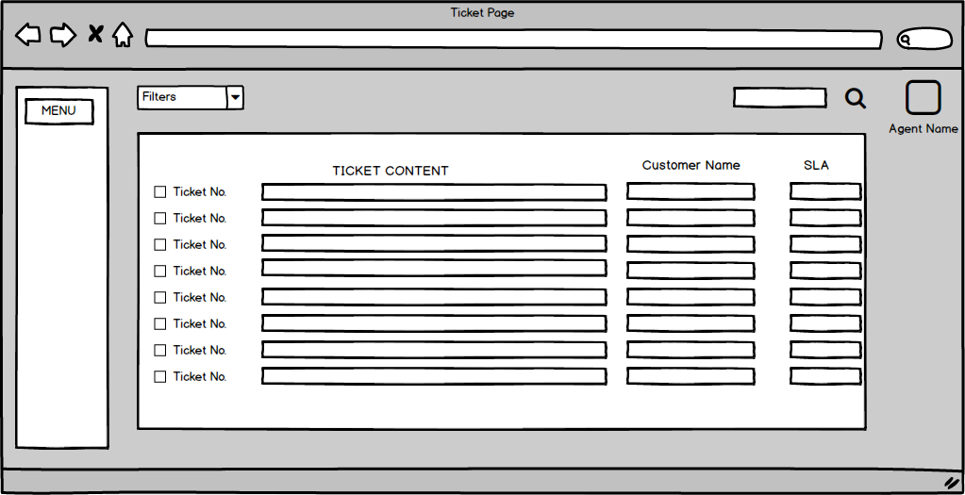
Document 8
Tools Visio and Axure
Microsoft Visio is primarily used for creating diagrams, flowcharts, org charts, process maps, network diagrams, and floor plans.
Its key features are:
- Drag-and-drop shapes for creating diagrams quickly.
- Ideal for business process modeling, system architecture diagrams, and IT infrastructure mapping.
- Supports a wide range of templates (e.g., flowcharts, UML, Activity Diagram).
- Integrates with Microsoft 365 tools like Excel and Teams.
- Can export diagrams as PDFs or images and share them.
Use Cases:
- Business analysts use Visio to map as-is and to-be processes.
- IT teams use it for network and system design.
- Project managers use it for workflow visualization.
Axure RP is a wireframing, prototyping, and documentation tool used for UX/UI design and interaction modeling.
Its key features:
- Create interactive prototypes with dynamic content, conditions, and logic.
- Supports responsive design for different screen sizes.
- Allows annotation and collaboration with stakeholders.
- Generates HTML-based interactive prototypes that can be tested in real browsers.
- Useful for creating realistic simulations of apps and websites before development.
Uses:
- UX designers use it for user journey flows and wireframes.
- BAs and Product Owners use it to gather feedback on mock interfaces.
- Developer’s reference Axure prototypes to understand UI behavior.

Document 9
BA Experience
My experience as BA in following phases:
- Requirement gathering: As a BA, in this project I did document analysis, Interviews and conducted JAD session for requirement gathering. The requirements being gathered was then documented in BRD. I also created a RTM document.
- Requirement Analysis: In requirement analysis phase, I analyzed the gathered requirements and prepared Functional Requirement Document. In this process, the duplicate requirements were removed. The functional requirements were then categorized and sorted. I conducted a session where requirements were prioritized. I also did feasibility study, Risk analysis and stakeholder analysis.
- Design: In Design phase, I created use case specification documents, build Use Case diagrams, Activity Diagrams and Screen Mockups.
- Development: In Development Phase, I managed the RTM document by following up with the development team in regular intervals. I kept the stakeholders updated about the progress of project. I also did continuous requirement validation during development phase.
- Testing: I supported Testing team in creating Test cases and test case documentation. And did functional testing to validate the functionality of the features.
- Deployment: While deployment phase, I supported in deployment planning. Also, after deployment I supported in organizing training sessions for delivery teams for smooth transition of process to new application.
After each phase was completed, I was responsible to get sign-offs from stakeholders to mark the completeness of that phase so that project can proceed to next phase.

