

RLMS

UPDATES AND ENHANCMENTS

Soumya Shetty | Product Owner | 17 Feb 2024

**Document 1: Definition of Done.**

A DoD is a set of criteria that a product increment must meet for the team to consider it complete and ready for customers. It is a shared understanding among the team members of when a product increment is ready for release, even when the increment is large and consists of many items. By clearly defining what “done” means to the project, an Agile team can focus on delivering value with every sprint and minimizing rework.

It is important to note that one person does not create the Definition of Done. Instead, it is agreed upon by the entire project team, including developers, testers, product owners, and other stakeholders. This ensures a smoother process during sprints since everyone is using the DoD as a guide alongside any checklists before marking an item as complete.

“If you deal with hand-offs to other teams, ensure your definition of done accounts for anything needed to ensure the other team is successful,” says Atlassian’s Modern Work Coach Mark Cruth. “Work with the other teams in the value stream to find out what you should be including in your DoD to support them.”

**Checklist for DOD:**

* **User Stories Defined** with clear acceptance criteria.
* **Product Owner Approval** of user stories and requirements.
* **Design Approved** (if needed).
* **Code Developed** following standards.
* **Version Control** used
* **Database Changes** applied.
* **Unit Tests Passed** for new/changed code.
* **Integration Tests Passed** with other systems.
* **Regression Testing Completed**.
* **Bug Fixes Applied** for critical issues.
* **UAT (User Acceptance Testing)** passed or ready for review.
* **Product Owner Review** completed.
* **Sprint Demo** conducted with stakeholders.
* **Acceptance Criteria Met** for each user story.
* **No Critical Bugs** remain.
* **Deployment Plan Ready** (including rollback).
* **Staging Validation** done before production.
* **Deployed to Production** successfully.
* **Release Notes Created**.
* **User/Technical Documentation Updated** (if necessary).
* **Stakeholder Notification** sent regarding the update.
* **Team Knowledge Sharing** on changes.
* **Sprint Retrospective** conducted to identify improvements.

**2. Product Vision**

|  |  |  |  |
| --- | --- | --- | --- |
| **Scrum Project**  **Name** | **RLMS – Updates and Enhancements** | | |
| **Venue** | **Conference Room 1** | | |
| **Date : 25/10/2024** | **Start Time: 11.00 am** | **End Time: 2.00 pm** | **Duration: 3 hours** |
| **Client** | ABC Bank Ltd | | |
| **Stakeholder List** | ABC Bank Ltd -Sponsor | | |
|  | Project Manager- N Srinivasan | | |
|  | Director- R Ramakrishnan, Xion Ltd | | |
|  | Scrum Team | | |
|  |  |  |  |
| **Scrum Team** | | | |
| **Scrum Master:** | Soumya Shetty | | |
| **Product Owner** | Soumya Shetty | | |
| **Scrum Developer 1** | Suraj Mali, | | |
| **Scrum Developer 2** | Mangesh Bhalerao, | | |
| **Scrum Developer 3** | Vanita Chettiar | | |
| **Scrum Developer 4** | Preeti | | |
| **UX Designer 1** | S Saisha, | | |
| **UX Designer 2** | Jenny Dsouza | | |
| **QA Tester 1** | Shweta Kunder | | |
| **QA Tester 2** | Sachin Sarolkar | | |
| **Support** | Vijeta M, Sheetal Mishra, Jaya H. | | |

|  |  |  |  |
| --- | --- | --- | --- |
| **Vision: What is your Vision, your overreaching goal for creating the product?** | | | |
| **Target Group** | **Needs** | **Product** | **Value** |
| Which market segment does the product address?  **Retail Loans**  Who are the Target users and Customers?  **The target users are the Bank Employees and The Retails Loan Customers.** | What problem does the product solve?  **The Product will improve operational efficiency, Lower operational costs, Increase Automation, Improve integration and strengthen security.** | What Product is it?  **It is updation and enhancements to RLMS application of the Bank**.  What makes it desirable and special?  **The updation in the current app will be adding Maintenance Module to the app and also 2 factor Authentication to Login and Approvals. Reduction of Multiple levels and users from sourcing of Loan until Sanction. Improved Integration and Security and Compliance as be Global standards. All these features make it desirable from Operational and Profitability angle.**  Is it feasible to develop the Product?  **Yes. The total Budget of the Product is Rs.50 Lakhs. Considering the size of the Bank and the ROI. We are expected to Break-even within 6 months, with faster processing, Lower Employee Costs and Automation of Tasks which will result in increased Profitability.** | How is the product going to benefit the Bank?  **The improvement and enhancements in RLMS application will result in faster Sanction of Loans, reducing TAT of Loans, reduction of Employee costs and this application will minimize multiple levels. This will in turn result in improvement in profitability of the Bank.**  What are the Business Goals?  **Improved Employee Efficiency. Reduction in Operational Costs. Better Customer Service. Improvement in Processes. Automation of Tasks.**  **Increased Profitability.**  What is the Business Model?  **Updations and Enhancements to the application will improve process and helps us stay ahead of our competitors. Having a RLMS application which is robust, dynamic and futuristic will help the Bank be ready for fast changing digital space.** |

3. User Stories

|  |  |  |
| --- | --- | --- |
| User Story No: 01 | Tasks: 2 Factor Authentication | Priority: Highest |
| Value Statement:  As a User  I want to- be OTP screen once I Login with User Id and Login  So that I -Can key in the OTP received on my mobile and e mail address | | |
| BV: 100 | CP: 2 |  |
| Acceptance criteria:  User should be getting an OTP screen once is logs in with Employee ID and Password. | | |

|  |  |  |
| --- | --- | --- |
| User Story No: 02 | Tasks: User Friendly Dashboard | Priority: Highest |
| Value Statement:  As a User  I want to- have a Cleaner and User Friendly Dashboard  So that I can: have a better User Experience and see all the Tabs in a Better Way | | |
| BV: 200 | CP:4 |  |
| Acceptance criteria: The Dashboard should be Simple, Clean and User Friendly which will allow user to use the application with ease. | | |

|  |  |  |
| --- | --- | --- |
| User Story No: 03 | Tasks: Key Loan Metrics | Priority: Medium |
| Value Statement:  As a User  I want to- be able to see Key Loan Metrics  So that I can: Know the performance and make Improvements | | |
| BV: 200 | CP:4 |  |
| Acceptance criteria: User should be able to see Key Loan Metrics (Loan Application Volume, Amount of Loan, TAT for Sanction, Number of Pending Files, Conversion Rate) of his Branch on a Weekly, Monthly, Quarterly and Yearly Basis. | | |

|  |  |  |
| --- | --- | --- |
| User Story No: 04 | Tasks: Customization | Priority: Medium |
| Value Statement:  As a User  I want to- be able to customize my screen  So that I can- Save my favorite screens on the Home Page. | | |
| BV: 100 | CP: 3 |  |
| Acceptance criteria:  User should be able to Customize his Homepage as per his Preference. He should be able to change background wallpaper as per his choice, select menu and color theme and add favorite menu options. | | |

|  |  |  |
| --- | --- | --- |
| User Story No: 05 | Tasks: Alerts | Priority: Medium |
| Value Statement:  As a User-  I want to- get Alerts on any Pending Tasks.  So that I can Attend the Tasks that are Pending. | | |
| BV: 200 | CP:3 |  |
| Acceptance criteria:  User should be able to get alerts on Loan Pending Tasks. | | |

|  |  |  |
| --- | --- | --- |
| User Story No: 06 | Tasks: Automated E mail | Priority: Highest |
| Value Statement:  As a User  I want- the Automated e-mail/ mobile notification to be sent to customers  So that I can- update the customer about his Loan application status. | | |
| BV:500 | CP:2 |  |
| Acceptance criteria:  Automated e-mails and mobile messages to be sent on Login, Sanction and Disbursement of Loan. | | |

|  |  |  |
| --- | --- | --- |
| User Story No: 07 | Tasks: Pre-Screening of Applicants | Priority: Highest |
| Value Statement:  As a User  I want to: have the applicant details Pre- screened.  So that I can know that the applicant meets the criteria for Loan | | |
| BV: 200 | CP:4 |  |
| Acceptance criteria:  The Loan applicant should get pre-screened before moving to the processing stage. | | |

|  |  |  |
| --- | --- | --- |
| User Story No: 08 | Tasks: Customized Reporting | Priority: Highest |
| Value Statement:  As a User  I want to get customized reports as per my Role  So that I can make appropriate decisions. | | |
| BV:500 | CP:4 |  |
| Acceptance criteria:  The User should get customized reporting as per their Role. Branch Head will get overall Branch Report. NPA Manager will get NPA related reports etc. | | |

|  |  |  |
| --- | --- | --- |
| User Story No: 09 | Tasks:Filter of Application as per Criteria | Priority: Medium |
| Value Statement:  As a User  I want to Filter Applications as per Name, Highest to Lowest, Most Urgent  So that I can attend items as per priority |  |  |
| BV:200 | CP:3 |  |
| Acceptance criteria:  There should be filter to search files by Name, Mobile No, Highest Amount to Lowest, Most Urgent to Normal, Pan Number, Application ID. | | |

|  |  |  |
| --- | --- | --- |
| User Story No: 10 | Tasks : Standing Instructions | Priority: Highest |
| Value Statement:  As a User  I want to set Standing Instruction / NACH to Loan Accounts  So that I can ensure the account is maintained. | | |
| BV:500 | CP:5 |  |
| Acceptance criteria:  Standing Instructions and NACH mandates of Loan accounts to be processed in RLMS applications. | | |

|  |  |  |
| --- | --- | --- |
| User Story No: 11 | Tasks: Resetting of Repayment Schedule | Priority : Highest |
| Value Statement:  As a User  I want to- Reset the Repayment Schedule of Loan in RLMS  So that I can reduce the EMI of Customer on his request. | | |
| BV:200 | CP:3 |  |
| Acceptance criteria:  The user should be able to reset Repayment Schedule when a customer requests for reset on repayment. | | |

|  |  |  |
| --- | --- | --- |
| User Story No: 12 | Tasks: NPA Management | Priority: Highest |
| Value Statement:  As a User  I want to be able to manage irregular account in RLMS application  So that I can do proper follow up of irregular Loans. |  |  |
| BV:500 | CP:5 |  |
| Acceptance criteria:  The user should be able to track irregular loans segment-wise, irregularity wise in RLMS application and attend High Priority Tasks. | | |

|  |  |  |
| --- | --- | --- |
| User Story No: 13 | Tasks: Alerts for Accounts to be Generated | Priority: Highest |
| Value Statement:  As a User  I want to- Get Alerts for High Priority Account that are Slipping to NPA  So that I can make proper follow up of such accounts. |  |  |
| BV:500 | CP:5 |  |
| Acceptance criteria:  The RLMS application should generate alerts for most urgent tasks that need to be done for follow up for Slipping Accounts. | | |

|  |  |  |
| --- | --- | --- |
| User Story No: 14 | Tasks: Automated Notices | Priority: Highest |
| Value Statement:  As a User  I want to generate automated Notices to Irregular Accounts  So that I can follow Standard Operating Procedure for Irregular Accounts |  |  |
| BV:500 | CP:4 |  |
| Acceptance criteria:  Automated Notices to be generated for Irregular Accounts on Monthly Basis. | | |

|  |  |  |
| --- | --- | --- |
| User Story No: 15 | Tasks:Automated Closure E- mail | Priority: Highest |
| Value Statement:  As a User  I want to send Automated e-mail to customer on closure of their Accounts  So that I can Issue No Dues Certificate and he can collect property Documents on time. |  |  |
| BV: 500 | CP:4 |  |
| Acceptance criteria:  Automated e-mail should be sent to customer for collection of Documents after closure of his Loan Account. | | |

**Document 4: Agile PO Experience**

As a Product Owner I had to understand the needs and requirements of all the Stakeholders involved and recreate changes and updates to the existing RLMS application of the Bank.

Following are the responsibilities of the PO in a project.

* **Market Analysis**: Analysis of market need/demand. Availability of similar products in the market.
* **Enterprise Analysis :** Due Diligence on the market opportunity.
* **Product Vision and Roadmap**: Product vision keeping the need analysis in mind. Product roadmap with high-level features and timeline.
* **Managing Product Features**: Managing stakeholder expectations and prioritizing needs. Prioritization of the epics, stories and features based on criticality and ROI involved.
* **Managing Product Backlog:** Prioritization of user stories. Reprioritization based on stakeholder needs. Epics planning.
* **Managing Overall Iteration Progress**: Sprint progress review. Reprioritization of sprints and epics if needed. Sprint retrospectives with Business Analyst.

From this Project I have learnt how the manage the sprint meeting such as

**Sprint Planning meeting**

**Daily scrum meeting**

**Sprint retrospective meeting**

**Backlog refinement meeting**

In addition, I have learned the process of User stories creation and what are the items to be included user stories such as

**Story No**

**Tasks**

**Priority**

**Acceptance criteria**

**BV & CP value.**

In Scrum, the Product Owner (PO) serves as the voice of the customer, ensuring the product delivers maximum value. They define the product vision, manage and prioritize the backlog, and create clear user stories with acceptance criteria. The PO collaborates closely with the Scrum Team, providing guidance during sprint planning, reviews, and backlog refinements. They act as the bridge between stakeholders and developers, making key decisions on priorities while ensuring that the team works on the most valuable features. Ultimately, the PO is responsible for aligning the product with business goals and customer needs.

Document 5: Product and sprint backlog and product and sprint burndown charts.

Product backlog:

|  |  |  |  |  |  |  |
| --- | --- | --- | --- | --- | --- | --- |
| **User story ID** | **User story** | **Tasks** | **Priority** | **BV** | **CP** | **Sprint** |
| RLMS01 | 01 | 2 Factor Authentication | Highest | 100 | 2 | 1 |
| RLMS02 | 02 | User Friendly Dashboard | Highest | 200 | 4 | 1 |
| RLMS03 | 03 | Key Loan Metrics | Highest | 200 | 4 | 1 |
| RLMS04 | 04 | Customization | Medium | 100 | 3 | 2 |
| RLMS05 | 05 | Alerts | Medium | 200 | 2 | 2 |
| RLMS06 | 06 | Automated e-mail | Highest | 500 | 2 | 2 |
| RLMS07 | 07 | Pre-screening of Applicants | Highest | 200 | 4 | 3 |
| RLMS08 | 08 | Customized Reporting | Highest | 500 | 4 | 3 |
| RLMS09 | 09 | Filter of Application as per Criteria | Medium | 200 | 3 | 3 |
| RLMS10 | 10 | Standing Instructions | Highest | 500 | 5 | 4 |
| RLMS11 | 11 | Resetting of Repayment Schedule | Highest | 200 | 3 | 4 |
| RLMS12 | 12 | NPA Management | Highest | 500 | 5 | 4 |
| RLMS13 | 13 | Alerts for Accounts to be generated | Highest | 500 | 5 | 5 |
| RLMS14 | 14 | Automated Notices | Highest | 500 | 4 | 5 |
| RLMS15 | 15 | Automated Closure E-mail | Highest | 500 | 4 | 5 |

**Sprint backlog**

|  |  |  |  |  |  |
| --- | --- | --- | --- | --- | --- |
| **User story ID** | **User story** | **Tasks** | **Owner** | **Status** | **Estimated effort** |
| RLMS01 | 01 | 2 Factor Authentication | Soumya Shetty | Done | 10 story points |
| RLMS02 | 02 | User Friendly Dashboard | Soumya Shetty | Done | 30 story points |
| RLMS03 | 03 | Key Loan Metrics | Soumya Shetty | Done | 50 story points |
| RLMS04 | 04 | Customization | Soumya Shetty | Done | 10 story points |
| RLMS05 | 05 | Alerts | Soumya Shetty | Done | 20 story points |
| RLMS06 | 06 | Automated e-mail | Soumya Shetty | Done | 10 story points |
| RLMS07 | 07 | Pre-screening of Applicants | Soumya Shetty | Done | 30 story points |
| RLMS08 | 08 | Customized Reporting | Soumya Shetty | Done | 20 story points |
| RLMS09 | 09 | Filter of Application as per Criteria | Soumya Shetty | Done | 20 story points |
| RLMS10 | 10 | Standing Instructions | Soumya Shetty | Done | 20 story points |
| RLMS11 | 11 | Resetting of Repayment Schedule | Soumya Shetty | Done | 20 story points |
| RLMS12 | 12 | NPA Management | Soumya Shetty | Done | 50 story points |
| RLMS13 | 13 | Alerts for Accounts to be generated | Soumya Shetty | Done | 10 story points |
| RLMS14 | 14 | Automated Notices | Soumya Shetty | Done | 10 story points |
| RLMS15 | 15 | Automated Closure E-mail | Soumya Shetty | Done | 10 story points |

Sprint Burndown

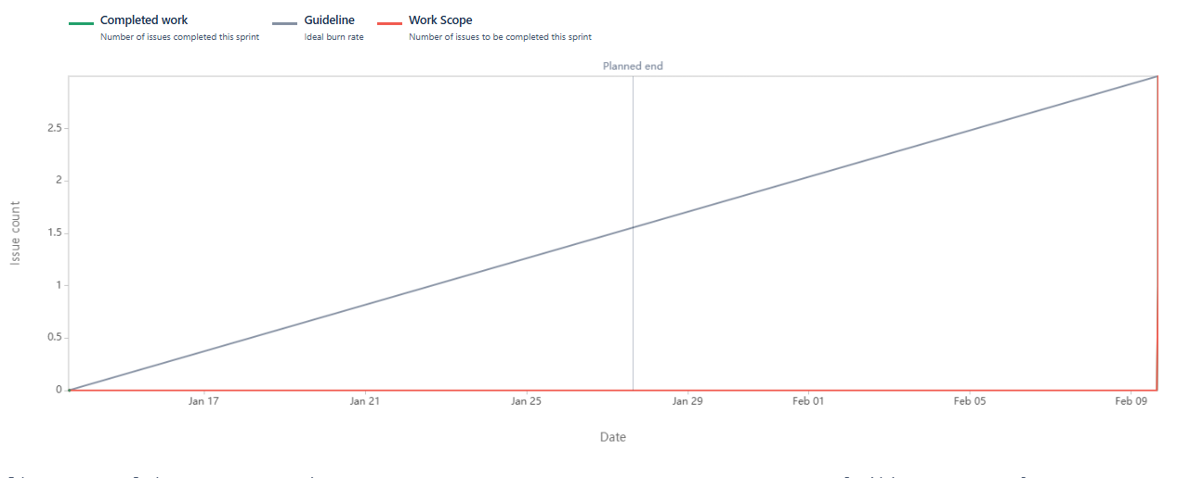

Product Burndown

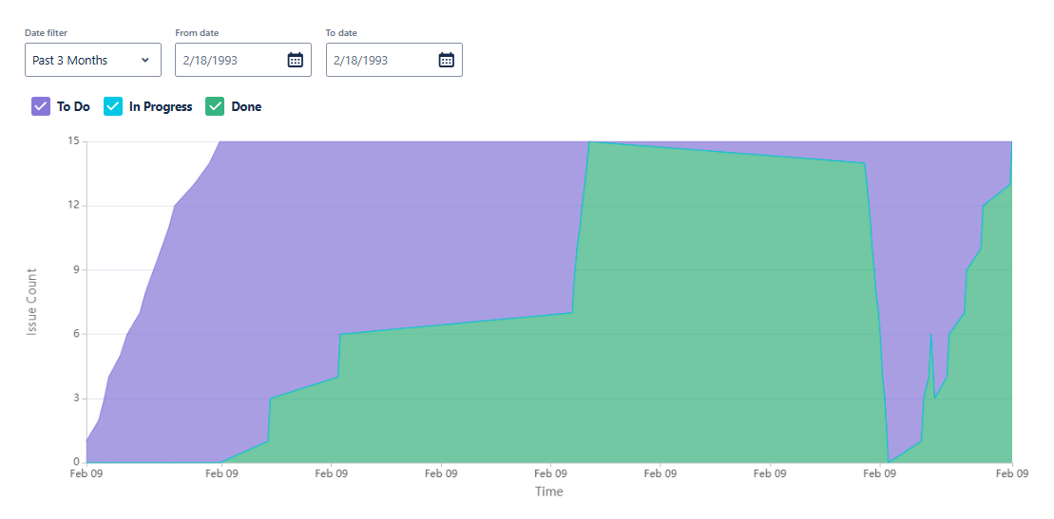

Document 6: Sprint meetings

Meeting Type 1: Sprint Planning Meeting

|  |  |
| --- | --- |
| Date | 03 Nov 2024 |
| Time | 11.00 am |
| Location | Conference Room 1 |
| Prepared By | Soumya Shetty |
| Attendees | Product Owner: Soumya Shetty  Project Manager : N Srinivasan  Design Team: S Saisha, Jenny Dsouza  Development Team: Suraj Mali, Mangesh Bhalerao, Vanita Chettiar, Preeti  Testing Team: Shweta Kunder, Sachin Sarolkar  Support Team: Vijeta M, Sheetal Mishra, Jaya H. |

Agenda Topic

|  |  |  |
| --- | --- | --- |
| Topic | Presenter | Time allotted |
| Sprint Planning | Soumya Shetty | 4.00 hours |

Other Information

|  |  |
| --- | --- |
| Observers | Abc Bank Team, Scrum Team |
| Resources |  |
| Special Notes | Sprints to be finalized in this meeting. |

Meeting Type 2: Sprint review meeting

|  |  |
| --- | --- |
| Date | 23 Dec 2024 |
| Time | 11.00 am |
| Location | Conference Room 3 |
| Prepared By | Soumya Shetty |
| Attendees | Scrum Team |

|  |  |  |  |
| --- | --- | --- | --- |
| Sprint status | Things to demo | Quick updates | What’s next |
| 2nd Sprint Completed | User stories 1 to 6 | User Stories 1 to 6 completed as planned | User stories 7 to 15 to be done |

Meeting Type 3 : Sprint retrospective meeting

|  |  |
| --- | --- |
| Date | 05 Feb 2025 |
| Time | 11.00 am |
| Location | Conference room 1 |
| Prepared By | Soumya Shetty |
| Attendees | Scrum Team |

|  |  |  |  |  |
| --- | --- | --- | --- | --- |
| Agenda | What went well | What didn’t go well | Questions | Reference |
| Sprint Retrospective Meeting | All the sprints were completed in time. | Co ordination between teams could be improved | - | - |

Meeting Type 4: Daily Standup meeting

|  |  |  |  |  |  |  |
| --- | --- | --- | --- | --- | --- | --- |
| Question | Name/Role | Week One ( 05 Nov 2024 to 09 Nov 2024) | | | | |
|  |  | Monday | Tuesday | Wednesday | Thursday | Friday |
| What did you do yesterday? | Developer 1 | Worked on US 1 | Worked on US 1 | Worked on US 1 | Worked on US 1 | Worked on US 1 |
| Developer 2 | Worked on US 2 | Worked on US 2 | Worked on US 2 | Worked on US 2 | Worked on US 2 |
| Developer 3 | Worked on US 3 | Worked on US 3 | Worked on US 3 | Worked on US 3 | Worked on US 3 |
| Developer 4 | Worked on US 3 | Worked on US 3 | Worked on US 3 | Worked on US 3 | Worked on US 3 |
| What will you do today? | Developer 1 | Will work on US 1 | Will work on US 1 | Will work on US 1 | Will work on US 1 | Will work on US 1 |
| Developer 2 | Will work on US 2 | Will work on US 2 | Will work on US 2 | Will work on US 2 | Will work on US 2 |
| Developer 3 | Will work on US 3 | Will work on US 3 | Will work on US 3 | Will work on US 3 | Will work on US 3 |
| Developer 4 | Will work on US 3 | Will work on US 3 | Will work on US 3 | Will work on US 3 | Will work on US 3 |
| What (if any ) is blocking your progress? | Developer 1 | Will need to work during same time for better results | Would need some help from Dev 2 for some doubts | - | - | - |
| Developer 2 | - | Will need support from UI and Testing Team for inputs | - | - | - |
| Developer 3 | Co ordination with Developer 4 | - | - | - | Will need support from UI and Testing Team for inputs |
| Developer4 | - | Will need support from UI and Testing | - | - | - |