Name: Snehal Wankhade

BA mock study

Assignment 1

1. Document Revisions

|  |  |  |
| --- | --- | --- |
| **Date** | **Version Number** | **Document changes** |
| 03/03/2025 | 1.0 | Initial Draft |
|  |  |  |
|  |  |  |
|  |  |  |
|  |  |  |

1. Approvals

|  |  |  |  |  |
| --- | --- | --- | --- | --- |
| **Role** | **Name** | **Title** | **Signature** | **Date** |
| Project Sponsor | Rajesh Khanna | Vice President |  |  |
| Business Owner | Sarah Mitchell | Director |  |  |
| Project Manager | Amit Mehra | Sr. Project Manager |  |  |
| System Architect | Priya Nair | Lead System Architect |  |  |
| Development Lead | Micheal Patel | Technical Lead |  |  |
| User Experience Lead | Olivia Sharma | UX Lead |  |  |
| Quality Lead | Ravi Iyer | QA Manager |  |  |
| Content Lead | Neha Verma | Content Strategies |  |  |

1. RACI Chart

|  |  |  |  |  |  |  |  |
| --- | --- | --- | --- | --- | --- | --- | --- |
| **Name** | **Position** | **\*** | **R** | **A** | **S** | **C** | **I** |
| Rajesh Khanna | Vice President |  |  |  |  |  |  |
| Sarah Mitchell | Director |  |  |  |  |  |  |
| Amit Mehra | Sr. Project Manager |  |  |  |  |  |  |
| Priya Nair | Lead System Architect |  |  |  |  |  |  |
| Micheal Patel | Technical Lead |  |  |  |  |  |  |
| Olivia Sharma | UX Lead |  |  |  |  |  |  |
| Ravi Iyer | QA Manager |  |  |  |  |  |  |
| Neha Verma | Content Strategies |  |  |  |  |  |  |
| Snehal | Business Analyst |  |  |  |  |  |  |

1. Introduction
   1. Business Goal

FreshServe Company aims to develop a centralized software solution to efficiently manage inventory across multiple manufacturing plants and warehouse while ensuring the quickest delivery of ice cream and milk products to customer.

This system will provide real-time inventory tracking, optimize stock levels, and implement intelligent logistics to minimize delivery time and reduce operational costs, ultimately enhancing customer satisfaction and business efficiency.

* 1. Business Objective

The objective is to develop a comprehensive IT solution that enhances inventory management, order processing and delivery optimization while ensuring a seamless customer experience. This solution will include a web-based platform and mobile application for Android and iOS to provide real-time access to inventory, orders, and logistics.

**Key functionalities to be Developed in the software**

1. Inventory Management System

* Real-time tracking of stock levels across manufacturing plants and warehouses.
* Automated stock replenishment and expiration tracking
* Batch and lot tracking for perishable goods
* Supplier and purchase order management
* Barcode scanning for inventory control

1. Order Management

* Customer order placement and processing
* Order status tracking with notifications
* Automated order allocation to nearest warehouse
* Integration with payment gateways for seamless transactions

1. Delivery and Logistics Optimization

* Route optimization for the fastest delivery
* Real-time order tracking for customers
* Delivery scheduling
* Deliver assignment and route guidance system

1. Customer and Vendor Management

* Customer registration, profile management and order history
* Vendor and supplier onboarding with contact tracking
* Communication system for order updates and support

1. Reporting and analysis

* Dashboard with key insights on inventory, sales and deliveries
* Demand forecasting and stock trend analysis
* Performance monitoring of logistics and supply chain

Mobile Application features

1. Customer App

* Order placement and history tracking
* Real-time order and delivery updates
* Secure payment options
* Push notifications for promotions and updates

1. Driver App

* Order assignment and route optimization
* GPS-based navigation for deliveries
* Status updates on completion

1. Admin/Warehouse App

* Stock updates and inventory tracking
* Order processing and shipment tracking
* Supplier and vendor management
  1. Business Rules

Inventory management Policies:

* Minimum and maximum stock threshold will be set for each warehouse to avoid shortage and overstocking
* Expiration management: Perishable items will be tracked using batch number and expiration date, ensuring FIFO stock rotation
* Supplier management: All supplies must be registered and approved before fulfilling purchased orders

Order processing rules:

* Order validation: Orders will be processed only if stock available is confirmed
* Cancellation Policy: Customer can cancel order within 2 minutes of placing the order
* Refund and Return Policy: Return will be accepted only for damaged or expired products

Delivery & Logistic Regulation:

* Delivery timeframe: Order must be delivered within predefined SLAs
* Delivery personnel must follow company policies, including hygiene and temperature-controlled transportation

Compliance and Regulatory Guidelines

* Food safety compliance
* Data Privacy and security
* Workplace safety standards
  1. Background

As the business expands, the company has faced significant challenges in inventory management, order fulfillment and delivery optimization. These issues have resulted in delays, insufficiency and increased operational costs, impacting overall customer satisfaction.

To address these challenges, the company has proposed the development of an integrated IT solution that will streamline inventory tracking, automatic order processing and optimize delivery routes. The solution will include web-based platform and mobile application (Android and iOS) to provide real-life stock visibility, intelligent order allocation and GPS-enabled delivery tracking.

By implementing this system, the company aims to reduce wastage, enhance operational efficiency, and improve customer experience. This project will enable scalability, cost saving and long-term business growth through data-driven decision-making and automation.

* 1. Project Objective

The objective of this project is to develop a centralized IT solution that enhances inventory management, order fulfilment, and delivery optimization for the company’s ice-cream and milk products distribution. This solution will provide real-time stock visibility, automated order processing and optimized logistics to improve operational efficiency and ensure fastest possible delivery to customers.

High level product Capabilities:

1. Efficient inventory management
2. Seamless order processing
3. Optimize delivery and logistics
4. Mobile Applications (Android and iOS)
5. Integration with other systems like synchronize with company’s existing financial and supply chain system and connecting with external delivery partners for extended coverage
   1. Project Scope

The project involves the development of comprehensive IT solution for inventory management and delivery optimization to enhance the company’s operations in ice-cream and milk product distribution. The system will include a web-based platform and mobile application (Android and iOS) to streamline inventory tracking, order tracking and delivery logistics.

In-Scope functionalities:

* Inventory management system
* Order management system
* Delivery and Logistics operations
* Mobile Applications (Android and iOS)
* Driver App
* Warehouse/Admin App
* Reporting and Analytics

Out of Scope

* Integration with third party e-commerce platform like Amazon, Flipkart
* Al-based predictive analytics
* International expansion of the system

1. Assumptions

Business and operation Assumptions:

1. The company has multiple warehouse and manufacturing plants across different locations
2. System will be primarily be used for domestic operations
3. Warehouse follows FIFO approach for managing perishable goods
4. The company has existing fleet of delivery vehicles
5. Customers expect fast delivery, with SLAs ranging from same-day delivery to 24 hours delivery depending on location
6. Company has dedicated warehouse staff, drivers and admin who will be trained to use the new system

Technical Assumptions

1. The system will be close based solution platform for centralize access across all locations
2. The solution will include web-based platform and mobile applications
3. Real time tracking of inventory and deliveries
4. Internet connectivity is stable and reliable across all warehouses and delivery location

Regulatory and Compliance Assumptions

1. The system will comply food safety regulations for dairy and perishable product handling
2. Customer data will be managed per data protection laws
3. Delivery personnel will follow standard hygiene and safety protocol when handling products

User and Training Assumptions

1. Employees and delivery personnel will be provided training on using the system and mobile app
2. Customer will have basic knowledge of using mobile apps for placing and tracking orders
3. A dedicated support team will be available to assist users

6 Constraints

1. The business must be completed within a fixed timeline and budget as per company allocation
2. The system will only support domestic operations in initial phase
3. The solution will be role-based, requiring stable internet connectivity for real-time data updates
4. The solution must support role-based access control, limiting unauthorized access to critical data
5. The software must handle high transaction loads efficiently, especially during peak order times
6. The system must comply with food safety regulations for handling dairy and perishable products
7. Delivery efficiency depends on real-world factors like traffic, weather condition and warehouse stock availability

7 Risks

1. Business Risks:

Budget overruns: Unexpected costs in development, integration or infrastructure upgrades may exceed allocated budget

The unexpected business benefits may take longer to materialize, leading to financial concerns

Strategy: Mitigate by demonstrating the ROI of the project to decision-makers through a robust business case

1. Technical Risks:

Challenges in integrating with existing ERP, payment gateways or third-party logistics systems may cause compatibility issues

Server failure, cloud server disruptions, high traffic loads

Strategy: Mitigate by conducting a detailed technical feasibility study and proof of concept before full-scale development

1. Requirements Risk  
   Misunderstanding or Miscommunication of requirements between operation, business and technical team  
   Strategy: Avoid by maintaining clear documentation, regular reviews and traceability matrix   
   Change in requirements during development   
   Strategy: Mitigate by implementing a robust change management process
2. Operational Risks:

Delivery delays

Incorrect inventory data, errors in stocks may lead to overstocking, or expired products being delivered

1. Compliance and security risks:

Unauthorized access, hacking attempts, or insufficient security measures may compromise sensitive data

Failure to comply with food safety or data privacy laws could lead to legal penalties

Strategy: Mitigate by engaging a legal team to review data usage policies

8 Business Process Overview

8.1 Legacy System (AS-IS)

The current system relies on manual processed and disconnected tools, leading to inefficient in inventory tracking, order management, and delivery logistics.

Manual inventory tracking via spreadsheets, increasing error and stock discrepancy

No real stock availability, leading to overstocking or stockouts

Warehouse staff manually update stock levels, leading to delays

8.2 Proposed Recommendations (TO-BE)

The proposed IT solution will automate inventory tracking, streamline order processing, and optimize delivery through a centralized digital platform

Real-time inventory updates using automated stock tracking and barcode scanning

Live-tracking and customer notification, enhancing transparency and satisfaction

Seamless order processing, integrating stock validation and warehouse assignment

Automated reporting and analytics, improving business insights for better decision-making

9 Business Requirements

|  |  |  |  |  |
| --- | --- | --- | --- | --- |
| Requirement ID | Description | Category | Source/Stakeholder | Priority |
| BR-01 | The system must allow customers to place orders via a mobile app and web portal | Functional | Customers, Sales & marketing Team | High |
| BR-02 | The system must provide real-time inventory updates to avoid over-ordering | Functional | Warehouse managers, operations Teams | High |
| BR-03 | The system should auto-assign warehouses based on stock availability and proximity to the customer | Functional | Logistic Team, Inventory management Team | High |
| BR-04 | The system should optimize delivery routes using AI-based algorithms to ensure quickest delivery times | Functional | Logistic Team, IT Team | High |
| BR-05 | Customer must receive real-time order tracking notifications via SMS, email and in-app updates | Functional | Customers, customer support Team | Medium |
| BR-06 | Warehouse staff should be able to scan barcodes for stock updates | Functional | Warehouse operations, IT Team | Medium |
| BR-07 | The system should support multiple payment methods, including credit/debit cards, UPI, wallets and COD | Functional | Finance Team, customers | High |
| BR-08 | The system must generate reports and analytics for inventory levels, sales trends, and delivery performance | Functional | Business Intelligence Team, Data Analytics Team | Medium |
| BR-09 | The system must allow admin users to manage roles and permissions for different employee levels | Functional | IT Admin Team, HR Team | Medium |
| BR-10 | The system must process at least 1,000 concurrent orders without performance degradation | Non-Functional | IT Team, Cloud infrastructure Team | High |
| BR-11 | The system should ensure 99.9% uptime with failover mechanism | Non-Functional | IT Team, Cloud operations Team | High |
| BR-12 | The system must comply with data security and privacy | Non-Functional | Legal Compliance Team, IT Security Team | High |
| BR-13 | The system must encrypt sensitive customer data | Non-Functional | IT Security Team, Database Admin Team | High |
| BR-14 | The system must support multi-language functionality English and Hindi | Non-Functional | Localization Team, UI/UX Team | Medium |
| BR-15 | The mobile app should be compatible with Android and iOS | Non-Functional | Mobile Ap Development Team, QA Testing Team | Medium |

10 Appendices

10.1 List of Acronyms

|  |  |
| --- | --- |
| Acronym | Full Form |
| AI | Artificial Intelligence |
| BI | Business Intelligent |
| COD | Cash On Delivery |
| CRM | Customer Relationship Management |
| BR | Business Requirement |
| UI | User Interface |
| UX | User Experience |
| UPI | Unified Payments Interface |
| QA | Quality Assurance |

10.2 Glossary of Terms

|  |  |
| --- | --- |
| Terms | Definition |
| Customer Relationship Management (CRM) | A system used to manage a company’s interactions with customers and streamline business processes |
| Inventory Management System (IMS) | A Software Application that tracks inventory levels, orders and stock movements |
| Unified Payments Interface (UPI) | A real-time digital payment system widely used in India for secure financial transaction |
| User Experience (UX) | The overall experience a user has while interacting with a system, focusing on usability and satisfaction |
| User Interface (UI) | The graphical and interactive components of a software application that users engage with |
| Warehouse Management System (WMS) | A software system that helps manage warehouse operations such as inventory tracking, order fulfillment, and logistic |

10.3 Related Documents

|  |  |  |  |
| --- | --- | --- | --- |
| Document Name | Description | Version | Date |
| Business Case Document | Justifies the need for the project, expected ROI and impact on business operations | 1.0 |  |
| Stakeholder Register | Identifies key stakeholders, their responsibility and influence on the project | 1.0 |  |
| Initial Risk Assessment Document | Identifies potential risks, their impact and preliminary mitigation strategy | 1.0 |  |
| High-Level Project Plan | Provides an initial-schedule, milestones and resource allocation before detailed planning | 1.0 |  |
| Budget Estimation and Cost Plan | Estimates project costs, including resources, development, infrastructure and licensing | 1.0 |  |
| Requirement Gathering Plan | Outlines the strategy for collecting business and technical requirements from stakeholders | 1.0 |  |
| Communication Plan | Defines how information will be shared among stakeholders, including meeting schedules and reporting structures | 1.0 |  |
| Vendor Evaluation Document | If third-party vendors are involved, this document assesses their capabilities, pricing and contracts | 1.0 |  |
| Legal & Compliance Checklist | Ensure the project aligns with regulatory requirements | 1.0 |  |

2 Process Flow Diagram

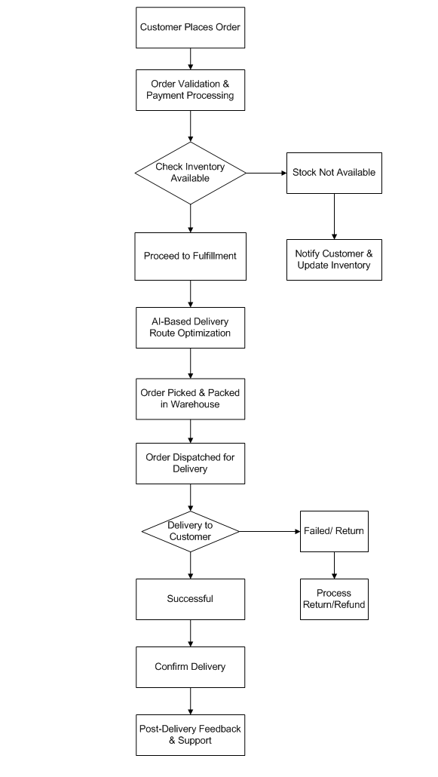

Assignment 2

1. Introduction letter to client

I hope this email finds you well. My name is Snehal Wankhade, and I am Business analyst at Company3. I will be working closely with you and your team to initiate the business understanding process for Project FreshServe.

My role is to bridge the gap between business needs and technical solution by gathering and analyzing requirements, identifying opportunities for improvement, ensuring that the final solution aligns with your objectives. Over the coming weeks, I will be engaging with key stakeholders, conducting discussions, and documenting business requirements to lay the foundation for a successful project.

I look forward to collaborating with you and your team to ensure a smooth and efficient process. Please feel free to share any insights, expectations, or concerns you may have- I am here to support you every step of the way.

Let’s schedule an initial discussion at your convenience to better understand your goals and priorities. Please let me know a suitable time that works for you.

Looking forward to working together!

Best regards,  
Snehal Wankhade  
Business Analyst   
Company3 IT solutions   
[Snehalwankhade@outlook.com](mailto:Snehalwankhade@outlook.com) | +91+9876543210

1. BRD for project- Online Store

Business Objective:

* Provide a user-friendly platform for customers to browse and purchase products
* Ensure a secure payment gateway for smooth transactions
* Implement inventory management to track product availability
* Offer multiple delivery options and real-time order tracking
* Integrate marketing and promotional tools for better customer engagement

Stakeholders:

* Customers: End-users purchasing products
* Store Admin: Managing inventory, orders and customer queries
* Sellers/Vendors: Adding and managing products
* Finance team: Handling payment transaction
* Marketing team: Managing promotions, advertisement
* IT team: Maintaining and securing the online store

Background:

The need for an online store arises from shifting customer behavior towards digital shopping. Traditional retail methods limit the reach and efficiency of business, leading to decreased sales and customer satisfaction. The implementation of an online platform is expected to increase revenue streams, enhance customer engagement, and streamline operations.

Project Objective:

* Provide a user-friendly platform for customer to browse and purchase projects
* Ensure a secure payment gateway for smooth transactions
* Implement inventory management to track product availability
* Offer multiple delivery options and real-time order tracking
* Ingrate marking and promotional tools for better customer engagement

Project Scop

In Scope Functionality

* User registration and Profile management
* Product catalog and search functionality
* Shopping cart and checkout process
* Payment gateway integration
* Order management and tracking
* Inventory management
* Discounts and promotions
* Customer support and feedback system
* Mobile App for iOS and Android

Out of Scope Functionality

* Physical store operations
* Third-party logistics management
* Custom-made products

Assumptions:

* Users will have internet access to browse and purchase products
* Payment gateway service will be provided by a third-party vendor
* Delivery services will be handled either in-house or through third-party logistics

Constraints:

* Compliance with global and reginal e-commerce regulations
* Dependency on external payment and logistics service providers

Risks:

* Security risks: Risk of online fraud, hacking and data breaches
* Supply chain delays due to logistics or inventory issues
* High competitions in the e-commerce industry

Business Process Overview

Legacy System (AS-IS)

* Limited accessibility and geographical reach
* Manual inventory tracking leading to inaccuracies
* Lack of real-time order tracking for customers
* Dependence on third-party platforms with high commission rates

Proposed Recommendations (TO-BE)

* A dedicated web and mobile platform for direct customer engagement
* Automated inventory management to prevent stock discrepancies
* Secure and integrated payment gateways for seamless transaction
* Real-time order tracking and automated customer notifications
* Personalized user experience with AI-driven recommendations

Business Requirements

|  |  |  |  |
| --- | --- | --- | --- |
| Requirement ID | Description | Category | Source/  Stakeholder |
| BR-01 | Users should be able to register, login and manage their profile | Functional | Customers |
| BR-02 | Customers should be able to browse and search for products | Functional | Customers |
| BR-03 | Shopping cart functionality should allow users to add, edit, and remove items | Functional | Customers |
| BR-04 | Secure payment gateway integration for online transactions | Functional | Finance team |
| BR-05 | Order tracking system to provide real-time delivery updates | Functional | Customer |
| BR-06 | Store admin should manage inventory and product listings | Functional | Store Admin |
| BR-07 | Promotional offers and discount management | Functional | Marketing team |
| BR-08 | System must comply with data privacy and security standards | Non-functional | IT team |

SRS Document

Introduction:

The online store project aims to develop a comprehensive e-commerce platform that enables customer to browse, select and purchase products through a user-friendly web and mobile interface. With the rise of digital shopping, businesses need an efficient online platform to enhance customer experience, streamline operations and boost sales.

Goal:

The primary goal of the Online store is to create a seamless and scalable e-commerce platform that offers an intuitive shopping experience, secure transactions and efficient order fulfillment. This platform will bridge the gap between business and customers, providing convenience and accessibility while optimizing operational efficiency.

Objective:

The objective of this project is to develop a robust, scalable and secure online store that enhances the shopping experience for customers while improving operational efficiency for business. The platform will enable users to browse products, make secure transactions, track orders in real-time, and receive personalized recommendations. Additionally, the system will support inventory management, seamless payment integration, and making tools to drive customer engagement and retention.

Use case diagram

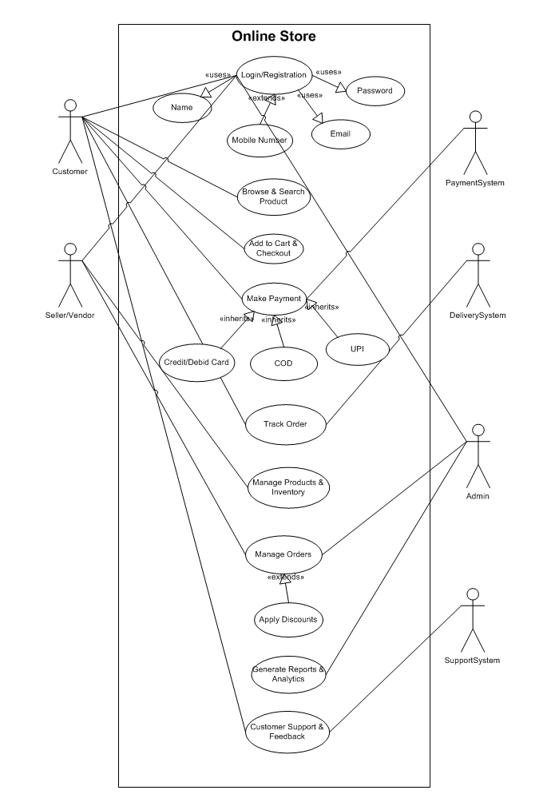

Use case specifications

Use case ID: UC-01

Use case Name: User registration and login

Actors: Customer, vendor/Seller

Description: A new user register for an account, or existing user logs into the system

Precondition:

The user must have a valid email pr mobile number for verification

Basic Flow:

1. The user navigates to the registration/ login page
2. For new users, system prompts for personal details such as name, email, password
3. The system sends an OTP for verification
4. The user enters the OTP and system confirms the account
5. The user logs in using registered credentials

Alternate Flow:

1. If user enters incorrect credentials, the system prompts for a retry
2. If the user forgets the password, they can reset it via email/SMS

Postconditions:

If the email/photo number is already registered, the system prevents duplicate accounts

Exceptions:

If the email/phone number is already registered, the system prevents duplicate accounts

Use case ID: UC-02

Use case Name: Browse products and search products

Actors: Customer

Description: Customer can browse and search for products using various filters and keywords

Preconditions:

The users must have access to the website or mobile application

Basic Flow:

1. The customer navigates to the online store
2. The system displays product categories and a search bar
3. The customer enters a search term, or selects a category
4. The system retrieves and displays relevant products
5. The customer selects a product for more details

Alternate Flow:

1. If no results match the search query and system suggests similar products
2. If the products is out of stock, the system displays a notification

Postconditions:

The customer views product details or refines the search

Exception:

Network failure prevents product retrieval

Use case ID: UC-03

Use case Name: Add to cart and checkout

Actor: Customer

Description: customers add items to the shopping cart and proceed with checkout

Preconditions: The customer must be logged in (if required)

Basic Flow:

1. The customer selects a product and click “Add to Cart”.
2. The system updates the cart and shows the cart summary
3. The customer proceeds to checkout
4. The system prompts for delivery and payment details
5. The customer confirms the order
6. The system processes the order and generates an order ID

Alternate Flows:

1. If the user modifies the cart, the system updates the total price accordingly
2. If payment fails, the system prompts the user to retry

Postconditions: The order is placed successfully, and the customer receives confirmation

Exceptions: System error prevents checkout completion

Use case ID: UC-04

Use case Name: make payment

Actors: customer, payment system

Description: Customer can securely make payments for their purchases

Preconditions: The customer has selected items and is at the checkout page

Basic Flow:

1. The customer selects a payment method (Credit/debit card, UPI etc.)
2. The system redirects to a secure payment gateway
3. The customer enters payment details and confirms
4. The payment system verifies and processes the transaction
5. The system confirms the payment and updates order status

Alternate Flow:

If payment is declined, the customer is prompted to try again or choose another method

Postconditions: The order status updates to “Paid”

Exceptions: Payment system downtime prevents transaction completion

Use case ID: UC-05

Use case Name: Track order

Actors: Customer, Delivery System

Description: Customers can track their order status in real-time

Preconditions: The customer has placed an order successfully

Basic Flow:

1. The customer logs into their account
2. The system retrieves and displays order details
3. The customer clicks on “Track Order”
4. The system retrieves real-time status from the delivery system
5. The customer views the estimated delivery time

Alternate Flow: If the delivery is delayed, the system notifies the customer

Postconditions: The customer is informed of their order’s delivery progress

Exceptions: Delivery system API failure prevents real-time updates

Use case ID: UC-06

Use case Name: Product management

Actor: Store Administrator

Description: The admin adds, updates or removes products from the catalog

Preconditions: The admin must be logged into the system

Basic Flow:

1. The admin navigates to the product management panel
2. The admin selects an action: Add, Edit or Remove a product
3. The system validates the data and updates the products catalog
4. The system reflects the changes in real-time for customers

Alternate Flow:

If the product stock reaches zero, the system marks it as “Out of Stock”

Postconditions: The product catalog is updated in the system

Exceptions: If mandatory product details are missing, the system shows error

Use case ID: UC-07

Use case Name: Generate Report and Analytics

Actor: Store Admin

Descriptions: Admin generate reports to analyze sales and inventory

Preconditions: The admin must have access to analytics

Basic Flow:

1. The admin logs into the analytics dashboard
2. The admin selects the type of report (sales, orders, inventory, etc.)
3. The system fetches data and generates the report
4. The admin downloads or shares the report

Alternate Flow: If there is no sales date for the selected period, the system displays a notification

Postconditions: The report is available for analytics

Exceptions: System downtime may delay report generation

Functional requirements

|  |  |  |
| --- | --- | --- |
| Requirement ID | Requirement Name | Requirement Description |
| FR-01 | User registration & authorization | Users should be able to register, login, and manage their account securely |
| FR-02 | Product Catalog & Search | Customer should be able to browse, search and filter products based on categories, price and rating |
| FR-03 | Shopping cart & Checkout | Customer should be able to add/remove products, modify quantities and proceed to checkout |
| FR-04 | Payment Processing | Integration with multiple secure payment gateways (credit/debit cards, UPI, PayPal, etc.) |
| FR-05 | Order management & tracking | Customer should receive real-time order tracking and status updates |
| FR-06 | Inventory management | The system should update stock availability in real time and notify when times are low or out of stock |
| FR-07 | Discounts & Promotions | Admins should be able to create and manage coupons, discounts, and special offers |
| FR-08 | Reviews & Ratings | Customer should be able to rate and review products after purchase |
| FR-09 | Customer support & chat-bot | Provide helpdesk system or chatbot for customer queries and complaints |
| FR-10 | Multi-Vendor support | Different sellers should be able to register and manage their own product listing |

Non-Functional Requirements

|  |  |  |
| --- | --- | --- |
| Requirement ID | Requirement Name | Description |
| NFR-11 | Security & data protection | Must comply with data privacy regulations |
| NFR-12 | Scalability | The system should handle increasing user traffic and transactions efficiently |
| NFR-13 | Performance | Pages should load within 2 seconds, and checkout should be completed within few clicks |
| NFR-14 | Reliability | System uptime must be at least 99.9% to ensure a smooth shopping experience |
| NFR-15 | Usability | The platform should have a responsive design for seamless navigation on web and mobile |
| NFR-16 | Compatibility | The website and mobile app should support multiple devices and browsers |
| NFR-17 | Backup & Recovery | Data should be backed up daily with disaster recovery measures in place |

1. ERD of Support Ticket

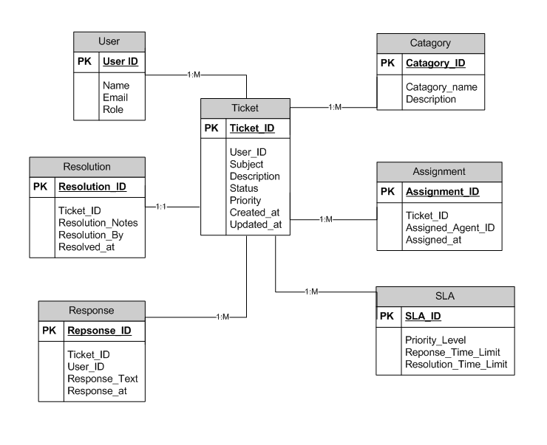

1. User Stories of shopping from ecommerce

|  |  |  |  |
| --- | --- | --- | --- |
| User Story No: 01 | Tasks: User Registration | | Priority: High |
| Value Statement:  As a new user  I want to register an account  So that I can save my details and track orders | | | |
| BV: 500 | | CP: 03 | |
| Acceptance Criteria:  Users can enter name, email, password, and phone number  User receives a verification email or OTP  Registration is successful after validation | | | |

|  |  |  |  |
| --- | --- | --- | --- |
| User Story No: 02 | Tasks: User Login | | Priority: High |
| Value Statement:  As a returning user  I want to log in my credentials  So that I can access my account and order history | | | |
| BV: 500 | | CP: 2 | |
| Acceptance Criteria:  User can login using email and password  System verifies credentials and grant access  Incorrect credentials show an error message | | | |

|  |  |  |  |
| --- | --- | --- | --- |
| User Story No: 03 | Tasks: Browse Product | | Priority: High |
| Value Statement:  As a customer  I want to browse products by category  So that I can find the items I need easily | | | |
| BV: 500 | | CP: 5 | |
| Acceptance Criteria:  Categories are displayed on the homepage  Users can navigate through categories  Filters and sorting options are available | | | |

|  |  |  |  |
| --- | --- | --- | --- |
| User Story No: 04 | Tasks: Search for products | | Priority: High |
| Value Statement:  As a customer  I want to search for specific products  So that I can quickly find what I need | | | |
| BV: 400 | | CP: 2 | |
| Acceptance Criteria:  Search bar is available on all pages  Relevant products appear as suggestions while typing  Search results display accurate match | | | |

|  |  |  |  |
| --- | --- | --- | --- |
| User Story No: 05 | Tasks: View product details | | Priority: High |
| Value Statement:  As a customer  I want to view detailed information about product  So that I can make an informed purchase decision | | | |
| BV: 500 | | CP: 3 | |
| Acceptance Criteria:  Product name, price and description are displayed  High-quality images and videos are available  Customer reviews and rating are visible | | | |

|  |  |  |  |
| --- | --- | --- | --- |
| User Story No: 06 | Tasks: Add product to Cart | | Priority: High |
| Value Statement:  As a customer  I want to add items to my cart  So that I can purchase multiple items in one order | | | |
| BV: 400 | | CP: 2 | |
| Acceptance Criteria:  Clicking “add to Cart” adds the product  Users can adjust the quality before checkout  Cart displays updated total price | | | |

|  |  |  |  |
| --- | --- | --- | --- |
| User Story No: 07 | Tasks: View Shopping Cart | | Priority: High |
| Value Statement:  As a customer  I want to review my shopping cart  So that I can modify my order before checkout | | | |
| BV: 400 | | CP: 2 | |
| Acceptance Criteria:  Carts show all added items with quantity and price  Users can remove or update items  Checkout button is clearly visible | | | |

|  |  |  |  |
| --- | --- | --- | --- |
| User Story No: 08 | Tasks: Apply discount code | | Priority: Medium |
| Value Statement:  As a customer  I want to apply promo code  So that I can avail discounts on my purchase | | | |
| BV: 300 | | CP: 3 | |
| Acceptance Criteria:  Users can enter promo code during checkout  System validates the code and applied the discount  Invalid codes display an error message | | | |

|  |  |  |  |
| --- | --- | --- | --- |
| User Story No: 09 | Tasks: Checkout | | Priority: High |
| Value Statement:  As a customer  I want to complete my purchase smoothly  So that I can receive my order without hassle | | | |
| BV: 500 | | CP: 3 | |
| Acceptance Criteria:  Users can enter shipping details and payment info  System confirms order summary before payment  Successful orders generate a confirmation email | | | |

|  |  |  |  |
| --- | --- | --- | --- |
| User Story No: 10 | Tasks: Order tracking | | Priority: High |
| Value Statement:  As a customer  I want to track my order status  So that I know when my order will be delivered | | | |
| BV: 500 | | CP: 3 | |
| Acceptance Criteria:  Users receive a tracking link-post-purchase  Order status updates in real-time  Notifications are sent for status changes | | | |

|  |  |  |  |
| --- | --- | --- | --- |
| User Story No: 11 | Tasks: Wishlist | | Priority: Medium |
| Value Statement:  As a customer  I want to save products to a Wishlist  So that I can purchase them later | | | |
| BV: 400 | | CP: 3 | |
| Acceptance Criteria:  Users can add/remove products from wish-list  Wishlist items remains saved for future access  Option to move items from Wishlist to cart | | | |

|  |  |  |  |
| --- | --- | --- | --- |
| User Story No: 12 | Tasks: Guest checkout | | Priority: Medium |
| Value Statement:  As a customer  I want to checkout without creating an account  So that I can make quick purchases | | | |
| BV: 400 | | CP: 3 | |
| Acceptance Criteria:  Users can enter shipping and payment details without login  System generates an orders summary email  Option to create an account after checkout | | | |

|  |  |  |  |
| --- | --- | --- | --- |
| User Story No: 13 | Tasks: Payment | | Priority: High |
| Value Statement:  As a customer  I want to make secure payments  So that my financial details remain protected | | | |
| BV: 500 | | CP: 2 | |
| Acceptance Criteria:  Payment transactions must be encrypted  Support for multiple methods  Payment confirmation and receipt sent to users | | | |

|  |  |  |  |
| --- | --- | --- | --- |
| User Story No: 14 | Tasks: Order cancellation | | Priority: Medium |
| Value Statement:  As a customer  I want to cancel my order  So that I can manage my purchase effectively | | | |
| BV: 300 | | CP: 3 | |
| Acceptance Criteria:  Users can cancel orders before they are shipped  Refunds are processed automatically based on the payment method  Notification is sent upon cancellation | | | |

|  |  |  |  |
| --- | --- | --- | --- |
| User Story No: 15 | Tasks: Order review and rating | | Priority: Medium |
| Value Statement:  As a customer  I want to review and rate products  So that I can share my experience | | | |
| BV: 300 | | CP: 5 | |
| Acceptance Criteria:  Users can submit reviews with star ratings  Admin moderate reviews before publishing  Reviews display along with product details | | | |

|  |  |  |  |
| --- | --- | --- | --- |
| User Story No: 16 | Tasks: Muli-language support | | Priority: Low |
| Value Statement:  As a non-English speaker  I want to browse the store in my language  So that I can easily understand product details | | | |
| BV: 300 | | CP: 5 | |
| Acceptance Criteria:  Users can select their preferred language  Website content translates automatically  Language preference is saved for future visits | | | |

|  |  |  |  |
| --- | --- | --- | --- |
| User Story No: 17 | Tasks: Order history and invoices | | Priority: High |
| Value Statement:  As a registered user  I want to view my past orders and invoices  So that I can track my expenses | | | |
| BV: 400 | | CP: 3 | |
| Acceptance Criteria:  Order history displays all past purchases  Users can download invoices as PDFs  Option to reorder items from past purchase | | | |

|  |  |  |  |
| --- | --- | --- | --- |
| User Story No: 18 | Tasks: Customer Support | | Priority: Medium |
| Value Statement:  As a customer  I want to chat with customer support  So that I can resolve my issues in real-time | | | |
| BV: 300 | | CP: 3 | |
| Acceptance Criteria:  Live chat is available during working hours  AI chatbot handles basic queries  Option to escalate to a human agent | | | |

|  |  |  |  |
| --- | --- | --- | --- |
| User Story No: 19 | Tasks: Personalized recommendation | | Priority: Medium |
| Value Statement:  As a customer  I want to see recommended products  So that I can discover relevant items | | | |
| BV: 400 | | CP: 3 | |
| Acceptance Criteria:  Recommendations are based on user activity  Displayed on the homepage and product pages  Users can hide or dismiss suggestions | | | |

|  |  |  |  |
| --- | --- | --- | --- |
| User Story No: 20 | Tasks: Loyalty Program integration | | Priority: Low |
| Value Statement:  As a frequent shopper  I want to earn rewards  So that I can redeem discounts on future purchases | | | |
| BV: 300 | | CP: 5 | |
| Acceptance Criteria:  Users can earn points on purchases  Points can be redeemed for discounts  Loyalty status is displayed user accounts | | | |

|  |  |  |  |
| --- | --- | --- | --- |
| User Story No: 21 | Tasks: Track return and refunds | | Priority: High |
| Value Statement:  As a customer  I want to track my return and refund status  So that I can stay informed about the process | | | |
| BV: 400 | | CP: 3 | |
| Acceptance Criteria:  Users can request return within the return policy period  Refund processing status is displayed in the order history  Notifications are sent when refunds are approved | | | |

|  |  |  |  |
| --- | --- | --- | --- |
| User Story No: 22 | Tasks: Gift wrapping option | | Priority: Medium |
| Value Statement:  As a customer  I want to choose gift wrapping at checkout  So that I can send presents directly to recipients | | | |
| BV: 200 | | CP: 5 | |
| Acceptance Criteria:  Gift wrapping is available for eligible products  Customers can add personalized messages  Additional cost for wrapping is shown before purchase | | | |

|  |  |  |  |
| --- | --- | --- | --- |
| User Story No: 23 | Tasks: Multiple payment methods | | Priority: High |
| Value Statement:  As a customer  I want to pay using various payment methods  So that I have flexibility in completing my purchases | | | |
| BV: 500 | | CP: 2 | |
| Acceptance Criteria:  Supports debit/credit cards, digital wallet, and COD  Payment methods are securely processed  Users receive confirmation upon successful payment | | | |

|  |  |  |  |
| --- | --- | --- | --- |
| User Story No: 24 | Tasks: address book for saved addressed | | Priority: Medium |
| Value Statement:  As a registered user  I want to save multiple delivery addresses  So that I can quickly select an address at checkout | | | |
| BV: 300 | | CP: 3 | |
| Acceptance Criteria:  Users can add, edit or delete addresses in their profile  Default address selection option is available  Address suggestions based on past orders | | | |

|  |  |  |  |
| --- | --- | --- | --- |
| User Story No: 25 | Tasks: Out-of-stock notifications | | Priority: Medium |
| Value Statement:  As a customer  I want to receive alerts when an out-of-stock item is available  So that I can purchase it when it is restocked | | | |
| BV: 300 | | CP: 3 | |
| Acceptance Criteria:  Users can apt-in for stock availability notifications  Items in wish-list display current stock status | | | |

|  |  |  |  |
| --- | --- | --- | --- |
| User Story No: 26 | Tasks: Mobile App compatibility | | Priority: High |
| Value Statement:  As a customer  I want to shop using a mobile app  So that I can make purchases conveniently on my phone | | | |
| BV: 400 | | CP: 3 | |
| Acceptance Criteria:  The mobile app must support iOS and Android  User experience should be optimized for small screen | | | |

|  |  |  |  |
| --- | --- | --- | --- |
| User Story No: 27 | Tasks: Push notification for offer | | Priority: Medium |
| Value Statement:  As a customer  I want to receive notifications for discounts and promotions  So that I can available of special offers | | | |
| BV: 300 | | CP: 2 | |
| Acceptance Criteria:  Users can enable/disable promotional notifications  Notifications are sent for new deals and flash sales  Clicking a notification redirects to the offer page | | | |

|  |  |  |  |
| --- | --- | --- | --- |
| User Story No: 28 | Tasks: Order modification after purchase | | Priority: Medium |
| Value Statement:  As a customer  I want to modify my order details  So that I can correct mistakes before shipping | | | |
| BV: 300 | | CP: 5 | |
| Acceptance Criteria:  Users can edit delivery address or cancel items  Changes are allowed only before order processing  Notifications are sent upon successful modification | | | |

|  |  |  |  |
| --- | --- | --- | --- |
| User Story No: 29 | Tasks: Track delivery personnel live | | Priority: High |
| Value Statement:  As a customer  I want to track my delivery agent live  So that I know when to expect my package | | | |
| BV: 400 | | CP: 3 | |
| Acceptance Criteria:  Real-time tracking is available for shipped orders  Estimated delivery time updates dynamically  Users receive alerts when the delivery is nearby | | | |

|  |  |  |  |
| --- | --- | --- | --- |
| User Story No: 30 | Tasks: Compare product side-by-side | | Priority: Low |
| Value Statement:  As a customer  I want to compare multiple products  So that I can make informed purchasing decisions | | | |
| BV: 200 | | CP: 5 | |
| Acceptance Criteria:  Users can select products for side-by-side comparison  Key attributes are highlighted for easy evaluation  Option to add directly to the cart from comparison | | | |

|  |  |  |  |
| --- | --- | --- | --- |
| User Story No: 31 | Tasks: Dark Mode UI | | Priority: Low |
| Value Statement:  As a enable dark mode  I want to enable dark mode  So that I can reduce eye strain while browsing | | | |
| BV: 100 | | CP: 5 | |
| Acceptance Criteria:  Toggle switch available for dark/light mode  System theme adapts based on user preference  UI elements remain readable in both modes | | | |

|  |  |  |  |
| --- | --- | --- | --- |
| User Story No: 32 | Tasks: Product subscription model | | Priority: Medium |
| Value Statement:  As a customer  I want to subscribe to recurring product deliveries  So that I can never run out of essential items | | | |
| BV: 400 | | CP: 3 | |
| Acceptance Criteria:  Users can select subscription frequency  Auto-payment setup for subscribed items | | | |

|  |  |  |  |
| --- | --- | --- | --- |
| User Story No: 33 | Tasks: Bulk order discounts | | Priority: Medium |
| Value Statement:  As a wholesale buyer  I want to get discounts on bulk purchases  So that I can save money on large orders | | | |
| BV: 400 | | CP: 3 | |
| Acceptance Criteria:  Discount tiers based on quantity thresholds  Applied automatically at checkout  Bulk order eligibility displayed on product pages | | | |

|  |  |  |  |
| --- | --- | --- | --- |
| User Story No: 34 | Tasks: Refer a friend | | Priority: Medium |
| Value Statement:  As a customer  I want to earn rewards by referring friends  So that I can sabe on future purchases | | | |
| BV: 200 | | CP: 2 | |
| Acceptance Criteria:  Unique referral codes are generated for each user  Rewards are credited when referred friends make a purchase  Referral tracking is available in the user account | | | |

|  |  |  |  |
| --- | --- | --- | --- |
| User Story No: 35 | Tasks: Guest user order tracking | | Priority: Medium |
| Value Statement:  As a guest user  I want to track my order without creating an account  So that I can check my delivery status easily | | | |
| BV: 300 | | CP: 5 | |
| Acceptance Criteria:  Guest users can enter order id and email to track orders  Tracking details are available without logging in  Order status updates are sent via email | | | |

|  |  |  |  |
| --- | --- | --- | --- |
| User Story No: 36 | Tasks: Split payment features | | Priority: Medium |
| Value Statement:  As a customer  I want to split my payment between multiple methods  So that I can use different sources to complete my purchase | | | |
| BV: 300 | | CP: 5 | |
| Acceptance Criteria:  Users can select multiple payment methods at checkout  System calculates balance allocation between payment options  Order confirmation is provided after a successful transaction | | | |

|  |  |  |  |
| --- | --- | --- | --- |
| User Story No: 37 | Tasks: Scheduled delivery option | | Priority: High |
| Value Statement:  As a customer  I want to schedule my delivery date and time  So that I can receive my order at a convenient time | | | |
| BV: 400 | | CP: 3 | |
| Acceptance Criteria:  Users can choose from available delivery slots  Options to reschedule before dispatch is available  Notifications are sent confirming the scheduled time | | | |

|  |  |  |  |
| --- | --- | --- | --- |
| User Story No: 38 | Tasks: AI assistance | | Priority: Low |
| Value Statement:  As a customer  I want to use voice commands to search and add items to my cart  So that I can shop hands-free and quickly | | | |
| BV: 300 | | CP: 5 | |
| Acceptance Criteria:  AI assistant understands product-related voice queries  Users can add/remove items via voice commands  Search results are displayed based on verbal input | | | |

|  |  |  |  |
| --- | --- | --- | --- |
| User Story No: 39 | Tasks: Barcode scanner for products | | Priority: Medium |
| Value Statement:  As a customer  I want to scan product barcodes  So that I can quickly find product details and order them online | | | |
| BV: 400 | | CP: 5 | |
| Acceptance Criteria:  Mobile app allows barcode scanning  Matching product details are displayed instantly  Option to add scanned products directly to the cart | | | |

|  |  |  |  |
| --- | --- | --- | --- |
| User Story No: 40 | Tasks: Live chat support | | Priority: High |
| Value Statement:  As a customer  I want to chat with a support agent in real-time  So that I can get immediate help with my orders and issues | | | |
| BV: 400 | | CP: 3 | |
| Acceptance Criteria:  Live chat is accessible from website and mobile app  Customers can connect with an agent within 1-2 minutes  Chat history is saved for future reference  Support agents can assist with orders, payments and returns | | | |