**Online Agriculture product store:  
1. Identify Functional requirements:**

|  |  |  |  |
| --- | --- | --- | --- |
| **Req ID** | **Req name** | **Description** | **Priority** |
| FR0001 | Farmer login | Farmer should be able to create account with application | 9 |
| FR0002 | Farmer profile | Farmer should be able to add the profile details like address, email and phone number | 6 |
| FR0003 | Farmer profile | Farmer should be able to add credit and debit card details | 5 |
| FR0004 | Search product | Farmer should be able to browse through category | 8 |
| FR0005 | Search product | Farmer should be able to search the expected product | 8 |
| FR0006 | Checkout | Farmer should be able to place order with expected quantity | 7 |
| FR0007 | Product tracking | Farmer should be able to receive tracking notifications like emails and sms. | 7 |
| FR0008 | Farmer review | Farmer should be able to write review about the received product | 6 |
| FR0009 | Farmer review | Farmer should be able to upload pictures while writing review about the received product | 6 |
| FR0010 | Product return | Farmer should be able to return the product if not meeting the expectations | 8 |
| FR0011 | Product refund | Farmer should be able to raise request for refund for return product | 8 |
| FR0012 | Manf. login | Manufacture should be able to create a login with application | 9 |
| FR0013 | Add new product | Manufacture should be able to add a product to the category | 8 |
| FR0014 | Add new product | Manufacture should be able to add a product details and photos adding it to category. | 7 |
| FR0015 | Update stock | Manufacture should be able to update the status stock for posted product | 7 |
| FR0016 | Remove product | Manufacture should be able to remove product post if manf. is stopped. | 7 |
| FR0017 | Delivery agent login | Delivery agent should be able to create account with application | 9 |
| FR0018 | Update status | Delivery agent should be able to update the tracking status of products | 8 |
| FR0019 | Update reason | Delivery agent should be able to update the reasons why not delivered to expected location | 8 |
| FR0020 | Delivery list | Delivery agent should be able to get list of products to be deliver list | 8 |
| NFR0021 | Page load time | Each Page should load within 2 seconds time | 9 |
| NFR0022 | Page response time | Each Page should respond within 2 seconds time | 8 |
| NFR0023 | Load on Sale day | Application should bare traffic of almost 1lac customer at the Sale time | 9 |
| NFR0024 | Product specific sale | Application should bare traffic on product specific day | 9 |
| NFR0025 | Packing | While delivering product a receipt should be stick on packaging | 7 |
| NFR0026 | OTP verify | While handing over product OTP should be verified | 8 |
| NFR0028 | Customer friendly | Application UI such way it should be user friendly | 9 |
| NFR0029 | Post checkout | Payment receipt should be sent over mail as well as in app. | 7 |
| NFR0030 | Feedback call | A customer service will give call to take feedback on user experience | 6 |

**2.Make wireframe and Prototypes:  
1. Login Page:  
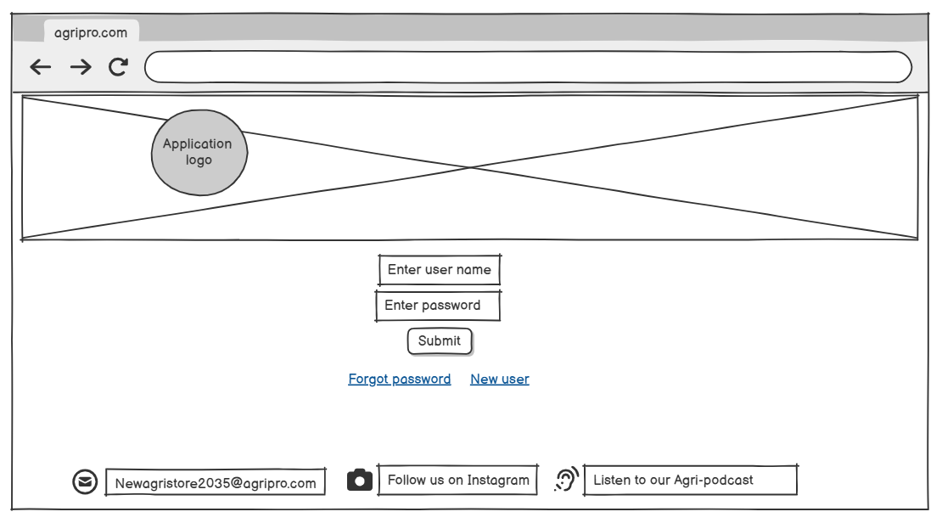**

**2. Browse the products:  
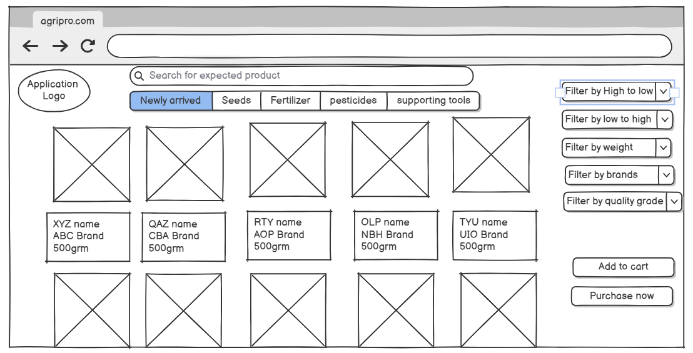  
3. Place order web page:  
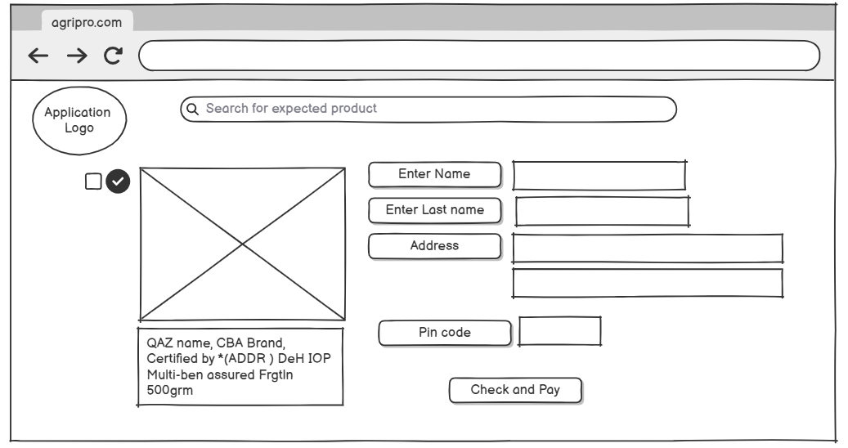  
4. Choose payment method and checkout:  
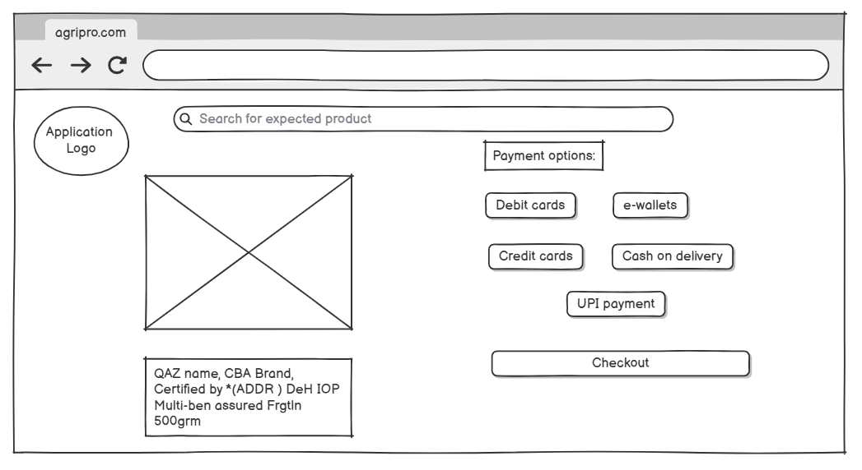  
5. Manufacturer Post new product category:  
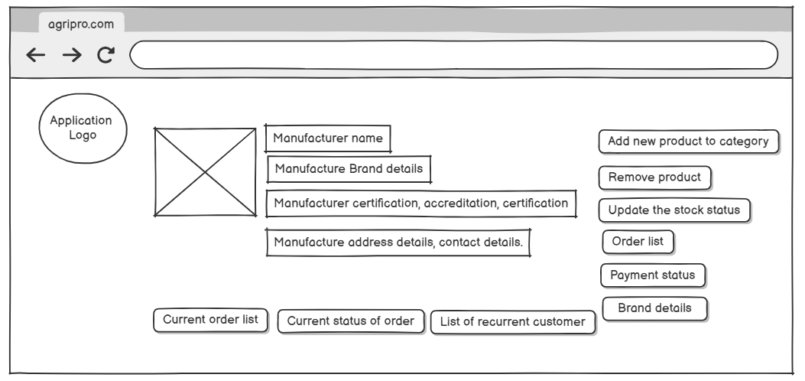**

**3. Make a note of tools which we are using for Wireframing:**

**1. Figma**

It is a Cloud-based application.

Real-time collaboration  
Interactive prototyping features  
Large community and plugin ecosystem

Best For Teams who need to collaborate live or work remotely

**2. Adobe XD**

It is a Desktop + Cloud sync application.

Seamless integration with other Adobe tools  
 Good prototyping and animation features  
 Responsive design support

Best For Designers already in the Adobe ecosystem

**3. Balsamiq**

It is Web, desktop application.

Low-fidelity, sketch-like visuals  
 Extremely fast and intuitive  
 Focus on structure over design

Best For Rapid wireframing with stakeholders not focused on visuals

**4. Axure RP**

* It is Desktop application.

Complex, high-fidelity interactions and logic  
Conditional workflows, dynamic content

Best For Enterprise projects or advanced interaction design

**5. MS Visio** It is Desktop and web application.  
 It Offers wireframe templates for Windows applications, websites, and mobile interfaces. We can download or create custom stencils (like UI elements).

**4. RTM**

|  |  |  |  |  |  |  |  |  |  |
| --- | --- | --- | --- | --- | --- | --- | --- | --- | --- |
| **Req ID** | **Req name** | **Description** | **Design** | **D1** | **T1** |  | **D4** | **T4** | **UAT** |
| FR0001 | Farmer login | Farmer should be able to create account with application | **Comp** | **Comp** | **Comp** | **…** | **Comp** | **Comp** | **Done** |
| FR0002 | Farmer profile | Farmer should be able to add the profile details like address, email and phone number | **Comp** | **Comp** | **Comp** | **…** | **Comp** | **Comp** | **Done** |
| FR0003 | Farmer profile | Farmer should be able to add credit and debit card details | **Comp** | **Comp** | **Comp** | **…** | **Comp** | **Comp** | **Done** |
| FR0004 | Search product | Farmer should be able to browse through category | **Comp** | **Comp** | **Comp** | **…** | **Comp** | **Comp** | **Done** |
| FR0005 | Search product | Farmer should be able to search the expected product | **Comp** | **Comp** | **Comp** | **…** | **Comp** | **Comp** | **Done** |
| FR0012 | Manf. login | Manufacture should be able to create a login with application | **Comp** | **Comp** | **Comp** | **…** | **Comp** | **Comp** | **Done** |
| NFR0026 | OTP verify | While handing over product OTP should be verified | **Comp** | **Comp** | **Comp** | **…** | **Comp** | **In-progress** | **Not Done** |
| NFR0028 | Customer friendly | Application UI such way it should be user friendly | **Comp** | **Comp** | **Comp** | **…** | **In-progress** | **In-progress** | **Not Done** |
| NFR0029 | Post checkout | Payment receipt should be sent over mail as well as in app. | **Comp** | **Comp** | **Comp** | **…** | **Comp** | **Comp** | **Done** |
| NFR0030 | Feedback call | A customer service will give call to take feedback on user experience | **Comp** | **Comp** | **In-progress** | **…** | **In-progress** | **In-progress** | **Not Done** |

**5.Test case Document:**

|  |  |  |  |  |  |
| --- | --- | --- | --- | --- | --- |
| **Test case ID** | **OAPS001** | Test case name | | Farmer able to login | |
| Project ID | OAPS-Z1 | Project name | | Online Agriculture product store | |
| PM ID | VAN13 | PM name | | Mr. Vandanam | |
| Test strategy ID | OAP-TC01 | Tester ID | | ALE34 | |
| Test Plan ID | OAPTP03 | Tester Name | | Ms. Alekya | |
| Test schedule ID | OAPTS1 | Date of test | |  | |
| Scenario | Login functionality | | | | |
| Link to that page |  | | | | |
| Input data | Valid user name Valid password | Valid user name Password forgot | | Invalid user name invalid password | |
| Expected behaviour | User gets logged in | User failed to login | | User failed to login | |
| Actual Behaviour |  |  | |  | |
| Comments |  |  | |  | |
| Results(Pass/Fail) |  |  | |  | |
|  |  |  | |  | |
| **Test case ID** | **OAPS002** | Test case name | | Manufacture able to login | |
| Project ID | OAPS-Z1 | Project name | | Online Agriculture product store | |
| PM ID | VAN13 | PM name | | Mr. Vandanam | |
| Test strategy ID | OAP-TC01 | Tester ID | | ALE34 | |
| Test Plan ID | OAPTP03 | Tester Name | | Ms. Alekya | |
| Test schedule ID | OAPTS1 | Date of test | |  | |
| Scenario | Login functionality | | | | |
| Link to that page |  | | | | |
| Input data | Valid user name Valid password | Valid user name Password forgot | | Invalid user name invalid password | |
| Expected behaviour | User gets logged in | User failed to login | | User failed to login | |
| Actual Behaviour |  |  | |  | |
| Comments |  |  | |  | |
| Results(Pass/Fail) |  |  | |  | |
| **Test case ID** | **OAPS003** | Test case name | | Logistic agent able to login | |
| Project ID | OAPS-Z1 | Project name | | Online Agriculture product store | |
| PM ID | VAN13 | PM name | | Mr. Vandanam | |
| Test strategy ID | OAP-TC01 | Tester ID | | ALE34 | |
| Test Plan ID | OAPTP03 | Tester Name | | Ms. Alekya | |
| Test schedule ID | OAPTS1 | Date of test | |  | |
| Scenario | Login functionality | | | | |
| Link to that page |  | | | | |
| Input data | Valid user name Valid password | Valid user name Password forgot | | Invalid user name invalid password | |
| Expected behavior | User gets logged in | User failed to login | | User failed to login | |
| Actual Behavior |  |  | |  | |
| Comments |  |  | |  | |
| Results(Pass/Fail) |  |  | |  | |
| **Test case ID** | **OAPS004** | Test case name | | Delivery agent able to login | |
| Project ID | OAPS-Z1 | Project name | | Online Agriculture product store | |
| PM ID | VAN13 | PM name | | Mr. Vandanam | |
| Test strategy ID | OAP-TC01 | Tester ID | | ALE34 | |
| Test Plan ID | OAPTP03 | Tester Name | | Ms. Alekya | |
| Test schedule ID | OAPTS1 | Date of test | |  | |
| Scenario | Login functionality | | | | |
| Link to that page |  | | | | |
| Input data | Valid user name Valid password | Valid user name Password forgot | | Invalid user name invalid password | |
| Expected behaviour | User gets logged in | User failed to login | | User failed to login | |
| Actual Behaviour |  |  | |  | |
| Comments |  |  | |  | |
| Results(Pass/Fail) |  |  | |  | |
| **Test case ID** | **OAPS005** | Test case name | | Farmer able to browse the product | |
| Project ID | OAPS-Z1 | Project name | | Online Agriculture product store | |
| PM ID | VAN13 | PM name | | Mr. Vandanam | |
| Test strategy ID | OAP-TC01 | Tester ID | | ALE34 | |
| Test Plan ID | OAPTP03 | Tester Name | | Ms. Alekya | |
| Test schedule ID | OAPTS2 | Date of test | |  | |
| Scenario | Browse the product | | | | |
| Link to that page |  | | | | |
| Input data | Search for particular type of seed | | Search for fertilizer | | Search for pesticides |
| Expected behaviour | Range of seeds diaplayed | | Multiple fertilizer brands  populated | | Multiple pesticides brands  populated |
| Actual Behaviour |  | |  | |  |
| Comments |  | |  | |  |
| Results(Pass/Fail) |  | |  | |  |

|  |  |  |  |
| --- | --- | --- | --- |
| **Test case ID** | **OAPS006** | Test case name | Farmer able to track the product |
| Project ID | OAPS-Z1 | Project name | Online Agriculture product store |
| PM ID | VAN13 | PM name | Mr. Vandanam |
| Test strategy ID | OAP-TC01 | Tester ID | ALE34 |
| Test Plan ID | OAPTP03 | Tester Name | Ms. Alekya |
| Test schedule ID | OAPTS2 | Date of test |  |
| Scenario | Tracke ordered product | | |
| Link to that page |  | | |
| Input data | Go to order list check the tracking status |  |  |
| Expected behaviour | Current tracking status  should be displayed |  |  |
| Actual Behaviour |  |  |  |
| Comments |  |  |  |
| Results(Pass/Fail) |  |  |  |
| **Test case ID** | **OAPS007** | Test case name | Farmer able to add address to  his profile |
| Project ID | OAPS-Z1 | Project name | Online Agriculture product store |
| PM ID | VAN13 | PM name | Mr. Vandanam |
| Test strategy ID | OAP-TC02 | Tester ID | JSN87 |
| Test Plan ID | OAPTP04 | Tester Name | Mr. Jason |
| Test schedule ID | OAPTS3 | Date of test |  |
| Scenario | Add address to profile | | |
| Link to that page |  | | |
| Input data | Go to profile, add all address details | Go to profile, add all address details without pincode | Go to profile, add all address details without land mark |
| Expected behaviour | Address added and displayed correctly | Address won’t be added | Address won’t be added |
| Actual Behaviour |  |  |  |
| Comments |  |  |  |
| Results(Pass/Fail) |  |  |  |
| **Test case ID** | **OAPS008** | Test case name | Farmer able to add review to received product |
| Project ID | OAPS-Z1 | Project name | Online Agriculture product store |
| PM ID | VAN13 | PM name | Mr. Vandanam |
| Test strategy ID | OAP-TC01 | Tester ID | ALE34 |
| Test Plan ID | OAPTP03 | Tester Name | Ms. Alekya |
| Test schedule ID | OAPTS2 | Date of test |  |
| Scenario | Add review to product | | |
| Link to that page |  | | |
| Input data | Go to product and add review with photos and ratings | Go to product and add review without photos and ratings | Go to product and add review with photos but without ratings |
| Expected behaviour | Review added and displayed correctly | Review won't be added | Review won't be added |
| Actual Behaviour |  |  |  |
| Comments |  |  |  |
| Results(Pass/Fail) |  |  |  |
| **Test case ID** | **OAPS009** | Test case name | Add new product to category |
| Project ID | OAPS-Z1 | Project name | Online Agriculture product store |
| PM ID | VAN13 | PM name | Mr. Vandanam |
| Test strategy ID | OAP-TC01 | Tester ID | ALE34 |
| Test Plan ID | OAPTP03 | Tester Name | Ms. Alekya |
| Test schedule ID | OAPTS2 | Date of test |  |
| Scenario | Add new product to category | | |
| Link to that page |  | | |
| Input data | Go to product list and add new with photos and details | Go to product list and add new without photos and details | Go to product list and add new with photos but no details |
| Expected behaviour | Product added and displayed correctly | Product won't be added | Product won't be added |
| Actual Behaviour |  |  |  |
| Comments |  |  |  |
| Results(Pass/Fail) |  |  |  |
| **Test case ID** | **OAPS010** | Test case name | Add delivery status to order |
| Project ID | OAPS-Z1 | Project name | Online Agriculture product store |
| PM ID | VAN13 | PM name | Mr. Vandanam |
| Test strategy ID | OAP-TC01 | Tester ID | JSN87 |
| Test Plan ID | OAPTP03 | Tester Name | Mr.Jason |
| Test schedule ID | OAPTS2 | Date of test |  |
| Scenario | Update the delivery status | | | |
| Link to that page |  | | | |
| Input data | Go to order list and update the delivered status | Go to order list and update the delivered status to another product | Go to order list and update the delivered status without OTP | |
| Expected behaviour | Delivery status updated correctly | Delivery status update failed | Delivery status update failed | |
| Actual Behaviour |  |  |  | |
| Comments |  |  |  | |
| Results(Pass/Fail) |  |  |  | |

**6. DB Design:  
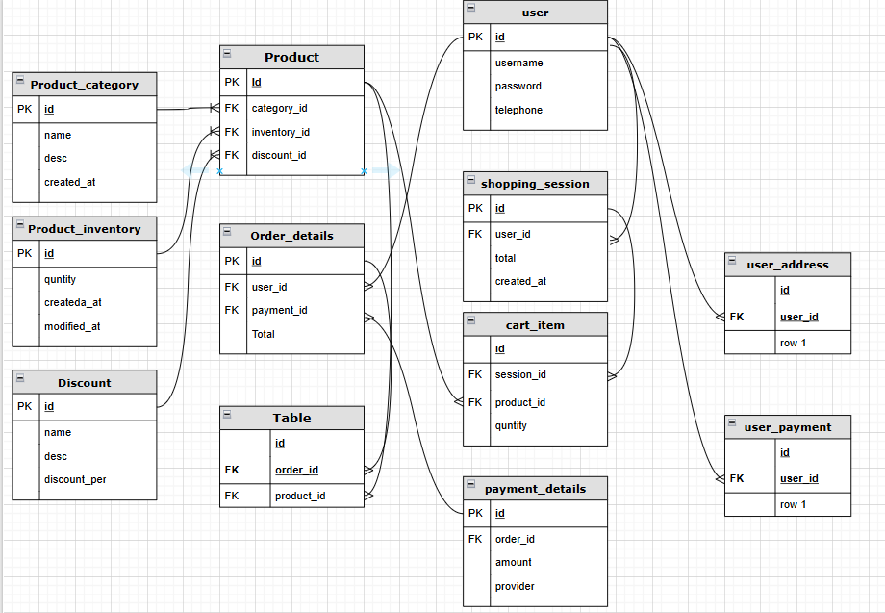**A **database schema** is a formal, structured description of a database, outlining its organization.   
An **Entity-Relationship Diagram (ERD),** on the other hand, is a visual representation of entities (like tables) and their relationships within a database.  
1. Primary Key: Uniquely identifies each record in a table. Must be unique & Not null.  
2. Foreign key: A key used to link two tables together. It's a field in one table that refers to the primary key in another table.

**7. What is a data flow diagram? Draw a data flow diagram to represent the in-flow and out-flow of data when a Farmer is placing an order for the product**A Data Flow Diagram (DFD) is a graphical representation used **to visualize the flow of data within a system**. It shows: Processes that transform data, Data stores where data is held, Data sources/sinks (external entities) that interact with the system, Data flows between all of the above.

DFDs are commonly used in systems analysis and design to depict how information moves within a system without specifying how the system is implemented.  
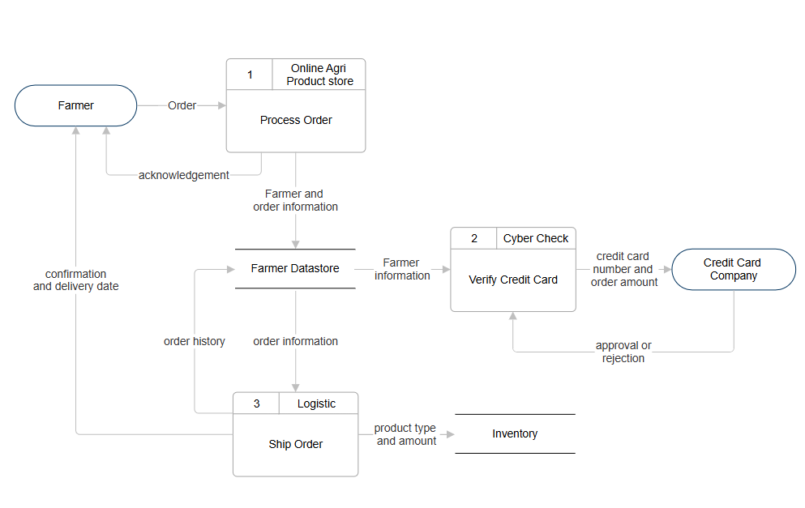  
  
**8. How do you handle change requests in a project?**A formal proposal to alter system, project or product as per the client or customer latest requirement is Change request.  
1. Receive and Document the Request

* Capture the source of the request (who requested it and why).  
  Record what is being changed: new requirement, scope addition, feature modification, etc.  
  Include supporting business rationale, documents, or examples.

2. Analyze the Change

* Assess: Impact on requirements, business rules, or processes; Effect on scope, timelines, cost, and resources, Dependencies (other modules, systems, integrations)  
  Identify any conflicts or overlaps with existing requirements.

3. Perform Impact Analysis

Collaborate with stakeholders (Project Manager, Developers, QA) to determine: Time and effort estimation, Technical feasibility, Risk assessment.  
Prepare an Impact Analysis Report.

4. Evaluate and Get Approval  
 Present the request and impact analysis to the Change Control Board (CCB) or project sponsor.  
 Facilitate discussions between stakeholders to assess the value vs. cost/risk  
 Document the decision (approved, rejected, or deferred).

5. Update Project Documentation

* If approved: Update requirements documents, user stories, process flows, etc.  
   Communicate the change clearly to all stakeholders.

6. Coordinate Implementation

Work with the development and QA teams to Prioritize the change, Ensure proper implementation,  
Align it with sprint or release cycles

7. Track and Monitor progress and test coverage.  
  
**9. As the project is in process, Ben and Kevin have contacted you. The reason is to inform you that they want the Farmers to sell their crop yields through this application i.e. Farmers should be able to add their crop yields or products and display to general public and should be able to sell them. They also want to introduce Auction system for their Crop yields. As a BA, what will be your response? Is this a change request or an enhancement???**  
  
Since the project is already in progress and this functionality was not part of the original scope, introducing:

1.A crop selling feature for farmers  
2.A public marketplace display, and   
3. An auction system

...represents a significant shift in business functionality and system scope. An **Enhancement** refers to an improvement or new feature added to an existing system to make it better — it's not about fixing a problem, but adding value. While A **Change Request** is a formal proposal for an alteration to a system, process, or product. It usually arises when something in the original scope, design, or implementation needs to be modified.  
So I think the request raised from farmer will be **an Enhancement** not the Change request.

**10.** **Come up with estimations – How many Manhours required**Manhours are the required hours to complete the desired project, those are categorized as below.  
Small:Upto 500hours  
Mediun: Upto 1000hours  
Large: Upto1500hours  
As our project is 18months with team size of 15 members, so our project comes under Medium size of project. And the structure already defined and requirements are ready. **11. Explain UAT Acceptance process:** 1. Planning  
 Define Scope: Identify what will be tested (features, workflows, integrations).  
 Prepare Test Plan: Outline objectives, schedule, entry/exit criteria, and responsibilities.  
 Select UAT Testers: Usually end-users or business stakeholders familiar with the requirements.

2. Designing Test Cases  
 Write UAT Test Cases/Scenarios: Based on business requirements and real-world use cases.  
 Get Approval: Business owners or stakeholders review and approve the test cases.

3. Environment Setup  
 UAT Environment: Should mimic production but be isolated.  
 Data Setup: Use realistic test data (anonymized if needed).

4. Execution  
 Test Execution: Users perform the test cases, logging results (pass/fail) and any issues.  
 Defect Logging: Any bugs or mismatches are reported to the dev team for resolution.  
  
 5. Bug Fixes & Revalidation  
 Bug Fixing: Development team resolves issues found during UAT.  
 Retesting: Users revalidate fixes to confirm the system now behaves as expected.

6. Sign-off  
 Final Review: All test cases passed or acceptable issues documented.  
 UAT Sign-off: Stakeholders formally approve the system for go-live.  
 Deployment Approval: Once signed off, the release moves into production.

**12.** **Explain Project closure document.**A Project Closure Document (also known as a Project Closure Report or Project Completion Report) is a formal document that marks the official end of a project. It summarizes everything that happened, confirms that objectives were met, and ensures nothing is left hanging.

**Purpose of the Project Closure Document**

Formally close the project  
Ensure all deliverables were completed and accepted  
Document lessons learned and project performance  
Release project resources (team, budget, tools)  
Provide a reference for future projects

**Key Components of a Project Closure Document**

1. Project Overview
   * Basic details (project name, sponsor, manager)  
     Summary of objectives and scope
2. Deliverables Summary
   * List of completed deliverables  
     Confirmation of stakeholder/customer acceptance
3. Project Performance
   * Scope: Was everything delivered as planned?  
     Schedule: Completed on time?  
     Budget: Stayed within budget?  
     Quality: Any major issues?
4. Lessons Learned
   * What went well?  
     What could have been better?  
     Recommendations for future projects
5. Outstanding Issues or Risks
   * Any open items not addressed  
     Plan for managing or handing them over (if any)
6. Project Metrics
   * KPIs, effort hours, cost details  
     Team performance insights
7. Resource Release
   * Team members reassigned or released  
     Closure of contracts/vendors
8. Final Approvals & Sign-off
   * Formal approval by sponsor/client  
     Signature section for stakeholders

|  |  |  |  |
| --- | --- | --- | --- |
| Sr no | Points to be included | Details | Reference link |
| 1 | UAT testing completion from Client | | |
|  | Date of sign off | 20th Sept 2025 | Business scope doc. |
|  | Name of member | Mr.Jason |  |
| 2 | Objective of project | | |
|  | user friendliness | Achieved |  |
|  | Customer satisfaction | ROI in 9months |  |
|  | More categories | Achieved |  |
| 3 | Functionalities worked on | | |
|  | Secure payment processing | Achieved |  |
|  | categories | Achieved |  |
| 4 | Infrastructure | | |
|  | Software installed | Achieved |  |
|  | laptop purchased | Achieved |  |
| 5 | Funding | | |
|  | Amount approved | Rs.2Cr | Financial breakdown doc. |
|  | Amount used | Rs1.80Cr |  |
| 6 | Overall project information | | |
|  | Escalations | 40 |  |
|  | Customer satisfaction | high |  |
| 7 | Value to company | | |
|  | Positive/Negative | Positive  -Company has gained an edge over the competitors -Client number increased -trained employees -new oppo |  |