## Q19. What is the difference between Brainstorming and JAD Sessions?

**Ans:**

* Brain storming: brain storming technique contain group of stake holders to give deep thought about particular topic. This technique basically useful in developing new ideas.
* JAD: JAD is conducted by bringing Stake holder and developer together at same place. JAD provide high accurate level of

requirement. Though JAD are conducted for different types purpose in SDLC JAD is Mostly conducted in two Ways, one is as eliciting technique and second is to clarify development teams doubts.

* Brainstorming: group discussion among stakeholders to collect ideas to include the relevant requirements.
* JAD session: the session conduct among selected stakeholders (business client system developer) to get more refined requirements.
* Brainstorming: Brainstorming can be done either individually or in groups. The ideas collected can then be reviewed/analyzed and where relevant included within the system requirements.
* JAD technique is an extended, facilitated workshop. It involves collaboration between stakeholders and systems analysts to

identify needs or requirements in a concentrated and focused effort.

* Brain Storming techniques last for about 2-3 hours
* JAD Sessions last for about 2-3 days
* Brain Storming covers all of the mentioned subjects.
* JAD covers technology used for the development.

## Q 20. Why Document Analysis is one of the compulsory techniques we use in a Project? Justify

## Ans:

Document Analysis is one of the compulsory elicitation techniques for any project.

Documentation of the system could provide lot of information which may include interface details, user manuals and software vendor manuals. It would be easy to transfer lot of information to a new system requirement document.

we have documentation about the current system which could provide some of the input for the new system requirements. Such documentation could include interface details, user manuals and software vendor manuals

You may have documentation about your current system which could provide some of the input for the new system requirements. Such documentation (if it exists) could include interface details, user manuals, and software vendor manuals.

Could be a lot of information and easy to transfer to a new system requirements document.

Document Analysis is an important gathering technique. Evaluating the documentation of a present system can assist when making AS

-ARE process documents and also when driving the gap analysis for scoping of the migration projects.

## Q21. In Which Context we will use Reverse Engineering? - 2 Marks

**Ans:**

[Reverse engineering](https://www.interaction-design.org/literature/topics/reverse-engineering) is a process that is designed to extract enough data from a product and then to be able to reproduce that product. It may involve moving to creating a product from scratch or from pre-developed components. It can be applied to any product (such as computer technology, manufactured products, biological products, chemical products, etc.) to determine how the components are put together and how it works.

Reverse engineering is a useful design and development technique with many potential applications. However, it is always important to get legal advice prior to conducting reverse engineering exercises and doubly so if you intend the outputs of your reverse engineering to become commercially available. There is no single process across industries for reverse engineering it is simply a process by which you take an end product and deduce how it is made and works.

## Q22. What is the difference between Brainstorming and Focus Groups?

**Ans:**

Here are the main differences between the two techniques:

|  |  |  |
| --- | --- | --- |
|  | Brainstorming | Focus Group |
| Purpose | Generate ideas | Improve existing ideas |
| Trigger | A need to solve a problem | A need to study an existing ide solution or process |
| Condition | Problem exists | Idea, solution or process exist |
| Setup |  |  |
| Number of participants | 6 - 8 | 6 - 12 |
| Participant types | Heterogeneous | Can be homogeneous or heterogeneous |
| Person running the show | Facilitator | Skilled moderator |
| Knowledge of topic of discussion | Not necessary | In depth knowledge of topic of discussion |
| Guide | Develop criteria for evaluating and rating ideas | Create a discussion guide and moderator scripts |
| Game Time |  |  |
| Ground rules | Must have | Nice to have |
| Duration | Restrict time to produce ideas  1 – 2 hrs. | 1 – 2 hrs. and sometimes over several days |
| Type of questions to ask | Progressive closed- ended to generate and build on ideas | Can be open-ended to genera qualitative data or closed-end to generate quantitative data |
| Observers | No | Yes |
| Result | List of ideas combined to form themes | Report of findings Could be   * bullet list of information learns * comparative analysis between to solutions |

|  |  |  |
| --- | --- | --- |
|  |  | - summary of response collected for each question |

## Q23. Observation Technique – Explain both Active and Passive approaches - 2 Marks

**Ans:**

Business analysts use observation techniques to gather information by watching and understanding workplace activities.

It is used to identify needs and opportunities, understand business processes, create performance standards, assess solution performance, and facilitate training and development.

Observation of activities or job shadowing, is the act of studying a work activity as it is being performed. It can be performed in either the user’s work environment or in a recreated test environment.

There are two approaches for observation and they are:

* **Active/noticeable**: while observing an activity the observer can ask any questions as they occur. Despite this interruption to the workflow, the observer can quickly understand the reasoning

and any undocumented processes within the activity.

* **Passive/unnoticeable**: in this approach, the observer does not interrupt the work while the user is performing the work activity. Any questions would be asked once the observation is over. This

allows a natural flow of events to be observed without interference by the observer, as well as the measurement of the time and quality of work.

## Q24. How do you conduct the Requirements Workshop- 2 Marks

Ans:

* This is a structured meeting with the specific goal of capturing requirements. It is used to define, prioritize and hopefully finalize

requirements for the new initiative that you’re working on. Requirements workshops typically last between one and a few days. They should also be a highly focused event that is let by a seasoned facilitator. Some benefits and disadvantages of the requirements workshop are identified in the following table:

|  |  |
| --- | --- |
| Benefits | Disadvantages |
| * Get to a set of meaningful   stated requirements in a  short,  intensive session. Having the | * There can be a lot of time,   coordination  and finances required.   * Getting the right resources in |

|  |  |
| --- | --- |
| right stakeholders involved that will allow for a much easier buy-in.   * Requirements are considered, discussed, and understood before going to   final approvals | the same room, at the same time with the proper authority to speak on the subject matter.   * You may have to run several workshops |

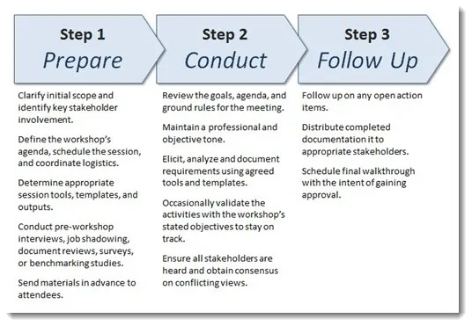

## Q25. In which context, Interview Technique can be conducted by a BA? How may approaches are there in conducting Interviews? (Structured – Unstructured) Explain them. Explain the difference between Open Ended Questions and Closed ended Questions – 4 Marks

**Ans:**

Interview Technique can be used to verify the facts, clarify ambiguity, trigger enthusiasm, engage end users, identify requirements, and the opinions and ideas. It is used to get more information from the people in a formal or informal setting by asking questions and documenting the responses.

It involves direct communication with the individuals or a group of people who are part of an initiative. There are two basic types of interviews. They are,

* **Structured Interview** - in which the interviewer has the predefined set of questions. It is a structured way of interview.
* **Unstructured Interview** - in which the interviewer does not have the predetermined set of questions and it may vary based on the stakeholder responses and interactions.
* **Open Ended Questions** - Open-ended questions are those that provide respondents with a question prompt and provide them a space in which to construct their own response
* ***Closed-ended questions*** Often the answer is a single word (e.g. Yes or No) or less commonly a short phrase. You are not looking

for an explanation or an elaboration to the question in the answer given to the question.

## Q26. Questionnaire Technique – Where we will use? Give one example - 3 Marks

**Ans:**

A questionnaire is a research instrument that consists of a set of questions or other types of prompts that aims to collect information from a respondent. A research questionnaire is typically a mix

of close-ended questions and open-ended questions.

Open-ended, long-form questions offer the respondent the ability to elaborate on their thoughts. The data collected from a data collection questionnaire can be both [qualitative](https://www.questionpro.com/blog/qualitative-market-research/) as well

as [quantitative](https://www.questionpro.com/blog/quantitative-market-research/) in nature. A questionnaire may or may not be delivered in the form of a [survey](https://www.questionpro.com/blog/surveys/), but a survey always consists of a questionnaire.

A survey or questionnaire is used to elicit business analysis information including information about the customers, products, work practices, and attitudes from a group of people in a structured way and in relatively short period of time.

Surveys are the preferred elicitation technique when faced with a large number of stakeholders or when stakeholders are geographically dispersed and you need to gather the same information from them.

## Examples:

1. How many times have you visited [website] in the past month? None

Once

More than once

1. What is the primary reason for your visit to [website]? To make a purchase

To find more information before making a purchase in-store to contact customer service

1. Who did you purchase these products for?

* Self
* Family member
* Friend
* Colleague
* On behalf of a business
* Other

## Q27. How to Sort the Requirements – Where we will use? Give one example - 3 Mark

Ans

When all the requirements are gathered there are chances of redundancy in those requirements so basically all the scattered requirements are put together and the repetition of requirements are removed which is known as sorting of requirements. The process for sorting is:

1. Identification of requirements.
2. Dividing the identified requirements into functional and nonfunctional requirements
3. If identified requirements are similar then they are put together and removed.

We will sort the requirements in two ways such as functional requirements and Non-Functional requirements.

* + Functional requirements define a function that a system or system element must be qualified to perform and must be documented in different forms. The functional requirements

describe the behavior of the system as it correlates to the system's functionality.

Examples of functional requirements are authentication, business rules, audit tracking, certification requirements, transaction corrections, etc.

* + Non-functional requirements are not related to the software's functional aspect. They can be the necessities that specify the criteria that can be used to decide the operation instead of

specific behaviors of the system.

* + Examples - usability, reliability, security, storage, cost, flexibility, configuration, performance, legal or regulatory requirements, etc.

## Q28. Priorities the Requirements – –Where we will use? Give one example - 3 Marks

**Ans:**

Large software systems have a few hundred to thousands of requirements. Neither are all requirements equal nor do the implementation teams have resources to implement all the documented requirements. There are several constraints such as limited resources, budgetary constraints, time crunch, feasibility, etc., which brings in the need to prioritize requirements.

Most customers on their part have a reasonable idea of what they need and what they want. But during requirements elicitation the customer provides the Business Analyst (BA) with all the requirements that he feels will make his work easier. The customer is not wrong on his part; the BA needs to understand the needs of the business to prioritize the requirements

Most requirements are interdependent and you will hardly find any requirement that exists independently. To understand why we need a dependency map – let us take a scenario where you have 8 requirements X,Y,Z,P,Q,R,M,O and N with priorities, on a 5- level scale where 1 is most critical and 5 least critical, as 1,2,1,4,5,1,2,2,3. So, with these priorities it would be logical to begin with requirements X, Z and R

1. MoSCoW – This prioritization technique was developed by Dai Clegg of Oracle UK Consulting. it is one of the more widely used techniques for its simplicity and ease of use. The letters of the word MoSCoW stand for Must, Should, Could and Won’t.
   * Must have (or Minimum Usable Subset) – These are features that must be included before the product can be launched.
   * Should haves be features that are not critical for the launch, but are considered to be important and of a high value to the user.
   * Could haves be features that are nice to have and could potentially be included without incurring too much effort or cost
   * Won’t have - are features that have been requested but are explicitly excluded from scope for the planned duration and may be included in a future phase of development.

MoSCoW method works better than the numeric rating system as it is much easier for the stakeholders to rate the requirements as Must, Should, Could or Would.

## MUST (M)

Defines a requirement that has to be satisfied for the final solution to be acceptable **e.g**. The HR system “must” store employee leave history.

## SHOULD (S)

This is a high-priority requirement that should be included, if possible, within the delivery time frame. Workarounds may be available for such requirements and they are not usually considered as time-critical or must-haves. **e.g**. The HR system “should” allow printing of leave letters.

## COULD (C)

This is a desirable or nice-to-have requirement (time and resources permitting) but the solution will still be accepted if the functionality is not included **e.g.** The HR system “could” send out notifications on pending leave dates.

## WON’T or WOULD (W)

This represents a requirement that stakeholders want to have, but have agreed will not be implemented in the current version of the system. That is, they have decided it will be postponed till the next round of developments **e.g**. The HR system “won’t” support remote access but may do so in the next release.

## Q29. Weekly status reporting – How we will drive? 2 Mark Ans:

A weekly status report, also known as a weekly check-in, is a communication tool that project managers use to keep tabs on their employees' work experiences. While a team lead can do a weekly status report in person, it's easier to do it online.

A weekly status report is a complete overview of your week at work, covering projects you've completed, ones that are still in progress and upcoming plans for the future.

A weekly report is a review of your workweek and provides a summary of what you completed, what projects are in progress and plans that outline your workflow for the next week. Typically, weekly reports are brief and concise and only one page long. Most professionals send weekly reports on Friday afternoons to establish consistent communication with team members and supervisors.

Additionally, a weekly report can benefit both you and your employer by providing insight into important aspects of the work you complete.

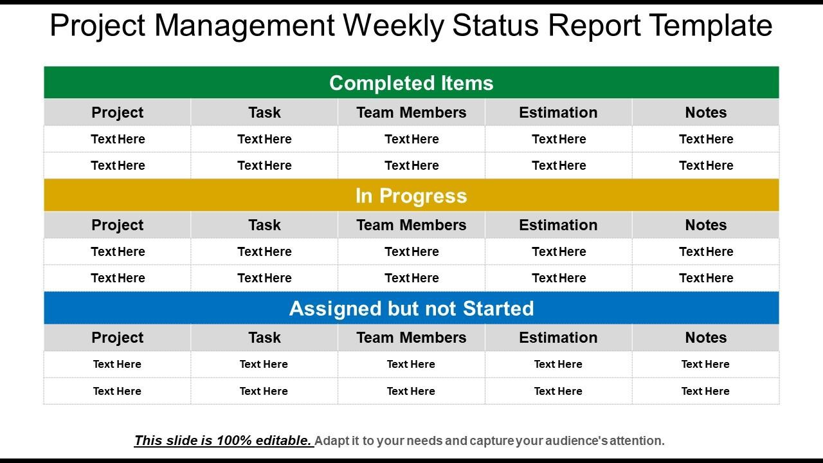

## Q30. Meeting Minutes Document – prepare one Sample -2 Mark

**Ans:**

Minutes is to create an official record of the actions taken at a Meeting. Minutes serve to both memorialize the actions taken for those attending the Meeting as well as for those who were unable to attend the Meeting.

Meeting minutes are notes that are recorded during a meeting. They highlight the key issues that are discussed, motions proposed or voted on, and activities to be undertaken.

**MEETING AGENDA**

|  |  |  |  |
| --- | --- | --- | --- |
| **Meeting/Project t Name:** | **Sprint Review Meeting** | | |
| **Date of Meeting: (MM/DD/YYYY)** | **23.01.2023** | **Time:** | **09:30** |
| **Meeting Facilitator:** | **Business Analyst** | **Location:** | **Pune** |

**1. Meeting Objective**

1. Discuss status of sprints
2. Discuss progress report of project
3. Discuss about impediments if any.
4. Suggest Solutions

|  |  |  |  |
| --- | --- | --- | --- |
| **2. Attendees** | | | |
| **Name Department/Divisi E-mail Phone on** | | | |
| Harshad Karate | Development Team | [Harshad.kharate@yahoo.com](mailto:Harshad.kharate@yahoo.com) | xxxxxxxxxx |
| Rajendra Kharate | Technical Team | XXXXXXXXXXX | XXXXXXXX |
| Rakesh | Business Analyst | XXXXXXXXXXX | XXXXXXXX |
|  |  |  |  |

|  |  |  |
| --- | --- | --- |
| **3. Meeting Agenda** | | |
| **Topic** | **Owner** | **Time** |
| Decision about the actions n sprints | Development Team |  |
| Decision on WIP items | Development Team |  |
|  |  |  |
|  |  |  |

## Q31. Change Tracker – Document - – prepare one Sample -2 Mark

**Ans:**

The role of BA in change request is very important as the change requests differ in number and complexity across business projects and may come in before, during or after implementation of a solution.

Below are the steps to follow

-->Understand the reason for the change

-->Understand the impact of the change

-->Understand the effort required to implement the change

-->Ensure that the change request follows the predetermined approval process

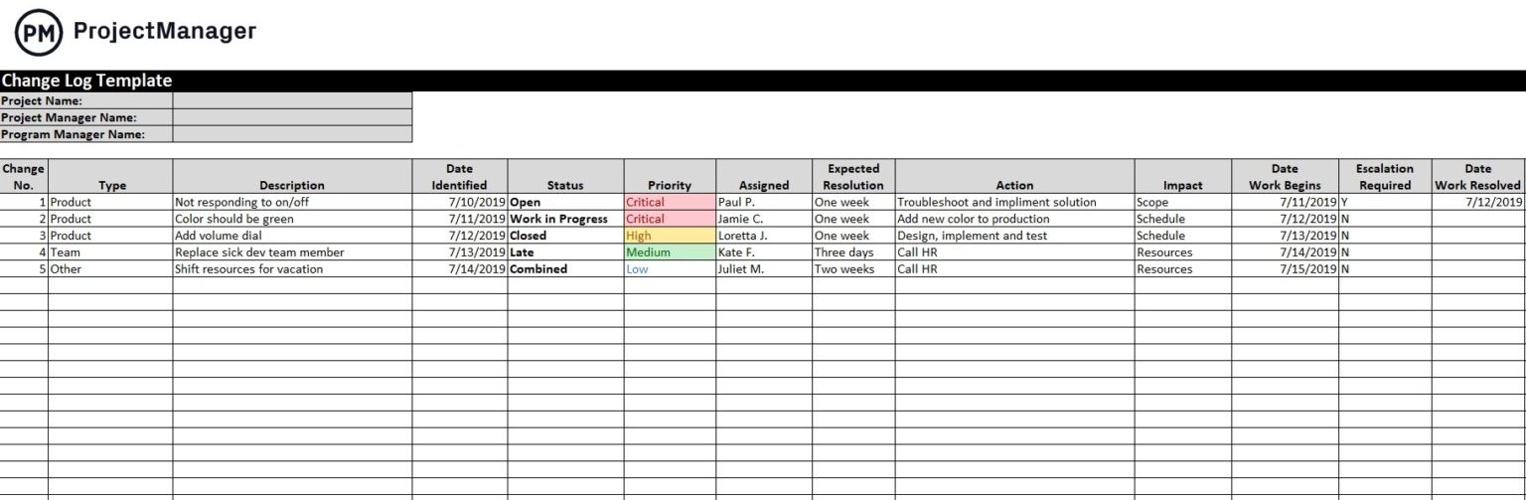

**Q32. Difference between Traditional Development Model and Agile Development Models – 5 Marks**

**Ans:**

**Traditional model:**

* Used to develop Simple Software
* In this testing is done once the development phase is totally completed
* It provides less security
* It provides less functionality in the software
* It supports fixed development model
* Development cost is less
* It consists of five phases
* Expectation is favored in the traditional model
* product delivered at the end of the project
* It is rigid to accept the change
* Models based on traditional software development- spiral, waterfall, V model, incremental model.

Traditional project management focuses on the linear approach. In the agile world, this project management approach is often known as the? waterfall approach.? In the traditional method, all the project phases are completed in sequential order. This rigid, top-down approach contains some fixed stages, such as plan, design, build, testing, user acceptance, deployment, release, etc. Unlike agile, traditional project management plans everything beforehand and not empirically.

In this approach, requirements are fixed, and budget and time get agreed on earlier. For this reason, teams often face budget and timeline problems with this approach. You can’t use traditional project management to develop complex products, as this approach leaves no room for changing the requirements. However, studies suggested that the waterfall or traditional approaches failure rate is nearly 21% while the agile failure rate is 8%.

## Agile model:

* It is used to develop complicated software
* In this testing and development process are performed concurrently
* it provides less high security
* It provides all functionality needed by the users
* It is used by professionals
* It supports changeable development model
* Development cost is higher
* It consists only three phases
* Adaptability is favored in the agile methodology
* Product delivered frequently within couple of weeks to couple of moths
* Change accepted even in late development stage
* Model based on agile software development - Scrum, XP, Crystal, Dynamic systems development method (DSDM), feature driven development (FDD), Adaptive software development (ASD)

Agile Project Management:

In agile project management, projects are time-boxed in short iterations. The iteration lasts for a maximum of a calendar month. And after each iteration, you’ll get a new releasable product increment. Agile project management focuses more on implementing the clients feedback and reviewing the product periodically. Customer collaboration is a vital factor in agile. It doesn’t follow a plan blindly and responses to changes quickly.

Today, agile methodology comes with different methods and frameworks for project management. For example, Scrum, Kanban, Less, Safe, and Scrumban are great examples of popular agile project management methods. These methods are the perfect choices for preventing time consumption, increasing customer satisfaction, and encouraging decision-making at every product development step. Initially, agile project management was considered for the software development industry and, in recent times, successfully implemented in other sectors like architecture, financial services, marketing, etc.

## Q33. Explain Brainstorming Technique – Where to use? 2 Marks

**Ans:**

The basic idea behind brainstorming is to find a conclusion for a specific problem by gathering a list of

ideas spontaneously contributed by its member(s).

In other words, brainstorming is a situation where a group of people meet to

generate new ideas and solutions around a specific domain of interest by removing inhibitions

These meetings are used for solving a process problem, inventing new products or product innovation, solving inter-group communication problems, improving customer service, budgeting exercises, project scheduling, etc.

1. Nominal group technique: In this technique Participants are asked to write their ideas anonymously. Then the facilitator collects the ideas and the group votes on each idea. The vote can be as simple as a show of hands in favor of a given idea. This process is called distillation.
2. Group passing technique: In this technique Each person in a circular group writes down one idea, and then passes the piece of paper to the next person, who adds some thoughts. This continues until everybody gets his or her original piece of paper back. By this time, it is likely that the group will have extensively elaborated on each idea.
3. Team idea mapping method: This method of brainstorming works by the method of association. It may improve collaboration and increase the quantity of ideas, and is designed so that all attendees participate and no ideas are rejected.
4. Directed brainstorming: Directed brainstorming is a variation of electronic brainstorming (described below). It can be done manually or with computers. Directed brainstorming works when the solution space (that is, the set of criteria for evaluating a good idea) is known prior to the session.

There are many other techniques as well. Most important thing is you have to decide which technique is most suitable for your team

You can use brainstorming throughout any design or work process, of course, to generate ideas for design solutions, but also any time you are trying to generate ideas, such as planning where to do empathy work, or thinking about product and services related to your project.

Brain storming: It is a creative technique to find a solution or to understand the need or requirement by a group of people. As a BA, by using brainstorming, we can gather the ideas and can creative solutions for problems in short time.

The steps involved in brainstorming

1. Prepare for brainstorming: start a clear and concise objective for the session. Generate as many ideas as possible and don’t limit the creative ideas instead limit the time for session. Decide who all are going to include in session and their role like participant or facilitator.
2. Conduct brainstorming session: Share new ideas without any discussion, criticism or evaluation. Record or note down all ideas.
3. Wrap up the brainstorming: once the time limit is reached create a list of ideas and eliminate the duplicates. Rate the ideas and prioritize the ideas using voting and distribute the final list of ideas.