**Business Requirements Document (BRD)**

## **For Inventory and Delivery Management System**

**Client**: [Ice-Cream & Dairy Company Name]

**Prepared by**: [Your Company Name]

**Date**: [Insert Date]

## **Project Overview**

The purpose of this project is to design and implement an **Inventory and Delivery Management System** for [Client Name], which operates manufacturing plants and warehouses across the country. The software aims to streamline inventory management and ensure the quickest delivery of ice-cream and milk products to customers.

## **Business Objectives**

|  |  |  |  |  |  |  |  |  |  |  |
| --- | --- | --- | --- | --- | --- | --- | --- | --- | --- | --- |
| | **Objective** | **Description** | | --- | --- | | Manage Inventory | Maintain real-time visibility of raw materials, finished goods, and warehouse stock levels | | Ensure Quick Delivery | Optimize order fulfillment by dynamically assigning deliveries from the nearest warehouse | | Reduce Wastage | Track expiry-sensitive products (perishables) to minimize spoilage | | Improve Customer Experience | Enable faster deliveries with order tracking and notifications | |

## **In Scope**

* Manufacturing plant and warehouse inventory tracking
* Customer order management
* Delivery and route optimization
* Reporting and analytics
* User role management (Admin, Warehouse Manager, Delivery Agent)

### **Out of Scope**

* Invoicing and payments
* Third-party vendor management
* International logistics

## Functional Requirements

|  |  |  |  |  |  |  |  |  |  |  |  |  |
| --- | --- | --- | --- | --- | --- | --- | --- | --- | --- | --- | --- | --- |
| | **Module** | **Requirement** | | --- | --- | | Inventory Management | Track incoming materials, finished goods, expiry, warehouse transfers | | Order Management | Customer orders, order status tracking, warehouse allocation | | Logistics & Delivery | Route optimization, assign nearest warehouse, delivery status updates | | Reporting & Analytics | Inventory reports, order fulfillment reports, delivery KPIs | | User Management | Role-based access control for Admin, Managers, Delivery Agents | |

## **Non-Functional Requirements**

|  |  |  |  |  |  |  |  |  |  |  |  |  |
| --- | --- | --- | --- | --- | --- | --- | --- | --- | --- | --- | --- | --- |
| | **Requirement** | **Details** | | --- | --- | | Scalability | Support up to 50 warehouses and 100,000 SKUs | | Availability | 99.9% uptime | | Security | Role-based access, data encryption | | Performance | Response time < 3 seconds for key operations | | Mobile Access | Responsive UI + mobile app for delivery agents | |

## **Assumptions & Constraints**

* Client will provide data on current inventory and warehouse locations
* Delivery agents will use Android smartphones
* Integration with Google Maps API for route optimization

## **Project Development Plan**

|  |  |  |  |  |  |  |  |  |  |  |  |  |  |  |  |  |  |  |  |  |  |  |  |  |
| --- | --- | --- | --- | --- | --- | --- | --- | --- | --- | --- | --- | --- | --- | --- | --- | --- | --- | --- | --- | --- | --- | --- | --- | --- |
| | **Phase** | **Duration** | **Deliverables** | | --- | --- | --- | | Requirement Gathering & Analysis | 3 weeks | Final BRD, Use Case Diagrams | | System Design (UI/Architecture) | 4 weeks | Wireframes, ER Diagram, System Design | | Development – Phase 1 (Inventory, Order Modules) | 6 weeks | Inventory Management, Order Management modules | | Development – Phase 2 (Logistics, Reporting, User Management) | 6 weeks | Delivery & Reporting modules | | Testing (UAT + QA) | 4 weeks | Test cases, UAT sign-off | | Deployment & Training | 2 weeks | Live system, Training materials | | Support & Maintenance | 6 months (post go-live) | Bug fixes, enhancements | |

Total Estimated ; 6 Months

## **Resource Plan**

|  |  |  |  |  |  |  |  |  |  |  |  |  |  |  |  |  |  |  |  |  |  |  |  |  |  |  |  |
| --- | --- | --- | --- | --- | --- | --- | --- | --- | --- | --- | --- | --- | --- | --- | --- | --- | --- | --- | --- | --- | --- | --- | --- | --- | --- | --- | --- |
| | **Role** | **Quantity** | **Responsibility** | | --- | --- | --- | | Business Analyst | 1 | Requirements gathering, documentation | | Project Manager | 1 | Project planning and coordination | | Backend Developer | 2 | API development, database management | | Frontend Developer | 2 | UI development (web + mobile) | | QA Tester | 1 | Test planning, execution | | UI/UX Designer | 1 | Wireframes, prototypes | | DevOps Engineer | 1 | Deployment, server management | | Trainer (optional) | 1 | User training & documentation | |

## **Estimated Budget**

|  |  |  |  |  |  |  |  |  |  |  |  |  |
| --- | --- | --- | --- | --- | --- | --- | --- | --- | --- | --- | --- | --- |
| | **Item** | **Estimated Cost** | | --- | --- | | Software Development | ₹XX,XX,XXX | | Hosting & Cloud | ₹X,XX,XXX/year | | Support & Maintenance | ₹X,XX,XXX/year | | Training | ₹X,XX,XXX | | **Total** | ₹XX,XX,XXX | |

## **Approval**

|  |
| --- |
|  |
| | **Name** | **Role** | **Signature** | **Date** | | --- | --- | --- | --- | | [Client Name] | Client Representative |  |  | | [Your Name] | Project Manager |  |  | |

Process Flow Chart

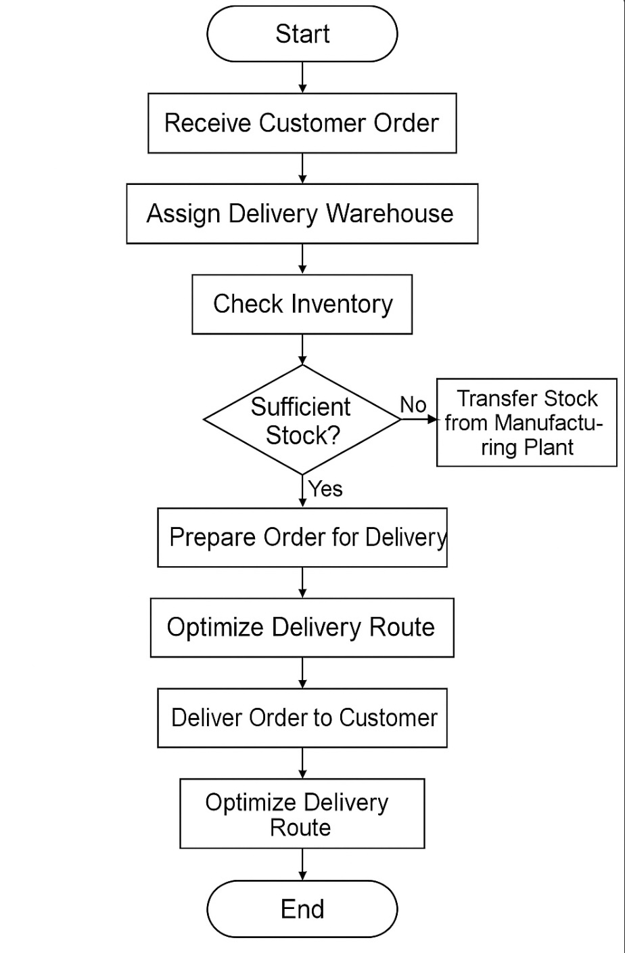

Assignment 2

1, Write an introduction letter to a client introducing yourself as a business analyst in charge of working with the client and his team to start the business understanding process?

**Subject:** Introduction – Your Business Analyst for [Project Name]

Dear [Client’s Name],

I hope this message finds you well.

My name is [Your Full Name], and I am pleased to introduce myself as the **Business Analyst** assigned to collaborate with you and your team on the [Project Name] initiative. I will be your primary point of contact throughout the **business understanding and requirement gathering** phase of this project.

My role will focus on closely engaging with you and key stakeholders to:

* Understand your business goals, current challenges, and future aspirations
* Gather, document, and analyse your functional and technical requirements
* Ensure that the solution we design fully aligns with your operational needs and adds tangible value

Over the next few weeks, I look forward to facilitating discussions, workshops, and walkthroughs that will help us clearly define the scope and objectives of the project. Open communication and collaboration will be key to our mutual success, and I am committed to making this process smooth and productive for you.

Please feel free to reach out to me anytime if you have questions, ideas, or would like to schedule our initial discussions.

Thank you, and I look forward to working with you and your team.

Warm regards,

**[**Ajas Asharaf**]**

Business Analyst

[Your Company Name]

[Your Contact Number]

[Your Email ID]

2, Prepare a brief BRD and SRS for a project- Horoscope or Ticketing system or online store.

# Business Requirements Document (BRD)

## **Project Title:**

## Online Store System

**Prepared by**: [Ajas Asharaf]

**Date**: [Insert Date]

**Client**: [Client Name]

## **Project Overview**

The purpose of this project is to develop an **Online Store** platform that allows customers to browse, purchase, and get delivery of a variety of products online, while providing administrators tools to manage products, orders, and inventory efficiently.

## **Business Objectives**

|  |  |  |  |  |  |  |  |  |  |  |
| --- | --- | --- | --- | --- | --- | --- | --- | --- | --- | --- |
| | **Objective** | **Description** | | --- | --- | | Enable Online Sales | Customers can browse, search, and buy products | | Streamline Order Processing | Allow seamless order placement, payment, and tracking | | Manage Inventory | Real-time inventory updates and stock management | | Improve Customer Experience | Offer a smooth, secure, and responsive shopping experience | |

## **Scope**

### In Scope

* Product catalogue management
* Shopping cart & checkout process
* Order management & tracking
* Customer account management
* Payment gateway integration

### Out of Scope

* Supplier/vendor management
* International shipping

## Key Stakeholders

|  |  |  |  |  |  |  |  |  |  |  |
| --- | --- | --- | --- | --- | --- | --- | --- | --- | --- | --- |
| | **Role** | **Stakeholder** | | --- | --- | | Sponsor | [Client Name] | | Product Owner | [Client Name] Representative | | Development Team | [Your Company Name] | | End Users | Customers (buyers), Admin users | |

## High-Level Requirements

* Customers can **search**, **browse**, and **filter** products
* Customers can **register**, **login**, and **manage accounts**
* Customers can **add products to cart** and **checkout**
* Admin can **add/update/delete products** and **manage inventory**
* Admin can **view/manage orders** and **generate reports**

# Software Requirements Specification (SRS)

## **Project Title**

## **: Online Store System**

**Prepared by**: [Ajas Asharaf]

**Date**: [Insert Date]

## **Introduction**

This document specifies the functional and non-functional requirements for the development of an **Online Store System**.

## Functional Requirements

|  |  |  |  |  |  |  |  |  |  |  |  |  |  |  |
| --- | --- | --- | --- | --- | --- | --- | --- | --- | --- | --- | --- | --- | --- | --- |
| | **Module** | **Requirement** | | --- | --- | | User Registration & Login | - Customers can register and login  - Password recovery | | Product Catalog | - Search, filter, and view product details  - Categories and sub-categories | | Shopping Cart | - Add/remove/update items  - View cart summary | | Checkout & Payments | - Enter shipping details  - Process payment (via gateway) | | Order Management | - View order history and status | | Admin Panel | - Manage products (CRUD)  - Manage orders  - Inventory management  - Generate reports | |

## **Non-Functional Requirements**

|  |  |  |  |  |  |  |  |  |  |  |
| --- | --- | --- | --- | --- | --- | --- | --- | --- | --- | --- |
| | **Requirement** | **Details** | | --- | --- | | Performance | System should respond in <2 seconds | | Security | SSL encryption, secure payment integration | | Usability | Responsive design for mobile & desktop | | Availability | 99.9% uptime | |

## **Assumptions & Constraints**

* Payment gateway account (Stripe, Razorpay, etc.) will be provided by client
* System will support transactions in INR (Indian Rupee)

## **System Interfaces**

|  |  |  |  |  |  |  |
| --- | --- | --- | --- | --- | --- | --- |
| | **Interface** | **Description** | | --- | --- | | Payment Gateway | Integrate for payment processing | | Email/SMS. | Send notifications to customers (order confirmations, etc.) | |

## **User Roles**

|  |  |  |  |  |  |  |
| --- | --- | --- | --- | --- | --- | --- |
| | **Role** | **Permissions** | | --- | --- | | Customer | Browse, buy, manage account | | Admin | Manage products, orders, customers | |

**Q3,** Make an ERD of creating a support ticket/Ticketing life cycle.

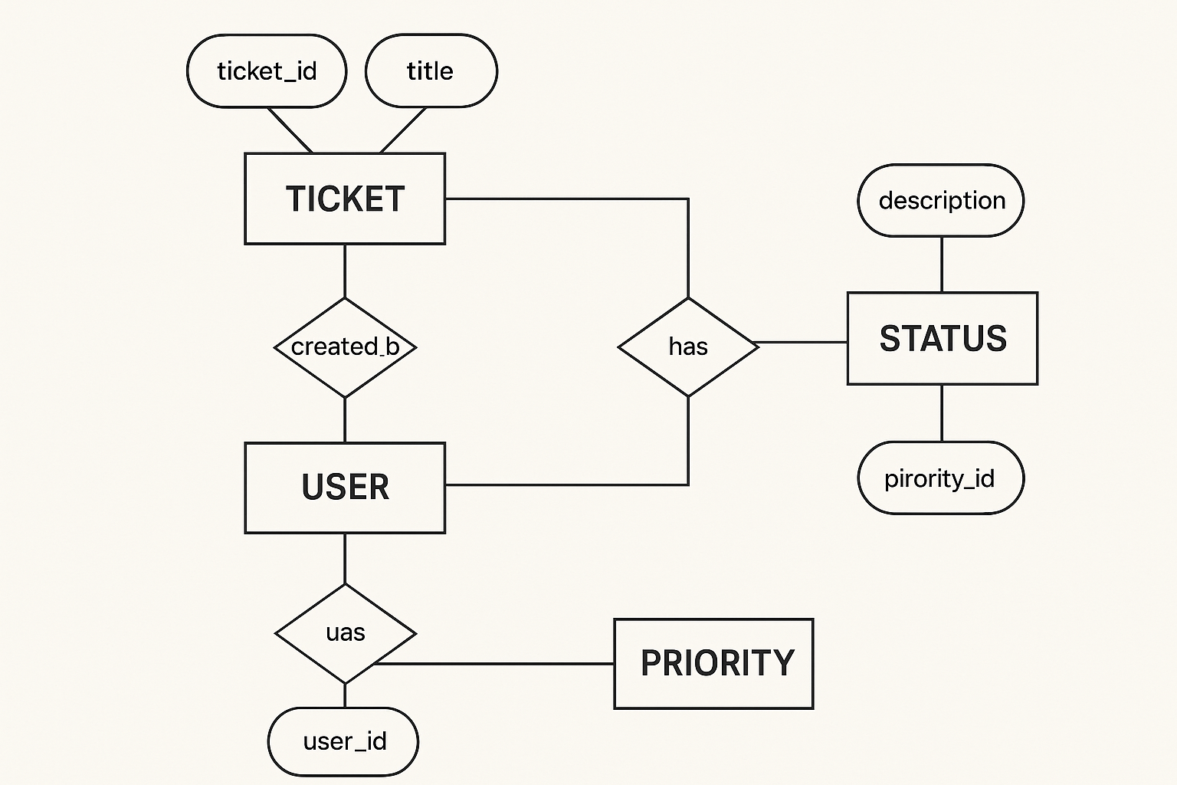

**Q4,** User story of shopping from ecommerce?

1. As a user, I want to register for an account so that I can make purchases.
2. As a user, I want to log into my account so that I can access my shopping history.
3. As a user, I want to reset my password so that I can regain access to my account.
4. As a user, I want to update my personal details so that my profile stays current.
5. As a user, I want to save multiple shipping addresses so that I can choose easily at checkout.
6. As a user, I want to browse products by category so that I can explore available items.
7. As a user, I want to search for a product by name or keyword so that I can find it quickly.
8. As a user, I want to filter products by price, rating, and brand so that I can narrow my choices.
9. As a user, I want to sort products by price or popularity so that I can see the best options first.
10. As a user, I want to view detailed product descriptions so that I can make informed decisions.
11. As a user, I want to add products to a shopping cart so that I can purchase multiple items together.
12. As a user, I want to update quantities in my cart so that I can adjust my purchase.
13. As a user, I want to remove products from my cart so that I can change my mind before checkout.
14. As a user, I want to save products to a Wishlist so that I can buy them later.
15. As a user, I want to move items from Wishlist to cart so that I can purchase them easily.
16. As a user, I want to apply discount codes so that I can get the best price.
17. As a user, I want to select a shipping method so that I can control delivery speed and cost.
18. As a user, I want to make secure online payments so that I can complete my purchase safely.
19. As a user, I want to view an order summary before payment so that I can confirm my order.
20. As a user, I want to save my payment methods so that I can checkout faster next time.
21. As a user, I want to receive an email confirmation after placing an order so that I know it was successful.
22. As a user, I want to track my order status so that I know when it will arrive.
23. As a user, I want to view my past orders so that I can reorder easily.
24. As a user, I want to cancel an order before it ships so that I can change my mind.
25. As a user, I want to return a product so that I can get a refund or replacement.
26. As a user, I want to rate products so that I can share my experience with others.
27. As a user, I want to write a review after purchase so that I can help other customers.
28. As a user, I want to view customer ratings and reviews so that I can make informed buying decisions.
29. As a user, I want to receive order status notifications so that I stay informed.
30. As a user, I want to enable two-factor authentication so that my account is secure.
31. As a user, I want to subscribe to promotional emails so that I get updates and offers.
32. As a user, I want to unsubscribe from promotional emails so that I can control communication.
33. As a user, I want to contact customer support via chat so that I can get quick help.
34. As a user, I want to raise a support ticket so that I can resolve issues formally.
35. As a user, I want to view FAQs so that I can find answers on my own.
36. As a user, I want to get personalized product recommendations so that I discover relevant products.
37. As a user, I want to share product links with friends so that I can get their opinion.
38. As a user, I want to compare products side by side so that I can choose the best one.
39. As a user, I want to view recently viewed items so that I can revisit them easily.
40. As a user, I want to participate in flash sales or limited-time deals so that I get discounts.