Question 1) 4 Quarterly Audits are planned Q1, Q2, Q3, Q4 for this Project. What is your knowledge on how these Audits will happen for a BA?

Answer:

|  |  |
| --- | --- |
| Stage | Q1 Audit Report – Requirement gathering |
| Duration Completed | 10 Weeks (Week 1 – Week 10) |
| Checklist | BRD and FRD and initial project scope Template |
| Elicitation results report |
| Duplicate requirement report |
| Client sign-offs |
| Email communication |

|  |  |
| --- | --- |
| Stage | Q2 Audit Report – Requirement Analysis |
| Duration Completed | 7 Weeks (Week 16 – Week 23) |
| Checklist | UML Diagrams |
| Business – functional requirements mapping |
| Client sign-off documents |
| RTM Document version control |
| Email communication |

|  |  |
| --- | --- |
| Stage | Q3 Audit Report – Design |
| Duration Completed | 7 weeks (Week 30 – week 37) |
| Checklist | Tools utilization |
| Documented evidence on client evidence |
| Stakeholder MOM |
| Email Communication |

|  |  |
| --- | --- |
| Stage | Q4 Audit Report – Development |
| Duration Completed | 20 weeks (Week 40 – Week 60) |
| Checklist | JAD session report |
| End user manual preparation document |
| BA and developer MOM |
| Email communication |

Question 2: BA Approach Strategy

Answer:

As a BA we need to firstly make sure that we gather all the requirements from the client. Once the requirements are gathered, we need to complete the stakeholder analysis using the ILS (Identify, List and Summary) method or the RACI (Responsible, Accountable, Consulted, Informed) method. After this is completed, we need to apply the elicitation techniques which can give us the 3C advantage (Complete, correct and consistent). After this, BA needs to sort the requirements which means we need to eliminate duplicate requirements and define them. Once the requirements are defined, we need to prioritize them using the MoSCoW method and then validate them through FURPS (Functionality, Usability, Reliability, Performance and Supportable). Then we understand the quality of requirements through SMART (Specific, Measurable, Attainable, Realistic, Timebound). After this the BRD needs to be prepared.

Elicitation techniques to be applied: There are different elicitation techniques. Some of them that can be used in this case study are:

Document analysis: Through this, we need to go ahead and read and understand the farming industry, and how it will help us in the preparation of the application.

Interviews: We can conduct interviews to understand how much the farmers are aware of technology and what needs to be included while developing the applications and what kind of products they are looking for.

Questionnaire: This can be used to know what exactly the farmers are expecting and can maybe get minor inputs.

Workshop: We can conduct a workshop with the farmers and know and prioritize what exactly is most important and also can get new inputs and outputs.

Stakeholder Analysis (RACI): Stakeholder analysis can be done using the RACI matrix which stands for Responsible, Accountable, Consulted and Informed. Through this we can identify who are the decision makers and the people who can influence the project and define the roles and responsibilities accordingly.

Documents to be written: BRD, FRD, Use case documents, RTM, Training materials, change requests docs.

Process to be followed to get sign off on documents: Getting a sign off means getting a confirmation that we have agreed to the previously discussed agenda. Usually, a sign off is taken in the form of email communication after all the requirements are gathered, validated, sorted, defined and then a BRD and SRS is created and sent to the client for approval. Sometimes we can conduct a meeting followed by an email for the sign off on documents.

Take approval from clients: Conduct meetings with the client and take feedback and also create MOM and send it to the responsible stakeholders.

Communication channels to establish and implement: Scrum meetings – through this we can update the client is on what has happened on a particular scrum day, sprint reviews – through this we can update the client with project updates every 2 weeks, monthly stakeholder updates meeting and email communication.

Change request handling: Change request form needs to be filled by the client, Impact analysis needs to be done by us as a BA, Approval process needs to be started and finally documentation needs to be done.

Update the project progress to the stakeholders: Weekly status reports and monthly review meetings.

Take sign off on UAT – Client project acceptance form: Prepare UAT, Conduct UAT, Fix issues, Accept Form, Final review meeting, Obtain Sign off.

Question 3: Explain and illustrate 3-tier architecture?

Answer: **3-Tier Architecture** is a popular approach in software development that divides the application into three distinct layers: **Presentation**, **Business Logic**, and **Data**

Data Base

Code/Technology

Screens/Pages

Application Layer Business Logic Layer Data Layer

Application Layer: This is usually the screens and pages or the Front end of the application that the user sees and interacts with and it handles the User interface components.

Business Logic Layer: This is the layer that is between the Application layer and Data Layer and acts as an intermediary. It takes the information from application layer and sends it to the data layer and responds back with that response to the application layer. These can be the printers, payment gateways etc.

Data Layer: This is the database layer and has the entire data stored it in in the form of tables. To retrieve data from the database we need to use database languages like MYSQL, Oracle, NoSQL etc.

The business logic and data layer are together called as Backend process.

Functionality of an IT application = Business logic achieved by technology/code + Data in the database

Question 4: BA Approach Strategy for Framing Questions

Answer: As a BA, it is our responsibility to extract requirements from the stakeholders and they are not trained to share the requirements in the way we need them.

Hence, we use have different technique to probe questions. Some of them are:

**5W 1H** which stands from **Why, Who, What, When, Where and How.**

**Why** the project is being initiated

**Who** are the stakeholders

**What** is the current process being followed

**When** the project needs to be completed

**Where** is the client location and where do the new application need to be deployed.

**How** does the new project help the current process

**SMART Analysis:** Once we gather the requirement we need to know if it is SMART which means **Specific, Measurable, Attainable, Relevant and Time bound**

We need to check if the requirement is specific to what we the client is looking for and also what we as a BA need to document it

We need to know if it can be measured and how it can be done

Need to check if it can be achieved

The requirement also needs to be relevant to the project

And also, if it is specific time bound.

**RACI Matrix:** RACI matrix helps the BA to identify the stakeholders through we will know who are **responsible, Accountable, Consulted and Informed**.

Once we know who the stakeholders are, we can probe questions accordingly and gather the correct requirements.

**Use Cases:** Use cases are high level diagrams which are actor specific and are used to identify the requirement. It is designed to know how the external user interacts with the system.

**Use case specs:** Use case specifications mean what is needed when a use case is written. To write a use case we would need

Name

Description

Actors (Primary, secondary)

Basic Flow

Alternative Flow

Exceptional flows

Pre-Conditions

Post-Conditions

Assumptions

Constraints

Dependencies

Inputs and Outputs

Business Rules

Misc Information

**Activity Diagram:** An activity diagram will model or tell how the system should behave in order to achieve business objectives, follow business rules and implement business logic.

It is drawn based on the system’s perspective and wherever the system is involved.

This is similar to flowcharts; however, flowcharts talk about the entire business process and activity diagram only talks about system perspective.

Take sign off on all documents and diagrams prepared from all stakeholders.

Models – Conceptual, DFD, Domain model, ER diagram, Data model

**Question 5:** Elicitation Techniques

**Answer:** Any meeting that we have with a client with an objective is called an elicitation technique. The requirements that we gather from a client need to be correct, complete and consistent. This can be achieved through elicitation techniques. There are different elicitation techniques that are listed below:

**Brainstorming:** In this technique the process experts and SME’s take part and meetings are conducted with them trying to understand the problem, find different solutions using the **5W1H method** and rate them and in the end a MOM has to be created and sent.

**Document Analysis:** In this technique, we read and understand the process/domain that we are working on and it is one of the most important techniques. As a BA knowing the domain helps us in a successful project completion.

**Reverse Engineering:** In this particular technique, we try and understand every possibility without knowing what the result would be.

**Focus Groups:** These are the groups that participate and use our project methods in the future. There are 2 different types of focus groups. **Homogenous** – They belong to the same domain that we are working on**. Heterogeneous** – They belong to a different domain but still like to use our methods.

**Observations:** The people who fall under this category are very new and who participate to observe what is going on and learn and they are passive and active.

**Workshops:** These are practical in nature and aim to completeness. In this technique, we conduct meetings or workshops where people can participate and share their knowledge on what exactly happens in their process so that we can understand the domain better and validate the requirements we gathered.

**JAD (Joint Application Development) session:** Often as a BA we may need to work on technical projects, however, we may not always have technical knowledge. In this scenario, we take the help of the technical experts like Database admin or Network admin etc; and attend the meetings along with them and gather requirements from the client.

**Interviews:** After gathering requirements from the client, we sort them and while sorting, there may be conflicts. In order to solve it, we conduct interviews with the clients and stakeholders.

There are 2 types of approaches; **Structured approach** – write down all the questions and ask the stakeholders. **Direct approach** – ask questions based on the client’s answers. These questions can be open ended or closed ended.

**Prototyping:** Through this technique we can show the sample of how the application that we will be working on looks. This can be done through Axure rp applicationss

**Questionnaire:** We create a questionnaire based on the questions we have on the project and this can be taken as a survey and once the answers to this survey are received, we measure them statistically through mean, median, mode etc.,

**Use case specifications:** Use cases are high level diagrams which are actor specific and are used to identify the requirement. It is designed to know how the external user interacts with the system. A use case spec is the document that explains about the use case diagram – Name, Description, Actors (Primary, secondary), Basic Flow, Alternative Flow, Exceptional flows, Pre-Conditions, Post-Conditions, Assumptions, Constraints, Dependencies, Inputs and Outputs, Business Rules, Misc Information

**Question 6:** This project Elicitation Techniques

Answer: We can use the below elicitation techniques for this project.

**Brainstorming:** Through this technique we can reach out to Peter, Kevin and Ben and conduct meetings with them and try understand the problem, find different solutions using the **5W1H method**. The reason why we do this is because, Peter, Kevin and Ben are already farmers and are aware of the on-going problems.

**Document Analysis:** We can use this technique to understand farming better and also how the manufacturing and supply chain works.

**Workshops:** We can conduct workshops in the nearby villages to inform the farmers how we would like to create an app for them for the farming products and take their feedback and inputs and gather the requirements. We should also conduct workshops with the dealers and manufacturers and try and get their inputs on how the supply of the products work.

**Interviews:** We can conduct interviews with farmers and ask what products they are looking for and features in the app that would help them.

Questionnaire: Survey needs to be conducted to know how many farmers are willing to use the app and how many of them actually have a mobile phone and the products and manufacturers that they are looking for.

Similar survey needs to be conducted with the manufacturers to know the cost of the products and what can be shipped to the villages and the delivery times etc.,

**Question 7:** 10 Business Requirements

BR001 – Product category list to be made available along with search icon

BR002 – To be able to add the product to buy-later list

BR003 – Login and password needed to enter into the app

BR004 – Registration needed with email id in order to be able to login

BR005 – Have a COD payment, Credit/debit card and UPI payments

BR006 – Email communication on order status to registered email id

BR007 – Delivery tracker to track the order

BR009 – Product category list to have pesticides, seeds and fertilizers

BR010 – Manufacturers to be able to upload their product list and list the pricing

BR011 – Manufacturers to be able to accommodate products with different payment options

**Question 8:** Assumptions

Answer:

* Farmers may not be willing to trust the mobile application over the usual physical purchasing methods.
* They may think that the products delivered may not be original
* They could think that the manufacturers would not respond to faulty products received.
* They could think that online payments are risky as their personal information would be shared.
* There could be possible losses in the beginning as the farmers need to get used to the mobile app
* Manufacturers may not be willing to sell the products online as it may require them to sell it for a lesser price
* The payment gateways may not work well due to low network connectivity in the villages and lead to financial questions.
* Getting different type of manufacturers on the app could be a challenge

**Question 9:** Project Requirements Priority

Answer:

|  |  |  |  |
| --- | --- | --- | --- |
| Req Id | Req Name | Req Description | Priority |
| BR001 | Product category availability | Product category list to be made available along with search icon | 8 |
| BR002 | Add products to cart | To be able to add the product to buy-later list | 4 |
| BR003 | Login info to login | Login and password needed to enter into the app | 9 |
| BR004 | New account set up | Registration needed with email id in order to be able to login | 10 |
| BR005 | Different payment options | Have a COD payment, Credit/debit card and UPI payments | 5 |
| BR006 | Order status update | Email communication on order status to registered email id | 5 |
| BR007 | Delivery tracking update | Delivery tracker to track the order | 6 |
| BR008 | Category list with all items | Product category list to have pesticides, seeds and fertilizers | 2 |
| BR009 | Product upload option | Manufacturers to be able to upload their product list and list the pricing | 3 |
| BR010 | Different Payment acceptance option | Manufacturers to be able to accommodate products with different payment options | 7 |

**Question 10:** Use Case Diagram

**Answer:**

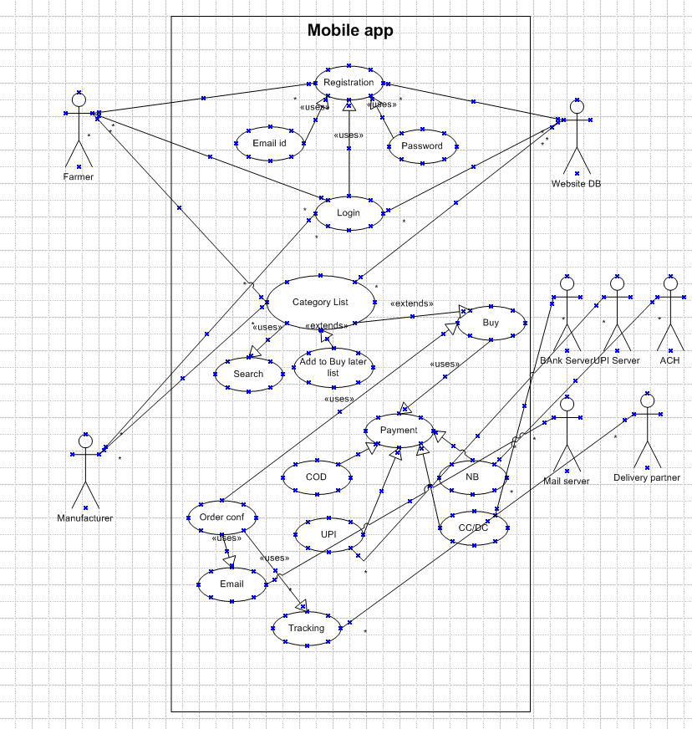

**Question 11:** Use Case Specifications

* **Use Case ID**: UC01
* **Use Case Name**: Login
* **Actors**: Farmer and Manufacturer
* **Description**: This use case allows a farmer and a manufacturer to log in to the platform using their registered email ID and password.
* **Preconditions**: The farmer and manufacturer have already created an account and are on the login page.
* **Postconditions**: They have successfully logged into the system and can access account features.
* **Basic Flow**:
  1. The farmer and manufacturer navigate to the login page.
  2. Enters their email ID and password.
  3. The system validates the login credentials.
  4. If the credentials are correct, they are logged in and redirected to the dashboard or product catalog.
  5. If the credentials are incorrect, the system prompts them to try again.
* **Alternative Flow**:
  1. If the farmer forgets their password, they can click on "Forgot Password" to reset it.
* **Exceptions**:
  1. If the system encounters a login error (e.g., server issues), the system shows an error message and prompts the farmer to try again later.
* **Use Case ID**: UC02
* **Use Case Name**: Add to Cart
* **Actors**: Farmer
* **Description**: This use case allows a farmer to add products to buy later list after logging in.
* **Preconditions**: The farmer is logged in and browsing the product catalog.
* **Postconditions**: The selected product is added to the farmer's shopping cart.
* **Basic Flow**:
  1. The farmer browses the product catalog and selects a product.
  2. The farmer clicks the "Add to buy later" button.
  3. The system adds the product to the farmer's buy later list.
* **Alternative Flow**:
  1. If the product is out of stock, the system displays a "Product unavailable" message.
* **Exceptions**:
  1. If there is an issue adding the product to the buy later list(e.g., system error), the system shows an error message.
* **Use Case ID**: UC03
* **Use Case Name**: Create Account
* **Actors**: New Farmer and Manufacturer
* **Description**: This use case allows a new farmer and a new manufacturer to create an account on the platform by submitting an email and setting up a secure password.
* **Preconditions**: The farmer and manufacturer have no existing account and is on the registration page.
* **Postconditions**: The new farmer and new manufacturer account is created and they are directed to the login page.
* **Basic Flow**:
  1. The new farmer and new manufacturer click on the "Create Account" button on the homepage.
  2. They are prompted to enter an email address and create a secure password.
  3. They click "Submit" to create the account.
  4. The system validates the email and password, ensuring that the email is unique and the password meets security requirements.
  5. The system creates the account and sends a confirmation email to them.
  6. They are redirected to the login page.
* **Alternative Flow**:
  1. If the email is already registered, the system prompts them to log in instead.
* **Exceptions**:
  1. If the password does not meet security requirements (e.g., too short, too simple), the system asks them to choose a stronger password.
* **Use Case ID**: UC04
* **Use Case Name**: Search for Products
* **Actors**: Farmer (User)
* **Description**: This use case allows the farmer to search for a product using specific keywords.
* **Preconditions**: The farmer is on the homepage or product catalog page.
* **Postconditions**: The system returns a list of products that match the search criteria.
* **Basic Flow**:
  1. The farmer enters a keyword (e.g., "fertilizer", "seeds") into the search bar.
  2. The system processes the search query and filters the products.
  3. The system displays a list of products that match the search keyword.
  4. The farmer can refine the search results using additional filters like price range or product category.
* **Alternative Flow**:
  1. If no products match the search, the system displays a "No results found" message.
* **Exceptions**:
  1. If the search query cannot be processed, the system displays an error message.
* **Use Case ID**: UC05
* **Use Case Name**: Browse Product Catalog
* **Actors**: Farmer (User)
* **Description**: This use case allows the farmer to browse through the available product catalog on the platform.
* **Preconditions**: The farmer is on the homepage of the platform.
* **Postconditions**: The farmer has access to a list of available products for viewing.
* **Basic Flow**:
  1. The farmer navigates to the product catalog page.
  2. The system displays a list of available products with descriptions, images, and prices.
  3. The farmer can scroll through the catalog or filter products based on categories (e.g., seeds, fertilizers, tools).
  4. The farmer can select a product to view more details.
* **Alternative Flow**:
  1. If no products are available, the system displays a "No products found" message.
* **Exceptions**:
  1. If the system fails to load the catalog, the system shows an error message and asks the farmer to try again later.
* **Use Case ID**: UC06
* **Use Case Name**: Payment Gateway
* **Actors**: Farmer (User)
* **Description**: This use case allows the farmer to complete a payment for their order using different payment methods, such as Cash-on-Delivery, Credit/Debit Card, or UPI.
* **Preconditions**: The farmer has products in the cart and is ready to check out.
* **Postconditions**: The payment is successfully processed, and the order is placed.
* **Basic Flow**:
  1. The farmer reviews the cart and proceeds to checkout.
  2. The farmer selects the payment method (Cash-on-Delivery, Credit/Debit Card, UPI).
  3. The system processes the payment based on the selected method.
  4. If the payment is successful, the system confirms the order and processes it.
  5. If the payment fails, the system asks the farmer to try again or choose a different payment method.
* **Alternative Flow**:
  1. If the farmer selects Cash-on-Delivery, the system confirms the order and schedules the delivery.
* **Exceptions**:
  1. If there is an issue with processing the payment (e.g., payment gateway error), the system prompts the farmer to retry.

**Use Case: Order Confirmation**

* **Use Case ID**: UC07
* **Use Case Name**: Order Confirmation
* **Actors**: System
* **Description**: This use case handles sending an order confirmation email to the farmer once their order is successfully placed.
* **Preconditions**: The farmer has completed the purchase process and the order is successfully placed.
* **Postconditions**: The farmer receives an order confirmation email.
* **Basic Flow**:
  1. The system processes the order and generates an order confirmation.
  2. The system sends an email to the farmer with the order details, including a tracking number and estimated delivery time.
* **Alternative Flow**:
  1. If the email cannot be sent, the system retries the email delivery.
* **Exceptions**:
  1. If the email system fails, the system logs the error for further investigation.

**Use Case: Track Order**

* **Use Case ID**: UC08
* **Use Case Name**: Track Order
* **Actors**: Farmer (User)
* **Description**: This use case allows the farmer to track the delivery status of their order.
* **Preconditions**: The farmer has placed an order and received a confirmation email with a tracking number.
* **Postconditions**: The farmer receives real-time information about the delivery status.
* **Basic Flow**:
  1. The farmer navigates to the "Track Order" section of the website.
  2. The farmer enters the tracking number received in the order confirmation email.
  3. The system displays the current status of the delivery (e.g., "In Transit", "Out for Delivery").
* **Alternative Flow**:
  1. If the tracking number is invalid or not recognized, the system displays an error message.
* **Exceptions**:
  1. If the tracking system is unavailable, the system prompts the farmer to check back later.

**Question 12:** Activity Diagram

Answer:

