Question 1 – Functional Requirements
Identify minimum 20 functional requirements
Functional requirements define the specific behaviour, functions or operation of a system. They describe what the system should do, outlining the necessary tasks, actions or activities it must perform to achieve its objective. Development team participates in functional requirements gathering, here in functional system should allow how users can perform or read within the system
Req. ID | Req. Name | Req. Description (actual Behaviour in the backend)
FR001 | Manufacturer  Login | Manufacturer should be able to login with application
FR002 | New user Register | New user should be able to Register with the application
FR003 | Search for the products | Farmer should be able to browse product with product catalog when he visited Website.
FR004 | Adding product to the cart | Farmer should be able to add the product to the cart
FR005 | Adding product to the wishlist | Farmer should be able to add the products to the wishlist for after buying
FR006 | Manufacturer Upload product | Manufacturer would be able to upload the products in application.
FR007 | Order confirmation | Farmer would be able to get confirmation of order through E-mail.
FR008 | Farmer buy product | Farmer should be able to buy product with login in application.
FR009 | Payment with different modes | Farmer should be able to make a payment with different modes
FR010 | Order tracking | Farmer would be able to track their order from order ID in the portal

Non-Functional requirements will describe the qualities and attributes of a system, focusing on how the system performs rather than specific behaviour or functions.

NFR001 | Usability | The application should have an intuitive and user-friendly
NFR002 | Standard size of packing slip | Printing packing slip should be accurately follows ‘4*6’ standard size.
NFR003 | Performance | The application must load pages within 3 seconds
NFR004 | Compatibility | The application should be compatible with major web browser with proper internet connectivity
NFR005 | Response time | The application should respond to user inputs within 2 seconds
NFR006 | Quality | The application should match quality standards
NFR007 | Availability | The Application should have sufficient stock available with updated stock
NFR008 | Presentation | Presentation of application should be proper and customer satisfying.
NFR009 | User friendly application | Application should be user friendly; features clarity will be there in application.
NFR010 | Transparency in application | There should be transparency in application.

Question 2–Minimum 5-page designs
Make wireframe and prototypes
- Login Page on Website-
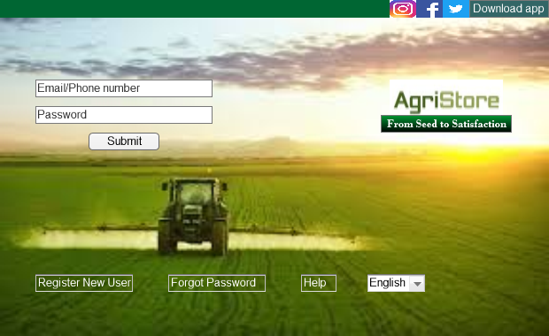
- Search Page on Website-
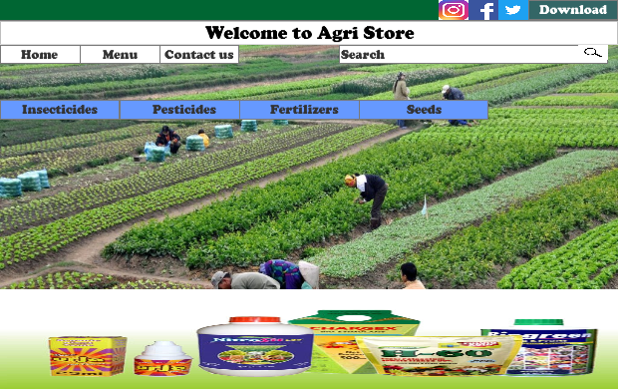

- Payment page in application-
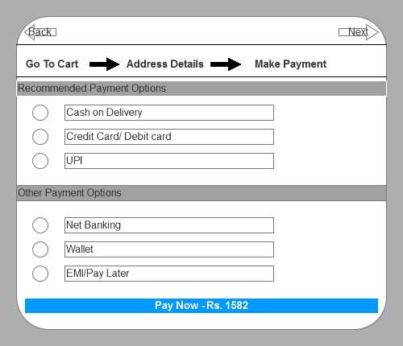
- Login Page in Application-
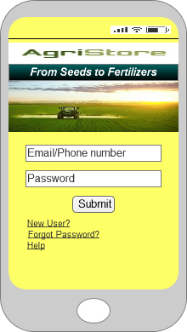

- Add to Cart-
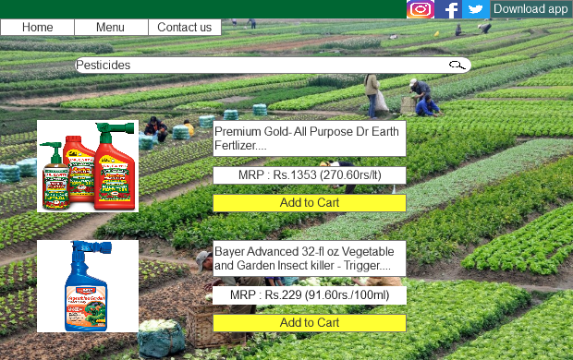

Question 3 – Tools (Visio, Balsamiq)
M S VISIO- M S VISIO is a diagramming tool that allows you to create diagram ranking from simple to complex, which aid in data visualization and process modeling, it is a more visual representation of complex information
Modeling the requirement-As a BA not always possible that all requirements are understandable, so in order to understand requirement in very crystal-clear manner we need to draw a diagram, to draw this diagram we will use M S VISIO.
In M S VISIO we can draw Use case diagram, Activity Diagram and sequence Diagrams. And also they can be utilized for building pictures like flowcharts, network diagrams.
File saved format in M S VISIO is - .VSD
Balsamiq-
Balsamiq is a web-based interface design tool for creating wireframes. It uses to generate digital sketched of your ideas or concepts for an application or website and to facilitate discussion and understanding before any code is written.
Balsamiq is static tool, No navigation is here in Balsamic. We can’t exports balsamiq files into HTML or Nor into JPEG.
File saving format for balsamiq is- .Bmml

Axure-
Axure RP is primarily used for creating wireframes, prototypes, and specifications for digital products like websites and apps. It allows designers and product managers to build interactive mockups and prototypes without needing to code, facilitating user testing and collaboration. It provides tools for creating detailed specifications and documentation for designs, which can be shared with developers and other stakeholders.
Axure is a versatile tool that empowers designers to create and test interactive prototypes, refine user experiences, and communicate design ideas effectively.

Question 4 – RTM
RTM is a document to track the requirement throughout the project lifecycle, ensuring that they are met and that no requirement are overlooked, BA will prepare RTM
Req. ID | Req. Name | Req. Description(actual Behaviour) | Design | Code | Unit testing | System Testing | UAT
FR001 | Manufacturer Login | Manufacturer should be able to login with application | Complete | Complete | Complete | Complete | Incomplete
FR002 | New user Register | New user should be able to Register with the application | Complete | Complete | Complete | Complete | Incomplete
FR003 | Search for the products | Farmer should be able to browse product with product catalog when he visited Website. | Complete | Complete | Complete | Incomplete | Incompleete
FR004 | Adding product to the cart | Farmer should be able to add the product to the cart | Complete | Complete | Complete | Incomplete | Incomplete
FR005 | Adding product to the wishlist | Farmer should be able to add the products to the wishlist for after buying | Complete | Complete | Complete | Incomplete | complete
FR006 | Manufacturer Upload product | Manufacturer would be able to upload the products in application. | Complete | Complete | Complete | Incomplete | Complete
FR007 | Order confirmation | Farmer would be able to get confirmation of order through E-mail. | Complete | Complete | Complete | Complete | Incomplete
FR008 | Farmer buy product | Farmer should be able to buy product with login in application. | Complete | Complete | Complete | Incomplete | Incomplete
FR009 | Payment with different modes | Farmer should be able to make a payment with different modes | Complete | Complete | Complete | Complete | Incomplete
FR010 | Order tracking | Farmer would be able to track their order from order ID in the portal | Complete | Complete | Complete | Incomplete | Complete

Req. ID | Req. Name | Req. Description(actual Behaviour) | Design | Code | Unit testing | System Testing | UAT
NFR001 | Usability | The application should have an intuitive and user-friendly | Complete | Complete | Inprogress | Complete | Incompelete
NFR002 | Standard size of packing slip | Printing packing slip should be accurately follows ‘4*6’ standard size. | Complete | Complete | Complete | Complete | Incomplete
NFR003 | Performance | The application must load pages within 3 seconds | Complete | Complete | Complete | Incomplete | Incomplete
NFR004 | Compatibility | The application should be compatible with major web browser with proper internet connectivity | Complete | Complete | Complete | Complete | Incomplete
NFR005 | Response time | The application should respond to user inputs within 2 seconds | Complete | Complete | Incomplete | Complete | Complete

Question 5 – 10 Test Case Documents –
A test case document is a detailed outline used by testers to ensure that a software application or system is working as expected.
- Login in online agricultural APP(with valid credentials)
Test case ID | PQ456TS001 | Test Case name | Login with valid credentials
Project ID | PQ456 | Project name | Online agricultural product store
PM ID | 4758 | PM Name | Vandanam
Test strategy ID | PQ456TS001 | Tetster ID | T001
Test schedule ID | PQ456TS001 | Tester name | John Smith
 |  | Date of test
Scenario | The user enters valid login credentials and clicks on the login button
Example | User name- Apurva.porwalks@coepd.com, Pass-Poru@123
Action | Inputs | Expected Output | Actual Output | Test browser | Test Result
Enter the user name and password, click on login button | User name- Apurva.porwalks@coepd.com, Pass-Poru@123 | The user should be succesfully logged in and redirected to the home page | user should be succesfully logged in and redirected to the home page | Chrome | PASS

- Login in online agricultural APP(with invalid credentials)
Test case ID | PQ456TS002 | Test Case name | Login with invalid credentials
Project ID | PQ456 | Project name | Online agricultural product store
PM ID | 4758 | PM Name | Vandanam
Test strategy ID | PQ456TS001 | Tetster ID | T002
Test schedule ID | PQ456TS001 | Tester name | John Smith
 |  | Date of test
Scenario | The uer enters invalid login credentials and clicks on the login button
Example | User name- Apurva.porwalks@coepd.com, Pass-invalid pswrd
Action | Inputs | Expected Output | Actual Output | Test browser | Test Result
Enter the user name and password, click on login button | User name- apurva.porwalks@coepd.com, Pass-invalid pswrd | The system should display an error message indicating invalid credentials | system displayed an error message indicating invalid credentials | firefox | PASS
- Add Product to cart
Test case ID | PQ456TS003 | Test Case name | Add Product to cart
Project ID | PQ456 | Project name | Online agricultural product store
PM ID | 4758 | PM Name | Vandanam
Test strategy ID | PQ456TS001 | Tetster ID | T003
Test schedule ID | PQ456TS001 | Tester name | John Smith
 |  | Date of test
Scenario | The user selects a prodcut and adds it to cart
Example | Select "Perry Fertilizer-1kg"
Action | Inputs | Expected Output | Actual Output | Test browser | Test Result
Click on the product, select the desired quantity and click on the "Add to Cart" button | Product-Perry Fertilizer,Quantity-1 kg | The product should be added to the cart with the correct quantity | Product added to the cart with quantity | safari | PASS

- Product Removal from CART
Test case ID | PQ456TS004 | Test Case name | Remove product from cart purchase
Project ID | PQ456 | Project name | Online agricultural product store
PM ID | 4758 | PM Name | Vandanam
Test strategy ID | PQ456TS001 | Tetster ID | T004
Test schedule ID | PQ456TS001 | Tester name | John Smith
 |  | Date of test
Scenario | The user removes a prodcut from the cart
Example | Remove "pesticides-1000 ml"
Action | Inputs | Expected Output | Actual Output | Test browser | Test Result
Find the product in the card, click on the remove button | Product-Pesticides-1000 ml | The product should be removed from the cart | Prodcut succesfully removed from the cart | chrome | PASS
- Add Product to wishlist
Test case ID | PQ456TS005 | Test Case name | Add product to wishlist
Project ID | PQ456 | Project name | Online agricultural product store
PM ID | 4758 | PM Name | Vandanam
Test strategy ID | PQ456TS001 | Tetster ID | T005
Test schedule ID | PQ456TS001 | Tester name | John Smith
 |  | Date of test
Scenario | The user add a product to the wishlist
Example | Add "organic seeds-cabbage" to the wishlist
Action | Inputs | Expected Output | Actual Output | Test browser | Test Result
Find the productand click "Add to the wishlist"button | Product-Organic seeds-cabbage | The product should be added to the wishlist | Product added to the wishlist | chrome | PASS
- Quantity update in cart
Test case ID | PQ456TS006 | Test Case name | Update quantity in cart
Project ID | PQ456 | Project name | Online agricultural product store
PM ID | 4758 | PM Name | Vandanam
Test strategy ID | PQ456TS001 | Tetster ID | T006
Test schedule ID | PQ456TS001 | Tester name | John Smith
 |  | Date of test
Scenario | The user updates the quantity of a product in the cart
Example | Update quantity of "fertilizer -2kg to 5 kg"
Action | Inputs | Expected Output | Actual Output | Test browser | Test Result
Find the product in the cart, update the quantity to 5 kg and click on the update button | Product -Fertilizer -2kg to 5 kg | The quantity of prodcut in the cart should be updated to 5 kg | Quantity of the product in the cart updated to 5 kg | safari | PASS
- Total cost of purchase
Test case ID | PQ456TS007 | Test Case name | Calculate total cost in the cart
Project ID | PQ456 | Project name | Online agricultural product store
PM ID | 4758 | PM Name | Vandanam
Test strategy ID | PQ456TS001 | Tetster ID | T006
Test schedule ID | PQ456TS001 | Tester name | John Smith
 |  | Date of test
Scenario | The user calculates the total cost of the product in the cart
Example | Calculate the total cost of all the products in the cart
Action | Inputs | Expected Output | Actual Output | Test browser | Test Result
Click on the"calculate total"button | NONE | The system should display the total cost of all the products in the cart | Total cost displayed-Rs.1650 | Firefox | PASS

- Checkout Process
Test case ID | PQ456TS008 | Test Case name | Proceed to checkout
Project ID | PQ456 | Project name | Online agricultural product store
PM ID | 4758 | PM Name | Vandanam
Test strategy ID | PQ456TS001 | Tetster ID | T006
Test schedule ID | PQ456TS001 | Tester name | John Smith
 |  | Date of test
Scenario | The user proceeds to checkout
Example | click on the "proceed to checkout" button
Action | Inputs | Expected Output | Actual Output | Test browser | Test Result
Click on the "proceed to the chcekout"button on the cart page | NONE | The user should be redirected to the checkout page | user redirected to the chekout page | chrome | PASS
- Payment mode
Test case ID | PQ456TS009 | Test Case name | Proceed to payment
Project ID | PQ456 | Project name | Online agricultural product store
PM ID | 4758 | PM Name | Vandanam
Test strategy ID | PQ456TS001 | Tetster ID | T006
Test schedule ID | PQ456TS001 | Tester name | John Smith
 |  | Date of test
Scenario | The user proceeds for payment and selection of mode
Example | Click on "payment option"button
Action | Inputs | Expected Output | Actual Output | Test browser | Test Result
Click on the "proceed to pay "button on the checkout page | NONE | The user should be redirected to the payment option page | user redirected to the payment selection page | chrome | PASS

- Order confirmation and tracking
Test case ID | PQ456TS010 | Test Case name | Order confirmation and tracking
Project ID | PQ456 | Project name | Online agricultural product store
PM ID | 4758 | PM Name | Vandanam
Test strategy ID | PQ456TS001 | Tetster ID | T010
Test schedule ID | PQ456TS001 | Tester name | John Smith
 |  | Date of test
Scenario | The user places the order and gets tracking
Example | Click on"complete order and track"
Action | Inputs | Expected Output | Actual Output | Test browser | Test Result
Click on"complete order and track" | Location is on and allowed to access current location | The user should be redirected to the complete order page and gets tracking ID | user redirected to the complete order page and gets a tracking ID | Firefox | PASS

Question 6 – DB Design
Draw database schema and ER diagram
DB schema is blueprint that outlines the structure of a database, including its table, fields, relationships, constraints, and other characteristics
Example:- Online agricultural product store
- Product Table
Product ID | Product Name | Category | Product Price | Remark
SED001 | Seeds |  | 500/KG
FER002 | Fertilizers |  | 750/L
PES003 | Pesticides |  | 450/L

- Farmer Table
Farmer Reg No | Farmer Name | Contact No | PAN | Address
FAR452 | Peter
FAR563 | Ben
FAR458 | Kevin

- Manufacturer Table
Company Name | Product ID | Product Price | Product Name
ABC PVT LTD | SED001 | 500/kg | Seeds
Xyz | FER002 | 750/l | Fertilizer
PQY traders | PES003 | 450/l | Pesticides

- Order Table-
Order id | Product Id | Farmer Reg | Product name
12365 | SRD001 | FAR452 | Seed
23654 | FER002 | FAR563 | Fertilizer
85236 | PES003 | FAR458 | Pesticides

This is the Online Agriculture Product Store data base, where we have 4 tables, and each tables are related to each other.
An ERD is a visual representation of the relationships between entities in a database, it depicts the entities (tables), attributes (properties) and relationship between them.

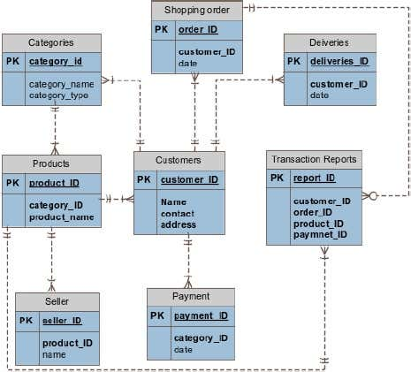

Product Table Manufacturer Table
Product ID |  | Product ID
Product ID

Order Table

Farmer Table Order Table
Farmer Reg No |  | Farmer Reg NO

Shows relationship b/w two entity

Product Table Manufacturer Table
Product Name
Product Name

All 3 tables and entities are called DB Schema
And ER Diagram and DB Schema are called- Data base Design.
Question 7 – Data Flow Diagram
What is a data flow diagram? Draw a data flow diagram to represent the in-flow and out-flow of data when a Farmer is placing an order for the product
A Data flow diagram is a graphical representation of the flow of data within a system. It visually shows how data moves from one process to another, how its stored and where its ends up
Actually, it helps analysts and designers to understand the flow of the data within a system, identify the inefficiencies and communicate system requirements to stakeholders.
Question 8 – Change Request
Due to change in the Government Taxation structure . we should change the Tax structure How do you handle change requests in a project?
Change request is nothing but it is an alteration or a modification to the given requirement
A change request is a formal proposal to alter a system product or a project
Whenever a change request comes from the client:
- Understand the scope of the change request and documents the change request
- Analyze the time and cost required to implement the change request
- Do the impact analysis-Project scope, schedule, budget resources and risks.
- Prioritize change requests based on its need and urgency or impact in the project
- Evaluate the benefits of the change request and its alignment with the project goals
- Communicate the change request to all relevant stakeholders, including client, project manager development team and BA
- Implement the change request and monitor it impact on the project
- Conduct testing and quality assurance to ensure the change request has been successfully implemented.
- Obtain approval from the client or the stakeholders before finalizing the change request with respect to the budget
So As a BA
- Initially I will document the change request.as we can not say no to client in respect to changes
- I will analyze the changed taxation structure , is it really a change or not?
- As a BA I need to take approval from change manager or project manager to move further in analyzing change requested.
- When it comes to change management, whether or not to incorporate the change ,depends on yet another important factor for me and as well as for project manager Vandanam to ensure whether the requested change tax structure is complex one or just a minor change. Because if it will complex it will take more time to delivery in overall project.
- So here The Soony company gives 2Cr Rs and 18 months time to APT IT solution for completion for this project . Now the main factor budget is affected by this changing structure of TAX. As a BA I will help to stakeholders to understand the impact, for example due to change in taxation suppose we need to pay 40lakh instead of 30lakh, so the delta of Rs. 10lakh will impact our project, because there are two stakeholders who are 3rd party (security specialist),and more employees are there in our project so I need to manage and adjust all this things for achieving goal in 18 months, so help to minimize the negative impact that results from this particular change.
- So can we done at 2cr 10 lakh, we ensure that we will deliver the project on time, (suppose client is not agree on 2cr 10lakh,) he says ok we will done on 2cr 6lakh/
Successfully change efforts necessitate the BA to articulate a realistic or convincing vision that appeals to both internal as well external stakeholder

Question 9 – Change Request Vs an Enhancement
As the project is in process, Ben and Kevin have contacted you. The reason is to inform you that they want the Farmers to sell their crop yields through this application i.e. Farmers should be able to add their crop yields or products and display to general public and should be able to sell them. They also want to introduce Auction system for their Crop yields.
As a BA, what will be your response? Is this a change request or an enhancement???
Enhancement is nothing but adding more value to the existing application without disturbing the present flow or system-improving existing personality
Change request is nothing but it is a alteration or modification to the given requirements

Here in this case, adding more features to the application sounds more like enhancement request as it involves adding new features to the existing project. As a BA, I would first gather more information from Ben and Kevin about the specific requirements for adding crop yields and implementing an auction system, I would the assess the impact of these changes n the project timeline, budget and other existing requirements and update the project plan and relevant stakeholders accordingly.

Question 10 – Estimations
Come up with estimations – How many Manhours required
Estimation-man hours required efforts of the resouces to complete a project.
SMALL-upto 500 hours
Medium-upto 1000 hours
Large=upto 1500 hours
As per the case study, the duration of the project is 18 months and the current team size is around 15. This will come under medium project.
As the trained resources are available, trainers are not required
Hence, the required man hours will be 15*1440 hrs=21600 hrs/-

Question 11 – UAT – Project has finally completed all the stages i.e., design, development, testing etc. Now, it is the role of a business analyst to contact the client for testing of the final product and have to successfully complete it. How are you going to handle this situation? And once it is done, what will be the process to close the project?
Explain UAT Acceptance process
UAT is the final stage of the software development lifecycle where the end user of the system test the product to ensure that it meets their requirements and is ready for deployment. The UAT acceptance process involves following steps:
Planning – The business analyst works with the client to plan the UAT phase, including defining the scope, identifying the test scenarios and cases , and setting the acceptance criteria.
Test execution- The end users perform the testing on the software product in real-world environment and provide feedback on its usability, functionality and performance.
Issue resolution- If any issues are identified during the UAT phase, they are recorded and addressed by the development team.
Sign-Off- Once the UAT is completed successfully, the end users sign-off on the product, indicating that it meets their requirements and is ready for deployment

To close the project, the following steps to be taken:
Project review: The BA conducts a project review to ensure that all the requirements have been met, and the project objectives have been achieved
Documentation: All Project documentation, including requirements documents, design documents, test cases and project plans are reviewed and updated
Closer meeting: it is held with the stakeholders to discuss the success of the project any lesson and other recommendation
Project closer report: The BA prepares a project clouser report that includes the projrct review, documentation updates, clouser meeting their outcomes, and all other recommendation

Question 12 – Project Closure Document
Explain Project closure document
A project closer document is also known as a project closure report, it is a formal documentation that summarizes the key outcome
It serves as a comprehensive record of the project’s accomplishment, challenge and overall performance providing valuable insights for stakeholders and project
Project closure documents Includes
- A brief overview of the original project requirement, including the project goal. Objective and scope.
- A description of what you accomplished during the project.
- Lesson learned and client feedback.
- Quality assurance and resource utilization
- Proof that you fulfilled all deliverables and objectives ( with confirmation from the client)
- Payment details, including any outstanding fees to /from suppliers or vendors.
- A performance reviews for all sections of the project.

