***COEPD Capstone 1 Part 2/3 – Submission by Aditi Gupta***

Online Agriculture Products Store

**Question 1. 5 Quarterly Audits planned for BA. My understanding of BA Audits:**

Auditing a Business Analyst (BA) across all project phases involves a comprehensive evaluation of their contribution throughout the project lifecycle. Below is the phase wise breakdown of the auditor’s consideration for a BA

1. Requirements Gathering Phase:

Focus: Similar to a dedicated requirements gathering audit, the auditor will assess the BA's effectiveness in capturing user needs, translating them into clear requirements, and ensuring stakeholder engagement.

Planning and Preparation: Did the BA have a well-defined plan for requirements gathering, considering stakeholders, communication channels, and data collection methods?

Were appropriate techniques chosen for gathering requirements (e.g., interviews, workshops, document analysis)?

Stakeholder Engagement:

Did the BA effectively identify and engage with all relevant stakeholders (users, subject matter experts, management)?

Were communication channels clear and did they encourage active stakeholder participation?

Requirements Elicitation: Did the BA use appropriate techniques to elicit requirements from stakeholders (e.g., active listening, open-ended questions, use case analysis)?

Were the gathered requirements documented clearly and comprehensively?

Requirements Analysis: Did the BA analyse the gathered requirements for clarity, consistency, completeness, and feasibility?

Were any conflicts or ambiguities in requirements identified and resolved?

Requirements Prioritization: Did the BA prioritize the requirements based on business needs, user importance, and project constraints?

Are the prioritized requirements documented and communicated to stakeholders?

Documentation and Traceability: Are the gathered requirements documented using a clear and consistent format (e.g., use cases, user stories)?

Is there a traceability matrix that links requirements to design documents and test cases?

2. Design Phase:

Focus: The audit will evaluate the BA's role in bridging the gap between requirements and technical solutions. Here's what the auditor might look for:

Refined Requirements: Did the BA collaborate with stakeholders to refine requirements based on technical feasibility?

Solution Prototypes: Did the BA work with designers and developers to create prototypes that effectively visualize the proposed solution and gather stakeholder feedback?

Data Modelling Participation: Did the BA participate in data modelling activities to ensure data structures align with requirements?

UI/UX Requirements: Did the BA work with UX designers to define user interface (UI) elements and functionalities that meet user needs?

System Flowcharts: Did the BA develop system flowcharts to illustrate the overall flow of data and processes within the solution?

Communication and Documentation: Did the BA effectively communicate design decisions and document design artifacts for future reference?

3. Development Phase:

Focus: The audit will assess the BA's role in ensuring requirements are translated into a functional product. Key areas include:

Bridging the Gap: Did the BA clarify ambiguities in requirements for developers and translate them into technical specifications?

Requirements Changes: Did the BA manage requirement changes effectively, analysing their impact and facilitating discussions with stakeholders and developers?

Communication and Collaboration: Did the BA facilitate regular communication between business stakeholders and developers to ensure alignment?

Test Planning and Support: Did the BA collaborate with testers to develop test cases and participate in managing defects identified during testing?

4. Testing Phase:

Focus: The audit will assess the BA's contribution to ensuring the final product aligns with business requirements. Here's what the auditor might consider:

Clarifications and Test Case Review: Did the BA clarify requirements for testers and review test cases to ensure they adequately cover business needs?

UAT Preparation: Did the BA participate in developing UAT test cases and plan UAT sessions with business stakeholders?

Defect Management and Communication: Did the BA help testers understand the business impact of defects and communicate effectively with stakeholders about testing progress?

Training and Knowledge Transfer: Did the BA participate in creating user training materials or conduct training sessions to prepare users for testing?

5. Deployment and Implementation Phase:

Focus: The audit will assess the BA's role in ensuring a smooth transition from the tested system to real-world use. Key areas include:

Deployment Planning and Preparation: Did the BA collaborate with development and IT operations to plan the deployment process and develop user documentation?

User Training and Support: Did the BA contribute to user training materials, deliver training sessions, or provide post-deployment user support?

Change Management: Did the BA assist with developing a change management strategy to help users adapt to the new system?

Monitoring and Evaluation: Did the BA collaborate with IT operations to monitor system usage and gather user feedback after deployment?

**BA Audit Checklist**

|  |  |  |  |  |
| --- | --- | --- | --- | --- |
| **Phase** | **Task** | **Details** | **Documents** | **Status** |
| **Initial Assessment and Preparation** | Define Objectives and Goals | Clearly state the purpose of the business analysis. Identify key business goals and objectives. | Project Charter, Business Case |  |
|  | Stakeholder Identification | Identify all stakeholders, document roles, influence, and expectations. | Stakeholder Register |  |
|  | Scope Definition | Define boundaries of the analysis, outline inclusions and exclusions. | Scope Statement |  |
| **Requirements Elicitation** | Techniques for Gathering Requirements | Conduct interviews, workshops, surveys, observations, and review documentation. | Interview Notes, Workshop Minutes, Surveys |  |
|  | Requirement Documentation | Document requirements using standardized templates. Ensure requirements are measurable and testable. | Requirements Document, Use Cases |  |
| **Analysis and Refinement** | Requirement Analysis | Prioritize and validate requirements, ensure alignment with business goals. | Requirements Prioritization Matrix, Validation Reports |  |
|  | Gap Analysis | Compare current vs. desired state, identify improvement areas. | Gap Analysis Report |  |
|  | Feasibility Study | Assess technical, operational, and financial feasibility. Evaluate risks and mitigation strategies. | Feasibility Study Report |  |
| **Modelling and Documentation** | Process Modelling | Create flowcharts, process maps, or diagrams using BPMN or other tools. | Process Models, Flowcharts |  |
|  | Data Modelling | Develop data flow diagrams or entity-relationship diagrams. Define data requirements. | Data Models, ER Diagrams |  |
|  | Business Rules Documentation | Define and document business rules, constraints, conditions, and policies. | Business Rules Document |  |
| **Solution Design and Validation** | Solution Design | Develop potential solutions, create prototypes or mock-ups. | Solution Design Document, Prototypes |  |
|  | Requirements Validation | Validate proposed solution with stakeholders, ensure it meets business needs. | Validation Reports, Feedback Forms |  |
|  | Impact Analysis | Assess the impact on existing systems and processes, identify necessary changes. | Impact Analysis Report |  |
| **Implementation Planning** | Implementation Strategy | Develop a detailed implementation plan, define timelines, milestones, and deliverables. | Implementation Plan, Timeline |  |
|  | Resource Allocation | Identify required resources, assign responsibilities and roles. | Resource Allocation Plan, RACI Matrix |  |
|  | Change Management | Plan for change management and user training, develop communication plans. | Change Management Plan, Training Plan |  |
| **Monitoring and Evaluation** | Performance Metrics | Define KPIs to measure success, establish benchmarks and targets. | KPI Document, Performance Metrics |  |
|  | Monitoring Plan | Develop a plan for ongoing monitoring and evaluation, use tools to track progress. | Monitoring Plan |  |
|  | Feedback and Adjustment | Collect feedback from stakeholders, make adjustments based on performance data. | Feedback Forms, Adjustment Reports |  |
| **Documentation and Reporting** | Final Report | Compile a comprehensive report with findings, analysis, and recommendations. | Final Report, Executive Summary |  |
|  | Presentation | Prepare and present key points, findings, and recommendations to stakeholders. | Presentation Slides |  |
|  | Archiving | Archive all relevant documents, models, and reports for future reference. | Archive Index, Document Repository |  |
| **Post-Implementation Review** | Review Meeting | Conduct a review meeting to discuss successes and areas for improvement. | Review Meeting Minutes |  |
|  | Lessons Learned | Document lessons learned, update best practices and methodologies. | Lessons Learned Document, Best Practices Update |  |

**Question 2. BA Approach Strategy:**

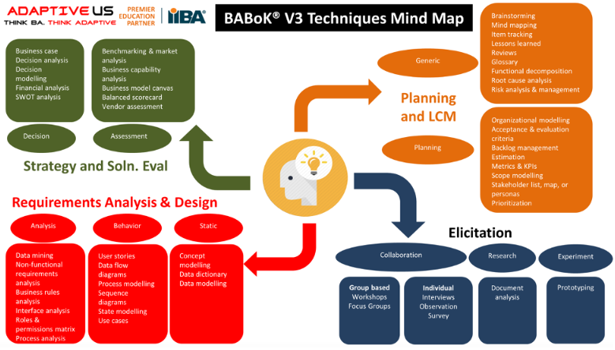

Elicitation Techniques used in this project

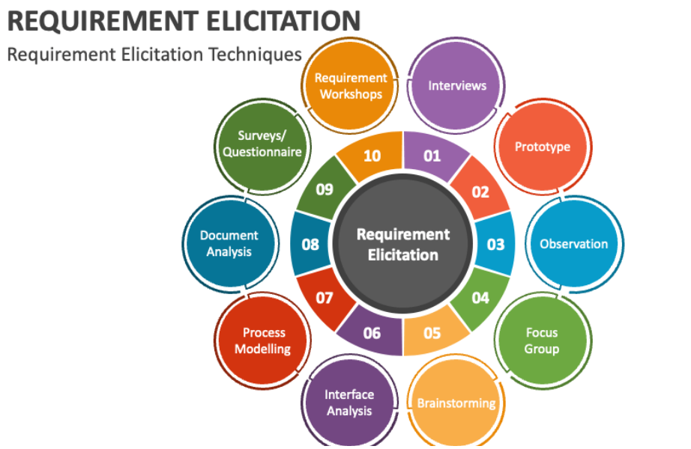

The elicitation techniques I will use for this project are as follows

* Interviews: Conduct one-on-one interviews with SOONY Committee members, farmers (Peter, Kevin, Ben), and potential manufacturer representatives to understand their needs and expectations.
* Requirement Workshop: Discussion and bran storming with various stakeholders such as SOONY member, farmers, manufacturers, SME, Developers and tester. Create user stories, uses cases, functional specifications required for this project

Stakeholder Analysis (RACI/ILS)

Identify Stakeholders

Internal Stakeholders:

SOONY Company:

SOONY Committee (Mr. Henry, Mr. Pandu, Mr. Dooku): Sponsors the project and represent SOONY's interests. They are responsible for providing resources, making final decisions, and ensuring the project aligns with SOONY's CSR goals. (Accountable)

APT IT Solutions:

Project Team (Mr. Vandanam, Ms. Juhi, Development & Testing Team): Responsible for building, testing, and delivering the online store platform according to project requirements and timelines. (Accountable)

External Stakeholders:

Farmers (Peter, Kevin, Ben): Represent the target user group who will benefit from using the platform to purchase agricultural products. Their needs and feedback are crucial for the platform's success. (Consulted)

Seed/Fertilizer/Pesticide Companies: These companies will potentially use the platform to sell their products to farmers. They have an interest in a user-friendly platform that reaches a wider audience. (Consulted/Informed)

Stakeholder Prioritization

Stakeholders are prioritized using the Power and Interest model as mentioned below:

High Power & High Interest: These are your top priority stakeholders. They have the most influence and are most likely to be actively involved in the project. You need to keep them informed, engaged, and addressed their concerns.

High Power & Low Interest: These stakeholders may not be actively involved, but their approval or disapproval can still impact the project. Keep them informed but don't require as much engagement.

Low Power & High Interest: These stakeholders may be affected by the project but don't have much say in its outcome. Provide them with updates but don't need extensive communication.

Low Power & Low Interest: These stakeholders have minimal influence and concern about the project. You may only need to communicate with them at key milestones.

Documentation

cope

2. In-Scope Features/Services

3. Out scope Features/Services

4. Solution Architecture Diagram

5. Technology Specifications

6. FRD – Functional and Non-Functional

7. BRD

8. PROJECT TIMELINE

9. RISKS AND MITIGATION PLAN

10. CHANGE MANAGEMENT

11. STANDARD TERMS AND CONDITION

**Planning and Requirement Analysis:**

Business Case: This document justifies the project's existence, outlining the problem it aims to solve, the expected benefits, and the project's feasibility.

Business Analysis Plan (BAP): This plan details the approach for gathering and documenting requirements, including timelines, resources, and communication strategies.

Stakeholder Management Plan: This plan identifies stakeholders, their interests, and communication strategies for keeping them engaged.

**Requirements Defining and Approval:**

Business Requirements Document (BRD): This document captures the project's functional and non-functional requirements, essentially what the system needs to do and how it should perform.

Use Cases and User Stories: These user-centric narratives describe how different user groups will interact with the system to achieve specific goals. (More common in Agile)

Functional Requirement Specification (FRS): This detailed document elaborates on the functional requirements outlined in the BRD. (Waterfall)

**Design and Prototyping:**

System Requirements Specification (SRS): This document translates the business requirements into technical specifications for the development team. (Waterfall)

Wireframes and Mock-ups: These visual representations provide a low-fidelity or high-fidelity blueprint of the system's interface and user experience.

**Implementation and Testing:**

Requirement Traceability Matrix (RTM): This matrix tracks each requirement throughout the SDLC, ensuring they are implemented, tested, and verified.

User Acceptance Criteria (UAC): These define the conditions that a feature must meet to be considered acceptable by the users.

**Deployment and Maintenance:**

Change Request Documents: These documents capture any modifications to the original requirements after the system is deployed.

Test Case Documentation: This may include the BA's contribution to creating or reviewing test cases to ensure the system functions as intended.

Document Sign-off Process:

* BA drafts the documents based on gathered requirements.
* BA conducts review sessions with stakeholders and the project team for feedback and clarification.
* Documents are revised based on feedback and circulated for final sign-off.
* Sign-off hierarchy will be established (e.g., SOONY Committee for final approval).

Client Approvals:

As BA for all business documents, I would like to take approval from Project sponsor - Mr. Henry and Financial Head – Mr Pandu, Project Coordinator - Mr Dooku, Key stakeholders - Peter, Kevin and Ben on email. For Approvals I remind them by a call or top-up on this mail.

Communication channels to establish and implement

* Project Management Tool (e.g., Jira, Mural) for issue tracking, task management, and document sharing.
* Regular Virtual project meetings (weekly/bi-weekly) with stakeholders and the project team on Teams
* Email communication for specific discussions and approvals.

How to handle Change Requests

* The BA will analyse the change request. Initially he performs Feasibility study to accept the change and then impact analyse to measure the change to project and finally effort estimation to implement the changes in the project.
* A formal process will be established for handling change requests. This may involve a change request form outlining the proposed change, rationale, and potential impact.
* The BA will assess the change request, gather stakeholder feedback, and communicate the decision (approve, reject, or require further information).

How to update the progress of the project to the Stakeholders

Project status reports will be prepared and presented to stakeholders at regular intervals. These reports will highlight progress made, upcoming milestones, and any potential risks.

BA shall take the feedback from the client and ensure necessary changes are communicated to the team.

UAT Sign-off- Client Acceptance Form

* User Acceptance Testing (UAT) will be conducted with farmers and potential manufacturers to ensure the platform meets their needs and expectations.
* A User Acceptance Test (UAT) plan will be developed outlining the testing scope, criteria, and roles.
* Upon successful completion of UAT, a Client Project Acceptance Form will be presented to the SOONY Committee for final sign-off.

|  |  |
| --- | --- |
| * Project Name | E-commerce system |
| This Document is Issued by | Aditi Gupta |
| Date | 04/09/24 |

The project Outcome has been measured against its acceptance criteria and has been formally accepted on behalf of the client.

Unless otherwise noted, the project may now be closed.

|  |
| --- |
| Additional Comments related to client Acceptance: Everything is working as planned |
| Key Metrics Achieved: Successful order confirmation |
| Key Metrics to be Tracked: Payment modes |
| Recorded Shortfalls (If any): No |

Mr Henry - Project Sponsor ___________________________________ Date: 04/09/24

Mr Vandanam - Project Manager ______________________________ Date: 04/09/24

Ms Aditi - Business Analyst ____________________________________ Date: 04/09/24

**Question 3. 3 Tier Architecture**

A 3-tier application is an application program that is organized into three major parts, comprising of data access layer tier at the bottom, the application tier (business logic) in the middle and the client tier (Presentation) at the top and each tier is distributed to a different place or places in a network. These tiers do not necessarily correspond to physical locations on various computers on a network, but rather to logical layers of the application.

Layers The 3-tier architecture consists of the three layers as follows –

• Presentation layer − This layer is also called the client layer. The front-end layer consists of a user interface. The main purpose is to communicate with the application layer.

• Application layer − This layer is also called the business logic layer. It acts as a middle layer between the client and the database server which are used to exchange partially processed data.

• Database layer − In this layer the data or information is stored. This layer performs operations like insert, update and delete to connect with the database.

**Question 4. BA Approach Strategy for framing questions:**

**Understanding the Source:**

5W1H: Who, What, When, Where, Why, and How. These basic questions help gather foundational information about the stakeholder's needs and perspectives.

**Clarity and Focus:**

SMART: Specific, Measurable, Achievable, Relevant, and Time-bound. Formulate questions that are clear, concise, and relevant to the specific topic at hand.

**Stakeholder Roles and Responsibilities:**

RACI: Responsible, Accountable, Consulted, Informed. Consider the stakeholder's role in the project (RACI) to tailor questions that align with their area of expertise.

**Understanding the System:**

3-Tier Architecture: Being familiar with the system's architecture (presentation, application, data) allows you to ask questions that probe deeper into specific functionality layers.

**Requirement Gathering Techniques:**

Use Cases: When discussing functionalities, consider how specific user roles interact with the system through use cases. This helps identify user needs and expectations.

Use Case Specs: If use case specifications are available, refer to them to formulate questions that clarify specific details within use cases.

Activity Diagrams: If activity diagrams exist, use them to ask questions about workflows and data flow within the system.

Models: Depending on the project, consider any existing models (data models, system models) to frame questions that ensure alignment with the overall system design.

Page Designs: For UI discussions, leverage any mock-ups or page designs to ask targeted questions about user interactions with specific interface elements.

**Question 5. Elicitation Techniques**

**Brainstorming -** his technique is used to generate new ideas and find a solution for a specific issue. The members included for brainstorming can be domain experts, subject matter experts. This session is generally conducted around the table discussion. All participants should be given an equal amount of time to express their ideas.

**Document Analysis -** This technique is used to gather business information by reviewing/examining the available materials that describe the business environment. Document analysis includes reviewing the business plans, technical documents, problem reports, existing requirement documents, etc. This is useful when the plan is to update an existing system. This technique is useful for migration projects.

**Reverse engineering -** This elicitation technique is generally used in migration projects. If an existing system has outdated documentation, it can be reverse engineered to understand what the system does. This is an elicitation technique that can extract implemented requirements from the system.

There are two types of reverse engineering techniques.

Black box reverse engineering: The system is studied without examining its internal structure (function and composition of software).

White box reverse engineering: The inner workings of the system are studied (analysing and understanding of software code).

**Focus group -** By using a focus group, you can get information about a product, service from a group. The Focus group includes subject matter experts. The objective of this group is to discuss the topic and provide information. A moderator manages this session. The moderator should work with business analysts to analyse the results and provide findings to the stakeholders.

**Observation –** The main objective of the observation session is to understand the activity, task, tools used, and events performed by others. During the session, the observer should record all the activities and the time taken to perform the work by others so that he/she can simulate the same. After the session, the BA will review the results and will follow up with the participants. Observation can be either active or passive.

**Workshop –** A requirements workshop can be defined as a structured and facilitated event for getting carefully selected stakeholders together to discover, refine, prioritize, validate and discuss requirements. A skilled facilitator usually manages workshop sessions. It is designed to be collaborative and has its roots embedded in Joint Application Design (JAD).

**JAD (Joint Application Development) -** This technique is more process-oriented and formal as compared to other techniques. These are structured meetings involving end-users, PMs, SMEs. This is used to define, clarify, and complete requirements.

**Interview –** This is the most common technique used for requirement elicitation. Interview techniques should be used for building strong relationships between business analysts and stakeholders. In this technique, the interviewer directs the question to stakeholders to obtain information. One to one interview is the most commonly used technique.

**Prototyping –** Prototyping is used to identify missing or unspecified requirements. In this technique, frequent demos are given to the client by creating the prototypes so that client can get an idea of how the product will look like. Prototypes can be used to create a mock-up of sites, and describe the process using diagrams.

**Survey/Questionnaire –** For Survey/Questionnaire, a set of questions is given to stakeholders to quantify their thoughts. After collecting the responses from stakeholders, data is analysed to identify the area of interest of stakeholders. Questions should be based on high priority risks. Questions should be direct and unambiguous. Once the survey is ready, notify the participants and remind them to participate.

**Question 6. The elicitation techniques I will use for this project are as follows**

* **Interviews:** Conduct one-on-one interviews with SOONY Committee members, farmers (Peter, Kevin, Ben), and potential manufacturer representatives to understand their needs and expectations.
* **Requirement Workshop:** Discussion and bran storming with various stakeholders such as SOONY member, farmers, manufacturers, SME, Developers and tester. Create user stories, uses cases, functional specifications required for this project.

**Question 7. List down 10 Business Requirements**

BR01 – Manufacturers and farmers should be provided login facility.  
BR02 – Farmers should be able to login into the website using their email id and secured password.  
BR03 – If it’s a new user, farmers can create a new account by submitting their email id and creating a new password.  
BR04 – Farmers should be provided with search option, so that they can search for any product they want to buy.   
BR05 – Farmers should be able to browse product catalogue once they visit the website.  
BR06 – Farmers should be able to add a product to buy-later list, provided they have logged in.  
BR07 – Famers should be provided easy-to-use payment gateway option which has payment options such as Cash On Delivery, Credit/Debit Card, UPI payment etc.  
BR08 – Users should receive an email about order confirmation.  
BR09 – Farmers should be provided with tracking facility, so that they can track the order and check delivery status  
BR10 – Manufactures should be able to upload and display their product on the website.

**Question 8. Assumptions to the above requirements**

1) Farmers can use basic technology

2) Farmers have active internet connection

3) Farmers have valid email ID and mobile number

4) There is a non-stop availability of Products from the Manufacturer

5) The Website is secured

6) Farmers have access to electronic gadgets such as mobile, laptop

7) The website is working without any glitches

8) Customer support is available 24/7

**Question 9. Prioritization of Project Requirements**

|  |  |  |  |
| --- | --- | --- | --- |
| **Req ID** | **Req Name** | **Req Description** | **Priority** |
| BR001 | Farmer Search for Products | Farmers should be able to search for available products in fertilizers, seeds, pesticides | 8 |
| BR002 | Manufacturer upload their Products | Manufacturers should be able to upload and display their products in the application. | 8 |
| BR003 | Login | Manufacturers and Farmers should be able to login | 8 |
| BR004 | Product Catalog | Farmer should be able to browse through product catalog. | 7 |
| BR005 | Add to Cart | Farmers should be able to add to cart to buy any product. | 9 |
| BR006 | Add to Wishlist | Farmers should be able to add products to buy later list. | 6 |
| BR007 | Create Login | Farmers should be able to create Login through email id and alphanumeric password. | 10 |
| BR008 | Payment Gateway | Farmers should be able to choose any one from COD, credit/debit card and UPI at the payment gateway. | 9 |
| BR009 | Order confirmation | User should get a confirmation email regarding their order status. | 8 |
| BR010 | Delivery tracking | Farmer should be able to track the delivery shipment. | 6 |

**Question 10- Use Case Diagram**

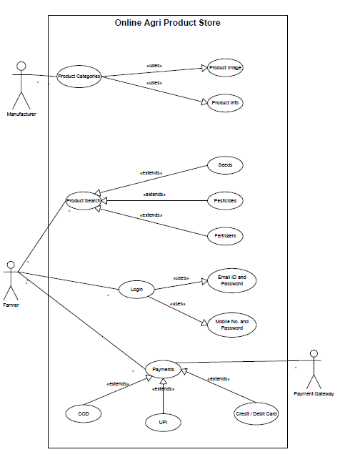

**Question 11- Use Case Specs for all use cases**

|  |  |
| --- | --- |
| **Brief Description** | **This use case describes how the customer (farmers) uses the online agricultural product store to buy**  **fertilizer’s** |
| **Actors** | Customers (Farmer) Admin |
| **Pre-Conditions** | There is an active network connection between both mobile application and online application store connection. |
| **Basic Flow** | 1. The use case begins when customer (farmer) searches for agricultural product. 2. Use case: validate user is performed (Customer search fertilizers) 3. Application displays the different alternatives that are available on this unit. In this case the customer always selects fertilizers. 4. The application prompts for an account. See supporting requirement SR-yyy for account type that shall be supported. 5. The customer selects one ‘’fertilizer’’ product. 6. Account and product details is sent to admin as transaction. The admin consortium replies with a go/no go reply telling if the all things are ok. 7. The customer selects the product delivery location. 8. Then application displays payment mode. 9. As per payment mode receipt is sent to customer by SMS and email 10. The use case end successfully. |
| **Alternative Flows** | **o Invalid user**  If in step 2 of basic flow of the use case: validate user does not complete successfully, then   * use case ends with a failure condition   + **Unavailable product**   if in step 5 in the basic flow the customer select product that can’t be available   * the application shall display the message indicating that the product out of stock. Please try after 2 to 3 days. * The use case resume at step 5   + **Product unavailable for particular location**   if in step 7 in the basic flow the customer select location at which product that can’t be available   * the application shall display the message indicating that the product unavailable for this location. Please try after 2 to 3 days. * The use case resume at step 7   + **No Response from admin**   If in step 8 of basic there is no response from the admin within 15 seconds, then   * The application will re-try * If there is still no response from admin the application shall display the message ‘network unavailable- try again later’ * Application goes to home page |
| **Key scenarios** | No Response from admin |
| **Post-condition** | * Successful completion   The user has to buy fertilizer and the internal logs have been updated   * Failure condition   The logs have been updated accordingly |
| **Special**  **Requirement** | [SpReq : WC-1] agricultural product shall dispense as per government policy  [SpReq : WC-2] The application shall keep a log, Including date and time, of all transactions |

USE- CASE SPECIFICATION FOR: <ONLINE PAYMENT by internet banking>

|  |  |
| --- | --- |
| **Brief Description** | This use case describes how the customer (farmers) makes online payment to agricultural product store |
| **Actors** | Customers (Farmer) Admin  Bank |
| **Pre-Conditions** | There is an active network connection between mobile application, bank and payment gateway connection. |
| **Basic Flow** | 1. The use case begins when customer (farmer) wants to make a payment. 2. Use case: validate user is performed 3. Application displays the different alternatives that are available on this unit. In this case the customer always selects mode of payment internet banking. 4. The application prompts to select bank. See supporting requirement SR-yyy for bank that shall be supported. 5. The customer selects one particular bank and inter log in credential. 6. Account and product details is sent to bank as transaction. The admin consortium replies with a go/no go reply telling if the all things are ok. 7. The customer selects the pay now option and make payment. 8. Then application display successful payment. 9. As a payment done receipt is send to customer by SMS or email. 10. The used case end successfully. |
| **Alternative Flows** | **o** **Invalid user**  If in step O of basic flow customer, the use case: validate user does not complete successfully, then   * use case ends with a failure condition   + **Unavailable funds in account**   if in step Q in the basic flow the customer select amount that can’t be available in bank account   * the application shall display the message indicating that insufficient balance. Please try with another account. * The use case resume at step N   + **Amount exceeds transfer limit**   if in step Q in the basic flow the customer selects amount exceeds withdrawal limit bank account   * The internet banking shall display a warning SMS and ask the customer to reenter the amount. * The use case resume at step Q.   + **No Response from admin**   If in step Q of basic there is no response from the admin within 15 seconds, then   * The application will re-try * If there is still no response from admin the application shall display the message ‘network unavailable- try again later’ * Application goes to home page |
| **Key scenarios** | No Response from admin and bank |
| **Post-condition** | * Successful completion   The user has successfully made a payment and the internal logs have been updated   * Failure condition   The logs have been updated accordingly. |
| **Special Requirement** | [SpReq : WC-1] the maximum transaction limit XYZ amount.  [SpReq : WC-2] The application shall keep a log, Including date and time, of all complete and incomplete transactions with the admin. |

USE- CASE SPECIFICATION FOR: <USER ID and PASSWORD CREATED by mobile number>

|  |  |
| --- | --- |
| **Brief Description** | This use case describes how the customer (farmers) Creates user id and password of online agricultural product store |
| **Actors** | Customers (Farmer)  Admin |
| **Pre-Conditions** | There is an active network connection between mobile application and online agricultural product store |
| **Basic Flow** | 1. The use case begins when customer (farmer) wants to Create user id and password. 2. Use case: validate user is performed 3. Application displays the different alternatives that are available on this unit. In this case the customer always selects mode Create user id and password by Mobile number. 4. The application prompts for admin. See supporting requirement SR-yyy for admin that shall be supported. 5. The customer inters user details (Name, Surname, Mobile number and email ID) and send OTP to mobile number by SMS. 6. Customer creates New User ID 7. Customer inter valid OTP 8. Customer create password 9. Then application display successful create user ID and Password. 10. As a create user ID and Password receipt is send to customer by SMS or email. 11. The used case end successfully. |
| **Alternative Flows** | **o** **Invalid OTP inter by customer**  If in step 27 of basic flow customer, the use case: validate user does not inter valid OTP, then   * the application shall display the message indicating that invalid OTP. Please type valid OTP. * The use case resume at step 27   + **Available of user ID**   if in step 26 in the basic flow the customer creates user ID that available in system.   * the application shall display the message indicating that already this user ID create. Please try with another on and show some options. * The use case resume at step 26   + **Already used mobile number**   if in step 25 in the basic flow the customer inters mobile number which already used to create account   * The application shall display mobile number already used please try with another number. * The use case resume at step 25.   + **Already used email ID**   if in step 25 in the basic flow the customer inters email id which already used into another account   * The application shall display email ID already used please try with another email id. * The use case resume at step 25. |
| **Key scenarios** | No Response from admin |
| **Post-condition** | * Successful completion   The user id has been successfully completed and the internal logs have been updated   * Failure condition   The logs have been updated accordingly. |
| **Special**  **Requirement** | [SpReq : WC-1] The application shall keep a log, Including date and time, of all complete and incomplete transactions with the admin. |

USE- CASE SPECIFICATION FOR: <AGRICULTURE PRODUCT UPDATION PROCESS BY MANUFACTURER>

|  |  |
| --- | --- |
| **Brief Description** | This use case describes how the manufacturers update the product at online agricultural product store |
| **Actors** | Customers (manufacturer)  Admin |
| **Pre-Conditions** | There is an active network connection between mobile application and online agricultural product store |
| **Basic Flow** | 1. The use case begins when manufacture wants to update any new agriculture product at agricultural product store. 2. Use case: validate user is performed 3. Application displays the different alternatives that are available on this unit. In this case the manufacture always selects sale agricultural product option. 4. The application prompts for admin. See supporting requirement SR-yyy for admin that shall be supported. 5. Manufacture chooses product categories. 6. The manufacture inters product details (Name, type of product, applicable of products, price and offers on product and delivery date). 7. Application displays the new product detail update successfully. 8. For the conformation manufacture also get receipt by SMS or email. 9. The used case end successfully. |
| **Alternative Flows** | **o** **Region wise product price display to customer**  If in step 37 of basic flow manufacture, the use case: validate application does not display price of product region wise, then   * the application shall display the product price region wise. Please type valid price. * The use case resume at step 37   **o Manufacture have option to choose product categories**  if in step 36 in the basic flow the manufacture has available options to choose product categories in system.   * the application shall display the message indicating that choose product categories. Please try with another on and show some options. * The use case resume at step 26 |
| **Key scenarios** | No Response from admin |
| **Post-condition** | * Successful completion   The product has been successfully updated and the internal logs have been updated   * Failure condition   The products have been updated accordingly. |
| **Special**  **Requirement** | [SpReq : WC-1] The application shall keep a log, Including date and time, of all complete and incomplete  transactions with the admin. |

USE- CASE SPECIFICATION FOR: < User should able to cancel the product>

|  |  |
| --- | --- |
| **Brief Description** | This use case describes how user cancel the product at online agricultural product store |
| **Actors** | Customers (manufacture) farmer  Admin |
| **Pre-Conditions** | There is an active network connection between mobile application and online agricultural product store |
| **Basic Flow** | 1. The use case begins when user wants to cancel agriculture product at agricultural product store. 2. Use case: validate user is performed 3. Application displays the different alternatives that are available on this cart unit. In this case the manufacture always selects agricultural product those user wants to cancel. 4. The application prompts for admin. See supporting requirement SR-yyy for admin that shall be supported. 5. System pop up text box with headline please provide reason to cancel the product. 6. User should provide reason and press ok. 7. Application displays the agricultural product pick date, time and location. 8. Application displays the cancel request has update successfully. 9. For the conformation manufacture also get receipt by SMS or email. 10. The used case end successfully. |
| **Alternative Flows** | **o** **Cancel period is over**  If in step 45 of basic flow manufacture, the use case: validate application does not display price of product region wise, then   * the application shall display the you cannot return this product. Please type valid price. * The use case resume at step 43   **o Farmer are too available on that date**  if in step 47 in the basic flow the manufacture has available options to choose product categories in system.   * the application shall display the message indicating that agricultural product pick date, time and location. But farmer not available on that day system should show option choose date, time and location. * The use case resume at step 45 |
| **Key scenarios** | No Response from admin |
| **Post-condition** | * Successful update cancel request   The product has been successfully cancelled and the internal logs have been updated   * Failure condition   The products have been cancelled accordingly. |
| **Special**  **Requirement** | [SpReq : WC-1] The application shall keep a log, Including date and time, of all complete and incomplete  transactions with the admin. |

**Question 12- Activity Diagram**

* Login
* Home Page
* Product Selection
* Checkout and Payment
* Delivery Tracking

1. **Login**

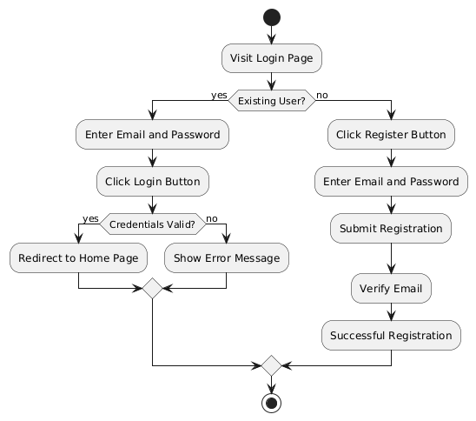

1. **Home Page**

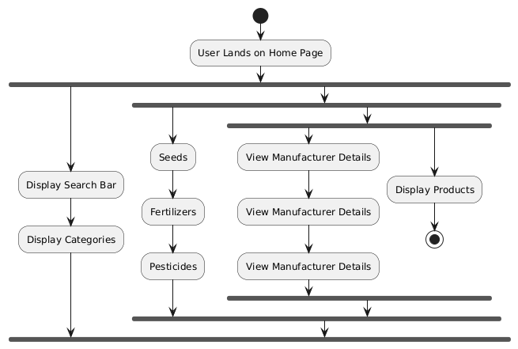

1. **Product Selection**

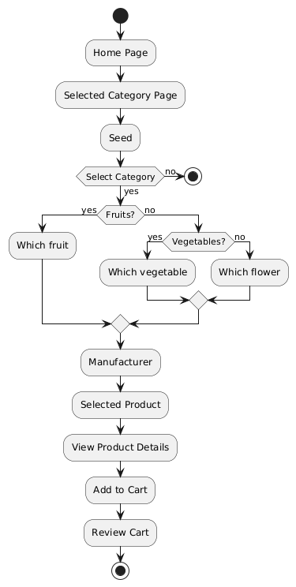

1. **Checkout and Payment**

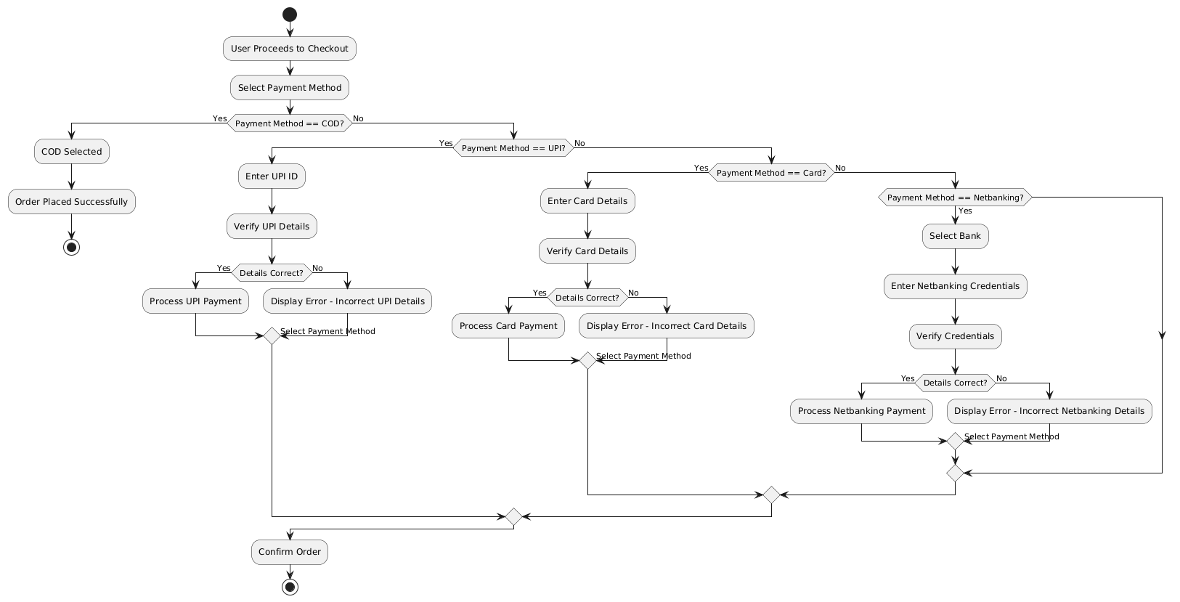

1. **Delivery Tracking**

