BLOG-1 - Business Analyst Role In Project Success
BLOG2 in the 3rd Page
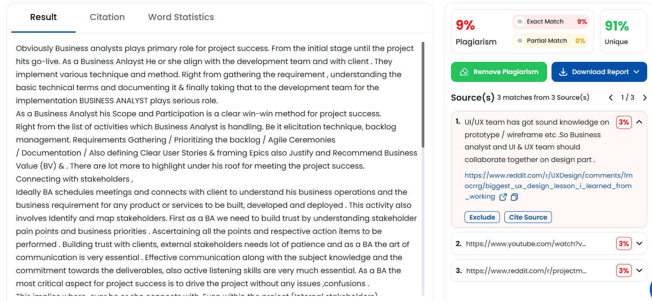
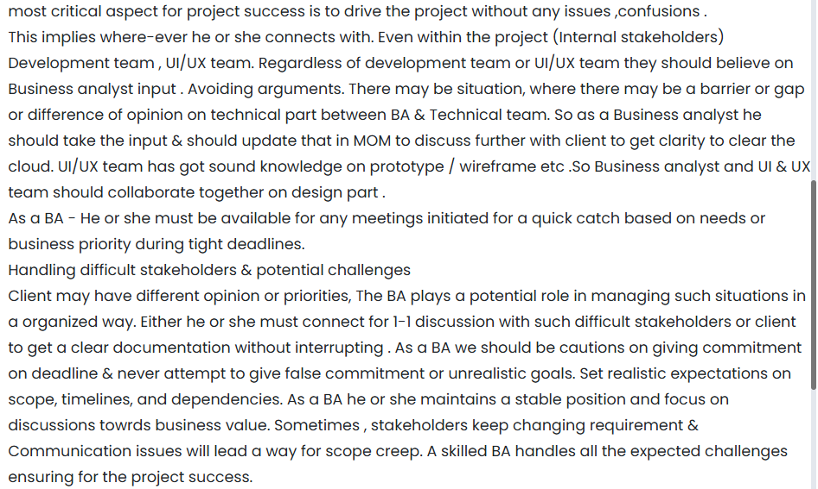
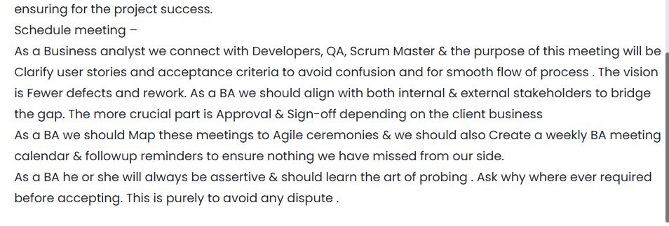

BLOG-2 - Interview Tips for Aspiring Business Analyst

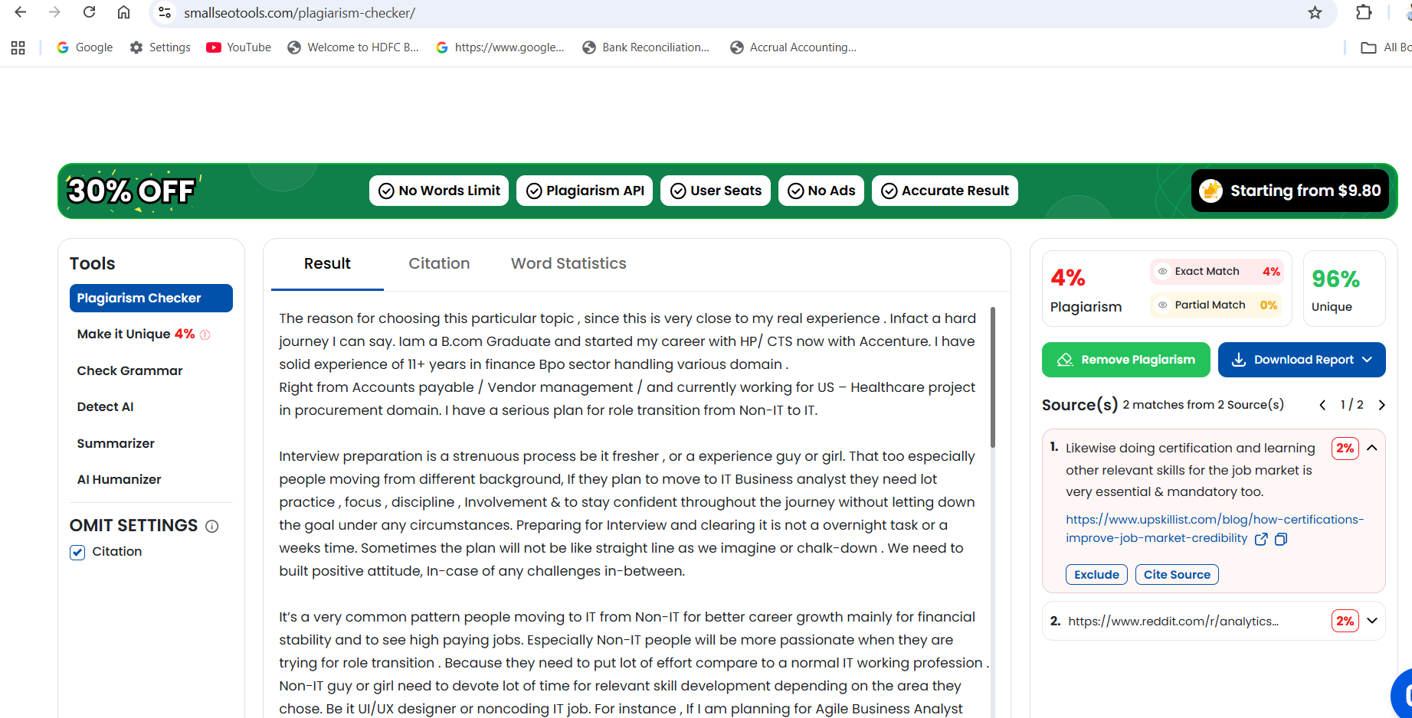
The reason for choosing this particular topic , since this is very close to my real experience . Infact a hard journey I can say. Iam a B.com Graduate and started my career with HP/ CTS now with Accenture. I have solid experience of 11+ years in finance Bpo sector handling various domain .
Right from Accounts payable / Vendor management / and currently working for US – Healthcare project in procurement domain. I have a serious plan for role transition from Non-IT to IT.

Interview preparation is a strenuous process be it fresher , or a experience guy or girl. That too especially people moving from different background, If they plan to move to IT Business analyst they need lot practice , focus , discipline , Involvement & to stay confident throughout the journey without letting down the goal under any circumstances. Preparing for Interview and clearing it is not a overnight task or a weeks time. Sometimes the plan will not be like straight line as we imagine or chalk-down . We need to built positive attitude, In-case of any challenges in-between.

It’s a very common pattern people moving to IT from Non-IT for better career growth mainly for financial stability and to see high paying jobs. Especially Non-IT people will be more passionate when they are trying for role transition . Because they need to put lot of effort compare to a normal IT working profession . Non-IT guy or girl need to devote lot of time for relevant skill development depending on the area they chose. Be it UI/UX designer or noncoding IT job. For instance , If I am planning for Agile Business Analyst role , then I need leverage my skills with proper certification like Business Analyst / Power BI / SQL / TABLEAU . Now lets deep dive into this topic in interview perspective .
The current market is very competitive with tough race. Apart from learning new skills for the relevant role & completing the certification is a basic & mandatory process. However practically we need to apply those concepts to gain the momentum to stay in the race.
Obviously interview is tyring process. Interviewer will gauge our performance under various parameters.
Preparing for interview is completely a different ball game. For instance cricket and baseball looks very similar but in reality the approaches are different. Likewise doing certification and learning other relevant skills for the job market is very essential & mandatory too. However practically meeting the core expectations of the interview panel are quite different. Once we get into the job from different background , Its going to be a tough journey for minimum 1 year , until we settle with the new environment. Interview pannel will look for beyond the basic criteria. Which means, as a applicant I need to be stable emotionally before attending the interview and also during the interview. The interviewer will also look our behavioural approach, which means how we behave in a particular given situation. To put in a clear note - do you have relevant experience of handling similar situation. Or even if we don’t have such experience can I think of solutions. In such situation we need to think about our creative ability on how to handle. This is mainly to handle different stakeholders. Because few client/ stakeholders will be tough to handle.
We should know how the business works , process flow , handling both internal & external stakeholders . We need to work on analytical thinking / as a Business analyst we should be assertive . These are beyond the technical sills or domain knowledge as a Business Analyst we should posses to meet the expectation.
Another best approach I can say , we can take any capstone project to gain the better knowledge practically before giving a interview. So that handling Interview will not be that much threatening.
Parellely a fresher can work as a Intern for sometime to understand how business functions and how team functions & how they interact. This will significantly help them.
As a experienced candidate I should be able to express my transferable skills effectively, If Iam from a different background. That’s the reason, I specified about behavioural approach.
Above all having PSM/ PSPO or any Agile related Certification will be a added advantage . Have a frequent mock session with your mentor or if we don’t have such mentor , the best choice we can hire a mentor and we can explain our passion and preparation level and we can ask him to take a screening. If nothing is possible, now we have plenty of AI tools to practice for interview. Attend udemy classes , or take a session with coursera . Meanwhile Start seeing relevant videos in youtube and we need to practice that to master the skill or atleast to stay active to get the confidence before stepping to interview. Practice in-front of mirror , try to do self evaluation about your expression and communication. This will be very helpful at the time of 1-1 interview, either virtual or face to face direct interview. As I specified , frequent mock session will be really helpful. Parallelly we should work on building our resume with relevant transferrable skills and also it is good to add our capstone project in resume. The job search pattern is keep changing its face. We need to stay active in Linked-in (Updating our resume in Naukri regularly) we also have other platform like Wellfound , Job Board search, Topal, Flex Jobs.
Building strong domain knowledge is the basic criteria . Meanwhile its highly important to have strong communication.
Communication means not just the oral or verbal conversation . Effective communication , which means art of expressing things in a professional way without any confusion and strong listening skills is what the interviewer will look for. As a BA we should potentially exibit these qualities.

