Srikanth Naineni
Talent Acquisition Specialist

PROFILE SUMMARY

Dynamic and results-driven HR Talent Acquisition Specialist with 6 years of experience in full-cycle recruitment, specializing in sourcing, screening, and onboarding top-tier talent across IT domains and familiar with ATS (Applicant Tracking Systems)

EDUCATION

2018

2014

2012
B.Tech/B.E.

Vaagdevi Engineering College, Warangal

XIIth

SR Junior College, Warangal

Xth

Rao's High School,Warangal.

WORK EXPERIENCE

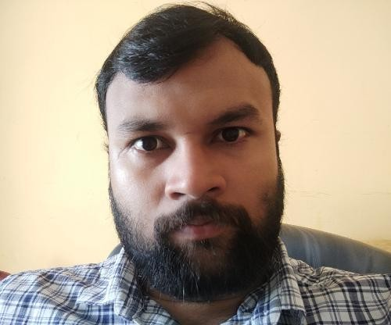
Jun 2022 -
PERSONAL INFORMATION
Email
nainenisrikanth54@gmail.com

Mobile
(+91) 8790478823

Total work experience
6 Years 1 Month
KEY SKILLS
Applicant Tracking System Attrition Management
HR Planning Succession Planning Employee Retention Selection
Business HR

Talent Development HR Operations Talent Management Recruitment Corporate HR
Human Resource Management
OTHER PERSONAL DETAILS
City
Hyderabad
Country
INDIA
Present

Jan 2022 - Jun 2022
Talent Acquisition Specialist

Cognizant
Responsible for sourcing consultants and short-list the resumes depending on the requirements. Working with IT requirements and creating job opportunities for various regions. Take the preliminary round of interview evaluate the communication skills and suitability of the candidate.
Establish strong working relationship with candidates for current and future opportunities. Sharing the shortlisted profiles with Stakeholders and aligning them for further process with client. Speak to the consultants regarding their technical skills, interest, availability and aligning for Interviews. Well versed with professional and social networking sites like LinkedIn. Coordinating with the panels and aligning fresh profiles for the first level of technical screening. Ensure to bring in candidates that fit in salary range for any deviation/niche skill-recruitment team to provide analysis and communicate the same to the Hiring Manager. Scheduling interviews, follow up and placing the candidates. Skills: IT Recruitment Internal Recruitment Full Life Cycle Recruiting Corporate Recruiting. Sourced and screened high-quality candidates for .NET and SAP (FICO, MM, ABAP, S/4HANA) roles using platforms like LinkedIn, Naukri
Senior Executive-HR

Infosys

Demonstrated a strong understanding of business requirements and hiring expectations to align recruitment
strategies accordingly.

Coordinated with hiring managers and key stakeholders to conduct intake sessions, gather detailed requisition requirements, and schedule interview panels.
Maintained regular communication with onsite stakeholders for seamless interview coordination and process alignment.
Conducted candidate engagement programs to ensure a positive onboarding experience and reduce offer dropouts.
Led HR discussions, including salary negotiations, explanation of employee benefits, and addressing candidate queries.
Managed end-to-end offer process, including obtaining offer approvals, preparing offer letters, and initiating background verification (BGV) for selected candidates.
Handled the complete Internal Job Posting (IJP) process for employee internal movements, ensuring fair and smooth transitions.

Mar 2019 - Dec 2021
LANGUAGES

English Telugu Hindi
Senior Associate-HR

GlobalLogic

Handled the entire recruitment life cycle, including sourcing, screening, interviewing, and placing qualified candidates across various technologies and domains.
Proactively searched and identified new consultants for current job openings using internal databases, job portals, referrals, and third-party sources.
Shortlisted resumes by analyzing job requirements and matching candidate profiles accordingly.
Communicated with consultantsʼ employers to negotiate and finalize billing rates.
Conducted pre-screening of candidates to assess qualifications, work experience, references, and technical fit.
Maintained a robust pipeline of potential candidates through job boards, LinkedIn, alumni networks, discussion groups, and other sourcing techniques.
Ensured timely communication with candidates regarding contract terms, compensation, availability, and relocation requirements.
Managed end-to-end recruitment for IT clients, from requirement gathering to final placement.
Maintained and updated a comprehensive consultant database categorized by technologies and experience.
Conducted preliminary and telephonic interviews to evaluate communication skills and technical abilities.
Scheduled and coordinated interviews for shortlisted candidates with clients and internal teams.
Built and nurtured a strong vendor network to support niche or bulk hiring needs.
Performed technical interviews, reference checks, online assessments, and coordinated client interviews to
the hiring process

